

FACULTY OF ENGINEERING AND ARCHITETCTURE
DEPARTAMENT OF COMPUTER ENGINEERING
CEN 302-SOFTWARE ENGINEERING

GREENTRACE

Prepared by:
Emiljana Xhaka
Klejsida Toci
Martina Marku
Elis Zela
Andri Mamillo
Marjana Rjepi
Rafail Agolli

Received by : M.Sc Shkumbin Fida
M.Sc Megi Nako

26/03/26
Contents
1) Executive Summary 3
1.1) Project Overview 3
1.2) Purpose and Scope of this Specification 3
2. Product/Service Description 4
2.1 Product Context 4
2.2 User Characteristics 4
2.3 Assumptions 5
2.4 Constraints 5
2.5 Dependencies 6
3) Requirements 6
3.1 User Scenarios List 6
3.2 User Scenarios Extended 8
3.3 Use Cases 9
3.4 Use Case Diagram 12
-- 12
3.5 Functional Requirements (FR) 12
3.6 Non-Functional Requirements (NFR) 13

1) Executive Summary

1.1) Project Overview
GreenTrace is a comprehensive, web-based Environmental Procurement Accountability Platform designed to modernize how environmental impact is tracked, reported, and audited in Albania. Currently, the oversight of large-scale construction and infrastructure projects often relies on fragmented, paper-based reporting and manual checks. These traditional methods are not only difficult for the public to access but are also prone to transparency gaps, making it hard to verify if businesses are actually protecting the air, water, and soil as promised.
GreenTrace addresses these challenges by providing a centralized, digital platform that streamlines and automates the entire environmental compliance lifecycle—from the initial tender and permit stage to the final execution of the project. By leveraging modern web technologies, the platform offers a user-friendly interface accessible to Government Administrators, Businesses, and Journalists. This system enhances environmental accountability, ensures rigorous adherence to "green" regulations, and provides a "Digital Watchdog" mechanism to protect public natural assets.

1.2) Purpose and Scope of this Specification
The purpose of this project is to develop a web application that will facilitate the oversight of environmental procurement by digitalizing and automating the compliance and monitoring processes. This application aims to replace traditional, hidden, or paper-based record-keeping systems, allowing for easier public access, better government management, and enhanced security of environmental data.
The system will enable businesses to submit verifiable digital proof of their eco-actions, allow government admins to monitor project milestones through a centralized dashboard, and empower journalists to flag irregularities or damage in real-time. This documentation provides detailed information about the functionalities and features of the software, catering to all key users, including Government Administrators (The Regulators), Businesses (The Proponents), and Journalists/Public Users (The Watchdogs).

2. Product/Service Description

2.1 Product Context
Our software, GreenTrace, is designed for environmental monitoring and procurement nationwide. It aims to function as an independent, centralized system accessible to Government Administrators, Businesses (Contractors), and Journalists. The platform facilitates the digital transfer and accessibility of environmental reports, impact assessments, and legal documentation between regulatory bodies and the public to ensure total transparency.

2.2 User Characteristics
1. Government Administrator (The Regulator):
- Generate comprehensive reports on business performance, environmental compliance statistics, and violation rates.
- Manage and update project information, including adding new procurement tenders or modifying existing project records.
- Maintain and update the system’s environmental requirements to ensure accurate information regarding national eco-standards.
- Track and manage the inventory of environmental permits, including adding new certificates or updating existing ones.
- Oversee and coordinate the overall operations of the platform, ensuring efficient functioning and adherence to best environmental practices.
2. Business User (The Contractor):
- View a comprehensive list of pending environmental milestones and tasks assigned to their specific projects.
- Postpone or reschedule reporting deadlines based on technical availability and project needs (subject to approval).
- Mark milestones as "Concluded" once the required proof of compliance (e.g., photos of waste management or water filtration) is uploaded.
- Access their company's project history, audit logs, and environmental obligation details.
3. Journalist (The Watchdog):
- Create discrepancy reports for new and existing projects, capturing relevant information and evidence regarding environmental damage.
- View and manage a centralized list of public pending milestones for all active infrastructure projects.
- Cancel or modify their own discrepancy reports based on new investigative findings or updated evidence.
- Assist the general public with inquiries and provide data-driven support throughout the transparency process.

2.3 Assumptions
- Administrators, business representatives, and journalists will receive proper training on how to use the GreenTrace application effectively.
- Government agencies and private businesses have the necessary IT infrastructure (computers, mobile devices, and internet connectivity) to support the web-based application.
- Proper verification and validation of project details and evidence will be performed during data entry to maintain high data integrity and accuracy.
- Journalists are responsible for ensuring that the information reported in "discrepancy logs" is accurate and that the evidence provided is authentic.
- Businesses are responsible for managing their assigned milestones and updating their status (concluded, postponed) correctly and honestly.
- The Administrator is responsible for maintaining up-to-date records of projects, legal standards, and valid certifications within the system.

2.4 Constraints
- The GreenTrace application requires a stable and reliable internet connection to function properly, as it is a cloud-based solution.
- Efficient usage and maximization of the application's capabilities are dependent on adequate training and adoption by all three user groups.
- The application's performance and reliability are dependent on the availability and proper functioning of the national network infrastructure and IT resources.
- The ability to search for projects and specific companies is limited by the accuracy and completeness of the data entered into the system.
- The user interface and functionality may be constrained by the limitations of the web technologies and frameworks used during development.

2.5 Dependencies
- The creation of new discrepancy reports is dependent on the active involvement and field-work of Journalists.
- Updating or marking environmental milestones as "Concluded" is dependent on the participation and data entry of Business Users.
- Generating national compliance reports and updating legal standards are dependent on the active involvement of the Government Administrator.
- Viewing the interactive map and general environmental data on the landing page is dependent on the accessibility of the application’s main database.

3) Requirements

3.1 User Scenarios List
1. Journalist / Public User Stories
- Project Timeline: As a journalist, I want to view a project timeline so that I can understand the current stage of the procurement process.
- Risk Notifications: As a journalist, I want to receive notifications for high environmental risk projects so that I can investigate them early.
- Eco-Scorecard: As a journalist, I want to see an environmental impact score (Eco-Scorecard) so that I can quickly evaluate the project’s sustainability.
- Document Access: As a journalist, I want to access official documents (e.g., Environmental Impact Assessment) so that I can analyze project details.
- Deadline Tracking: As a journalist, I want to track changes in project deadlines so that I can detect delays or irregularities.
- Map Visualization: As a public user, I want to view projects on a map so that I can understand their geographical impact.
- Follow Projects: As a public user, I want to follow specific projects so that I stay informed about updates.
- Whistleblowing (New): As a journalist/public user, I want to submit an anonymous report about a violation so that I can alert the authorities without fear of retaliation.
2. Business (Company) User Stories
- Company Profile: As a business, I want to create a company profile so that I can apply for public tenders.
- Smart Checklist: As a business, I want to access a smart checklist so that I know exactly which environmental documents are required.
- Certificate Upload: As a business, I want to upload environmental certificates (e.g., ISO 14001) so that I can prove compliance.
- Carbon Calculator: As a business, I want to calculate my carbon footprint so that I can meet green tender requirements.
- Submission Portal: As a business, I want to submit project documentation so that I can participate in procurement processes.
- Eco-Score Tracking: As a business, I want to track my Eco-Score so that I can improve my environmental performance.
- Visual Proof: As a business, I want to upload proof of environmental actions (e.g., waste management photos) so that I can show compliance during project execution.
- Smart Alerts (New): As a business, I want to receive automated reminders before a deadline so that I don't miss my environmental compliance submissions.
3. Government Administrator Stories
- Project Publishing: As an admin, I want to create and publish new procurement projects so that businesses can apply.
- Standard Setting: As an admin, I want to define environmental requirements for each project so that standards are enforced.
- Bid Evaluation: As an admin, I want to review and evaluate business applications so that I can select the most compliant bidder.
- Dashboard Monitoring: As an admin, I want to monitor project progress through a dashboard so that I can ensure compliance.
- Milestone Approval: As an admin, I want to approve or reject milestones so that projects follow environmental regulations.
- Violation Alerts: As an admin, I want to receive alerts when deadlines or environmental rules are violated so that I can take action.
- Compliance Reports: As an admin, I want to generate reports on environmental compliance so that I can evaluate overall performance.
- System Audit (New): As an admin, I want to view an Audit Log of all system changes so that I can ensure data integrity and prevent tampering.

Nr | Name | Description
US_01 | Create New Tender | Gov. Admin: Sets up a new project and defines environmental rules.
US_02 | Define Eco-Milestones | Gov. Admin: Sets specific dates for waste, water, and air quality checks.
US_03 | Review Business Bids | Gov. Admin: Evaluates which company has the best "Green" history.
US_04 | Approve Compliance Proof | Gov. Admin: Verifies geotagged photos and GPS data sent by contractors.
US_05 | Reject Compliance Proof | Gov. Admin: Marks a task as "Failed" if the submitted proof is insufficient.
US_06 | Manage System Users | Gov. Admin: Creates, edits, or blocks Business and Journalist accounts.
US_07 | Generate Audit Report | Gov. Admin: Exports a full PDF history of the project for legal accountability.
US_08 | Approve Postpone Request | Gov. Admin: Reviews and grants a deadline extension to a business.
US_09 | Register Company Profile | Business: Creates an account and uploads mandatory environmental certifications.
US_10 | Apply for Green Tender | Business: Submits a technical and environmental proposal for an active project.
US_11 | Upload Photo Evidence | Business: Uses the app to capture and send geotagged photos of compliance.
US_12 | Upload Legal Documents | Business: Attaches waste receipts, water tests, or transport permits.
US_13 | Input Carbon Data | Business: Enters fuel and energy consumption for the Carbon Calculator.
US_14 | Request Deadline Extension | Business: Submits a request for more time based on site needs.
US_15 | View Private Eco-Score | Business: Tracks internal sustainability performance before it is finalized.
US_16 | Search Project Map | Journalist/Public: Locates infrastructure projects via an interactive map.
US_17 | Report Discrepancy | Journalist/Public: Submits a whistleblowing report with photo/video proof.
US_18 | Follow Project Updates | Journalist/Public: Subscribes to receive automated notifications on projects.
US_19 | Compare Eco-Scores | Journalist/Public: Performs side-by-side comparison of company performances.
US_20 | Calculate Eco-Scorecard | System: Automatically updates the 1-100 score based on evidence/reports.
US_21 | Trigger Violation Alert | System: Sends automated warnings if deadlines are missed.

3.2 User Scenarios Extended
US_01: Create New Tender
- Admin clicks "Create Project" on the dashboard.
- Admin enters project details (Name, Location, Scope).
- Admin selects the mandatory environmental standards required.
- System validates the input and publishes the tender to the map.
- If fields are missing: System highlights errors and prevents publication.
US_04: Approve Compliance Proof
- Admin navigates to the "Pending Approvals" section.
- Admin opens the proof (photo/document) submitted by a Business.
- System displays the GPS location and timestamp extracted from the photo.
- Admin confirms the evidence matches site requirements and clicks "Approve".
- If evidence is invalid (US_05): Admin clicks "Reject" and provides a reason for the failure.
US_11: Upload Photo Evidence
- Business user selects an active milestone from their project list.
- User clicks "Capture Evidence" and takes/uploads a photo.
- System automatically extracts GPS coordinates and Time from the image.
- System saves the proof and updates the status to "Pending Verification."
- If no GPS data is detected: System prompts the user to re-upload using the mobile-responsive interface on-site.
US_13: Input Carbon Data
- Business user enters the "Carbon Calculator" module.
- User inputs monthly data (e.g., liters of fuel, kWh of electricity).
- System runs the calculation algorithm.
- System updates the company’s internal Eco-Score and saves the record.
US_17: Report Discrepancy
- Journalist identifies a project on the Interactive Map.
- User fills out the Whistleblowing form and uploads video/photo proof.
- User chooses to submit as "Anonymous" or "Verified Journalist."
- System generates a "Red Flag" alert (US_21) and notifies the Administrator.
US_20: Calculate Eco-Scorecard (System)
- System detects a change (Milestone approved, rejected, or violation reported).
- System applies the weighted scoring algorithm (1-100).
- System refreshes the public scorecard on the project page.
US_21: Trigger Violation Alert (System)
- System monitors the database for expired deadlines every 24 hours.
- If a deadline is passed without an upload, system marks the status as "Overdue."
- System sends automated "Red Flag" emails to both the Admin and the Contractor.

3.3 Use Cases

# | Use Case ID | Use Case Name | Primary Actor | Description
1 | UC-01 | Create New Tender | Gov. Admin | Set up a new project with environmental rules.
2 | UC-02 | Define Eco-Milestones | Gov. Admin | Set specific dates for waste/water/air checks.
3 | UC-03 | Review Business Bids | Gov. Admin | Evaluate which company has the best "Green" history.
4 | UC-04 | Approve Compliance Proof | Gov. Admin | Verify photos/GPS data sent by the contractor.
5 | UC-05 | Reject Compliance Proof | Gov. Admin | Mark a task as "Failed" if the proof is insufficient.
6 | UC-06 | Manage System Users | Gov. Admin | Create, edit, or block Business/Journalist accounts.
7 | UC-07 | Generate Audit Report | Gov. Admin | Export a full PDF history of the project for legal use.
8 | UC-08 | Approve Postpone Request | Gov. Admin | Review and grant a deadline extension to a business.
9 | UC-09 | Register Company Profile | Business | Create an account and upload mandatory environmental certifications.
10 | UC-10 | Apply for Green Tender | Business | Submit a technical and environmental proposal for an active project.
11 | UC-11 | Upload Photo Evidence | Business | Use the app to capture and send geotagged photos of compliance.
12 | UC-12 | Upload Legal Documents | Business | Attach waste disposal receipts, water tests, or transport permits.
13 | UC-13 | Input Carbon Data | Business | Enter fuel and energy consumption for the Carbon Calculator.
14 | UC-14 | Request Deadline Extension | Business | Submit a request for more time based on technical or site needs.
15 | UC-15 | View Private Eco-Score | Business | Track internal sustainability performance before it is finalized.
16 | UC-16 | Search Project Map | Journalist/Public | Locate infrastructure projects via an interactive map interface.
17 | UC-17 | Report Discrepancy | Journalist/Public | Submit a whistleblowing report with photo/video proof of damage.
18 | UC-18 | Follow Project Updates | Journalist/Public | Subscribe to receive automated notifications on specific projects.
19 | UC-19 | Compare Eco-Scores | Journalist/Public | Side-by-side comparison of company environmental performance.
20 | UC-20 | Calculate Eco-Scorecard | System | Automatically update the 1-100 score based on evidence/reports.
21 | UC-21 | Trigger Violation Alert | System | Send automated warnings to Admin/Business if deadlines are missed.

3.4 Use Case Diagram
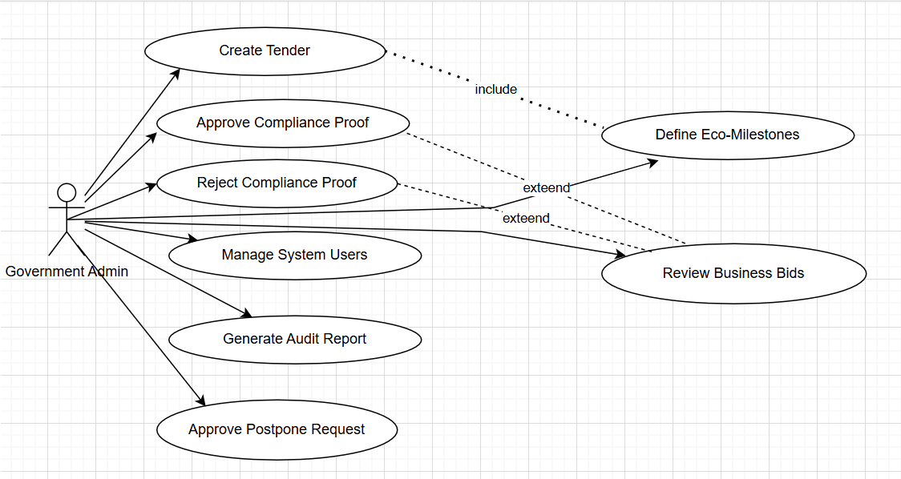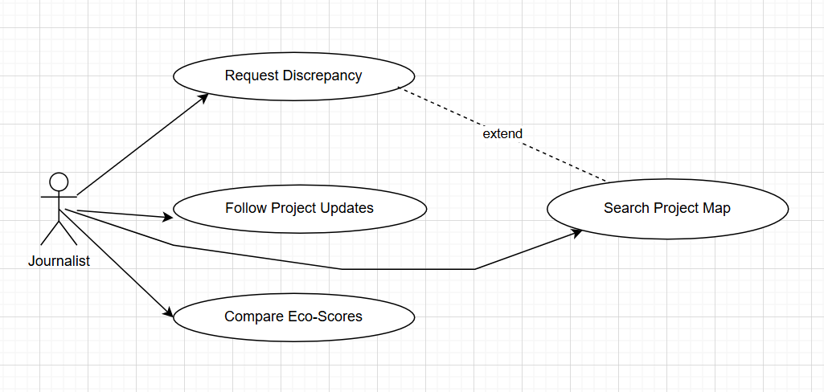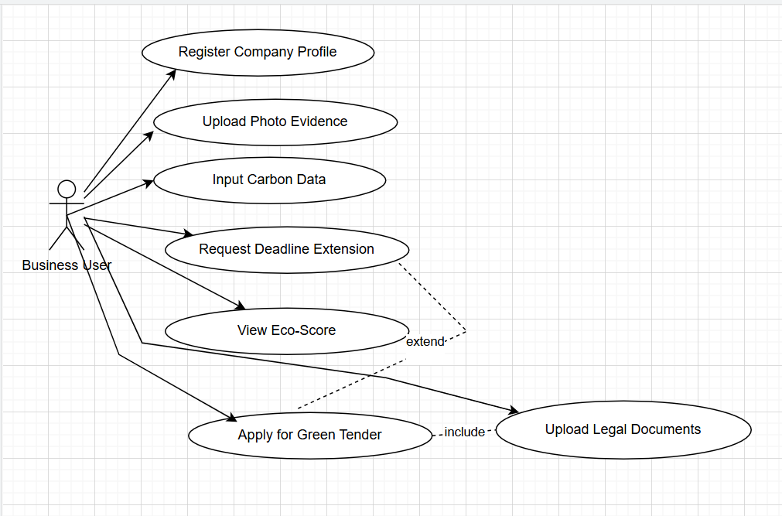

--

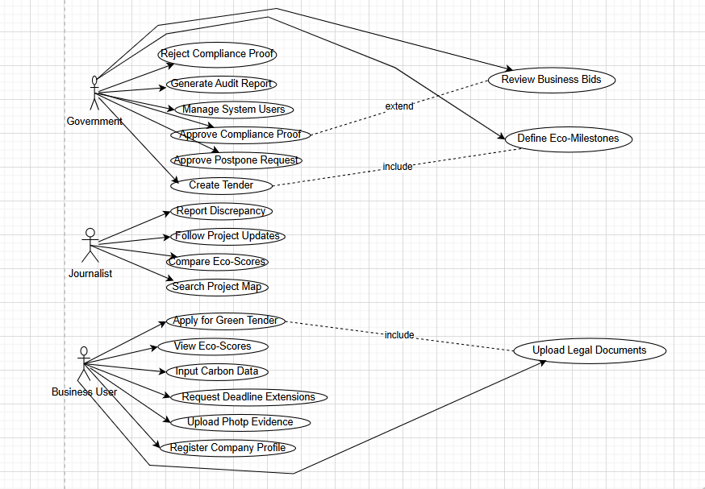

3.5 Functional Requirements (FR)
A. Government Administrator (The Regulator)
- FR-01: The system shall allow Admins to create and publish new procurement projects with custom environmental milestones.
- FR-02: The system shall provide a verification interface to review, approve, or reject evidence (photos/PDFs) submitted by businesses.
- FR-03: The system shall allow Admins to grant or deny deadline extension requests submitted by contractors.
- FR-04: The system shall provide a user management module to register, suspend, or delete Business and Journalist accounts.
- FR-05: The system shall generate a "Digital Audit Trail" for every project, showing every change made by any user.
- FR-06: The system shall enable Admins to set "Risk Levels" (Low, Medium, High) for projects based on their geographical location.
B. Business User (The Contractor)
- FR-07: The system shall allow businesses to create a profile and upload mandatory legal certifications (e.g., ISO 14001).
- FR-08: The system shall provide a "Compliance Portal" where businesses can upload geotagged photos as proof of environmental action.
- FR-09: The system shall include a "Carbon Footprint Calculator" where businesses input fuel and energy data to receive a sustainability score.
- FR-10: The system shall provide a notification system to alert businesses of upcoming or missed deadlines.
- FR-11: The system shall allow businesses to view their current "Eco-Score" and compare it against the project's requirements.
C. Journalist & Public (The Watchdogs)
- FR-12: The system shall display an interactive map (OpenStreetMap/Google Maps API) showing all active environmental projects.
- FR-13: The system shall provide an "Anonymous Whistleblowing" form to report environmental damage with photo/video attachments.
- FR-14: The system shall allow users to "Follow" specific projects and receive automated email updates on their status.
- FR-15: The system shall provide a public search engine to filter projects by Company Name, City, or Eco-Score.
D. Automated System Features
- FR-16: The system shall automatically update the Eco-Scorecard (1-100) whenever a milestone is approved or a violation is reported.
- FR-17: The system shall automatically timestamp and extract GPS metadata from all uploaded image files.
- FR-18: The system shall send automated "Red Flag" alerts to the Admin when a "Discrepancy Report" is filed by a journalist.

3.6 Non-Functional Requirements (NFR)

Category | Requirement Code | Description
Security | NFR-01 | All sensitive data (passwords, certificates) must be encrypted using AES-256 standards.
Performance | NFR-02 | The Public Map and Project Dashboards must load in under 3 seconds on a standard 4G connection.
Scalability | NFR-03 | The system must handle up to 1,000 concurrent users without degradation in performance.
Availability | NFR-04 | The system shall have an uptime of 99.9%, excluding scheduled maintenance.
Integrity | NFR-05 | The system must prevent any user (including Admins) from deleting "Compliance Evidence" once it has been verified.
Usability | NFR-06 | The web application must be Fully Responsive, functioning perfectly on Desktop, Tablet, and Mobile.
Legal | NFR-07 | The system must comply with GDPR (General Data Protection Regulation) regarding the handling of user personal data.

