

FACULTY OF ENGINEERING AND ARCHITETCTURE
DEPARTAMENT OF COMPUTER ENGINEERING
CEN 302-SOFTWARE ENGINEERING

GREENTRACE
Draft1

Prepared by:
Emiljana Xhaka
Klejsida Toci
Martina Marku
Elis Zela
Andri Mamillo
Marjana Rjepi
Rafail Agolli

Received by : M.Sc Shkumbin Fida
M.Sc Megi Nako

26/03/26
Contents
1. EXECUTIVE SUMMARY 3
1.1 Project Overview 3
1.2 Purpose and Scope of this Specification 3
2. Product/Service Description 4
2.1 Product Context 4
2.2 User Characteristics 4
2.3 Assumptions 5
2.4 Constraints 5
2.5 Dependencies 6
3) SOFTWARE DESIGN / DIAGRAMS 6
3.1 .User Scenarios List 6
3.2 User Scenarios Extended 21
3.3 Use Cases 22
3.4 Use Case Diagram 26
-- 28
4 Requirements 29
4.1 Functional Requirements (FR) 29

1. EXECUTIVE SUMMARY

1.1 Project Overview
In recent years, we have increasingly heard about injustices affecting the environment. In Albania, large-scale infrastructure and construction projects are being implemented with the aim of supporting tourism and economic development. However, this raises an important question: what happens to the environment, and is this development truly beneficial for the living organisms that inhabit these areas?
A notable example is the Narta Lagoon area, where the construction of an airport and related infrastructure has significantly affected a fragile ecosystem. Such interventions have led to the degradation of natural habitats, loss of biodiversity, and disruption of ecological balance.Unfortunately, the environmental component is often not treated as a priority, even though many ecosystems have already been significantly damaged. Despite this, such projects continue to be developed without sufficient transparent and publicly accessible monitoring.
In this context, GreenTrace is a web-based Environmental Procurement Accountability Platform designed to improve transparency, monitoring, and reporting of environmental impact in Albania. Currently, environmental oversight of construction and infrastructure projects relies mainly on fragmented documentation and manual verification processes. These methods are inefficient, difficult to access, and often lack transparency, making it challenging to ensure compliance with environmental regulations.
GreenTrace addresses these limitations by providing a centralized digital system that manages the entire environmental compliance lifecycle, from project approval and permitting to execution and monitoring. The platform enables different stakeholders — government administration, businesses, and journalists — to interact with environmental data in real time. Journalists, as the “fourth power,” play an important role by exposing violations and increasing public awareness.
By digitalizing environmental reporting and introducing structured verification mechanisms, GreenTrace increases accountability, reduces administrative burden, and improves public access to environmental information. It acts as a “digital watchdog” to ensure that companies’ environmental commitments are properly tracked and verified.

1.2 Purpose and Scope of this Specification
The purpose of this project is to develop a web application that facilitates the monitoring and management of environmental procurement processes through digitalization and automation. The system aims to replace traditional paper-based methods with a centralized platform that ensures transparency, efficiency, and data integrity.
The application enables businesses to upload digital evidence of environmental compliance, allows government administrators to monitor project progress through a centralized dashboard, and provides journalists and the public with tools to report and track environmental violations.
The scope of this specification includes defining the system’s functionalities, user roles, and core platform features. This document is intended for all stakeholders, including Government Administration (regulators), Businesses (project implementers), and Journalists/Public Users (environmental monitors).

2. Product/Service Description

2.1 Product Context
Our software, GreenTrace, is designed for environmental monitoring and procurement at a national level. It aims to function as an independent, centralized system accessible to Government Administrators, Businesses (Contractors), and Journalists.The platform enables the digital transfer and access of environmental reports, environmental impact assessments, and legal documentation between regulatory institutions and the public, ensuring full transparency.

2.2 User Characteristics
Government Administrator (The Regulator):
- Generate comprehensive reports on business performance, environmental compliance statistics, and violation rates.
- Manage and update project information, including adding new procurement tenders or modifying existing project records.
- Maintain and update the system’s environmental requirements to ensure accurate information regarding national eco-standards.
- Track and manage the inventory of environmental permits, including adding new certificates or updating existing ones.
- Oversee and coordinate the overall operations of the platform, ensuring efficient functioning and adherence to best environmental practices.
Business User (The Contractor):
- View a comprehensive list of pending environmental milestones and tasks assigned to their specific projects.
- Postpone or reschedule reporting deadlines based on technical availability and project needs (subject to approval).
- Mark milestones as "Concluded" once the required proof of compliance (e.g., photos of waste management or water filtration) is uploaded.
- Access their company's project history, audit logs, and environmental obligation details.

Journalist (The Watchdog):
- Create discrepancy reports for new and existing projects, capturing relevant information and evidence regarding environmental damage.
- View and manage a centralized list of public pending milestones for all active infrastructure projects.
- Cancel or modify their own discrepancy reports based on new investigative findings or updated evidence.
- Assist the general public with inquiries and provide data-driven support throughout the transparency process.

2.3 Assumptions
Administrators, business representatives, and journalists will receive proper training on how to use the GreenTrace application effectively.
Government agencies and private businesses have the necessary IT infrastructure (computers, mobile devices, and internet connectivity) to support the web-based application.
Proper verification and validation of project details and evidence will be performed during data entry to maintain high data integrity and accuracy.
Journalists are responsible for ensuring that the information reported in "discrepancy logs" is accurate and that the evidence provided is authentic.
Businesses are responsible for managing their assigned milestones and updating their status (concluded, postponed) correctly and honestly.
The Administrator is responsible for maintaining up-to-date records of projects, legal standards, and valid certifications within the system.

2.4 Constraints
The GreenTrace application requires a stable and reliable internet connection to function properly, as it is a cloud-based solution.
Efficient usage and maximization of the application's capabilities are dependent on adequate training and adoption by all three user groups.
The application's performance and reliability are dependent on the availability and proper functioning of the national network infrastructure and IT resources.
The ability to search for projects and specific companies is limited by the accuracy and completeness of the data entered into the system.
The user interface and functionality may be constrained by the limitations of the web technologies and frameworks used during development.

2.5 Dependencies
The creation of new discrepancy reports is dependent on the active involvement and field-work of Journalists.
Updating or marking environmental milestones as "Concluded" is dependent on the participation and data entry of Business Users.
Generating national compliance reports and updating legal standards are dependent on the active involvement of the Government Administrator.
Viewing the interactive map and general environmental data on the landing page is dependent on the accessibility of the application’s main database.

3) SOFTWARE DESIGN / DIAGRAMS

3.1 .User Scenarios

3.1.1 User Stories
1. Journalist / Public User Stories
- Project Timeline: As a journalist, I want to view a project timeline so that I can understand the current stage of the procurement process.
- Risk Notifications: As a journalist, I want to receive notifications for high environmental risk projects so that I can investigate them early.
- Eco-Scorecard: As a journalist, I want to see an environmental impact score (Eco-Scorecard) so that I can quickly evaluate the project’s sustainability.
- Document Access: As a journalist, I want to access official documents (e.g., Environmental Impact Assessment) so that I can analyze project details.
- Deadline Tracking: As a journalist, I want to track changes in project deadlines so that I can detect delays or irregularities.
- Map Visualization: As a public user, I want to view projects on a map so that I can understand their geographical impact.
- Follow Projects: As a public user, I want to follow specific projects so that I stay informed about updates.
- Whistleblowing (New): As a journalist/public user, I want to submit an anonymous report about a violation so that I can alert the authorities without fear of retaliation.
2. Business (Company) User Stories
- Company Profile: As a business, I want to create a company profile so that I can apply for public tenders.
- Smart Checklist: As a business, I want to access a smart checklist so that I know exactly which environmental documents are required.
- Certificate Upload: As a business, I want to upload environmental certificates (e.g., ISO 14001) so that I can prove compliance.
- Carbon Calculator: As a business, I want to calculate my carbon footprint so that I can meet green tender requirements.
- Submission Portal: As a business, I want to submit project documentation so that I can participate in procurement processes.
- Eco-Score Tracking: As a business, I want to track my Eco-Score so that I can improve my environmental performance.
- Visual Proof: As a business, I want to upload proof of environmental actions (e.g., waste management photos) so that I can show compliance during project execution.
- Smart Alerts (New): As a business, I want to receive automated reminders before a deadline so that I don't miss my environmental compliance submissions.
3. Government Administrator Stories
- Project Publishing: As an admin, I want to create and publish new procurement projects so that businesses can apply.
- Standard Setting: As an admin, I want to define environmental requirements for each project so that standards are enforced.
- Bid Evaluation: As an admin, I want to review and evaluate business applications so that I can select the most compliant bidder.
- Dashboard Monitoring: As an admin, I want to monitor project progress through a dashboard so that I can ensure compliance.
- Milestone Approval: As an admin, I want to approve or reject milestones so that projects follow environmental regulations.
- Violation Alerts: As an admin, I want to receive alerts when deadlines or environmental rules are violated so that I can take action.
- Compliance Reports: As an admin, I want to generate reports on environmental compliance so that I can evaluate overall performance.
- System Audit (New): As an admin, I want to view an Audit Log of all system changes so that I can ensure data integrity and prevent tampering.

3.1.2 User Senarios List
Nr | Name | Description
US_01 | User Registration | Users create an account by providing personal data and selecting a role.
US_02 | User Login | Users access the system using credentials.
US_03 | Manage Profile | Users update personal data and settings.
US_04 | View Projects | Users browse all available projects.
US_05 | View Project Details | Users access detailed information of a project.
US_06 | Search Projects | Users search projects by keywords.
US_07 | Filter Projects | Users filter projects by location, risk, and company.
US_08 | Follow Project | Users subscribe to project updates.
US_09 | Receive Notifications | Users receive system alerts.
US_10 | View Project Map | Users explore projects on a map.
US_11 | Compare Projects | Users compare multiple projects.
US_12 | Report Issue | Users report environmental concerns.
US_13 | Comment on Project | Users interact through comments.
US_14 | Apply for Project | Businesses apply for tenders.
US_15 | Upload Documents | Businesses upload required files.
US_16 | Validate Submission | System checks completeness of application.
US_17 | Calculate Eco-Score | System computes environmental score.
US_18 | Save Draft | Businesses save incomplete applications.
US_19 | Submit Application | Businesses submit final application.
US_20 | Track Application Status | Businesses monitor application progress.
US_21 | Upload Progress Evidence | Businesses upload execution proof.
US_22 | Communicate with Admin | Businesses contact administrators.
US_23 | Create Project | Admin creates new projects.
US_24 | Manage Projects | Admin edits or deletes projects.
US_25 | Evaluate Applications | Admin reviews submitted applications.
US_26 | Rank Applications | Admin ranks applications based on criteria.
US_27 | Approve/Reject Application | Admin decides on applications.
US_28 | Monitor Milestones | Admin tracks project progress.
US_29 | Issue Warnings | Admin sends warnings for violations.
US_30 | Generate Reports | Admin creates system reports.
US_31 | View Dashboard | Admin views analytics dashboard.
US_32 | Manage Users | Admin manages system users.
US_33 | Detect Risks | System identifies environmental risks.
US_34 | Provide Recommendations | System suggests improvements.
US_35 | Logout | Users log out from system.

3.1.3 USER SCENARIOUS EXTENDED
US_01: Register Account (User)
This scenario describes how a new user creates an account in the system by providing personal information and completing the verification process.
a. The user navigates to the system homepage and selects the registration option.
b. The system displays a registration form with required input fields.
c. The user selects their role (Journalist, Business, or Admin).
d. The user enters personal information such as full name, email address, and password.
e. The user confirms the password and completes all required fields.
f. The user submits the registration form.
g. The system validates all entered data, including checking for empty fields and correct formatting.
h. The system verifies that the provided email is not already registered.
i. If all data is valid, the system creates a new account in the database.
j. The system generates a verification email and sends it to the user.
k. The user opens the email and clicks the verification link.
l. The system activates the account and confirms successful registration.
US_02: Login to System (User)
This scenario describes how an existing user logs into the system using valid credentials.
a. The user opens the login page from the system interface.
b. The user enters their registered email and password.
c. The user clicks the login button to access the system.
d. The system validates the credentials against stored user data.
e. The system checks if the account is active and not restricted.
f. If the credentials are correct, the system creates a secure user session.
g. The system redirects the user to the appropriate dashboard based on their role.
h. If the credentials are incorrect, the system displays an error message and prompts the user to try again.
US_03: Manage Profile (User)
This scenario describes how users update and manage their personal account information.
a. The user logs into the system successfully.
b. The user navigates to the profile or account settings section.
c. The system displays the current user information.
d. The user edits personal details such as name, email, or password.
e. The user submits the updated information.
f. The system validates the updated data.
g. The system saves the changes in the database.
h. The system confirms that the profile has been updated successfully.
US_04: View Projects (Journalist/Public User)
This scenario describes how users browse and explore available projects within the platform.
a. The user logs into the system or accesses the public interface.
b. The user navigates to the “Projects” section from the main menu.
c. The system retrieves a list of all available projects from the database.
d. The system displays the projects in a structured format such as a list or grid view.
e. Each project includes summary information such as title, location, status, and Eco-score.
f. The user scrolls through the list and explores the available projects.
g. The user selects a project of interest for further exploration.
US_05: View Project Details (Journalist/Public User)
This scenario describes how users access detailed information about a selected project.
a. The user selects a project from the list of available projects.
b. The system retrieves all relevant project data from the database.
c. The system displays detailed information including description, objectives, and location.
d. The system presents the project timeline with different stages of development.
e. The system displays the Eco-score and environmental risk level using visual indicators.
f. The system shows all uploaded documents such as reports and certifications.
g. The system displays milestone progress and current status of the project.
h. The user reviews all information to better understand the project.
US_06: Search Projects (User)
This scenario describes how users search for projects using keywords or specific criteria.
a. The user navigates to the projects section.
b. The user enters a keyword or search term in the search bar.
c. The user initiates the search action.
d. The system processes the query and searches the database.
e. The system retrieves matching projects based on the search criteria.
f. The system displays the results in a list format.
g. The user reviews the results and selects a project if needed.
US_07: Filter Projects (User)
This scenario describes how users filter projects based on specific attributes.
a. The user opens the projects section.
b. The user selects filtering options such as location, risk level, or company.
c. The user applies the selected filters.
d. The system processes the filter criteria.
e. The system retrieves projects that match the selected filters.
f. The system updates the displayed project list dynamically.
g. The user reviews the filtered results.
US_08: Follow Project (Journalist/Public User)
This scenario describes how users follow a project to receive updates.
a. The user opens the detailed page of a project.
b. The user clicks the “Follow Project” button.
c. The system checks whether the user is authenticated.
d. If the user is logged in, the system adds the project to the user’s watchlist.
e. The system confirms that the project has been successfully followed.
f. The system tracks updates related to the project.
g. The user receives notifications whenever changes occur.
US_09: Receive Notifications (User)
This scenario describes how users receive notifications about project updates.
a. The system detects an update such as a new document, deadline change, or milestone update.
b. The system identifies users who are subscribed to the project.
c. The system generates a notification message.
d. The system sends the notification to users via the platform.
e. The user receives and views the notification.
f. The user may navigate to the project for more details.
US_10: View Project Map (User)
This scenario describes how users view project locations using a map interface.
a. The user navigates to the map view section of the system.
b. The system loads geographic data of all projects.
c. The system displays project locations on an interactive map.
d. The user zooms in or out to explore different areas.
e. The user clicks on a map marker to view project details.
f. The system displays a summary of the selected project.
g. The user can navigate to the full project details page.
US_11: Compare Projects (User)
This scenario describes how users compare multiple projects based on environmental and performance indicators.
a. The user navigates to the projects section.
b. The user selects two or more projects for comparison.
c. The system retrieves detailed data for the selected projects.
d. The system processes and organizes the data into comparable attributes.
e. The system displays a comparison view including Eco-score, risk level, and progress.
f. The user analyzes the differences between the selected projects.
g. The user may select another project to refine the comparison.
US_12: Report Issue (User)
This scenario describes how users report environmental or procedural issues related to a project.
a. The user navigates to a specific project page.
b. The user selects the “Report Issue” option.
c. The system displays a form for submitting the issue.
d. The user enters details describing the problem or concern.
e. The user submits the report.
f. The system validates the submitted information.
g. The system stores the report in the database.
h. The system confirms that the issue has been successfully submitted.
i. The admin is notified about the reported issue.
US_13: Comment on Project (User)
This scenario describes how users interact with projects by posting comments.
a. The user opens a project details page.
b. The user scrolls to the comments section.
c. The user writes a comment related to the project.
d. The user submits the comment.
e. The system validates the content (e.g., no empty or invalid input).
f. The system stores the comment in the database.
g. The comment becomes visible to other users.
h. Other users may read or respond to the comment.
US_14: Apply for Project (Business User)
This scenario describes how a business user submits an application for a project.
a. The business user logs into the system.
b. The user navigates to the available projects section.
c. The user selects a project and clicks “Apply”.
d. The system displays the application form.
e. The user enters company details and required information.
f. The user uploads required documents such as certificates and environmental plans.
g. The system validates all input fields and uploaded files.
h. The system checks whether all required data has been provided.
i. The user reviews the completed application.
j. The user submits the application.
k. The system stores the application and sets the status to “Pending”.
US_15: Upload Documents (Business User)
This scenario describes how business users upload documents required for compliance.
a. The user navigates to the document upload section.
b. The user selects a file from their device.
c. The system checks the file format and size.
d. The system uploads the file to the server.
e. The system stores the file in the database.
f. The system confirms successful upload.
g. The uploaded document becomes part of the application.
US_16: Validate Application Submission (System)
This scenario describes how the system validates submitted applications.
a. The system receives the application data.
b. The system checks all required fields for completeness.
c. The system verifies that all required documents are uploaded.
d. The system validates data consistency and correctness.
e. If all requirements are met, the system marks the application as valid.
f. If any data is missing, the system highlights missing fields.
g. The system notifies the user about the validation result.
US_17: Calculate Eco-Score (System)
This scenario describes how the system calculates the environmental score of a project.
a. The system collects all environmental data from the application.
b. The system processes the data using predefined scoring algorithms.
c. The system evaluates key environmental indicators.
d. The system calculates the Eco-score based on the data.
e. The system assigns a corresponding risk level.
f. The system stores the calculated results.
g. The Eco-score is displayed on the project page.
US_18: Save Draft (Business User)
This scenario describes how a business user saves a partially completed application.
a. The user fills part of the application form.
b. The user clicks the “Save Draft” option.
c. The system stores the incomplete data temporarily.
d. The system confirms that the draft has been saved.
e. The user can return later to continue editing.
f. The system retrieves the saved draft when the user reopens it.
US_19: Submit Application (Business User)
This scenario describes how a business user submits a completed application.
a. The user completes all required fields in the application form.
b. The user reviews all provided information.
c. The user clicks the submit button.
d. The system validates all data again.
e. The system stores the application in the database.
f. The system updates the status to “Pending”.
g. The system confirms successful submission.
US_20: Track Application Status (Business User)
This scenario describes how business users monitor the progress of their applications.
a. The business user logs into the system.
b. The user navigates to the dashboard.
c. The system retrieves all submitted applications.
d. The system displays each application with its current status.
e. The status may include “Pending”, “Approved”, or “Rejected”.
f. The user reviews the status and any feedback provided.
g. The user may take further action if required.
US_21: Upload Progress Evidence (Business User)
This scenario describes how a business user uploads evidence to demonstrate project progress during execution.
a. The business user logs into the system.
b. The user navigates to the active project dashboard.
c. The user selects the milestone or phase that requires evidence submission.
d. The system displays the upload interface for progress evidence.
e. The user selects files such as images, videos, or reports from their device.
f. The system validates file type, size, and format.
g. The system uploads and stores the evidence in the database.
h. The system confirms successful upload.
i. The uploaded evidence becomes available for admin review.
US_22: Communicate with Admin (Business User)
This scenario describes how a business user communicates with administrators regarding applications or project issues.
a. The business user logs into the system.
b. The user navigates to the communication or messaging section.
c. The user selects a specific project or application.
d. The user writes a message or inquiry.
e. The user sends the message to the administrator.
f. The system delivers the message to the admin interface.
g. The admin receives and reads the message.
h. The admin responds through the system.
i. The business user receives the reply.
US_23: Create Project (Admin)
This scenario describes how an administrator creates a new project in the system.
a. The admin logs into the system.
b. The admin navigates to the “Create Project” section.
c. The system displays a project creation form.
d. The admin enters project details such as title, description, and location.
e. The admin defines environmental requirements and compliance criteria.
f. The admin sets deadlines and milestones for the project.
g. The admin uploads initial documentation if required.
h. The admin submits the project.
i. The system validates all entered data.
j. The system stores the project in the database.
k. The project becomes visible to all users.
US_24: Manage Projects (Admin)
This scenario describes how an administrator manages existing projects in the system.
a. The admin logs into the system.
b. The admin navigates to the projects management section.
c. The system displays a list of all projects.
d. The admin selects a specific project.
e. The admin edits project details such as description, deadlines, or requirements.
f. The admin may also delete or archive the project if necessary.
g. The admin saves the changes.
h. The system updates the project information in the database.
i. The updated project data is reflected in the system.
US_25: Evaluate Applications (Admin)
This scenario describes how an administrator evaluates applications submitted by businesses.
a. The admin logs into the system.
b. The admin navigates to the applications section.
c. The system displays all submitted applications.
d. The admin selects an application for review.
e. The system displays all application details and documents.
f. The admin reviews compliance with environmental requirements.
g. The admin examines the Eco-score and supporting evidence.
h. The admin adds evaluation comments or notes.
i. The system saves the evaluation results.
US_26: Rank Applications (Admin)
This scenario describes how the system ranks applications based on evaluation criteria.
a. The admin accesses the list of evaluated applications.
b. The system retrieves all relevant application data.
c. The system applies predefined ranking criteria.
d. The system calculates ranking positions for each application.
e. The system sorts applications based on their scores.
f. The ranked list is displayed to the admin.
g. The admin reviews the ranking results.
US_27: Approve or Reject Application (Admin)
This scenario describes how an administrator makes a final decision on an application.
a. The admin selects an application after evaluation.
b. The admin reviews all evaluation details and notes.
c. The admin decides whether to approve or reject the application.
d. The admin confirms the decision.
e. The system updates the application status accordingly.
f. The system notifies the business user of the decision.
g. The decision is recorded in the system database.
US_28: Monitor Project Milestones (Admin)
This scenario describes how an administrator monitors the progress of project milestones.
a. The admin logs into the system.
b. The admin opens the project dashboard.
c. The system displays all defined milestones and progress indicators.
d. The business uploads evidence for completed milestones.
e. The admin reviews the submitted evidence.
f. The admin verifies whether the milestone requirements are met.
g. The admin approves or rejects the milestone.
h. The system updates the project progress status.
i. The system records the decision for auditing purposes.
US_29: Issue Warnings (Admin)
This scenario describes how an administrator issues warnings to businesses for non-compliance.
a. The admin identifies a project or application with issues.
b. The admin opens the warning or notification interface.
c. The admin writes a warning message describing the issue.
d. The admin sends the warning to the business user.
e. The system delivers the warning notification.
f. The system logs the warning in the database.
g. The business user receives and reviews the warning.
US_30: Generate Reports (Admin)
This scenario describes how an administrator generates reports based on system data.
a. The admin logs into the system.
b. The admin navigates to the reporting section.
c. The admin selects the type of report to generate.
d. The admin selects the desired time period.
e. The system retrieves relevant data from the database.
f. The system processes and organizes the data.
g. The system generates the report in a structured format.
h. The system displays the report to the admin.
i. The admin downloads or exports the report.

US_31: View Dashboard (Admin)
This scenario describes how an administrator accesses and analyzes system data through the dashboard interface.
a. The admin logs into the system using valid credentials.
b. The admin is redirected to the main dashboard interface.
c. The system retrieves aggregated data related to projects, applications, and environmental performance.
d. The system displays key metrics such as number of projects, compliance levels, and Eco-scores.
e. The system presents data visually using charts, graphs, and indicators.
f. The admin reviews the displayed information to understand overall system performance.
g. The admin may interact with dashboard elements to view more detailed data.
US_32: Manage Users (Admin)
This scenario describes how an administrator manages system users and their roles.
a. The admin logs into the system.
b. The admin navigates to the user management section.
c. The system displays a list of all registered users.
d. The admin selects a specific user from the list.
e. The admin views user details including role and activity.
f. The admin updates user roles or permissions if necessary.
g. The admin may deactivate or activate user accounts.
h. The admin saves the changes.
i. The system updates user information in the database.
j. The changes are reflected immediately in the system.
US_33: Detect Risks (System)
This scenario describes how the system automatically detects environmental risks based on project data.
a. The system continuously monitors project data and environmental indicators.
b. The system analyzes data using predefined rules and algorithms.
c. The system identifies patterns that indicate potential risks or non-compliance.
d. The system evaluates the severity of detected risks.
e. The system flags projects that exceed risk thresholds.
f. The system updates the project status with risk indicators.
g. The system notifies administrators about high-risk projects.
h. The system logs all detected risks for future analysis.
US_34: Provide Recommendations (System)
This scenario describes how the system provides recommendations to improve project performance and compliance.
a. The system analyzes project data and performance metrics.
b. The system identifies areas where improvement is needed.
c. The system generates recommendations based on predefined guidelines.
d. The system displays recommendations to users and administrators.
e. The recommendations may include actions to improve Eco-score or compliance.
f. Users review the suggested improvements.
g. Users may take action based on the recommendations.
h. The system updates the recommendations as project data changes.
US_35: Logout from System (User)
This scenario describes how users securely log out from the system.
a. The user clicks the logout button from the system interface.
b. The system receives the logout request.
c. The system terminates the active user session.
d. The system clears authentication and session data.
e. The system ensures that no further actions can be performed without login.
f. The user is redirected to the homepage or login page.
g. The system confirms that the logout process is completed successfully.

3.2 Use Cases
GreenTrace – Use Cases
UC-01: User Registration
UC Name | UC-01: User Registration
Summary | Allows Business users or Journalists to create a new account to access the platform.
Trigger | User clicks the "Register" button.
Dependency | None
Actors | Primary: Business / Journalist Secondary: Email System
Preconditions | The user must have a valid and accessible email address.
Main Sequence | 1. User selects the Register option. 2. User selects their role (Business or Journalist). 3. System displays the registration form. 4. User enters Name, Email, Password. 5. User submits the form. 6. System sends a verification link to the email.
Alternative Sequence | 4a. If the email already exists, the system shows an error and suggests login.
Non-Functional Requirements | Security: Passwords must be encrypted (bcrypt/Argon2) and meet complexity requirements.
Postconditions | A new user account is created with status Pending Verification and stored in the database.

UC-02: User Login
UC Name | UC-02: User Login
Summary | Authenticates a user into the system using registered credentials.
Trigger | User clicks the "Login" button.
Dependency | UC-01
Actors | All Users (Gov Admin, Business, Journalist, Public)
Preconditions | The user must have a created and verified account.
Main Sequence | 1. User opens Login page. 2. User enters Email and Password. 3. System validates credentials. 4. System checks if account is verified. 5. System redirects user to the appropriate dashboard based on role.
Alternative Sequence | 3a. If credentials are invalid, show error message. After 5 failed attempts account is temporarily locked.
Non-Functional Requirements | Performance: Authentication must be processed in less than 2 seconds.
Postconditions | User is authenticated and receives a session token.

UC-03: Register Company Profile
UC Name | UC-03: Register Company Profile
Summary | Allows Business users to create a company profile and upload mandatory environmental certifications.
Trigger | User navigates to "Company Profile".
Dependency | UC-01, UC-02
Actors | Primary: Business
Preconditions | User must be logged in as a Business account.
Main Sequence | 1. User opens Company Profile section. 2. User enters company data (NIPT, Legal Name, Address). 3. User uploads documents (QKB, ISO certificates). 4. User saves profile.
Alternative Sequence | 3a. If file format is not PDF/JPG, system shows error message.
Non-Functional Requirements | Storage: Documents must be stored in encrypted cloud storage.
Postconditions | Company profile is marked as Completed and eligible for tenders.

UC-04: Create New Tender
UC Name | UC-04: Create New Tender
Summary | Allows Government Administrators to initialize a new public project with specific Green requirements.
Trigger | Admin clicks the "Create New Tender" button in the procurement dashboard.
Dependency | UC-02
Actors | Primary: Government Admin
Preconditions | Admin must have Procurement Officer or SuperAdmin privileges.
Main Sequence | 1. Admin enters general project details (Title, Budget, Location, Industry). 2. Admin specifies the Green criteria required for the project. 3. Admin sets the deadline for bid submissions. 4. Admin uploads official tender documents. 5. Admin publishes the tender to the public map and portal.
Alternative Sequence | 5a. Admin saves the tender as a Draft to be published at a later date.
Non-Functional Requirements | Visibility: The tender must appear on the interactive map immediately after publication.
Postconditions | A new tender is created and becomes visible for Business users to apply.

UC-05: Define Eco-Milestones
UC Name | UC-05: Define Eco-Milestones
Summary | Allows the Admin to set specific environmental checkpoints that the winning business must meet.
Trigger | Admin selects "Manage Milestones" during or after tender creation.
Dependency | UC-04
Actors | Primary: Government Admin
Preconditions | A tender must be created or in draft status.
Main Sequence | 1. Admin creates a new milestone entry. 2. Admin defines the requirement (e.g., Waste Management Plan Approval). 3. Admin sets a specific deadline for this milestone. 4. Admin defines the required evidence type (e.g., Geotagged Photo, PDF Permit). 5. Admin assigns a Weight to the milestone for Eco-Score calculation.
Alternative Sequence | 2a. Admin selects a pre-defined milestone template from a Standard Green Criteria library.
Non-Functional Requirements | Usability: The interface must allow easy date selection via a calendar widget.
Postconditions | Project milestones are saved and will be tracked during the execution phase.

UC-06: Apply for Green Tender
UC Name | UC-06: Apply for Green Tender
Summary | Allows Business users to submit technical, financial, and environmental proposals for an open tender.
Trigger | Business user clicks "Apply Now" on a specific tender page.
Dependency | UC-02, UC-03
Actors | Primary: Business
Preconditions | Business must have a completed and verified company profile.
Main Sequence | 1. User reviews tender requirements and eco-milestones. 2. User uploads the Technical Proposal. 3. User uploads the Environmental Impact Statement. 4. User enters the financial bid amount. 5. User submits the application.
Alternative Sequence | 5a. If the submission deadline has passed, system disables the Submit button and shows an Expired notice.
Non-Functional Requirements | Integrity: Once submitted, the proposal cannot be edited unless the Admin requests a revision.
Postconditions | Application status is set to Submitted and becomes visible to the Government Admin for review.

UC-07: Review Business Bids
UC Name | UC-07: Review Business Bids
Summary | Allows Government Administrators to evaluate submitted bids based on environmental and technical merits.
Trigger | Admin opens the Submitted Bids list for a specific tender.
Dependency | UC-06
Actors | Primary: Government Admin
Preconditions | The tender submission deadline must have passed or the tender must be in Review status.
Main Sequence | 1. Admin opens a business application. 2. Admin reviews uploaded documents and environmental claims. 3. Admin assigns scores based on the evaluation criteria. 4. Admin selects a Winner or moves the bid to a Shortlist. 5. Admin finalizes the selection and notifies all participants.
Alternative Sequence | 4a. Admin rejects a bid for failing to meet mandatory environmental minimums and provides a reason.
Non-Functional Requirements | Transparency: All evaluation scores must be recorded for potential audit.
Postconditions | A winning business is selected, and the project status moves to Execution.

UC-08: Upload Photo Evidence
UC Name | UC-08: Upload Photo Evidence
Summary | Allows Business users to capture and send geotagged photos as proof of environmental compliance.
Trigger | User selects the "Upload Photo" option for a specific project milestone.
Dependency | UC-02, UC-06
Actors | Primary: Business
Preconditions | The user must be logged in and assigned to an active project.
Main Sequence | 1. User selects an active milestone. 2. User clicks Capture Evidence and uploads a photo. 3. System automatically extracts GPS coordinates and timestamp from the image. 4. System validates that coordinates match the project site. 5. User submits the evidence.
Alternative Sequence | 4a. If no GPS data is found, system prompts the user to re-upload on-site.
Non-Functional Requirements | Security: The system must detect and block edited metadata to prevent fraud.
Postconditions | Photo is stored and the milestone status changes to Pending Review.

UC-09: Upload Legal Documents
UC Name | UC-09: Upload Legal Documents
Summary | Allows Business users to attach waste receipts, water tests, or transport permits.
Trigger | User navigates to "Document Submission".
Dependency | UC-02
Actors | Primary: Business
Preconditions | The user must have a valid Business account.
Main Sequence | 1. User selects the document category (e.g., Waste Permit). 2. User uploads a PDF document. 3. User enters the validity date of the document. 4. User saves the submission.
Alternative Sequence | 3a. If the validity date has already passed, the system displays a warning.
Non-Functional Requirements | Security: Documents must be encrypted and stored in a secure cloud environment.
Postconditions | The document is attached to the project file for administrative audit.

UC-10: Input Carbon Data
UC Name | UC-10: Input Carbon Data
Summary | Allows Business users to enter fuel and energy consumption data for the Carbon Calculator.
Trigger | User enters the "Carbon Calculator" module.
Dependency | UC-02
Actors | Primary: Business
Preconditions | The project must be in the In Progress phase.
Main Sequence | 1. User enters the Carbon Calculator module. 2. User inputs monthly data (e.g., liters of fuel, kWh of electricity). 3. System runs the calculation algorithm. 4. System updates the internal Eco-Score and saves the record.
Alternative Sequence | 4a. If consumption exceeds project limits, system triggers a High Consumption warning.
Non-Functional Requirements | Accuracy: Calculations must adhere to international environmental standards.
Postconditions | Project total carbon footprint is updated in real-time.

UC-11: Approve Compliance Proof
UC Name | UC-11: Approve Compliance Proof
Summary | Allows Government Administrators to validate documents and photos submitted by businesses.
Trigger | Admin opens the Pending Reviews list.
Dependency | UC-08, UC-09
Actors | Primary: Government Admin
Preconditions | Proof must have been submitted by a Business user.
Main Sequence | 1. Admin opens the proof (photo/document) submitted by a Business. 2. System displays the GPS location and timestamp extracted from the photo. 3. Admin reviews uploaded legal files. 4. Admin verifies compliance with milestone rules and clicks Approve. 5. System updates project status.
Alternative Sequence | 3a. Admin requests additional information before approving.
Non-Functional Requirements | Auditability: Every approval action must be logged in the audit trail.
Postconditions | Milestone is marked as Completed and the business Eco-Score is updated.

UC-12: Reject Compliance Proof
UC Name | UC-12: Reject Compliance Proof
Summary | Allows Admin to mark a task as Failed if submitted proof is insufficient or fraudulent.
Trigger | Admin identifies a discrepancy during the review process.
Dependency | UC-11
Actors | Primary: Government Admin
Preconditions | Evidence must be in Pending Review status.
Main Sequence | 1. Admin selects Reject. 2. Admin selects a rejection reason (e.g., Invalid Location, Blurred Photo). 3. Admin adds mandatory feedback comments. 4. Admin submits the rejection.
Alternative Sequence | None.
Non-Functional Requirements | Clarity: Rejection reasons must be clearly communicated to the Business actor.
Postconditions | Business is notified, and the milestone status changes to Action Required.

UC-13: Request Deadline Extension
UC Name | UC-13: Request Deadline Extension
Summary | Allows Business users to submit a request for more time based on site needs.
Trigger | Business user navigates to an active milestone.
Dependency | UC-02
Actors | Primary: Business
Preconditions | Request must be submitted before the current milestone expires.
Main Sequence | 1. User selects Request Extension. 2. User enters the new proposed date. 3. User uploads justification documents (e.g., weather reports, logistics delays). 4. User submits the request.
Alternative Sequence | 1a. If the milestone is already overdue, the system disables the extension request option.
Non-Functional Requirements | Policy: Only one extension request allowed per milestone unless authorized by SuperAdmin.
Postconditions | Request status is set to Extension Pending.

UC-14: Approve Postpone Request
UC Name | UC-14: Approve Postpone Request
Summary | Allows Gov. Admin to review and grant a deadline extension to a business.
Trigger | Admin opens the Extension Requests dashboard.
Dependency | UC-13
Actors | Primary: Government Admin
Preconditions | An active extension request must exist in the system.
Main Sequence | 1. Admin reviews the business justification. 2. Admin approves the new deadline. 3. System automatically updates the project timeline. 4. System notifies the business.
Alternative Sequence | 2a. Admin can reject the request, keeping the original deadline in place.
Non-Functional Requirements | Transparency: The history of all timeline changes must be visible in the project history.
Postconditions | The project schedule is shifted to the new approved date.

UC-15: Search Project Map
UC Name | UC-15: Search Project Map
Summary | Allows Journalist/Public users to locate infrastructure projects via an interactive map.
Trigger | User accesses the "Map View" from the homepage.
Dependency | None.
Actors | Primary: Journalist / Public
Preconditions | Map data must be populated from published tenders and active projects.
Main Sequence | 1. User opens the interactive map. 2. User navigates through regions or zooms into specific sites. 3. System displays project icons color-coded by risk/status. 4. User clicks an icon to see a summary popup.
Alternative Sequence | None.
Non-Functional Requirements | Performance: Map markers must load efficiently using clustering for high density.
Postconditions | User gains a geographical overview of environmental transparency.

UC-16: Report Discrepancy
UC Name | UC-16: Report Discrepancy
Summary | Allows Journalist/Public users to submit a whistleblowing report with photo/video proof.
Trigger | A journalist/citizen notices environmental damage at a project site.
Dependency | UC-15
Actors | Primary: Journalist / Public
Preconditions | User must provide evidence (photo/description).
Main Sequence | 1. Journalist identifies a project on the Interactive Map. 2. User fills out the Whistleblowing form and uploads video/photo proof. 3. User chooses to submit as Anonymous or Verified Journalist. 4. System generates a Red Flag alert and notifies the Administrator.
Alternative Sequence | 2a. User can choose to remain anonymous in the public view.
Non-Functional Requirements | Confidentiality: Whistleblower identity must be protected within the system.
Postconditions | A Community Dispute flag is placed on the project until Admin review.

UC-17: Follow Project Updates
UC Name | UC-17: Follow Project Updates
Summary | Allows Journalist/Public users to subscribe to receive automated notifications on specific projects.
Trigger | User clicks the Follow icon on a project page.
Dependency | UC-02, UC-15
Actors | Primary: Journalist / Public
Preconditions | User must be logged in to receive personalized notifications.
Main Sequence | 1. User clicks Follow. 2. User selects notification frequency (Real-time, Weekly). 3. System saves the subscription to the user profile. 4. System sends a notification whenever a milestone is approved or flagged.
Alternative Sequence | None.
Non-Functional Requirements | Scalability: System must handle thousands of simultaneous project subscriptions.
Postconditions | User stays updated on project development without manual checking.

UC-18: Compare Eco-Scores
UC Name | UC-18: Compare Eco-Scores
Summary | Allows Journalist/Public users to perform side-by-side comparison of company environmental performance.
Trigger | User selects the "Comparison Tool" from the main menu.
Dependency | UC-20
Actors | Primary: Journalist / Public
Preconditions | Companies must have at least one completed project score.
Main Sequence | 1. User adds Company A and Company B to the comparison list. 2. System displays a side-by-side chart of Eco-Scores. 3. System highlights differences in carbon output and milestone compliance.
Alternative Sequence | None.
Non-Functional Requirements | Accuracy: Comparison data must reflect the most recent calculated scores.
Postconditions | User understands which business is more environmentally responsible.

UC-19: View Private Eco-Score
UC Name | UC-19: View Private Eco-Score
Summary | Allows Business users to track internal sustainability performance before it is finalized.
Trigger | User navigates to the "Performance Analytics" tab in the Business Dashboard.
Dependency | UC-20
Actors | Primary: Business
Preconditions | The user must be logged in as a Business Actor.
Main Sequence | Step 1: User opens the Eco-Scorecard view. Step 2: System displays the current score and a breakdown of points earned/lost. Step 3: System shows a trend graph of performance over time.
Alternative Sequence | None.
Non-Functional Requirements | Privacy: Businesses can only see their own detailed breakdown, not those of competitors.
Postconditions | User is informed of their environmental standing and compliance health.

UC-20: Calculate Eco-Scorecard
UC Name | UC-20: Calculate Eco-Scorecard
Summary | The system automatically updates the 1-100 score based on evidence and compliance reports.
Trigger | A milestone is approved (UC-11) or carbon data is submitted (UC-10).
Dependency | UC-10, UC-11
Actors | Primary: Automated System
Preconditions | Data must be validated and saved in the project database.
Main Sequence | Step 1: System detects a change (Milestone approved, rejected, or violation reported). Step 2: System applies the weighted scoring algorithm (1-100). Step 3: System refreshes the public scorecard on the project page.
Alternative Sequence | Step 2a: If critical data is missing, system assigns Pending Calculation status and notifies the Admin.
Non-Functional Requirements | Reliability: The scoring algorithm must be consistent and protected from manual tampering.
Postconditions | The new Eco-Score is reflected across all public and private dashboards.

UC-21: Trigger Violation Alert
UC Name | UC-21: Trigger Violation Alert
Summary | The system sends automated warnings to Admin/Business if deadlines are missed.
Trigger | Carbon data exceeds limits or a milestone deadline is missed without an extension.
Dependency | UC-10, UC-13
Actors | Primary: Automated System
Preconditions | Thresholds must be predefined by the Admin during Tender creation (UC-04).
Main Sequence | Step 1: System monitors the database for expired deadlines every 24 hours. Step 2: If a deadline is passed without an upload, system marks the status as Overdue. Step 3: System sends automated Red Flag alerts to both the Admin and the Contractor.
Alternative Sequence | None.
Non-Functional Requirements | Speed: Violation alerts must be generated in near real-time within seconds of data entry.
Postconditions | The project is automatically flagged for review and the internal audit log is updated.

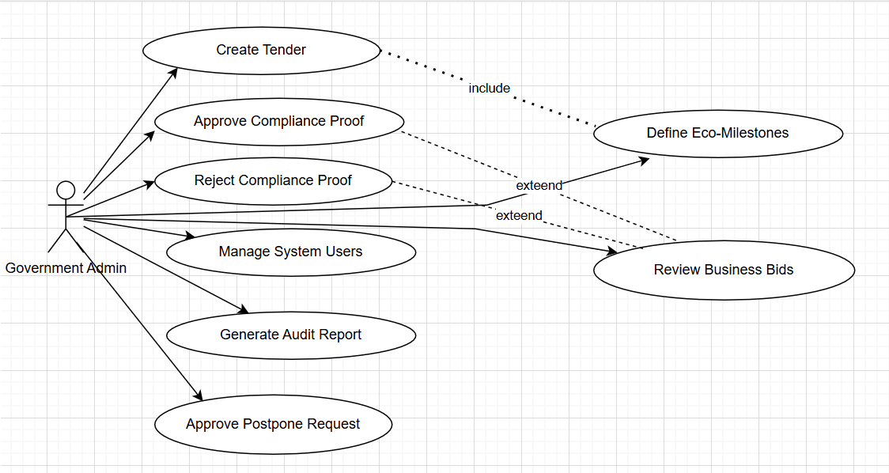
3.4 Use Case Diagram
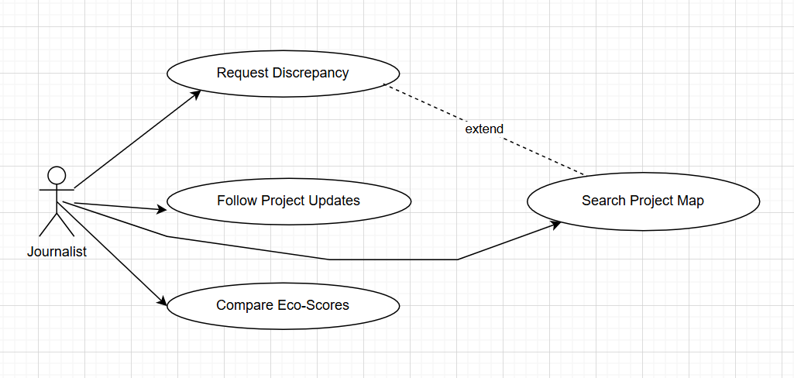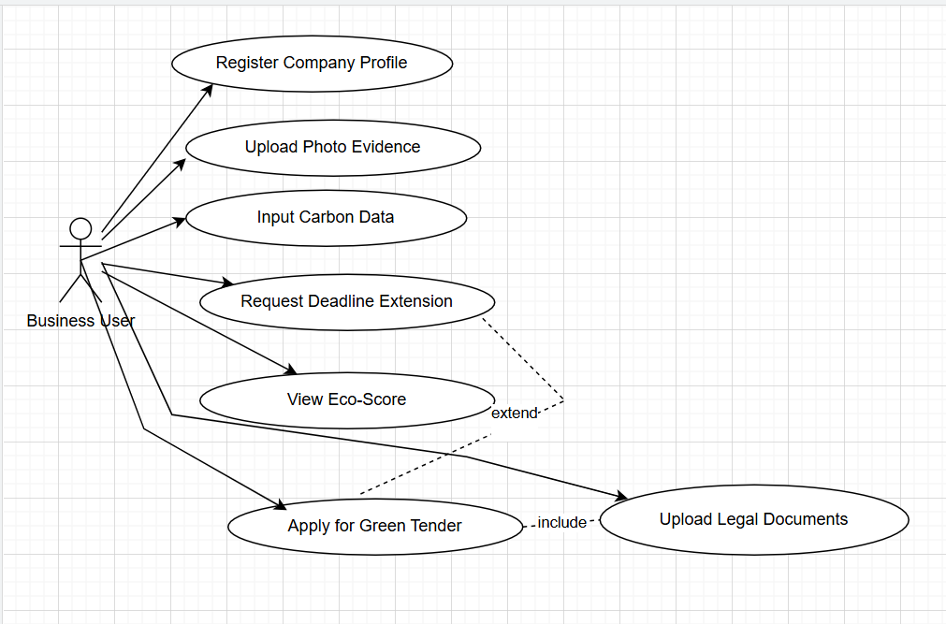

--

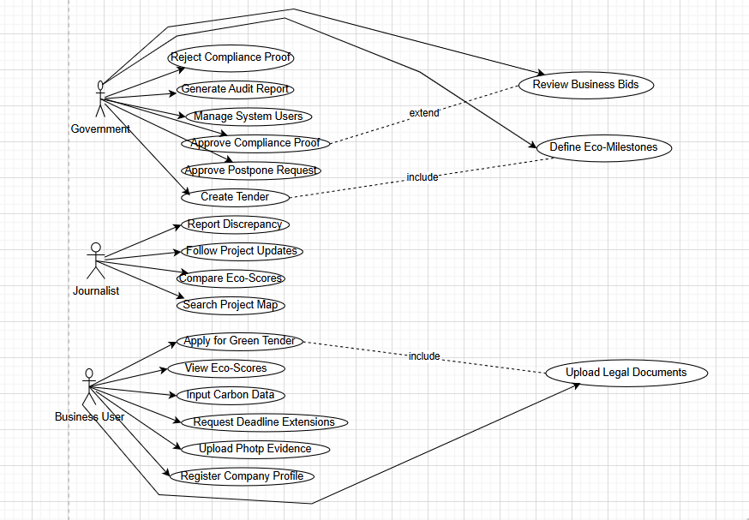

4 Requirements

4.1 Functional Requirements (FR)

Authentication & General
Req# | Requirement | Comments | Priority
FR_01 | The system shall provide role-based access control. | Journalist, Business, Admin. | High
FR_02 | The system shall allow user registration. | With email verification. | High
FR_03 | The system shall allow secure login. | Email and password. | High
FR_04 | The system shall support password encryption. | Hashing passwords (bcrypt). | High
FR_05 | The system shall allow password change. | User settings. | High
FR_06 | The system shall allow logout. | End session. | High
FR_07 | The system shall validate all user inputs. | Prevent errors and injection. | High
FR_08 | The system shall support email verification. | Account confirmation. | Medium
FR_09 | The system shall lock account after multiple failed logins. | Prevent brute-force attacks. | High
FR_10 | The system shall log all user activities. | Digital audit trail. | High

Journalist Module
Req# | Requirement | Comments | Priority
FR_11 | The system shall display an interactive map showing all active projects. | OpenStreetMap / Google Maps API. | High
FR_12 | The system shall allow searching and filtering projects. | By company, city, Eco-Score, risk. | High
FR_13 | The system shall display project details including milestones and evidence. | Full transparency. | High
FR_14 | The system shall show the Eco-Score for each project. | Dynamic score 1-100. | High
FR_15 | The system shall show project risk level using color coding. | Green / Orange / Red. | High
FR_16 | The system shall allow users to follow projects and receive notifications. | Subscription feature. | High
FR_17 | The system shall provide an anonymous whistleblowing form with file upload. | Photo/video evidence. | High
FR_18 | The system shall allow side-by-side comparison of company Eco-Scores. | Journalist comparison tool. | Medium
FR_19 | The system shall allow viewing contractor history and past performance. | Accountability. | High

Business Module
Req# | Requirement | Comments | Priority
FR_20 | The system shall allow businesses to create a profile and upload certifications. | ISO 14001, QKB documents. | High
FR_21 | The system shall allow businesses to apply for open tenders. | Tender participation. | High
FR_22 | The system shall allow uploading geotagged photos as proof of compliance. | GPS metadata validation. | High
FR_23 | The system shall allow uploading legal documents with validity dates. | Waste permits, water tests. | High
FR_24 | The system shall include a Carbon Footprint Calculator. | Fuel and energy data input. | High
FR_25 | The system shall allow businesses to view their private Eco-Score breakdown. | Performance analytics. | High
FR_26 | The system shall allow businesses to request deadline extensions. | With justification documents. | High
FR_27 | The system shall notify businesses of upcoming or missed deadlines. | Automated reminders. | High
FR_28 | The system shall allow businesses to save draft applications. | Continue later. | Medium
FR_29 | The system shall validate uploaded document formats. | PDF and image files only. | High

Government Administrator Module
Req# | Requirement | Comments | Priority
FR_30 | The system shall allow admins to create and publish new procurement projects. | With custom eco-milestones. | High
FR_31 | The system shall allow admins to define eco-milestones with deadlines and evidence types. | Weighted milestones. | High
FR_32 | The system shall allow admins to review and evaluate submitted business bids. | Score-based evaluation. | High
FR_33 | The system shall provide a verification interface to approve or reject compliance evidence. | Photo and GPS review. | High
FR_34 | The system shall allow admins to grant or deny deadline extension requests. | Timeline management. | High
FR_35 | The system shall provide a user management module to register, suspend, or delete accounts. | Business and Journalist accounts. | High
FR_36 | The system shall enable admins to set Risk Levels for projects. | Low, Medium, High. | High
FR_37 | The system shall allow admins to receive and respond to whistleblowing reports. | Red Flag alert system. | High
FR_38 | The system shall generate a Digital Audit Trail for every project. | All changes by all users. | High
FR_39 | The system shall generate compliance reports. | Monthly and annual. | High
FR_40 | The system shall allow admins to view a dashboard with project analytics. | Overview and KPIs. | High

Automated System Features
Req# | Requirement | Comments | Priority
FR_41 | The system shall automatically calculate and update the Eco-Scorecard (1-100). | On every milestone or carbon data change. | High
FR_42 | The system shall automatically send violation alerts when deadlines are missed. | Red Flag emails to Admin and Contractor. | High
FR_43 | The system shall automatically extract GPS and timestamp metadata from uploaded photos. | Fraud prevention. | High

3.6 Non-Functional Requirements (NFR)
Non-Functional Requirements
Code | Requirement | Category | Priority
NFR_01 | All sensitive data (passwords, certificates) must be encrypted using AES-256 standards. | Security. | High
NFR_02 | The Public Map and Project Dashboards must load in under 3 seconds on a standard 4G connection. | Performance. | High
NFR_03 | The system must handle up to 1,000 concurrent users without degradation in performance. | Scalability. | High
NFR_04 | The system shall have an uptime of 99.9%, excluding scheduled maintenance. | Availability. | High
NFR_05 | The system must prevent any user from deleting verified Compliance Evidence. | Integrity. | High
NFR_06 | The web application must be fully responsive on Desktop, Tablet, and Mobile. | Usability. | High
NFR_07 | The system must comply with GDPR regarding the handling of user personal data. | Legal. | High

