- Show the charter trip number, date, and destination.
SELECT char_trip, char_date, char_destination from charter;

- Which charters are using the aircraft 2778V?
SELECT char_trip from charter where AC_NUMBER = "2778V";


- What are the average hours flown by aircraft going to “ATL” – Atlanta?
SELECT avg(CHAR_HOURS_FLOWN) AS
AVG_HOURS_FLOWN FROM CHARTER
WHERE CHAR_DESTINATION="ATL";

- How many flights are going to each city?
SELECT CHAR_DESTINATION, COUNT(*) AS number_of_flights
FROM charter
GROUP BY CHAR_DESTINATION;

- Which customers who went to ATL did not go to STL?
SELECT DISTINCT CUS_CODE
FROM charter
WHERE CHAR_DESTINATION = 'ATL'
AND CUS_CODE NOT IN (
SELECT CUS_CODE
FROM charter
WHERE CHAR_DESTINATION = 'STL');
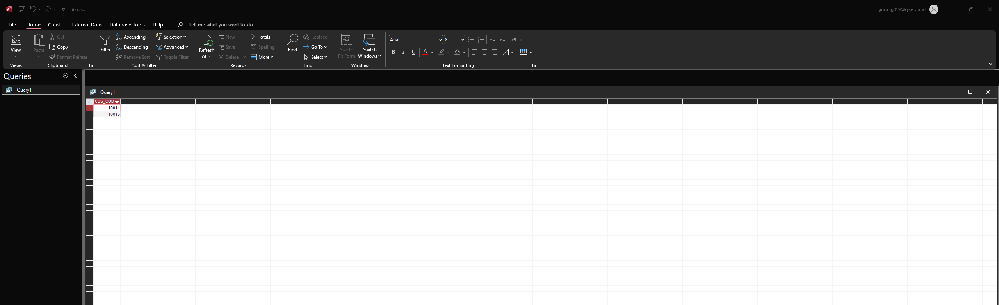
- Which customers who went to ATL did go to STL?
SELECT DISTINCT CUS_CODE
FROM charter
WHERE CHAR_DESTINATION = 'ATL'
AND CUS_CODE IN (
SELECT CUS_CODE
FROM charter
WHERE CHAR_DESTINATION = 'STL');
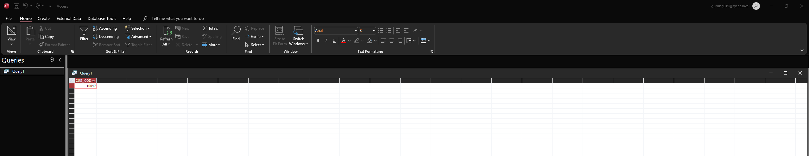
- Did any customers with an outstanding balance charter a flight on Feb. 5 or Feb. 6?
SELECT DISTINCT CUS_CODE
FROM charter
WHERE (CHAR_DATE = '2023-02-05' OR date = '2023-02-06')
AND outstanding_balance > 0;

- How much is outstanding at the company?
SELECT SUM(CUS_BALANCE) AS total_outstanding
FROM customer;
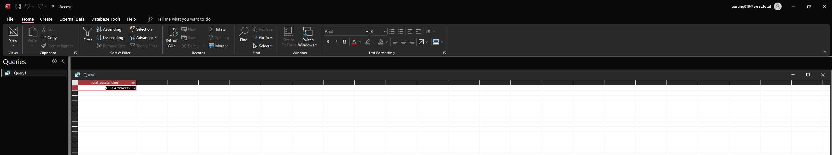
- What is the average charter distance?
SELECT AVG(CHAR_DISTANCE) AS average_distance
FROM charter;

- Who crewed the TYS charters?
SELECT *
FROM CHARTER,CREW
WHERE CHARTER.CHAR_TRIP=CREW.CHAR_TRIP
AND CHAR_DESTINATION='TYS';
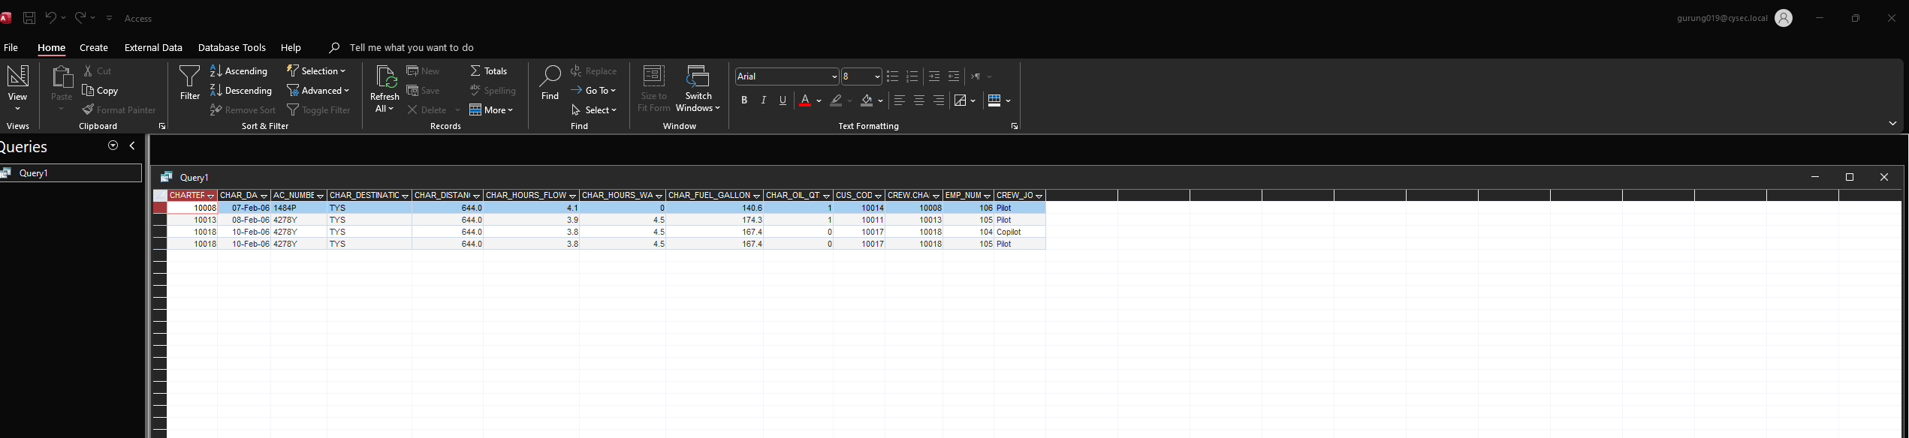

- What are the names of everyone involved in the TYS charters?
SELECT DISTINCT name
FROM (
SELECT crew_member_name AS name
FROM charters
JOIN crew ON charters.crew_id = crew.crew_id
WHERE destination = 'TYS'
UNION
SELECT passenger_name AS name
FROM charters
JOIN passengers ON charters.passenger_id = passengers.passenger_id
WHERE destination = 'TYS'
) AS all_involved;

- What are the names of everyone involved in the TYS charters and their role (either CREW or PASSENGER)? Arrange the report by role with crew members first.
SELECT name, role
FROM (
SELECT crew_member_name AS name, 'CREW' AS role
FROM charters
JOIN crew ON charters.crew_id = crew.crew_id
WHERE destination = 'TYS'
UNION
SELECT passenger_name AS name, 'PASSENGER' AS role
FROM charters
JOIN passengers ON charters.passenger_id = passengers.passenger_id
WHERE destination = 'TYS'
) AS all_involved
ORDER BY role, name;

- What is the mileage charge for each flight flown after February 9? Note: “Charge per mile” is relative to the model; miles are an attribute of the charter. Show charter date, customer last name, charter distance, charge per mile, and mileage charge Arrange the above report so that the information displays dates in increasing fashion. Then, within dates, arrange by customer last name.

SELECT charter_date, customer_last_name, charter_distance, charge_per_mile,
(charter_distance * charge_per_mile) AS mileage_charge
FROM charters
JOIN customers ON charters.customer_id = customers.customer_id
WHERE charter_date > '2023-02-09'
ORDER BY charter_date, customer_last_name;

- Produce a similar chart showing “gallons per mile flown”.
SELECT charter_date, customer_last_name, charter_distance, gallons_per_mile,
(charter_distance * gallons_per_mile) AS total_gallons
FROM charters
JOIN customers ON charters.customer_id = customers.customer_id
WHERE charter_date > '2023-02-09'
ORDER BY charter_date, customer_last_name;

- For the plane which flew the most miles, how old is its airframe, left engine, and right engine
- For this heavily used plane, its travels in February accounted for what fraction of its airframe age?

