|  |  |  |  |
| --- | --- | --- | --- |
| Cyber Threat | Behavior | R Value | Conclusion |
| Clickjacking | Time Spent | -0.1085 | Negligible Negative |
| Password Security | 0.0419 | Negligible Positive |
| Enable Security | -0.0197 | Negligible Negative |
| Sharing Location | 0.1584 | Negligible Positive |
| Accept Unknown | 0.1123 | Negligible Positive |
| Number of Friends | -0.1613 | Negligible Negative |
| Number of Groups | 0.0500 | Negligible Positive |
| Click on Unknown Link | 0.2868 | Weak Positive |

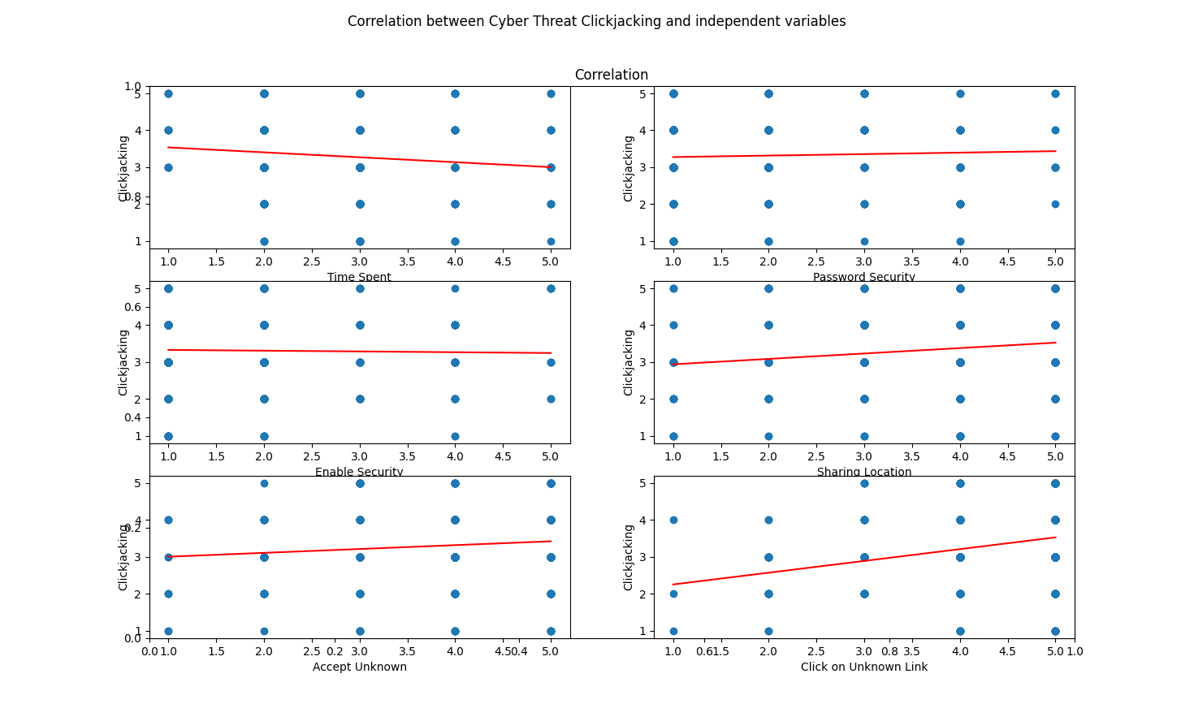

|  |  |  |  |
| --- | --- | --- | --- |
| Cyber Threat | Behavior | R Value | Conclusion |
| Cyber Bullying | Time Spent | -0.1667 | Negligible Negative |
| Password Security | 0.0259 | Negligible Positive |
| Enable Security | -0.0668 | Negligible Negative |
| Sharing Location | 0.1300 | Negligible Positive |
| Accept Unknown | 0.1010 | Negligible Positive |
| Number of Friends | -0.1021 | Negligible Negative |
| Number of Groups | -0.1719 | Negligible Negative |
| Click on Unknown Link | 0.0529 | Negligible Positive |

|  |  |  |  |
| --- | --- | --- | --- |
| Cyber Threat | Behavior | R Value | Conclusion |
| Fake Profile | Time Spent | 0.0570 | Negligible positive |
| Password Security | 0.0855 | Negligible Positive |
| Enable Security | 0.1070 | Negligible Positive |
| Sharing Location | -0.0725 | Negligible Negative |
| Accept Unknown | -0.0316 | Negligible Negative |
| Number of Friends | 0.0311 | Negligible Positive |
| Number of Groups | 0.1340 | Negligible Positive |
| Click on Unknown Link | -0.0108 | Negligible Negative |

|  |  |  |  |
| --- | --- | --- | --- |
| Cyber Threat | Behavior | R Value | Conclusion |
| Location Leakage | Time Spent | -0.0991 | Negligible Negative |
| Password Security | 0.0136 | Negligible Positive |
| Enable Security | -0.0640 | Negligible Negative |
| Sharing Location | 0.4806 | Moderate Positive |
| Accept Unknown | 0.1666 | Negligible Positive |
| Number of Friends | -0.2276 | Weak Negative |
| Number of Groups | -0.1976 | Negligible Negative |
| Click on Unknown Link | 0.1031 | Negligible Positive |

|  |  |  |  |
| --- | --- | --- | --- |
| Cyber Threat | Behavior | R Value | Conclusion |
| Malware | Time Spent | -0.1560 | Negligible Negative |
| Password Security | 0.0097 | Negligible Positive |
| Enable Security | 0.0087 | Negligible Positive |
| Sharing Location | 0.1149 | Negligible Positive |
| Accept Unknown | 0.1157 | Negligible Positive |
| Number of Friends | -0.14951 | Negligible Negative |
| Number of Groups | -0.1887 | Negligible Negative |
| Click on Unknown Link | 0.1349 | Negligible Positive |

|  |  |  |  |
| --- | --- | --- | --- |
| Cyber Threat | Behavior | R Value | Conclusion |
| Spam | Time Spent | -0.1255 | Negligible Negative |
| Password Security | -0.0567 | Negligible Negative |
| Enable Security | -0.0243 | Negligible Negative |
| Sharing Location | 0.0741 | Negligible Positive |
| Accept Unknown | 0.1273 | Negligible Positive |
| Number of Friends | -0.1608 | Negligible Negative |
| Number of Groups | -0.0707 | Negligible Negative |
| Click on Unknown Link | 0.0171 | Negligible Positive |

