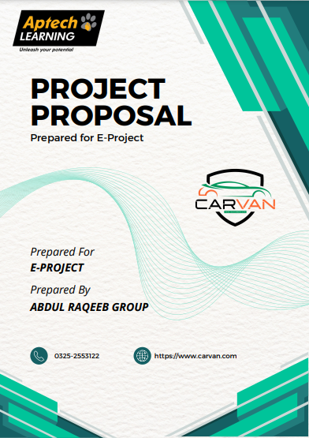

[c https://carvan.com](c%20%20%20%20%20https://carvan.com) m

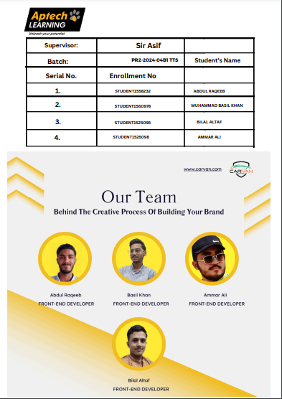

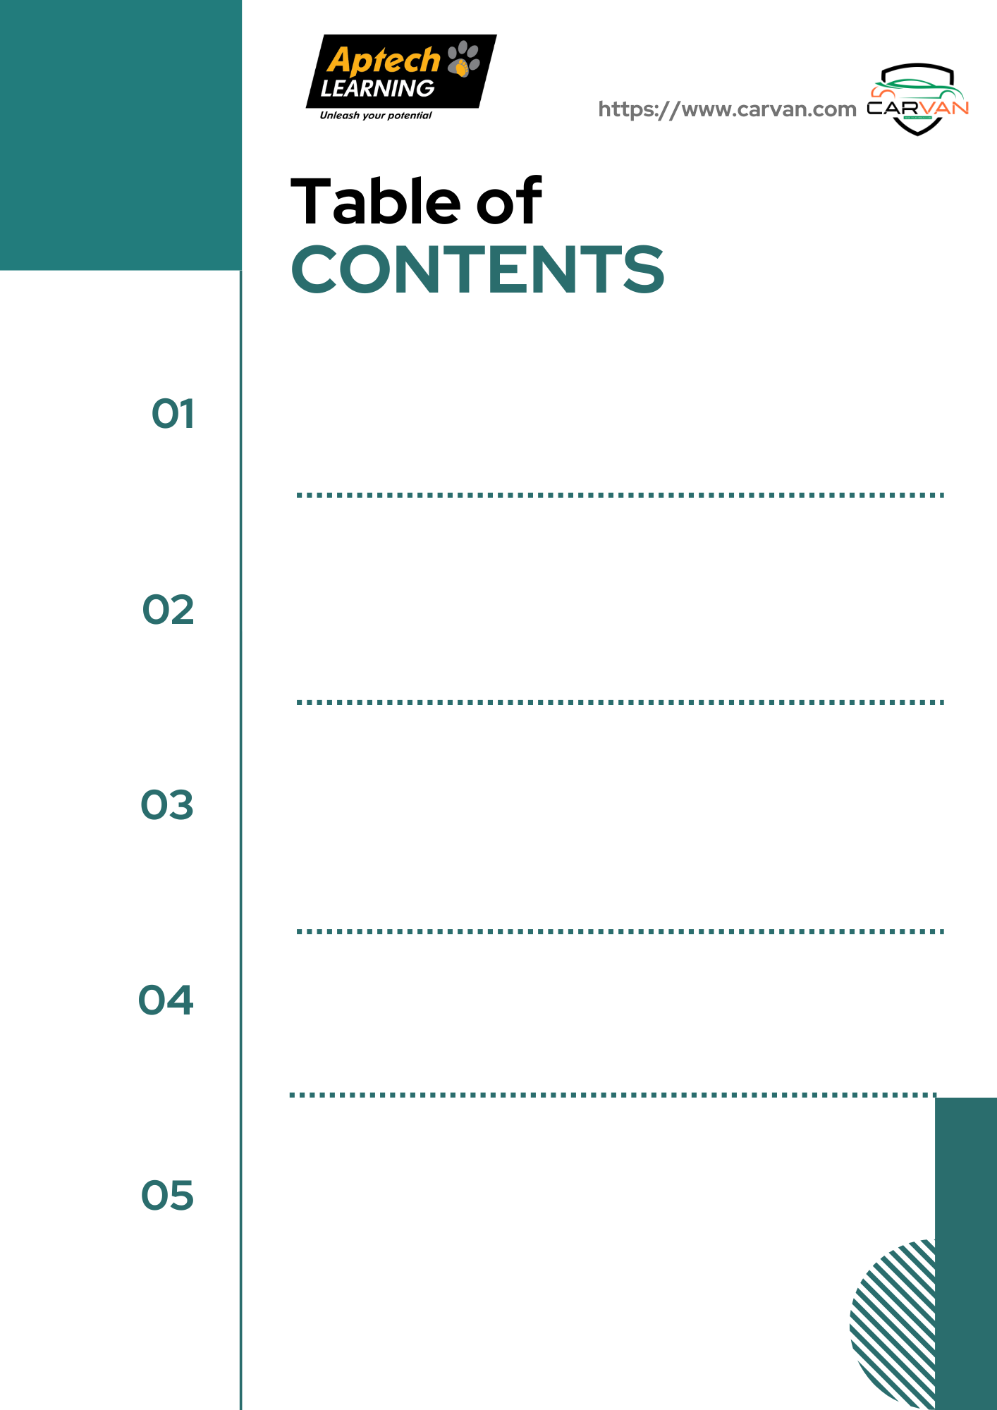

**CERTIFIED OF COMPLETION OF COMPLETION:** 4

**ACNOWLEDGEMENT** 5

**PROBLEM STATEMENT** 6

**HARDWARE AND SOFTWARE** 7

**USER GUIDE** 8

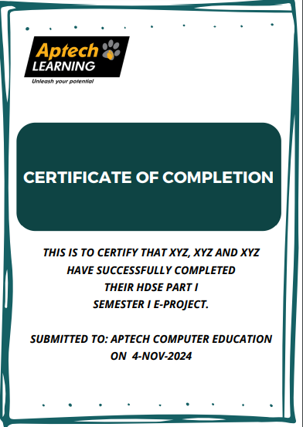

# 

# CERTIFIED OF COMPLETION OF COMPLETION:

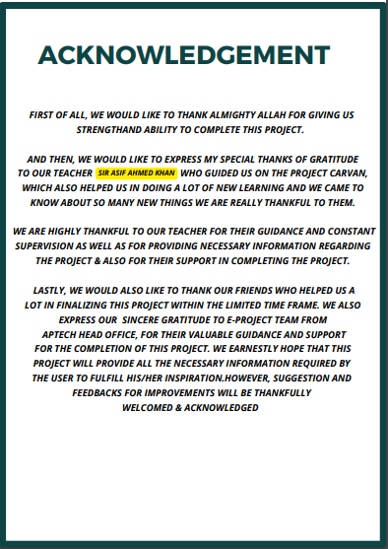

# ACNOWLEDGEMENT

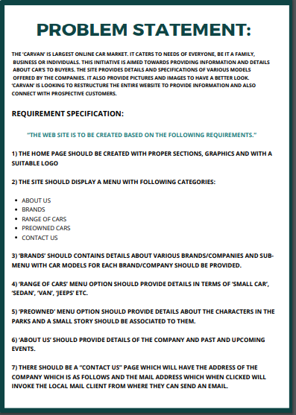YY

# PROBLEM STATEMENT

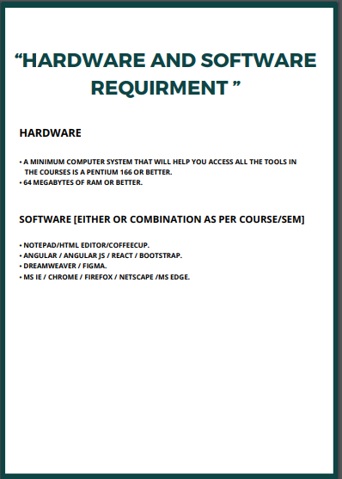

# HARDWARE AND SOFTWARE

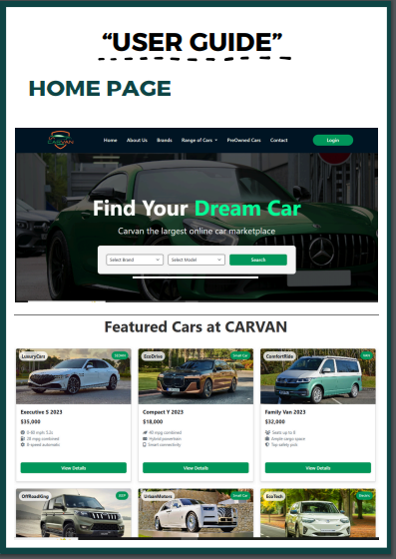

# 

# USER GUIDE

