AquaMaps for EU BON
AquaMaps is an approach to generating model-based, largescale predictions of where aquatic species occur naturally. The modelling approach uses species occurrence data coupled with expert knowledge to estimate species tolerances for environmental factors that can be used as predictors of species presence (e.g., depth, sea temperature, salinity for marine species, and net primary production, soil carbon, elevation for freshwater species).
Predictions, expressed as probabilities of species occurrence, are generated by matching species tolerances (environmental envelopes) against local environmental conditions to determine the relative suitability of an area for a species (Fig. 1). These probabilities are illustrated through color-coded species range maps in half-degree latitude and longitude cell resolution.
The AquaMaps for EU BON has two main interfaces. Marine Aqua Maps feature standardized distribution maps for over 1,032 European fishes and marine mammals, while Freshwater AquaMaps feature maps for 173 species (including 33 fishes and 140 non-fish species). These interfaces allow users to search, view and explore species maps. Experts are able to review, modify and approve maps.
PK NA NA NA NA NA NA NA NA NA
NA
NA NA NA NA NA NA NA NA NA NA NA NA NA NA NA NA NA NA NA NA NA NA NA NA NA NA NA NA NA NA NA NA NA * NA NA NA NA NA NA NA NA NA
NA
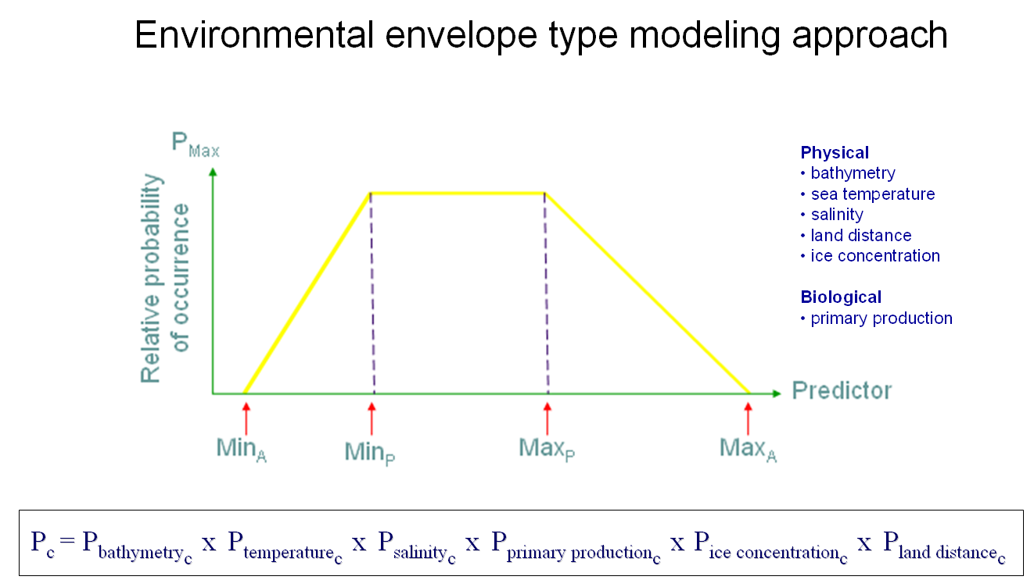

Expected advantages
- Addresses biases from occurrence data: Uses FishBase and SeaLifeBase to prevent inclusion of misidentified species. Incorporates of expert information on species-habitat preferences to counter sampling bias. Applies species distributions within FAO areas, bounding boxes or drainage basins to exclude potentially suitable habitat in which a species is not known to occur;
- Easy species search: Call species maps using either common name or scientific name, or select from a checklist (e.g., by country or large marine ecosystem);
- Interactive species maps: Explore maps covering a species' predicted natural range (1) in the current period, (2) by the year 2100 (based on IPCC A2 emission scenario), (3) in all suitable habitats outside of a species' currently known natural range, as well as (4) a map of geo-referenced occurrences of the species. Multispecies maps (e.g., biodiversity) are also available;
- Editable/Reviewed maps: Includes a Create-Your-Own-Map tool that allows a user to view and change mapping parameters and settings, and to regenerate a new map applying changes made. Maps reviewed and edited by experts or through verification against known distribution are also available;
- Downloadable data: Predicted probabilities of species occurrence (native range) can be exported in csv format.

Applicability
AquaMaps for EU BON is an online interface that will be publicly accessible through the European Biodiversity Portal. Development is ongoing through the prototype Visualization and Decision Support Interface at http://www.aquamaps.org/eubon/home.php. The map data will be updated following the AquaMaps production run in 2016. Inclusion of range maps as species probability layers in GeoCAT through CartoDB is being considered.
For regular users, searching, exploring and downloading of maps and the associated data are the expected common usage for AquaMaps for EU BON. The interfaces are user-friendly, making it easy use and perform these applications. However, Marine AquaMaps have more search options compared to Freshwater AquaMaps (Fig.2).
For more advanced users, map editing and regeneration can be done through the Create-Your Own-Map (CYOM) tool. If a user is an expert, arrangements can be made to include their expert-reviewed/edited maps in AquaMaps for EU BON. The data required to use the CYOM to edit/correct a species' map would include:
- Ecological data (marine AquaMaps): depth range or habitat description (proxy to depth range); bounding box coordinates for species' known natural range; FAO areas (standardized large geographical fishing areas used by the Food and Agriculture Organization) where native/endemic; feeding and breeding environment (neritic, oceanic, pelagic, demersal, etc.)
- Ecological data (freshwater/terrestrial AquaMaps): ecosystems or watershed basins allocations within species' known natural range; FAO areas where native/endemic
- Geo-referenced species occurrence data

Potential users
The target users of this online interface are students, researchers, conservation planners, and non-government organizations.

Contact details
Please contact Rainer Froese (rfroese@geomar.de) for more information.
PK NA NA NA NA NA NA NA
NA
NA NA NA NA NA NA NA NA NA NA NA NA NA NA NA NA NA NA NA NA NA NA NA NA NA NA NA NA NA NA NA * NA NA NA NA NA NA NA NA NA
NA
