Portfolio Project Part II: Concurrency Counters in Java

Richard Aquilo Jr.
Colorado State University Global
CSC450: Secure Programming Techniques and Principles
Module 8 Portfolio Project (Part II)
February 08, 2026

Table of Contents
Portfolio Project Part II: Concurrency Counters in Java 4
Introduction 4
Requirements alignment (Module 8 Portfolio Project) 4
Pseudocode 5
Algorithm: Two-Thread Counter (Java) 5
Source Code (Java) 5
File: CSC450_Mod8_CounterThreads.java 5
Build and run (Java) 7
Program analysis (reliability and security) 8
Performance issues with concurrency 8
Vulnerabilities exhibited with use of strings 9
Security of the data types exhibited 9
Variable shadowing and exceptions: reliability impact 10
Comparison: Java vs. C++ implementations (performance and security) 11
Screenshots and evidence 13
Figure 1 14
Java application executing in the console. 14
Figure 2 15
Java source code in the IDE/editor (CSC450_Mod8_CounterThreads.java). 15
Figure 3 16
Git repository destination. 16
Figure 4 17
Git Push Ref Specifications. 17
Figure 5 18
Git Push Confirmation. 18
Figure 6 19
Git push evidence. 19
Figure 7 20
GitHub repository commit page (recent commit). 20
Figure 8 21
GitHub repository commit details (changed files). 21
Figure 9 22
GitHub repository Code page. 22
Figure 10 22
Repository URL and latest commit hash. 22
References 23

Portfolio Project Part II: Concurrency Counters in Java

Introduction
This portfolio project (Part II) demonstrates core concurrency concepts in Java by implementing two coordinated threads that act as counters. Thread 1 counts up from 0 to 20. After Thread 1 reaches 20, Thread 2 begins counting down from 20 to 0. The solution uses safe synchronization to prevent race conditions, provides reliable and readable console output, and includes a security-focused analysis aligned to Module 8 topics (exceptions, variable shadowing, and data sensitivity).

Requirements alignment (Module 8 Portfolio Project)
This submission addresses the Module 8 Portfolio Project requirements as follows:
- Two coordinated threads: Thread 1 counts up from 0 to 20; Thread 2 waits until 20 is reached and then counts down from 20 to 0.
- Pseudocode of the algorithm is provided below.
- The complete Java source code is included in this document and also provided as a standalone .java file for the Git repository.
- A security-focused program analysis addresses: (1) performance issues with concurrency, (2) vulnerabilities exhibited with use of strings, and (3) security of the data types exhibited.
- A detailed comparison between Java and C++ performance implementations is provided (3–4 pages in typical double-spaced format).
- Figures are reserved for required screenshots (application output, source code, and Git/GitHub evidence).
Evidence supporting execution, source code, and repository submission is provided in Figures 1–10.

Pseudocode

Algorithm: Two-Thread Counter (Java)
shared counterValue := 0
latch reachedTwenty := 1 // signals when 20 is reached
lock stateLock
lock consoleLock

THREAD CountUp:
FOR i from 0 to 20:
lock(stateLock)
counterValue := i
unlock(stateLock)
lock(consoleLock)
print "UP : " + i
unlock(consoleLock)
IF i == 20:
reachedTwenty.countDown()
sleepMillis(120)

THREAD CountDown:
reachedTwenty.await()
FOR i from 20 down to 0:
lock(stateLock)
counterValue := i
unlock(stateLock)
lock(consoleLock)
print "DOWN: " + i
unlock(consoleLock)
sleep(120ms)

MAIN:
start thread CountUp
start thread CountDown
join both threads
print "Done."

Source Code (Java)

File: CSC450_Mod8_CounterThreads.java
//============================================================================
// Name : CSC450_Mod8_CounterThreads.java
// Author : raquilo2 (Richard Aquilo Jr.)
// Description : Module 8 Portfolio Project Part II - Java Concurrency Counters
//============================================================================

package csc450.mod8;

import java.util.concurrent.CountDownLatch;
import java.util.concurrent.TimeUnit;

/**
* CSC450 Module 8 Portfolio Project Part II - Java Concurrency Counters
* Thread 1 counts up to 20, then Thread 2 counts down to 0.
*/
public class CSC450_Mod8_CounterThreads {

// Shared state protected by a lock.
private static final class SharedState {
private int counterValue = 0;
private final Object lock = new Object();
}

// Latch ensures Thread 2 starts only after Thread 1 reaches 20.
private static final CountDownLatch reachedTwenty = new CountDownLatch(1);

public static void main(String[] args) {
SharedState state = new SharedState();

Thread upThread = new Thread(() -> {
for (int i = 0; i <= 20; i++) {
synchronized (state.lock) {
state.counterValue = i;
System.out.println("[UP ] counter = " + state.counterValue);
}

if (i == 20) {
reachedTwenty.countDown(); // Signal Thread 2 to start.
}

sleepMillis(120);
}
}, "Counter-Up-Thread");

Thread downThread = new Thread(() -> {
try {
// Wait until Thread 1 reaches 20.
reachedTwenty.await();
} catch (InterruptedException e) {
Thread.currentThread().interrupt();
System.err.println("Down thread interrupted while waiting.");
return;
}

for (int i = 20; i >= 0; i--) {
synchronized (state.lock) {
state.counterValue = i;
System.out.println("[DOWN] counter = " + state.counterValue);
}
sleepMillis(120);
}
}, "Counter-Down-Thread");

upThread.start();
downThread.start();

try {
upThread.join();
downThread.join();
System.out.println("Done. Final counter = " + state.counterValue);
} catch (InterruptedException e) {
Thread.currentThread().interrupt();
System.err.println("Main thread interrupted while joining.");
}
}

private static void sleepMillis(long ms) {
try {
TimeUnit.MILLISECONDS.sleep(ms);
} catch (InterruptedException e) {
Thread.currentThread().interrupt();
System.err.println("Sleep interrupted.");
}
}
}

The final source file as displayed in the IDE is documented in Figure 2.

Build and run (Java)
The Java program was compiled and executed in Eclipse IDE (Run As → Java Application), and the console output shown in Figure 1 was captured from Eclipse. Execution output is shown in Figure 1, and the source file used for execution is shown in Figure 2. Git repository and push workflow evidence are shown in Figures 3–6, and GitHub commit/code verification is shown in Figures 7–10.
Eclipse steps (used for this submission):
- Open/create project: CSC450_Mod8.
- Place CSC450_Mod8_CounterThreads.java in src/csc450/mod8/.
- Ensure package declaration is: package csc450.mod8;
- Run: Right-click CSC450_Mod8_CounterThreads.java → Run As → Java Application.
- Expected output: [UP ] counter = 0 through 20, followed by [DOWN] counter = 20 through 0, then Done. Final counter = 0.
Optional command-line verification (from classpath root):
- javac csc450/mod8/CSC450_Mod8_CounterThreads.java
- java csc450.mod8.CSC450_Mod8_CounterThreads

Program analysis (reliability and security)

Performance issues with concurrency
Concurrency can improve responsiveness by allowing independent tasks to overlap, but it also introduces overhead and complexity. In this application, the primary performance costs are thread creation, context switching, and synchronization overhead. Synchronization is intentionally kept small: updates to shared state are guarded by a private lock, while console printing uses a separate lock to avoid interleaved output. The design uses a CountDownLatch to coordinate the phase change ("start counting down after 20") without busy-waiting. Avoiding busy-wait loops improves efficiency and reduces CPU usage.
In larger systems, performance risks include lock contention (many threads competing for the same monitor), deadlocks caused by inconsistent lock acquisition order, and reduced scalability if shared mutable state grows. For demonstration purposes, the program includes a 120 ms sleep; this is not a performance optimization and would normally be removed. In production code, time-based sleeps should be replaced with real work or more precise coordination primitives to avoid unnecessary latency.

Vulnerabilities exhibited with use of strings
Strings are security-relevant when they originate from untrusted sources (users, files, network input, environment variables). Although this counter demonstration uses only constant string literals (e.g., "UP : "), the same printing/logging pattern can become vulnerable if untrusted strings are logged directly. Common risks include:
• Log forging (inserting newline characters to spoof log records),
• Terminal control-sequence injection (escape sequences that manipulate terminal output),
• Injection into interpreters (SQL, OS commands, expression languages) if strings are concatenated unsafely, and
• Denial-of-service by very large inputs (memory pressure).
Mitigations include validating and constraining string length/content, encoding/escaping output based on the destination (logs vs. HTML vs. SQL), using parameterized APIs for SQL, and using structured logging rather than raw concatenation.

Security of the data types exhibited
The program uses an int counter in the small range 0–20, eliminating overflow risk in this context. Shared state is minimized to a single integer and is accessed only under a private lock to prevent race conditions and visibility problems. Java’s memory model requires proper synchronization to guarantee that writes by one thread become visible to another; using synchronized blocks provides both mutual exclusion and the required happens-before relationship.
The coordination flag is represented by a CountDownLatch rather than a shared boolean. This reduces the risk of incorrect signaling logic and avoids fragile patterns like spin-waiting on a non-volatile field. The code also restores the thread’s interrupted status when an InterruptedException occurs, which supports reliable cancellation behavior in larger applications.

Variable shadowing and exceptions: reliability impact
Module 8 emphasizes how variable shadowing and exceptions can quietly reduce reliability. Shadowing occurs when a local variable or parameter uses the same name as a field, causing the field to be accidentally ignored. In concurrent programs, shadowing can be especially damaging because it can make synchronization appear correct while the wrong variable is being read or written. This implementation avoids shadowing by:
• Using clearly named fields inside the SharedState class (counterValue, lock),
• Keeping SharedState fields private to enforce encapsulation, and
• Using distinct variable names inside loops (i) that do not overlap with shared
fields.
Exceptions affect reliability when they are unhandled (crashes) or handled improperly (swallowing errors, leaking sensitive data in messages, or leaving the program in an inconsistent state). The program catches InterruptedException in each thread, restores the interrupt flag, and exits the thread loop safely. A boundary catch for RuntimeException prevents uncontrolled termination, which is a common reliability improvement in threaded applications. In real systems, exception handlers should log safely (without exposing sensitive data) and report failures in a way that supports recovery or graceful shutdown.

Comparison: Java vs. C++ implementations (performance and security)
Both the Java and C++ versions of this application implement the same observable behavior: one thread counts up to 20 and signals a second thread to count down to 0. However, the languages differ in runtime model, memory management, concurrency primitives, and typical vulnerability classes. Those differences influence both performance and security posture.
Threading and synchronization primitives: In the C++ implementation, coordination is achieved using std::mutex and std::condition_variable with a shared boolean flag (reachedTwenty). Correctness depends on disciplined locking and avoiding data races; in C++, a data race is undefined behavior and can lead to incorrect output or hard-to-debug failures. In the Java implementation, coordination uses a CountDownLatch, and shared state updates are protected with synchronized blocks. Java’s runtime and memory model provide structured guarantees when synchronization is used correctly. Both solutions avoid busy-waiting, which is a key performance and reliability improvement.
Performance considerations: For a small two-thread demonstration, the performance differences are negligible compared to the deliberate 120 ms sleeps. In general, C++ can have lower baseline overhead because it compiles to native code and does not require a managed runtime. Java may incur JIT warmup and garbage collection overhead, but modern JVMs can optimize long-running workloads significantly. For concurrency, both ecosystems offer efficient primitives; performance often depends more on algorithm design, lock contention, and workload characteristics than on language alone. In heavily concurrent applications, the JVM’s monitor optimizations and mature concurrency utilities (java.util.concurrent) can reduce developer error and improve scalability compared with ad hoc locking.
Memory safety and vulnerability surface: One major security differentiator is memory safety. C++ allows pointer arithmetic, manual memory management, and unsafe casts that can result in buffer overflows, use-after-free, and other memory corruption vulnerabilities. Even when std::string is used, developers can still introduce memory hazards with raw pointers or incorrect lifetimes elsewhere in a program. Java’s managed memory model (automatic garbage collection, no pointer arithmetic) eliminates entire classes of memory corruption bugs. This makes the Java implementation typically less vulnerable to low-level memory exploitation.
Input handling and string-related risks: Both languages are vulnerable to injection and log-forging risks if untrusted strings are concatenated into logs, commands, or SQL statements without validation and escaping. Java developers often benefit from mature libraries and strong standard APIs that encourage safer patterns (e.g., prepared statements). C++ developers can be equally safe, but the burden is higher because unsafe patterns are easier to express and harder to detect. The safest outcome in either language comes from secure design: validating inputs, constraining length, encoding output appropriately, and using parameterized APIs.
Exception handling and reliability: The Java solution explicitly handles InterruptedException, restoring the interrupted status, which is a recommended pattern for reliable multithreaded code. Java’s checked exceptions also encourage developers to think about failure paths, though they can be misused. In C++, exceptions exist but are not always used consistently, and concurrency-related errors can become undefined behavior if data races occur. In sum, Java’s structured exception and runtime model typically leads to more predictable failure behavior, which supports reliability.
Which implementation is less vulnerable and why: For this assignment’s scope, the Java implementation may be considered less vulnerable to security threats primarily because it avoids whole categories of memory-safety vulnerabilities (buffer overflows, use-after-free) and offers standardized concurrency utilities that reduce the risk of synchronization mistakes. That said, neither language is automatically secure: poor input validation, overly verbose exception messages, insecure logging, or misuse of cryptography can undermine both. A secure implementation in either language depends on applying least privilege, limiting data exposure, and handling errors in a controlled, non-leaky manner. The Java implementation and submission artifacts referenced in this comparison are evidenced in Figures 1–2 and Figures 7–10.

Screenshots and evidence
Required screenshots below. The system tray date/time is visible when possible, and filenames/repository names are readable.
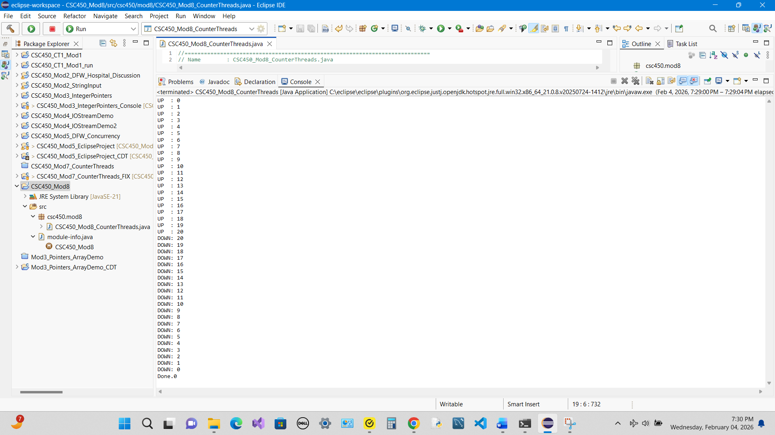

Figure 1

Java application executing in the console.
Note. Console output captured from Eclipse showing count up (0–20), count down (20–0), and final completion message.

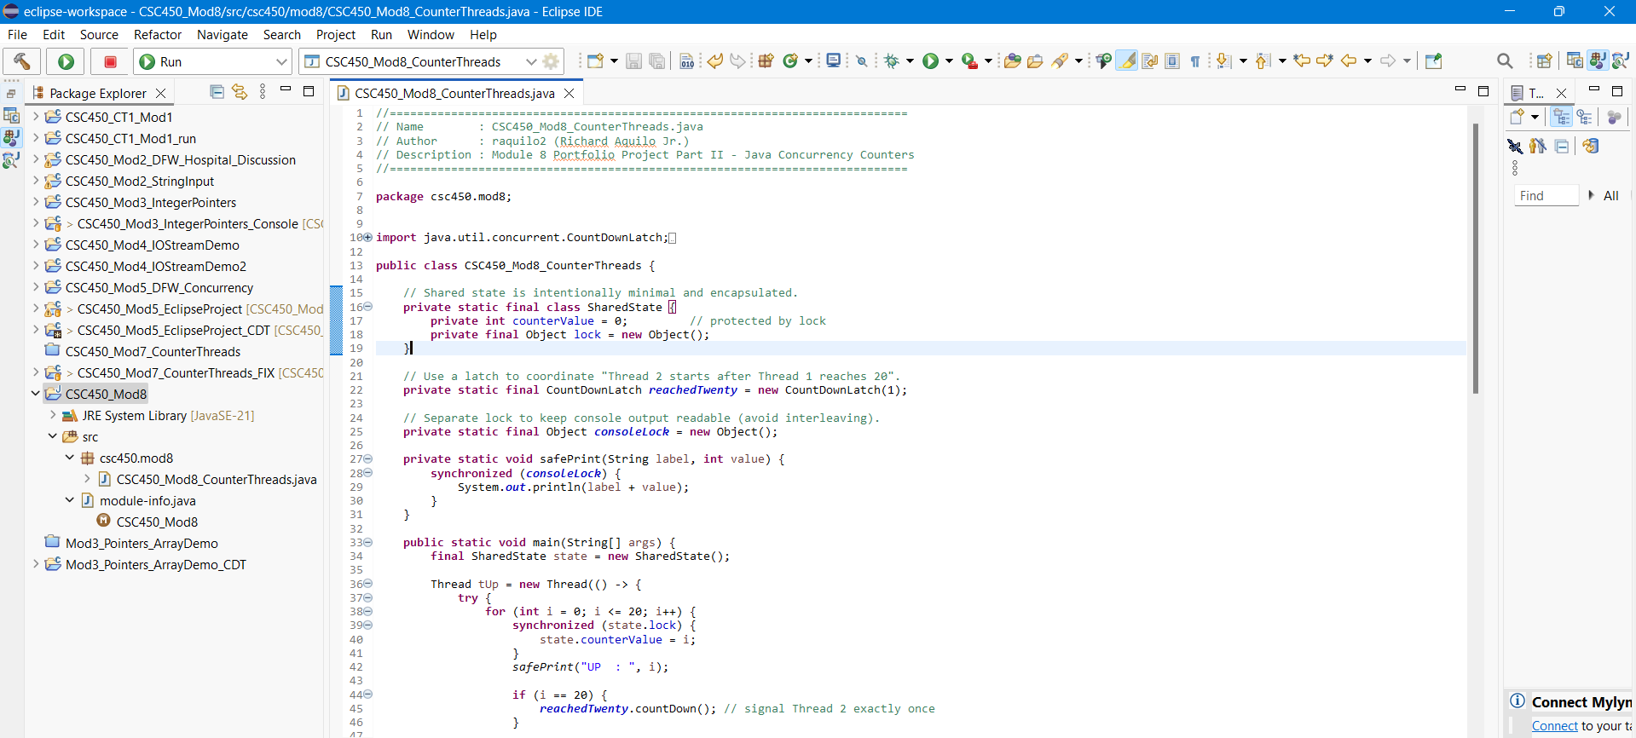
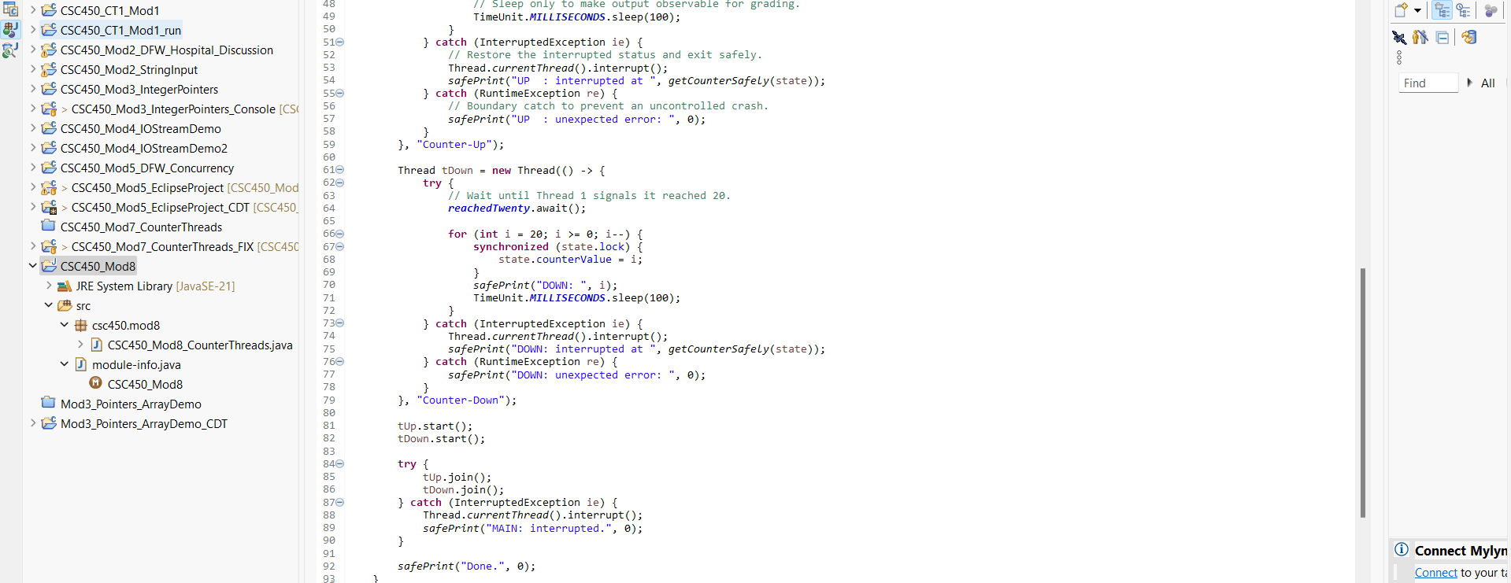
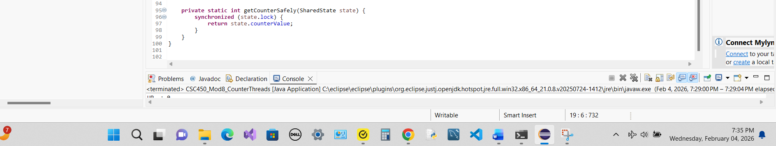

Figure 2

Java source code in the IDE/editor (CSC450_Mod8_CounterThreads.java).
Note. Eclipse editor view of CSC450_Mod8_CounterThreads.java showing CountDownLatch and synchronized shared-state access.

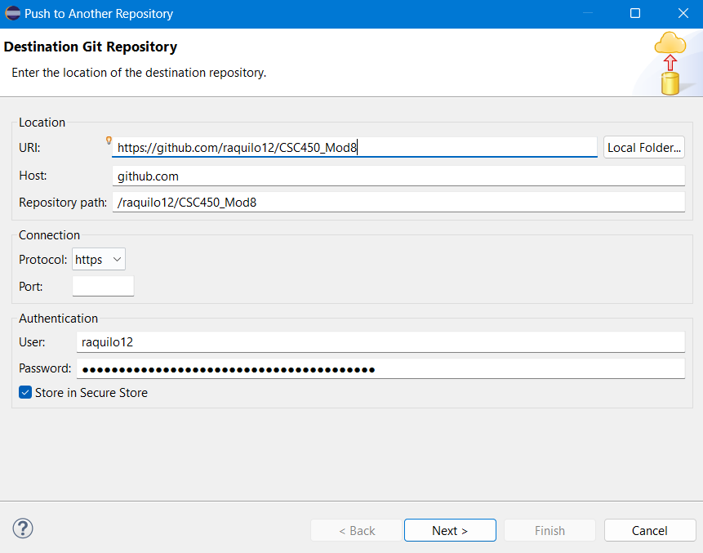

Figure 3

Git repository destination.

Note. Destination Git repository configured for project push operations.
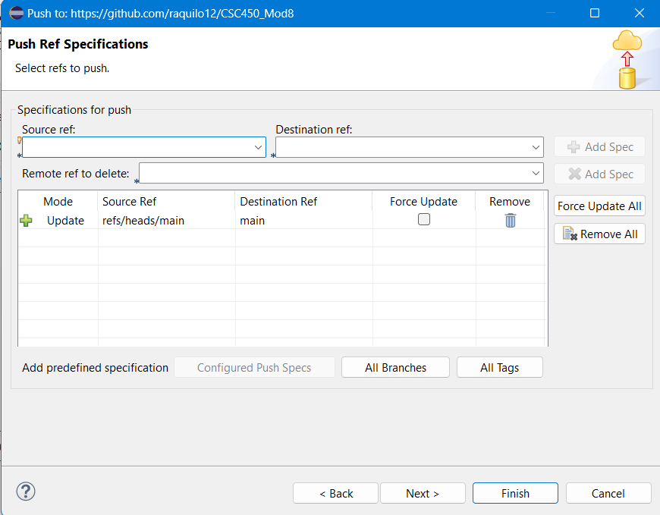

Figure 4

Git Push Ref Specifications.

Note. Select refs to push.

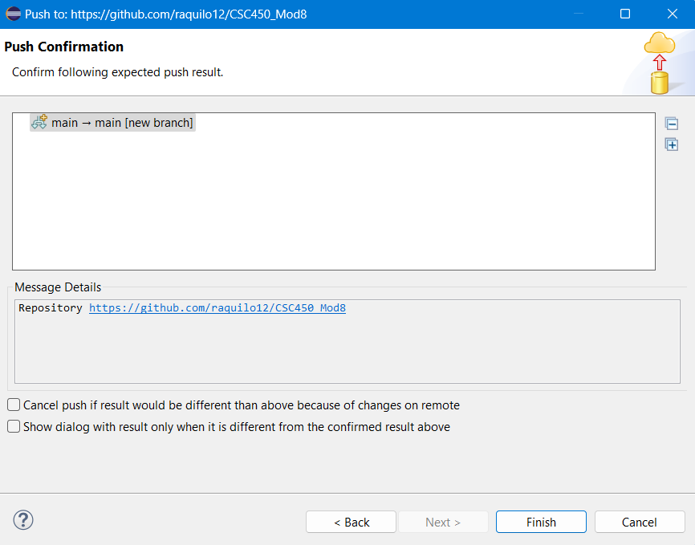

Figure 5

Git Push Confirmation.

Note. Push confirmation showing repository and updated commit.

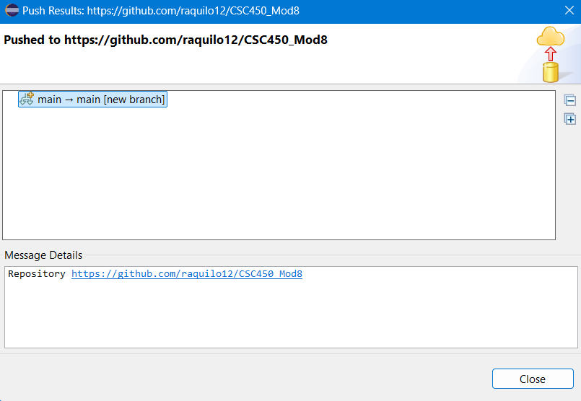

Figure 6

Git push evidence.
Note. Push confirmation captured from Eclipse Git tooling showing successful push and remote origin URL.
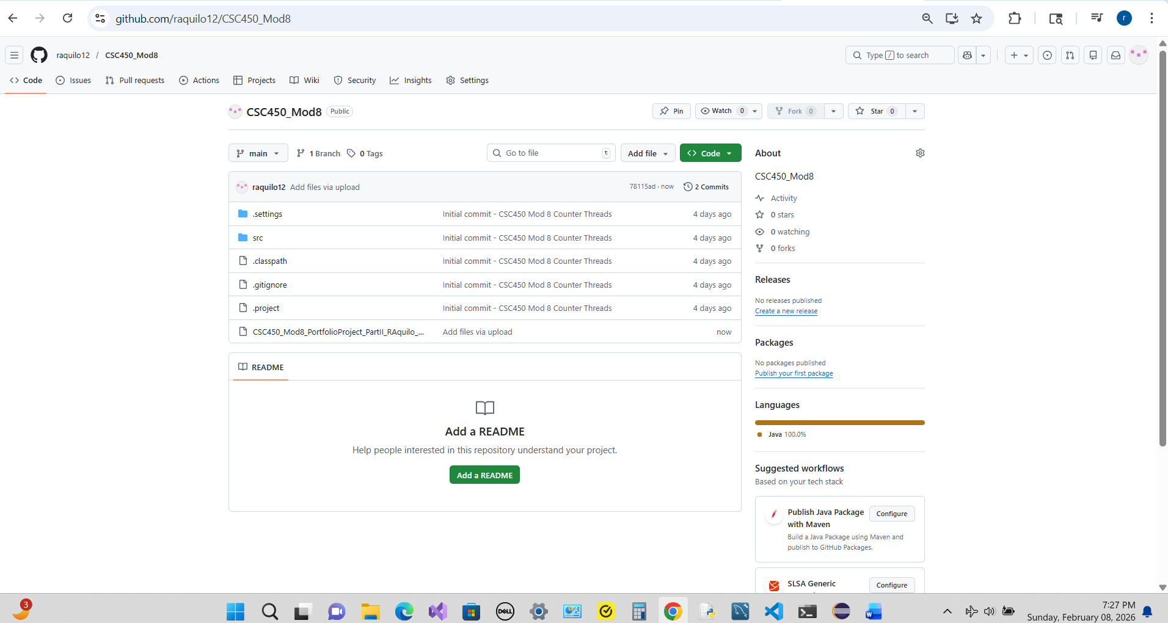

Figure 7

GitHub repository commit page (recent commit).

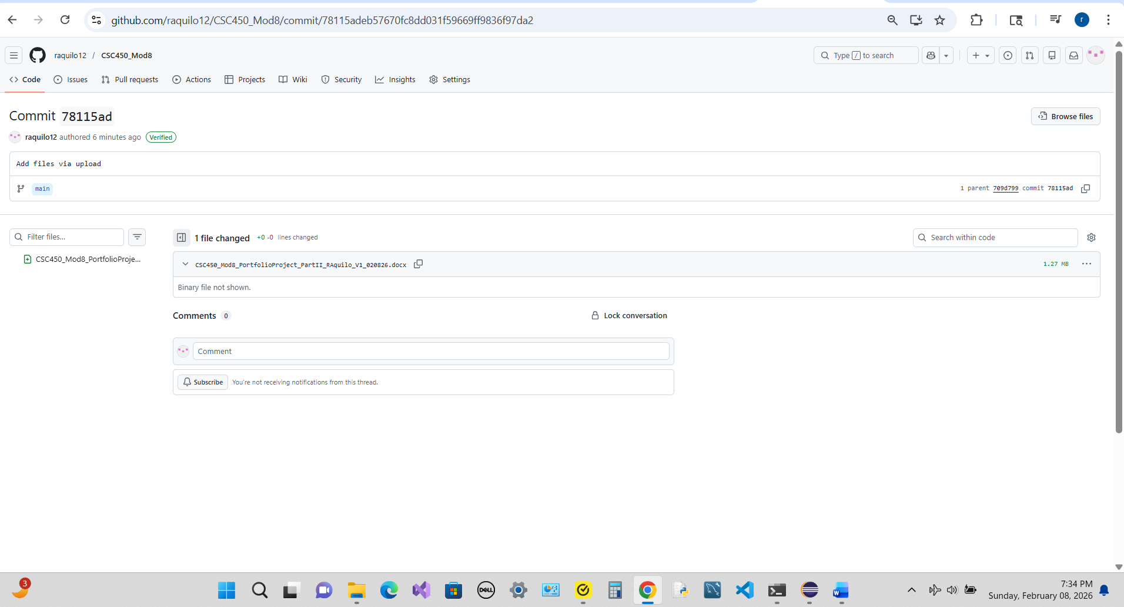

Figure 8

GitHub repository commit details (changed files).

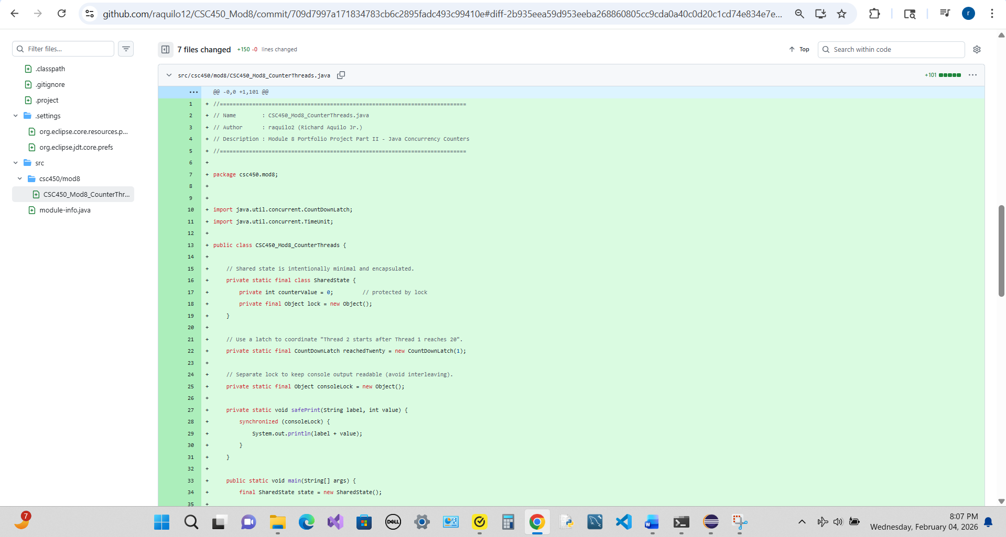

Figure 9

GitHub repository Code page.

- Repository URL: https://github.com/raquilo12/CSC450_Mod8
- Latest commit (short): 78115ad
- Latest commit (full): 78115adeb57670fc8dd031f59669ff9836f97da2

Figure 10

Repository URL and latest commit hash.

Note: GitHub repository URL and latest commit identifiers captured at submission time.

References
Carnegie Mellon University, Software Engineering Institute. (n.d.). SEI CERT Oracle
coding standard for Java. https://wiki.sei.cmu.edu/confluence/display/java
Goffi, A., Gorla, A., Mattavelli, A., & Pezzè, M. (2023). Intrinsic redundancy for
reliability and beyond. iMdea.
https://software.imdea.org/~alessandra.gorla/papers/Goffi-Redundancy-
PAUSE17.pdf
Oracle. (n.d.). Java platform, standard edition documentation (java.util.concurrent).
https://docs.oracle.com/en/java/
Williams, A. (2019). C++ concurrency in action: Practical multithreading (2nd ed.).
Manning.

