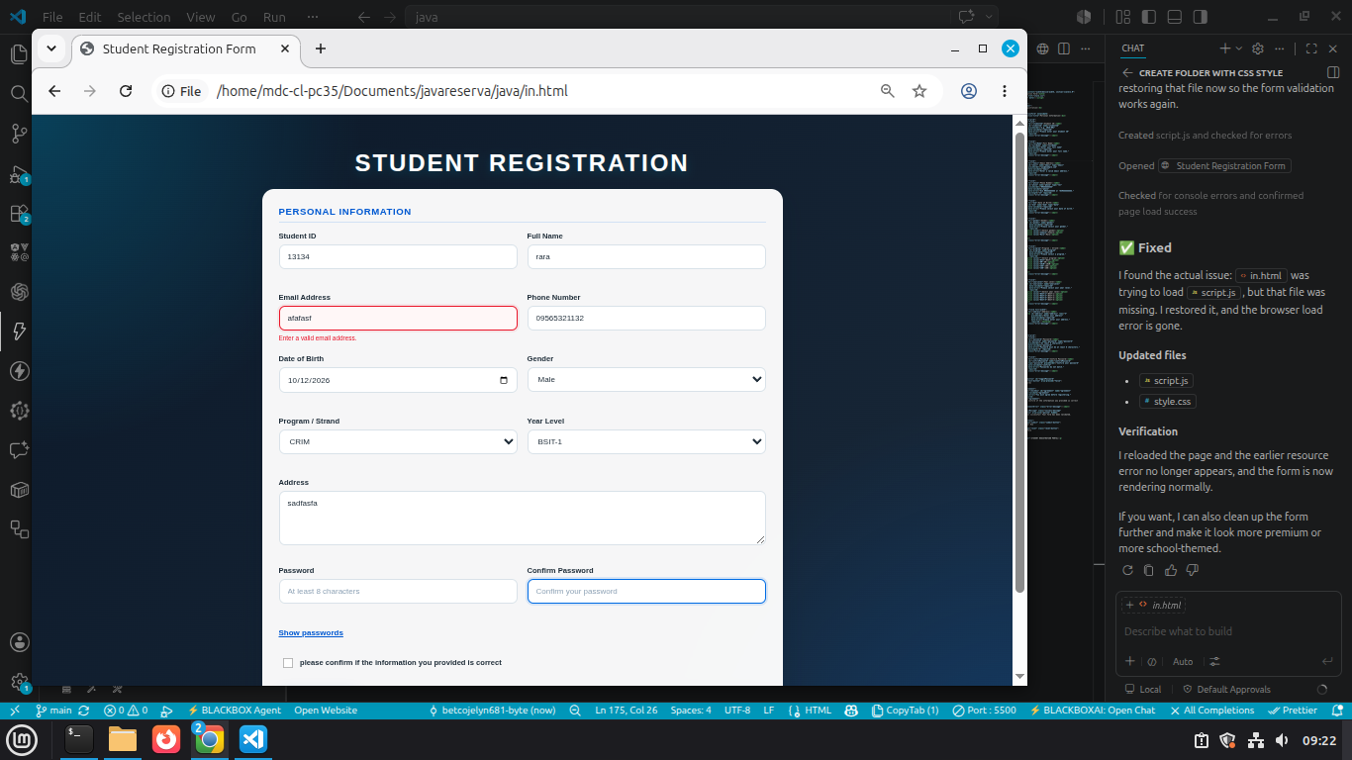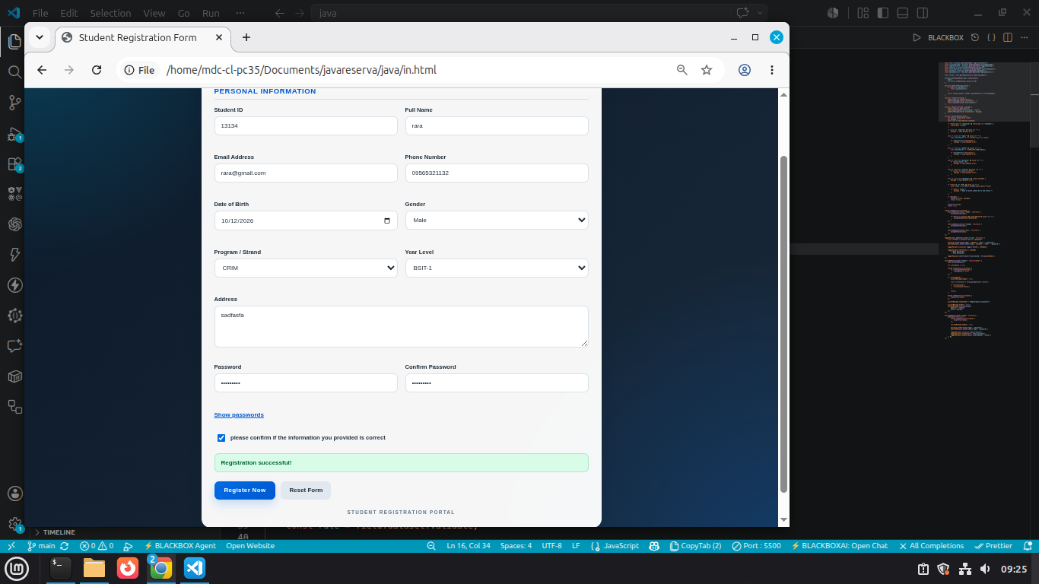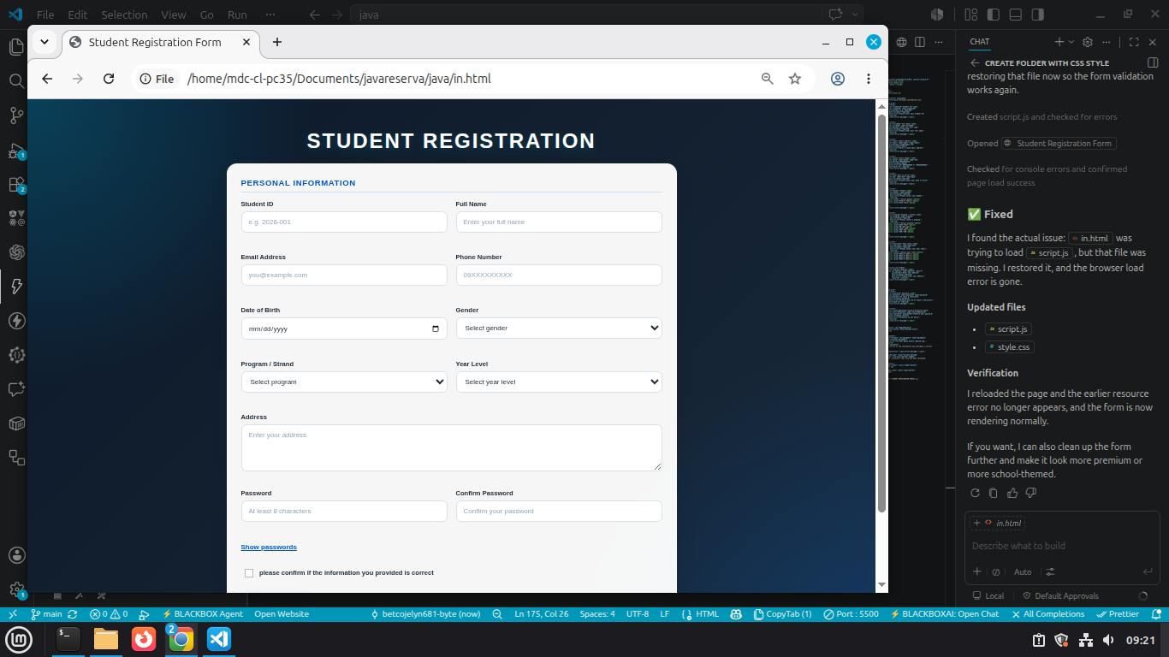
The form allows users to enter information and submit it after completing the required fields. I validated the information by checking for empty fields and incorrect inputs before accepting the submission. I used preventDefault() to stop the form from refreshing the page when the submit button is clicked. I displayed error messages to inform users about missing or invalid information. I used CSS classes to highlight errors and show success messages with different styles. I used data-* attributes in HTML and the dataset property in JavaScript to store and access additional information about form fields. Finally, I manipulated the class attribute to change the appearance of the form elements based on their validation status. When all information is correct, the form displays a success message.

