**Vocabia ICTMAWD.112**

**Vocabia** is a simple dictionary app that helps users learn new words, their meanings, synonyms, antonyms, and more. It features a user-friendly interface with a search function to easily find words.

**Class Diagram.**

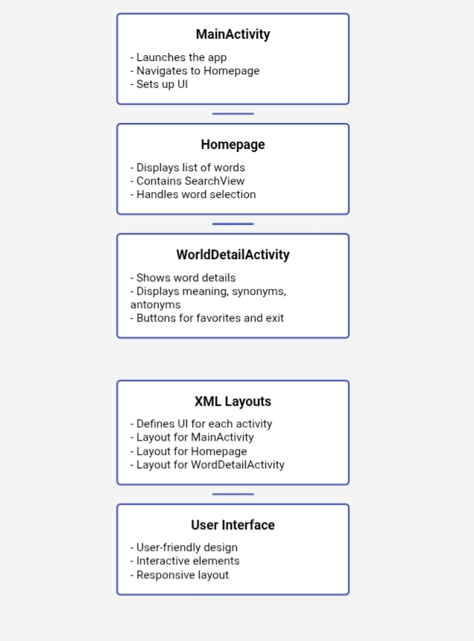

**Advanced Concept of Programming**

* **Inheritance**
* **Polymorphism**
* **Abstract classes**
* **Method overriding**
* **Encapsulation**
* **Interfaces**
* **Composition**
* **Event handling**

**Group Name:**

* Vocabia

**Member’s contributions:**

Samonte Rain( Leader)

* contribution: Word detail activity, meaning, words

Aspa,Venjamin C.

* contribution: homepage, start button, searchlist,

Ilano, Claster James

* contribution: menu

Delarmente, Rain

* contribution: none

Donaire, Andrei

* contribution: none