Puzzle Bomb

an interactive VR game where you have to do various puzzles in order to defuse a bomb

Team members: Harabagiu Stefan, Panainte Rares, Tudurache Teodora

Similar products & Relevant Links(>=3)

**Name: Keep talking and nobody explodes**

**Url: https://keeptalkinggame.com**

**Relevant Features**

- You have to defuse a bomb

- Cooperative

-

**Name: Them Bombs**

**Url: https://thembombs.com/**

**Relevant Features**

- Cooperative, one player diffuses others have to give him information

- Have to solve puzzles based on manuals

- Players have different information (only one player can see the bomb) encouraging communication

**Name: The Past Within**

**Url: https://store.steampowered.com/app/1515210/The_Past_Within/**

**Relevant Features**

- Find clues and cooperate with your friend to solve puzzles

- Players have different information encouraging communication

-

-------------------------------------------------------------------------------------

Main Features

* **PRINCIPAL MAIN VERY IMPORTANT FEATURE:**

**You do puzzles in order to defuse a bomb**

**Players have different information (only one player sees the bomb, but he doesn’t see the manual)**

* **Other features:**
* **cooperative**
* **encourages communication**
* **timed challenges**
* **the explosion should be scary so the gameplay will be very suspenseful towards the end**

User Journey - Step by step flow through app

1. Main menu
2. Join game
3. Gets assigned role ( diffuser or person who has manual)
4. Start the puzzle
5. Either bomb explodes or you manage to diffuse it
6. End screen showing statistics about the game, with button to replay
7. Back to main menu

Moodboard (10+ images)

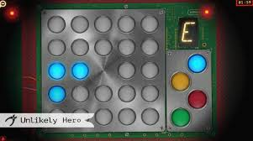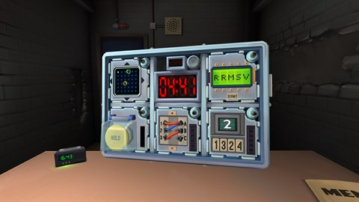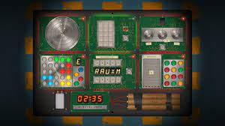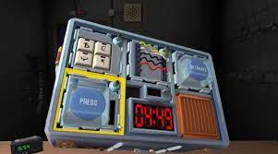

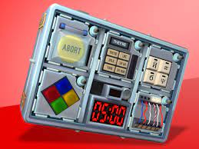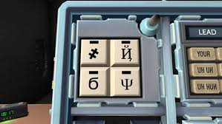

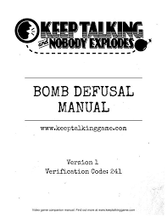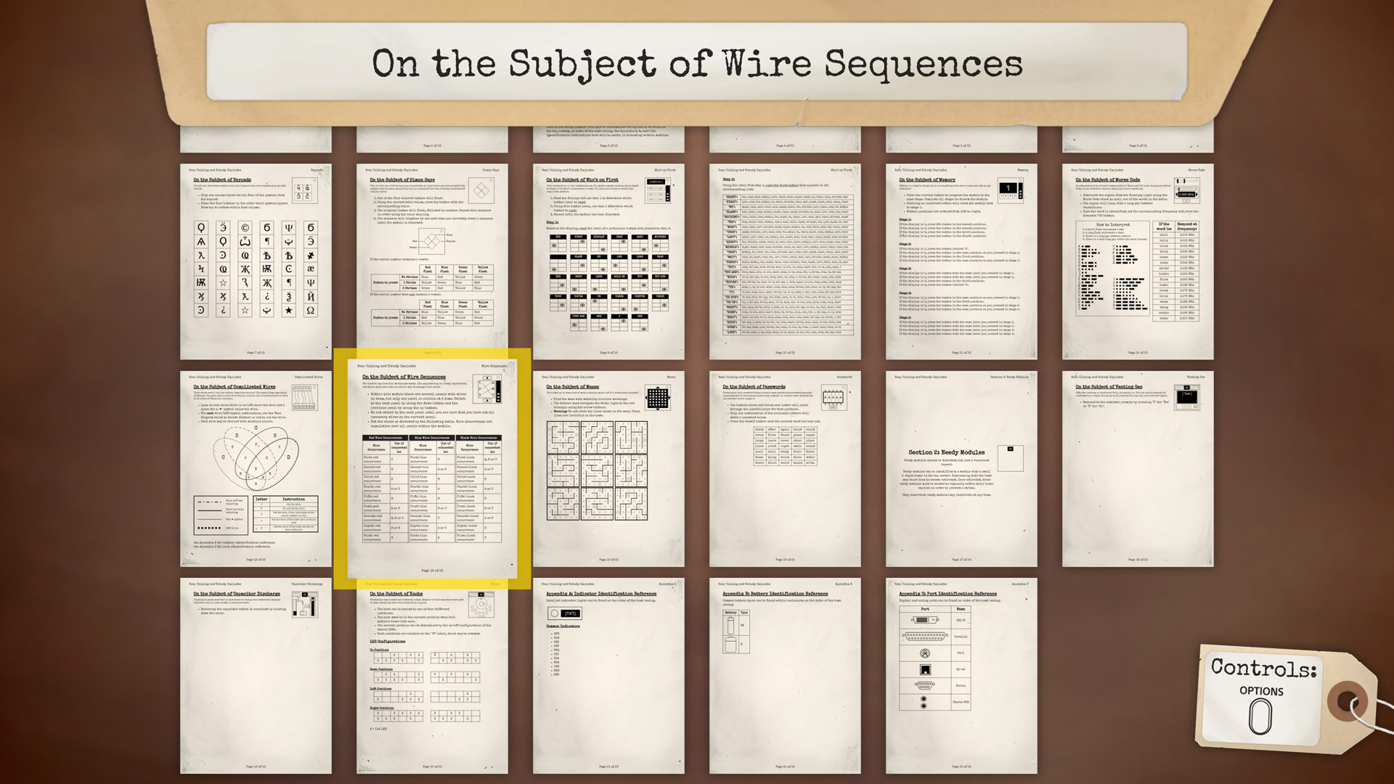

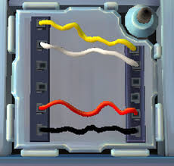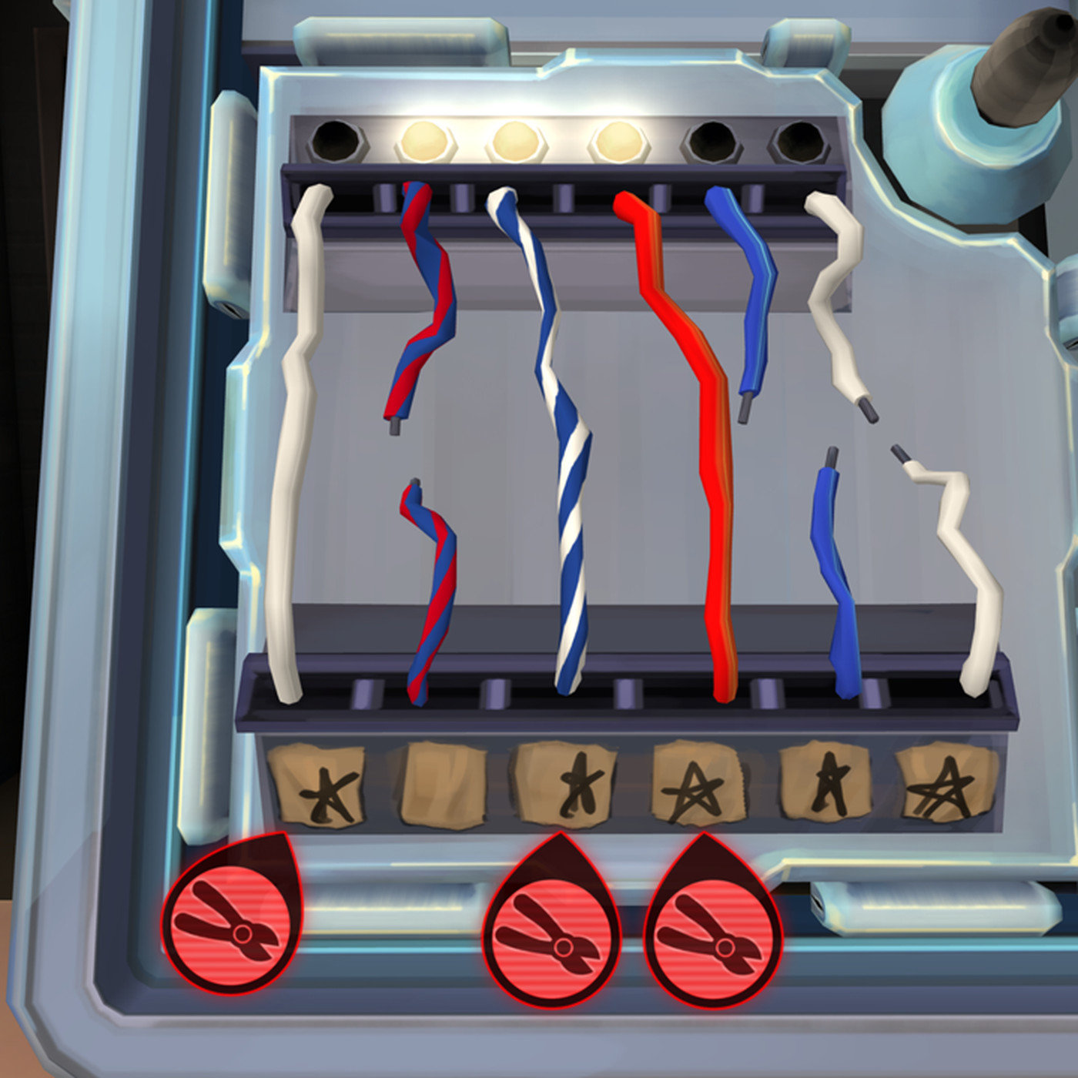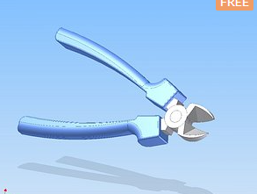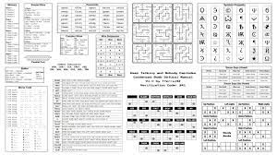

------------------------------------------------------------------------------------->>

Technologies, Libraries, Assets (>=5)

1. 3D model for a safe: https://www.turbosquid.com/3d-models/free-safe-3d-model/436776
2. 3D model for a drawer which can hide objects like keys that help you to defuse the bomb: https://www.turbosquid.com/3d-models/3d-drawer-model-1837724
3. 3D model for wire cutter: https://www.turbosquid.com/3d-models/3d-wire-cutter-model/359929
4. Sound effect when the bomb is about to go off:

https://www.videvo.net/royalty-free-sound-effects/beeps-bomb/

1. OpenXR Toolkit

https://mbucchia.github.io/OpenXR-Toolkit/

1. Explosion particles

https://assetstore.unity.com/packages/vfx/particles/fire-explosions/fx-explosion-pack-30102