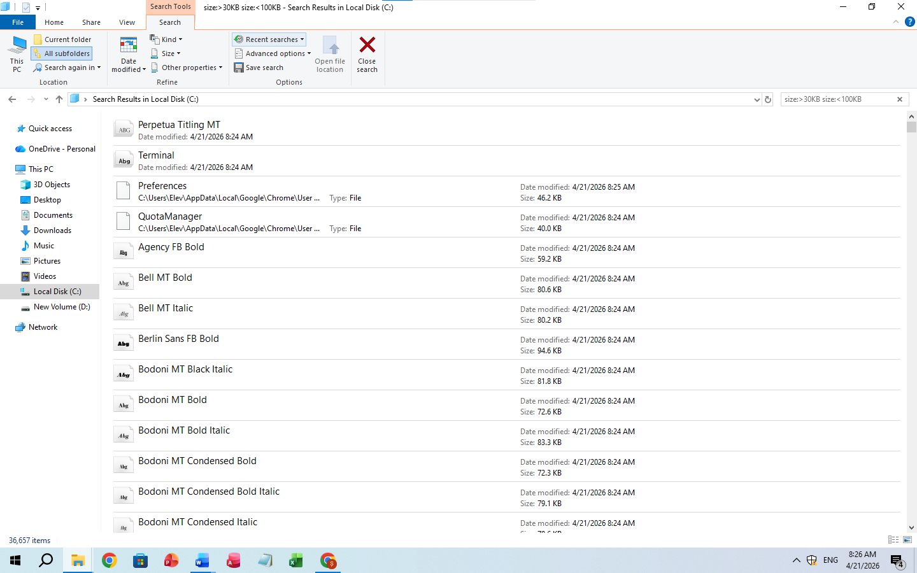

$$lim_{\left\{n →∞\right\}\left.\left( \backslash frac\left\{1\right\}\left\{n^{2}\right\}+ \backslash frac\left\{2\right\}\left\{n^{2}\right\}+ ⋯+ \backslash frac\left\{n\right\}\left\{n^{2}\right\}\right.\right)}$$

