Software Requirements Specification

for

Library activity management

Version 1.0.8 approved

Prepared by Draghici Bogdan, Flori Marius-Rares

27.02.2021

Table of Contents

Table of Contents ii

Revision History iii

1. Introduction 1

1.1 Purpose 1

1.2 Document Conventions 1

1.3 Intended Audience and Reading Suggestions 1

1.4 Product Scope 1

1.5 References 1

2. Overall Description 2

2.1 Product Perspective 2

2.2 Product Functions 2

2.3 User Classes and Characteristics 2

2.4 Operating Environment 2

2.5 Design and Implementation Constraints 3

2.6 User Documentation 3

2.7 Assumptions and Dependencies 3

3. External Interface Requirements 3

3.1 User Interfaces 3

3.2 Hardware Interfaces 8

3.3 Software Interfaces 8

3.4 Communications Interfaces 8

4. System Features 8

4.1 User registration 8

4.2 User login 9

4.3 Librarian login, creation and removal 10

4.4 User's personal information 11

4.5 Online library 12

4.6 Book filter, sort and search 12

4.7 Adding and removing books 13

4.8 Book reservation 14

4.9 Book reports 15

5. Other Nonfunctional Requirements 16

5.1 Performance Requirements 16

5.2 Safety Requirements 16

5.3 Security Requirements 16

5.4 Software Quality Attributes 17

5.5 Business Rules 17

6. Other Requirements 17

Appendix A: Glossary 17

Appendix B: Analysis Models 17

Appendix C: To Be Determined List 17

Revision History

|  |  |  |  |
| --- | --- | --- | --- |
| **Name** | **Date** | **Reason For Changes** | **Version** |
| Draghici Bogdan | 28.02.2021 | Added security requirements, user documentation, software interfaces, communication interfaces and some system features (17 system requirements). | 1.0.0 |
| Flori Marius-Rares | 01.03.2021 | Added purpose, product scope, references and product perspective. | 1.0.1 |
| Draghici Bogdan | 03.03.2021 | Added performance requirements and finished adding system features (39 requirements). | 1.0.2 |
| Draghici Bogdan | 05.03.2021 | Updated software interfaces, communications interfaces and security requirements.  Added operating environment, safety requirements and business attributes. | 1.0.3 |
| Draghici Bogdan | 06.03.2021 | Added user classes and characteristics and 11 software quality attributes.  Divided the requirements into more system features.  Removed 2 requirements and added 4 new requirements. | 1.0.4 |
| Flori Marius-Rares | 07.03.2021 | Added document conventions, Intended Audience and Reading Suggestions, Product Functions. | 1.0.5 |
| Flori Marius-Rares | 07.03.2021 | Modified requirements for filter, the priority reservations, design and implementation constraints, assumptions and dependencies, product perspective.  Added mock-ups for registration, login, home and information pages. | 1.0.6 |
| Draghici Bogdan | 08.03.2021 | Modified document conventions, product perspective, product functions, design and implementation constraints.  Added mock-ups for book description, library for user and administrator, reservations and reports for user and administrator pages.  Updated table of contents. | 1.0.7 |
| Draghici Bogdan | 08.03.2021 | Modified document conventions, design and implementation constraints, software quality attributes | 1.0.8 |
| Draghici Bogdan | 30.03.2021 | Renamed administrator to librarian and administrator manager to administrator. | 1.1.0 |
|  |  |  |  |

# Introduction

## Purpose

This document describes the specifications for the Library Activity Management project.

## Document Conventions

The format of the report has the following characteristics: default margins (1 inch), 1 line spacing, font Arial with a size of 11. The following characters “<>” will be use to mark the name of a part of code which is used in the implementation of the application. The following abbreviations will be used in this document:

-IDE = Integrated Development Environment

-SQL = Structured Query Language

-DB = Database

-HTML = Hypertext Markup Language

-CSS = Cascading Style Sheets

-HTTP = Hypertext Transport

## Intended Audience and Reading Suggestions

The types of audience for this document are the following:

-developers

-documentation writers

-users

-administrators

The rest of the document contains, in this order, the following categories:

-overall description of the product (product perspectives, product functions, user classes, design etc.)

-external interface requirements (user/software/hardware/communications interfaces)

-system features

-other nonfunctional requirements

## Product Scope

The aim of the project is to develop a software system for automation the process of managing the activity of a library:

- collecting data corresponding to available books;

- customer data management;

- generating reports;

- providing information through a web portal;

- querying the system;

- document flow management for making reservations.

## References

- [www.aman.ro](http://www.aman.ro)

# Overall Description

## Product Perspective

This project was created in the idea of a self-contained product that, in the future will help to manage the daily activities of a group of libraries. This application will be able to change the way that information about books and readers is stored from the physical forminto a compact, computer stored system.

The information about books will be available for any customer through a web portal. Those customers can create reservations when they are logged in. Also, the librarians can create and close reports as librarians of the system.

For a smoothly use of the product, the important information about books and customers stored in a database can be accessed by sending queries to the database server.

## Product Functions

The final version of the product will have the following features:

-user registration

-user login

-librarian creation and removal

-search functions for books

-book reservations

-book reports

-user’s personal information

-online library with the books available

-adding or removing books

## User Classes and Characteristics

The application will have 4 classes, displayed hierarchically as follows:

1. The visitor - any person that accesses the web application. It can see and search for books.

2. The user - any person connected with an account. It can create reservations and see book reports.

3. The librarian – a user with more permissions. It can add and remove books from library centers and also create and close reports for the books.

4. The administrator– the class with the most permissions. It can add and remove librarians.

## Operating Environment

The user minimum requirements are:

-Operating System Windows 10 version 1903

-Web browser Google Chrome version 75.0.3770 or Microsoft Edge version 1903

## Design and Implementation Constraints

The integrated development environment, frameworks and the technologies used to create this project are the following:

-Visual Studio IDE 2019 Community Edition

-C# programming language version 8.0 or newer

-HTML version 5

-CSS version 3

-HTTP protocol

-ASP.NET Core 3.0 or newer

-SQL Server

## User Documentation

This document is the only user documentation available for the web application. For more information, please contact us via e-mail or phone number available at the end of this document and on the website.

## Assumptions and Dependencies

To have access at this site, every user must have the followings:

-working computer

-internet connection

-an operating system

-a web browser

# External Interface Requirements

## User Interfaces

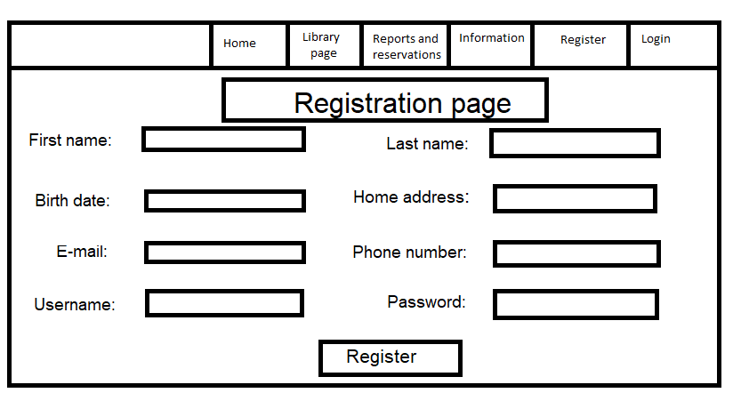Registration page:

Login page:

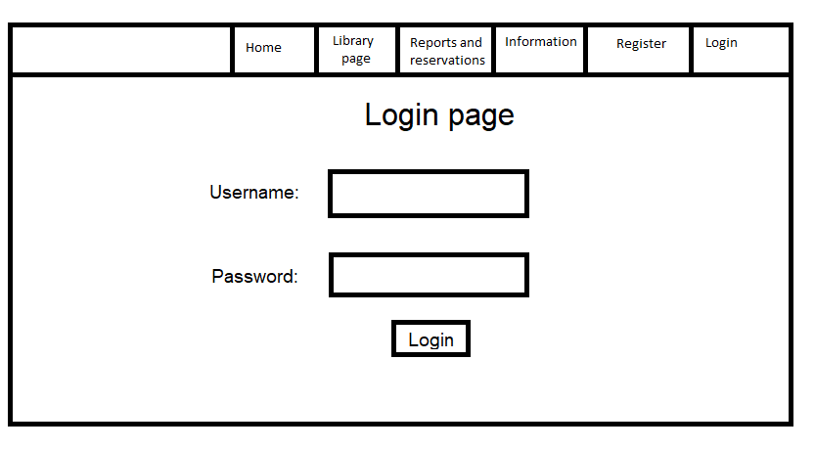

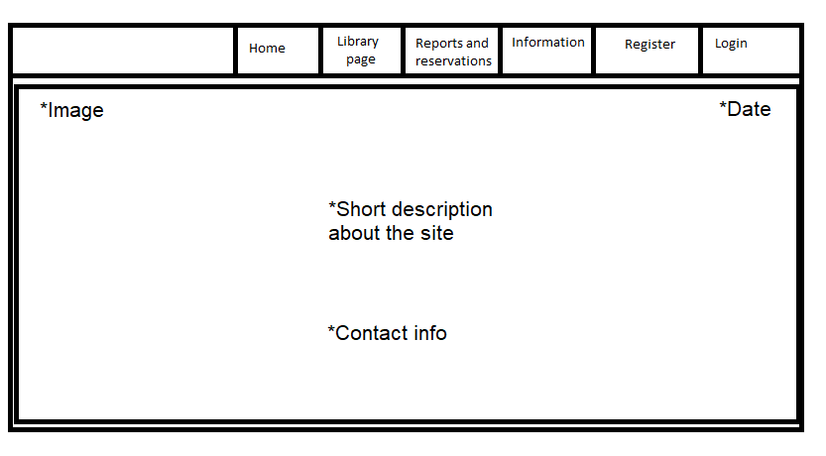Home page:

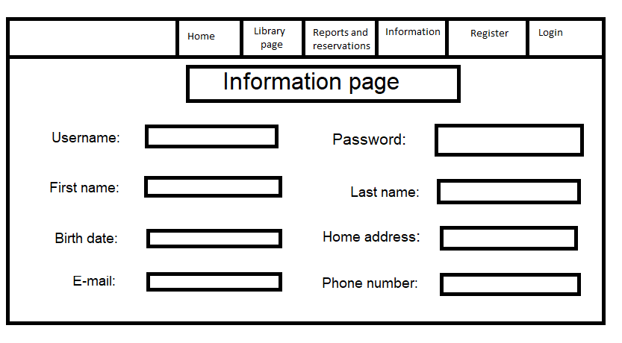Personal information page:

Library page for user:

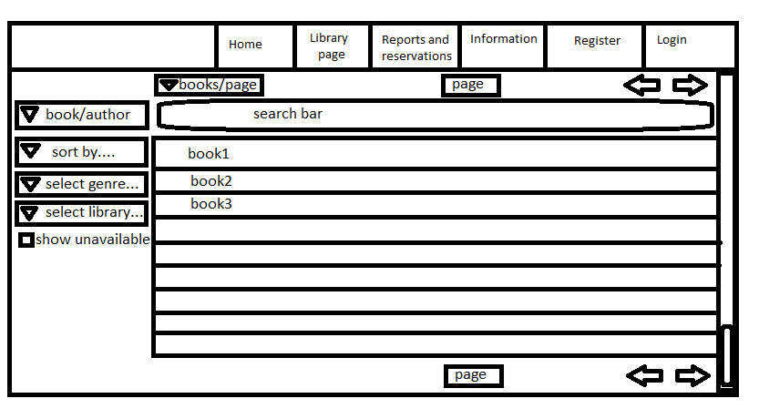

Library page for administrator/librarian:

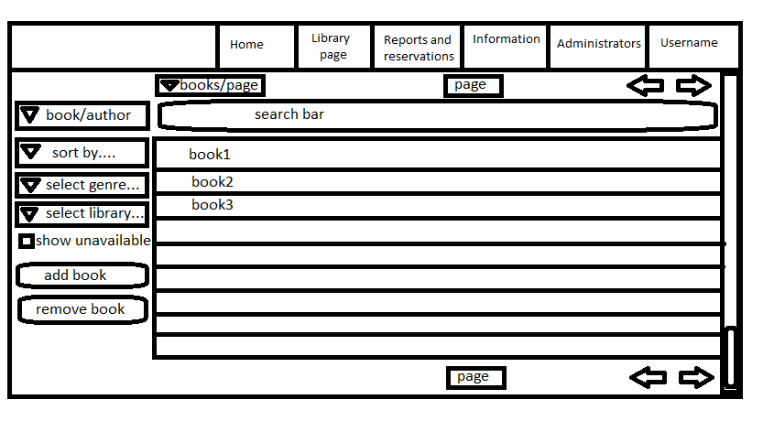

Book description page:

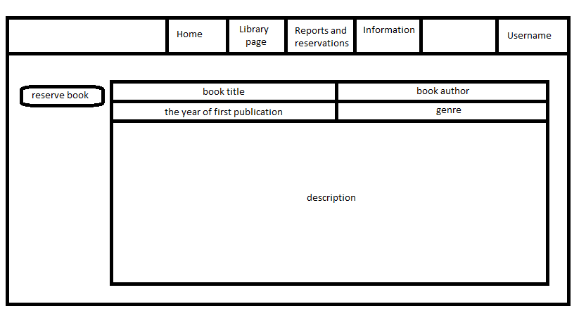

Reports and reservations page for user:

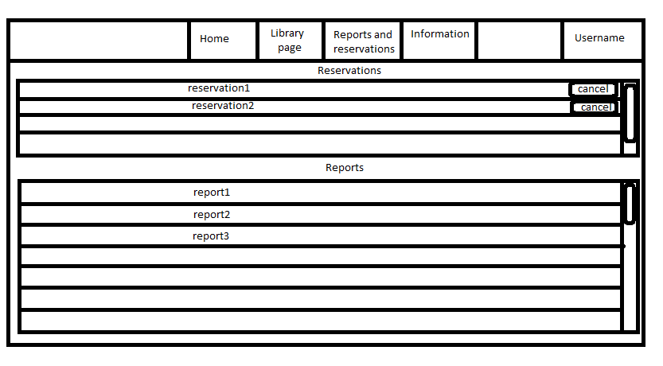

Reports and reservations page for administrator/librarian:

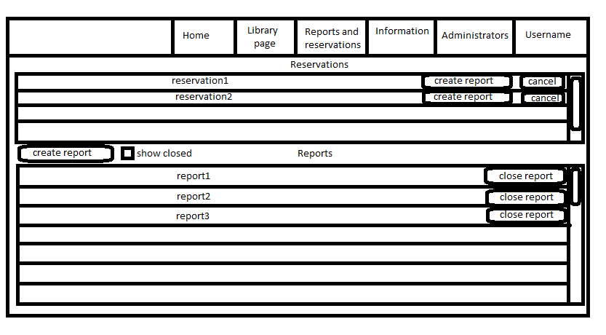

## Hardware Interfaces

Not applicable.

## Software Interfaces

The requests to the database server will be made with the help of the prototype function <requestToDBServer(query)>. This method will update and also interrogate the database according to the specified message <query>.

The responses from the database server are returned using the function <responseFromDBServer()>.

## Communications Interfaces

The program will have a web page for communication with the users, thus requiring a web browser and network server communications protocols.

As communication standards, the application uses a HTTP protocol.

The web page will be synchronized with the information in the database server.

# System Features

In this paragraph are noted and described the functional requirements for the application.

Those requirements will be organized by the use case in sections.

## User registration

4.1.1 Description and Priority

The visitors can create an account on the library web application to extend the functionality available for the user.

The visitor will sign up on the register page, by completing some of its personal information: first name, last name, home address, birth date, phone number, e-mail address, username and password. This information will be saved for facilitating the online reservation and booking process.

This feature has a high priority. Despite user being to book a book without an account, the librarian at the library center must be registered and logged in as a librarian in order to create a digital book report for a visitor.

4.1.2 Stimulus/Response Sequences

Input: On the register page the following information will be completed: first name, last name, home address, birth date, phone number, e-mail address, username and password, then press the registration button.

Output: The information will be verified and either will send a query to the database to create a new user, then redirect the client to its personal information page, or notify the user that some fields were not correctly completed.

4.1.3 Functional Requirements

REQ-11: For each information on the registration page, an input field will be displayed that is required to be completed by the client.

REQ-12: Each input field will have a tag that will specify the table and column where the information will be stored in the database server.

REQ-13: The register page will have a button that will verify that all required fields are completed, the username and password have at least 6 characters each, and the e-mail address has the correct format.

REQ-14: In case the verification of the input was completed successfully, a query is sent to the database server with the client’s information.

REQ-15: In case there were conditions unfulfilled, the customer will be notified that the input does not respect some convention rules.

REQ-16: When the server receives a registration signal, the personal data received must be verified for uniqueness: the e-mail and user must not be already in use by any other user.

REQ-17: If neither the e-mail, nor the user were found in the database, the account is created successfully and stored in the database server, and the server will send a signal to the user that will redirect him to its personal information page.

REQ-18: If any of the e-mail and username received is already in the database, the server will notify about this aspect and suggest trying to log in the account or use another username / e-mail.

## User login

4.2.1 Description and Priority

The user access in the application can be made with a user name and a password. When accessing the application without those, the functionality for the visitors will be reduced.

On the login page the user will need to complete the username and password.

When logged in, the user will be able to make reservations of the books, see those reservations and the book reports of the books which it borrowed and read.

This feature has a high priority. Although not all visitors want to make online reservations or see the book reports online, the librarian at the library center must be registered and logged in as a librarian in order to create a digital book report for a visitor.

4.2.2 Stimulus/Response Sequences

Input: On the sign in page, the visitor completes the username and password fields with his/her account’s personal information, then press the login button.

Output: The information will be verified and compared with the information in the DB server and either redirect the user to its personal information page, or notify the user that some fields were not correctly completed.

4.2.3 Functional Requirements

REQ-21: On the login page 2 input fields will be displayed that must be completed by the visitor with the username and password of the account.

REQ-22: Each input field will have a tag that will specify the table and column where the information will be verified from the database server.

REQ-23: The login page will have a button that will send a signal to the database server with the credentials of the user. The user name will then be searched in the database.

REQ-24: In case the username was not found, the server will send a message with this statement and suggest creating a new account.

REQ-25: In case the username is found, the password transmitted by the user will be compared with the one stored in the database.

REQ-26: If the passwords match, the visitor will login in the account, being redirected to the personal information page.

REQ-27: If the passwords do not match, the user will be notified that the password introduced is incorrect.

## Librarian login, creation and removal

4.3.1 Description and Priority

The librarians will be able to login in their account the same way as a normal user, the librarians being also users, but also having special permissions.

Creating an librarian account is different from creating a user account, but it is required to have a user account in order to create a librarian.

Only the administrator can create a new librarian or remove an existing one.

This feature has a high priority, without librarians, there will be none to update the application information.

4.3.2 Stimulus/Response Sequences

Input1: The visitor will enter the sign in page, then complete the username and password fields with librarian credentials, then press the login button.

Output1: A signal will be transmitted to the server that will verify the information and either redirect the librarians to its personal information page or refresh the login page and notify the user that some information is incorrect.

Input2: The administrator will enter the administrator page in order to remove or add a librarian. It can choose which librarian privileges to add or remove from an existing user account.

Output2: The database will be updated accordingly to the modifications made by the administrator.

4.3.3 Functional Requirements

REQ-31: The login in the librarian account is the same as in a user account, and the only difference is that it will have special permissions and more pages to manage when logged in. Those permissions are given by some fields in the database that enables a user account to have more capabilities.

REQ-32: The librarians will be able to will enter the librarians page, where will be a list with the librarians from all library centers and some information about each one.

REQ-33: The administrator will have a removal button in front of every librarian in the list and a button for adding a new librarian on the top of this list.

REQ-34: When the removal button is pressed, an input field for administrator’s password and a confirmation button will appear.

REQ-35: When the button for adding a new librarian is pressed, a confirmation button and 2 fields will appear: one is for the user account that will be promoted to librarian, and the other one for the administrator’s password.

REQ-36: When the confirmation button (specified at REQ-34, REQ-35) is pressed, the database will verify the administrator’s password. In case the password is correct, the selected librarian is removed, remaining with the user characteristics (for REQ-34), or the user is updated to the librarian class.

## User’s personal information

4.4.1 Description and Priority

The visitor can access the personal information page when logged in.

The user can also modify some information, such as: home address, e-mail, phone number and password. For the personal information changes to take place, it is required the confirmation of the account password.

This feature has a medium priority, being optional for the user to change this information.

4.4.2 Stimulus/Response Sequences

The personal information page can be accessed anytime by pressing the personal info button from the header of the site when the user is logged in.

Input: The user will modify some of the personal information, then press the confirmation button.

Output: The information of the user will be updated in the database and the new information will be displayed on the information page after refreshing the page.

4.4.3 Functional Requirements

REQ-41: The header of the web application will contain the button [Personal info] that is visible only when a user is logged in, and will redirect the user to its personal information page.

REQ-42: The personal information page will contain a view with fields for all personal information of the user, taken from the database server.

REQ-43: The personal information page will contain an edit button that will make the fields for e-mail, phone number, home address and password editable. A new field for password confirmation, a confirmation button and a cancel button will also appear.

REQ-44: In the case the user presses the cancel button, all modifications will be discarded.

REQ-45: For confirmation of changes of e-mail, phone number, home address or/and password field(s), will be necessary to confirm the account’s password, by completing the confirmation password field that appeared, and press the confirm button that will send a signal to the database server.

REQ-46: The database server will verify the password received with the one stored in it for the current user, and in case of a match, it will update the user information with the one received. In case the passwords do not match, the server will notify the user about this aspect.

REQ-47: After the database was updated, the changes of the personal information will appear after a refresh of the user’s personal page.

## Online library

4.5.1 Description and Priority

The books from the libraries available for the public will be displayed on the library page.

Any visitor of the library web page will be able to enter the library page and see a list with the books, each one showing the title, author and genre.

This feature has high priority, the books being the center part of the webpage.

4.5.2 Stimulus/Response Sequences

Input: The visitors will enter the library page via the button in the header bar of the webpage.

Output: The visitors, users and librarians will see the list of books through which they can scroll.

4.5.3 Functional Requirements

REQ-51: The books page, where the book titles and authors are displayed, can be accessed via a button in the header of the web page.

REQ-52: In the books page, will be displayed a list with the books from the library centers, with the title, author and genre of the book. The information is taken from the database server.

REQ-53: The books are distributed in pages, showing 100 book titles at most per page. The current and the total number of pages will be displayed on the top and at the bottom of the list.

REQ-54: The user will be able to change the pages with books, such as going to the next page, previous page, or first page, by using buttons that execute the specified functions.

## Book filter, sort and search

4.6.1 Description and Priority

The books displayed in the library page can be reordered and/or reduced by using sorting, filters and searching. Thus, any visitor of the library web page will be able to optimally find the books of their interest.

This feature has low priority, the searching could be also done manually.

4.6.2 Stimulus/Response Sequences

Input: The visitors, users and librarians can use the search bar, select the sort type and filter the books by a given criteria. This will send a query to the database with the given particularities for the books.

Output: The order of the books and their number displayed in the list will change accordingly to the searching criteria used by the client.

4.6.3 Functional Requirements

REQ-61: The user will be able to filter the books by genre and the library center where the books can be found, each of these criteria having a dropdown menu in the library page.

REQ-62: The user will be able to sort the books alphabetically by book title or author, or ascending/descending by the year published, this feature also being displayed as a dropdown menu.

REQ-63: The user will be able to search books by title of author names.

REQ-64: The user will be able to choose to view the unavailable/available books.

## Adding and removing books

4.7.1 Description and Priority

The librarians can add and remove books in the library web page with the help of a removal button and an addition button.

When logged in as librarian, the removal and the addition buttons are displayed before the list of books on the library page.

This feature has high priority, without this feature not being able to add new books to the library center or remove the degraded book.

4.7.2 Stimulus/Response Sequences

Input1: The librarian uses the remove button, then a field for the book ID and confirmation button will appear. After completing the book ID to be removed, the button is pressed.

Output1: A signal is sent to the DB, which will delete the book with the mentioned ID.

Input2: The librarian uses the addition button, then multiple fields will appear for writing the new book information and a confirmation button appear. After completing the required fields, the button is pressed.

Output2: A signal is sent to the DB, which will create the book with the information received from the librarian.

4.7.3 Functional Requirements

REQ-71: The librarian will have two additional buttons on the library page, for adding and removing books in/from the database.

REQ-72: The button for removal will have as effects the appearance of a new input field, where the librarian will write unique book ID to remove, and a confirmation button.

REQ-73: When the confirmation button specified at REQ-72 is pressed, a signal is sent to the database server. In case the book with the specified ID is found, it will be removed and display this as a message to the librarian. In case the book ID is not found, this information will be displayed instead.

REQ-74: When pressing the book addition button specified at REQ-71, a confirmation button and a few input fields will appear for completing with information about the new book, such as: title, author and genre of the book, library center where the book is registered, the number of books, genre and optionally a short description.

REQ-75: When pressing the confirmation button specified at REQ-74, a signal will be sent to the database server, which will generate the number of books, each with a unique ID and the information specified. The IDs of the books will be displayed to the librarian to note them.

## Book reservation

4.8.1 Description and Priority

Users will be able to reserve books when logged in. From the book’s description, the user will be able to reserve it by pressing the button “reserve”. This will result in the appearance of a field for specification of the date when the user will pick up the book, and a dropdown menu with the library centers where the book is available.

This has a high priority, this feature being necessary because every user must be able to reserve a book online from any library center available.

4.8.2 Stimulus/Response Sequences

Input: The user will select a book from the list in the library page, this action leading him to a page with information about the book, such as author, title, date published, genre, and a short description. On this page is also the reservation button.

Output: When the reservation button is used, a book that corresponds with the information on the page is set as reserved in the database and a reservation is set for it.

4.8.3 Functional Requirements

REQ-81: When the user is logged in, in the book description page will appear the reservation button will appear if at least one book of that type is available.

REQ-82: After pressing the reservation button on the current book description, an input field, a dropdown button will appear and a confirmation button will appear in order to complete the book reservation.

REQ-83: The input field will let the user select the day for picking up the book. When choosing the day, the application will look for the following:

-the correctness of the format “dd/mm/yyyy”,

-not be an inexistent date (ex: 31/04/2021),

-not be a day from the past (ex:15/11/1939)

-not be more than 7 days apart from the current day.

In case any of these restrictions are not fulfilled, a warning will be displayed for the user and the book reservation button will be disabled.

REQ-84: The dropdown button will let the user select the library center from where to pick up the book. The dropdown is populated with the names of the library centers where the book can be found. This information is retrieved from the database server when pressing the reservation button explained at REQ-81.

REQ-85: The confirmation button, that appeared when executing the instruction from REQ-82, is disabled until the information in the input field and dropdown button are completed correctly. When enabled and pressed, a request will be sent to the database server, which will create a book reservation with the user’s username, the library center, reservation date, and the id of one of the books that correspond to the book description, that will set it from available to reserved.

REQ-86: The user can see its own reservations in the reservations and reports page, which can be accessed via a reservations and reports button from the header of the website. On this page are 2 lists: first a list with the book reservations, and second the list with the book reports.

REQ-87: Each reservation in the reservation list will contain the book title and author, library center from where the book must be picked up, reservation date and a cancel button to remove the reservation.

REQ-88: The librarians will also be able to see all reservations and additionally have for each reservation the user who made it and 2 buttons: one for creating a book report when the user picks up the book, and the other to cancel the reservation when the date to pick up passes.

REQ-89: When the user picks up the reserved book in time, the librarian logged in as librarian will use the report creation button of the reservation (see REQ-88). This action will show an input field for the due term for the retrieval of the book and a confirmation button.

## Book reports

4.1.1 Description and Priority

Librarians will be able to create reports for books.

A report is created with the following information: the client, the day booked, the due term, the retrieval date, the library center from where it is booked and the book ID.

The user can see the book’s report on the reports page, where it can also see all the reports of the books he has ever booked.

Also, the librarians can see the book reports for all books and users on the reports page.

This has a high priority, because the book reports must be added in the online system.

4.1.2 Stimulus/Response Sequences

Input1: The librarian will use the report creation button from the top of the reports page.

Output1: Some fields for the user and book information and a confirmation button will appear in order to create the report.

Input2: The librarian will complete with the requested information and use the confirmation button.

Output2: The book report is created and will appear in the list of the book reports of the client and the librarians.

4.1.3 Functional Requirements

REQ-91: When the librarian will use the report creation button from the report page, a confirmation button the fields for the following information will appear: book ID, due date, username, first name, last name, home address, e-mail and phone number.

REQ-92: The librarian will complete the book ID field and the username field, in case the client has an account on the website, or all the other ones contrary, in order to have the customer’s name and contact information.

REQ-93: When the confirmation button is pressed, it will be verified that either the username is completed and existent in the database, or all the other fields for the customer information are completed. The book ID and the due date are required fields for both cases. In case all conditions are respected, the database will create and add the book report, contrary the librarian will be notified that the book report could not be made.

REQ-94: Each book report in the report list has the book title, author, library center, pickup date, due date and retrieval date. In case the book was brought back, the report is noted as closed. Contrary, the report is noted as open, and the retrieval date field will be empty.

REQ-95: The librarians will also be able to see all the book reports and additionally have for each book report the user who borrowed the book and a button for retrieval confirmation for when the user retrieves the book. This button is available only for open reports (that do not have the retrieval date completed).

REQ-96: The input fields for the due date will be completed with the same restrictions as REQ-83, except that the due date can be at most 2 months apart from the pickup date. The date will be chosen depending on the book’s volume and its difficulty of understanding.

REQ-97: When the user retrieves the book, the librarian logged in as admin will use the retrieval confirmation button. This will send a message to the database server, that will complete the book report retrieval date with the current day, thus closing the book report. The book status is changed from unavailable to available.

# Other Nonfunctional Requirements

## Performance Requirements

The web application must be able to manage a large amount of information about books and output in the web browser the information retrieved from the database server in less than 10 seconds from the initial request.

The web application should be able to handle a medium number of users, at least 100 users at any given moment of time.

The interval between each request from the user and its response from the database server must be less than 5 seconds.

The memory transfer from the user to the database and from the database to the user must be less than 10MB.

## Safety Requirements

Not applicable.

## Security Requirements

The personal information of the users will be safely stored in the server database.

This information is secured, requiring a user and a password in order to access it.

The user logged in will be able to see only its personal information.

The name, e-mail, phone number and address of the user can be accessed only by librarians and administrators in order to create reports for the books and contact the user. Any other information will be inaccessible by any other person beside the owner of the account.

## Software Quality Attributes

As software quality attributes, the final product must have the following characteristics:

-each class must not have more than 2000 lines written

-each written line must not have more than 200 characters written

-each class name and function will be written in upper camel case (e.g.: ClassName, FunctionName)

-each variable will be written in lower camel case (e.g.: variableName)

-each method will have above itself a comment with the method description of its parameters’ description

-the comments for methods and classes will be made by using “//”

-the comments for variables and additional information will be made by using “//”

-each comment will be placed on a separate line, not at the end of a line of code

-each accolade will be on a separate line, without existing any other character on that line

-use the default Code Editor settings (smart indenting, four-character indents, tabs saved as spaces).

-if continuation lines are not indented automatically, indent them one tab stop (four spaces)

-only one statement per line must be written

-all statements must have open and close accolades

-use parentheses to make clauses in an expression apparent

## Business Rules

Not applicable.

# Other Requirements

Appendix A: Glossary

Not applicable.

Appendix B: Analysis Models

Not applicable.

Appendix C: To Be Determined List

Not applicable.