I Statistics

1. UDP with percentage 88.9%
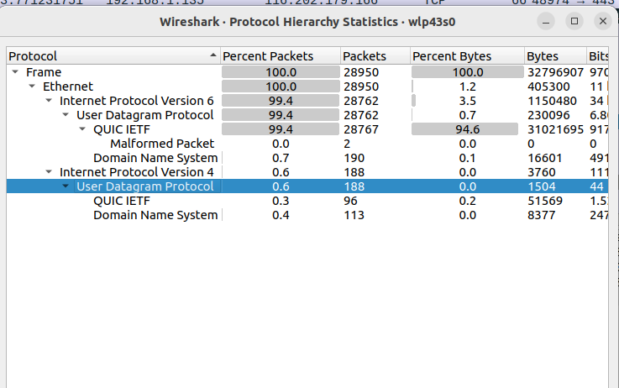

2.
a. max vol: ~=287
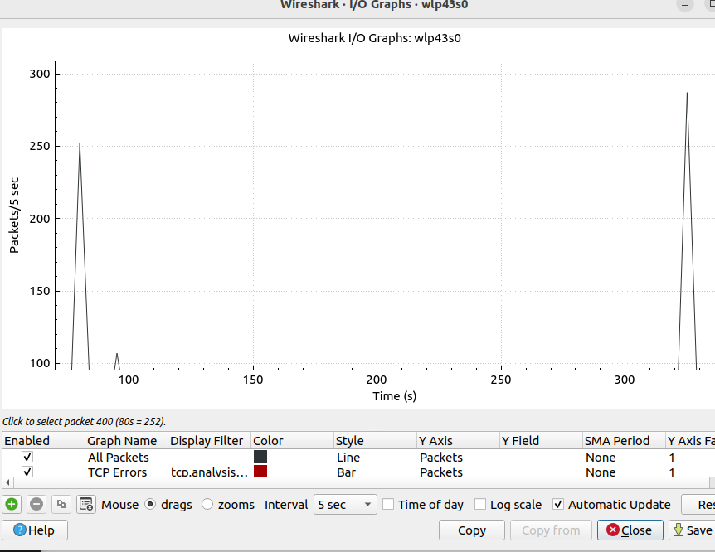
b. volume of data: second=8+3=11=>8 packets aprox
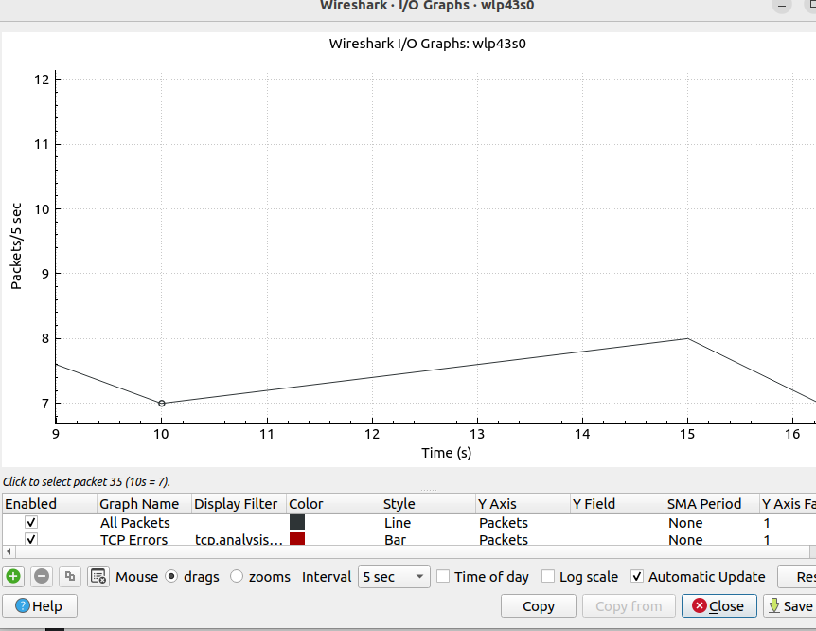
II. UDP
length: 53

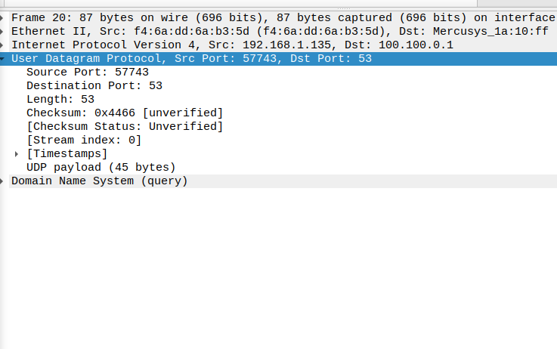
2.source: ac:b6:87:d0:49:dc
dest:Broadcast
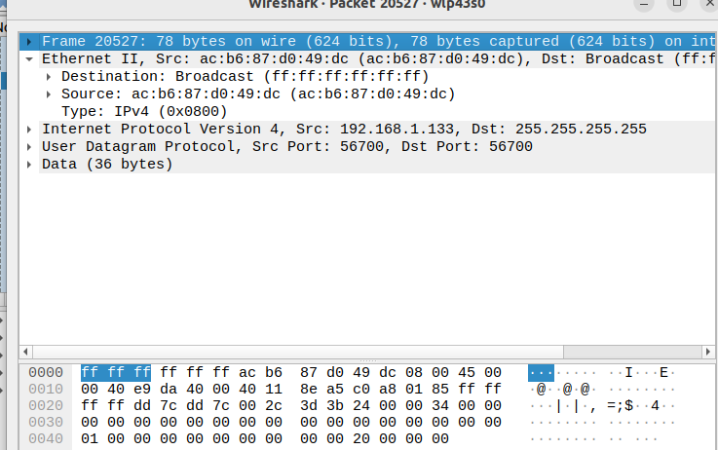
3. sum: 72(IP)+52(UDP)=124

III.TCP
1. source socket:51544
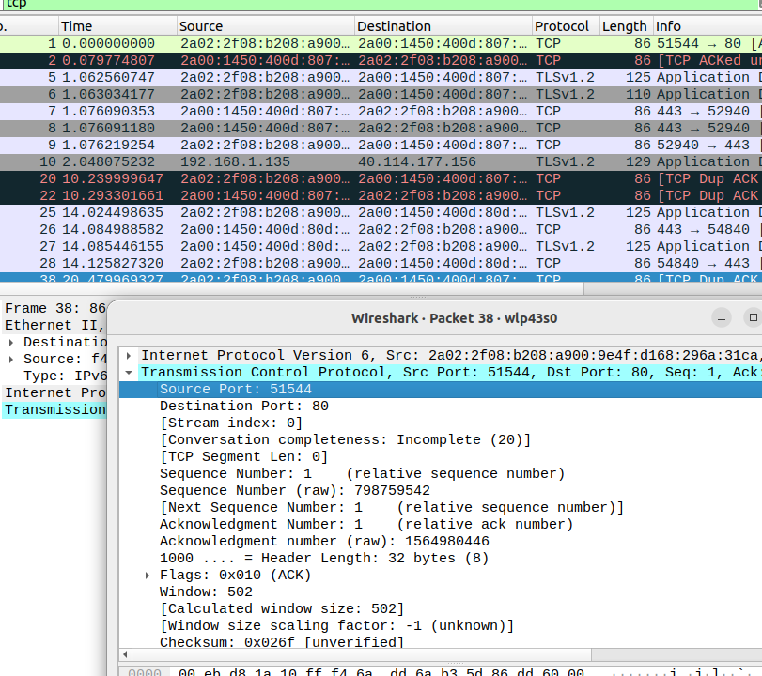
2. syn ack→49,60
syn→49.56
=>diff=0.4

3.
src port→2bites
dest→2b
seq nb→4
acknowledgment nb→4
data offset→1
flag→1
window size→2
checksum→2
=>12+2+4=18=>options: 40-18=22
