**MIS 536 Advanced Business Analytics**

**Reading: Use Search Engine Like A Pro**

The internet keeps growing bigger every day. If you want to search it effectively you’re going to need to develop a couple of tricks to help you narrow the search. Here are a few really easy ones to integrate into your next search:

1. **Exact phrase**: The simplest and most effective way to search for something specific is to use **quote marks** around a phrase or name to search for those exact words in that exact order. For instance, searching for **Joe Bloggs** will show results with both **Joe** and **Bloggs** but not necessarily placed sequentially. Searching for **“Joe Bloggs”** will surface only those that specifically have the name Joe Bloggs somewhere on the page. The exact or explicit phrase search is very useful for excluding more common but less relevant results.

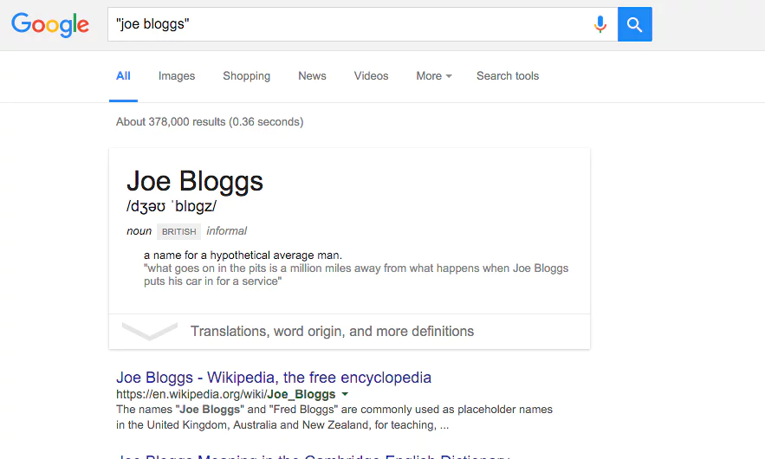

1. **Exclude terms**: If exact phrase doesn’t get you what you need, you can specifically exclude certain words using the minus symbol. A search for **“Joe Bloggs” -jeans** will find results for Joe Bloggs, but it will exclude those results for the Joe Bloggs brand of jeans.

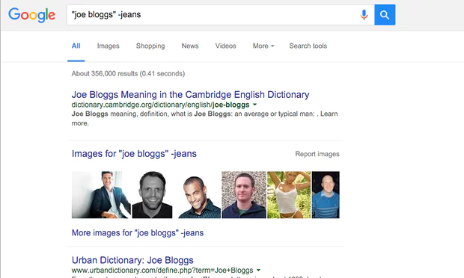

1. **Either OR**: Default text searches find results with all the words of the query. By using the **OR** term you can search for one or another term, not just all the terms. OR searches can be useful for finding things that you’re not sure which term will be used from a known list.

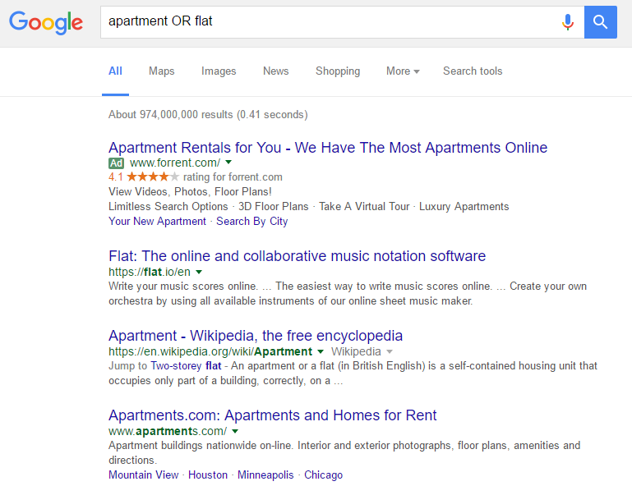

1. **Synonym search**: Sometimes it’s useful to search for a less specific term. If you’re not sure which term will be used you can use synonym search. Searching for **plumbing ~university** will bring up results for plumbing from colleges as well as universities, for example.

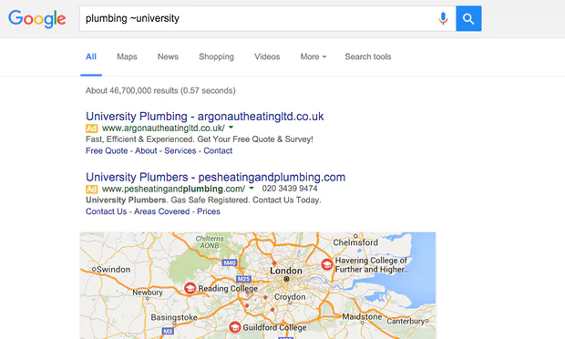

1. **Search within a site:** The search engines of most websites are poor. You can search using Google instead by using the site or domain limiter. Searching with **site:iastate.edu** followed by a search term, will find results from only iastate.edu. Combining with explicit search terms makes it even more powerful.

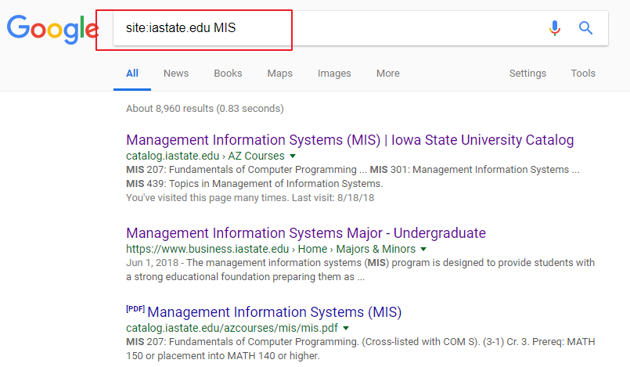

1. **The power of the asterisk:** Like the blank tile in Scrabble, the asterisk works as a wild card within searches. It can be used in place of a missing word or part of a word, which is useful for completing phrases, but also when you’re trying to search for a less definite article. A search for **architect\*** will search for architect, but also architectural, architecture, architected, architecting and any other word which starts with architect.

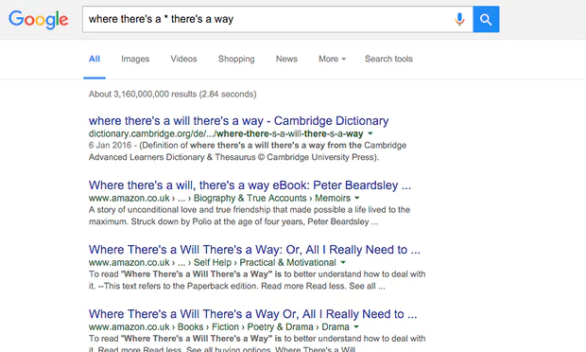

1. **Searching between two values:** Searching for something with a qualifier between two ranges is a good way of answering questions. For instance, if you’re looking for the who were the British prime ministers between 1920 and 1950 a search using **british prime minister 1920.. 1950** will bring up results with dates ranging between 1920 and 1950. That’s your search term followed by **two full stops and a space**.

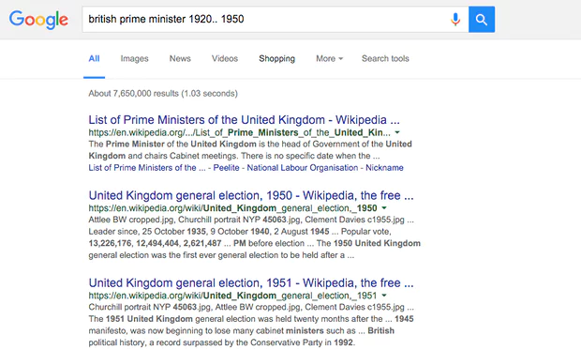

1. **Search for word in the body, title or URL of a page:** Sometimes you only want to find text either within the URL, body or title of a page. Using the qualifier **inurl:** will search just within the url. The qualifier **intext:** will search within the body, while **intitle:** will search only within a page title. For example, **intitle:review** will bring up all the articles with “review” in the page title.

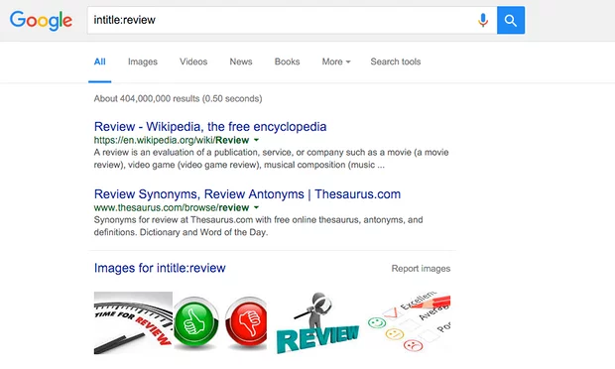

1. **Search for related sites:** The related qualifier is useful for finding similar sites. Searching for **related:iastate.com** for instance, will bring up the websites of other universities that Google deems the most similar to the Iowa State University.

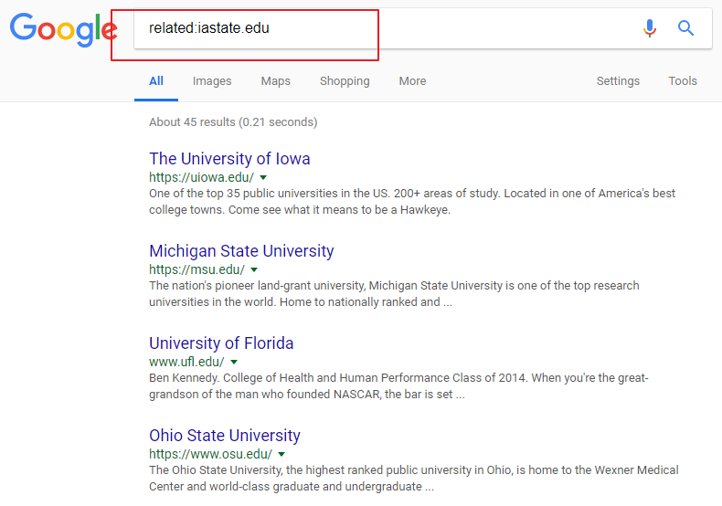

1. **Combine them:** All these search tools can be combined to narrow down or expand searches. While some of them may be used only rarely, some such as explicit phrase searches are useful in almost all cases.

