23/11/17
We did our SDD exam. Despite this being an invariably sad occasion, due to the scarring experience of completing the exam, I can now begin to once again focus on the game that I’ll get to make. I already have a few ideas!

24/11/17
Today we got the assignment in SDD. I’ve already been thinking about what I’m going to do for a while now, so now that we’ve got the go-ahead, I can pitch my idea to Ms. Chen. I’m thinking of maybe doing a roguelike game with an ASCII interface (like crawl), except I’m going to set it at school, and the player needs to make it from the farm to the front of school. Hopefully, Ms. Chen will approve my idea, so I can get started ASAP!
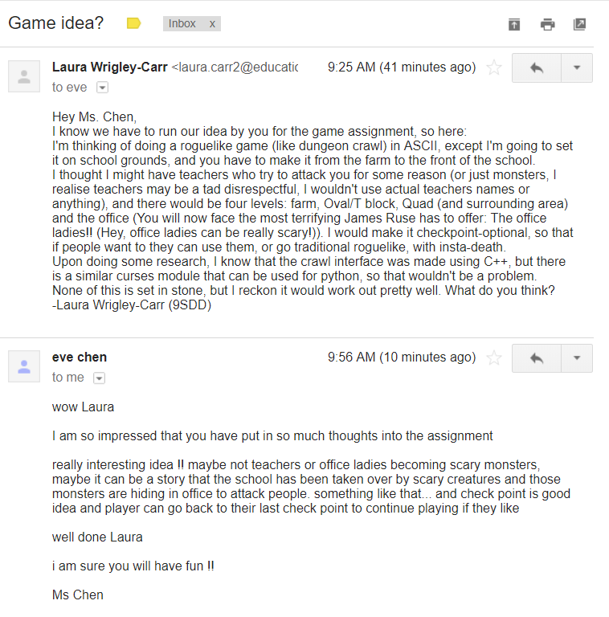
25/11/17
Today I emailed my idea to Ms Chen, to see what she thought. I got my response surprisingly quick.
Now that I’ve got approval, I can get started. I’m hoping to get a lot done in the next little while, as once I get back to school next year, there’ll be tons of other work I’ll have to do, and I don’t want to have to finish this in a rush.

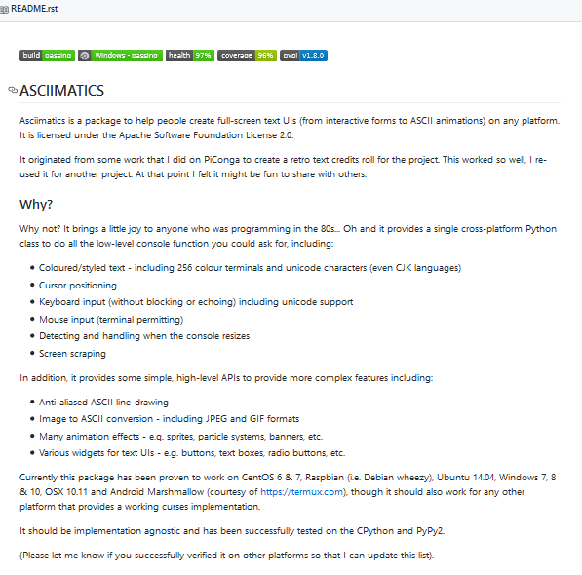
26/11/17
Guess what? I’ve already run into a slight problem (actually, it’s a pretty big problem). I discovered that python curses aren’t available on the windows version of python. My first thought was ‘Use another operating system!’ But since I need to have it working on a windows computer when I hand it in, it’s probably not the best idea to develop it on a different operating system. I decided to call in the cavalry, after unsuccessfully finding a solution on the internet. (There are a few tools that are meant to be like python curses but for windows, but the majority seem to be pretty ancient (like windows xp ancient)) By ‘the cavalry’ I of course mean my dad, Gavin Carr. He’s a geek himself so he knows a good bit about computers. Of course, 5 minutes after outlining my problem, he does a quick google search and manages to find a solution (why?????). I’ve decided to use a module called asciimatics. It’s pretty much exactly like python curses (even down to the same codes for the colours!), except it runs on windows, and it looks to be regularly maintained. Thanks, Dad!
28/11/17
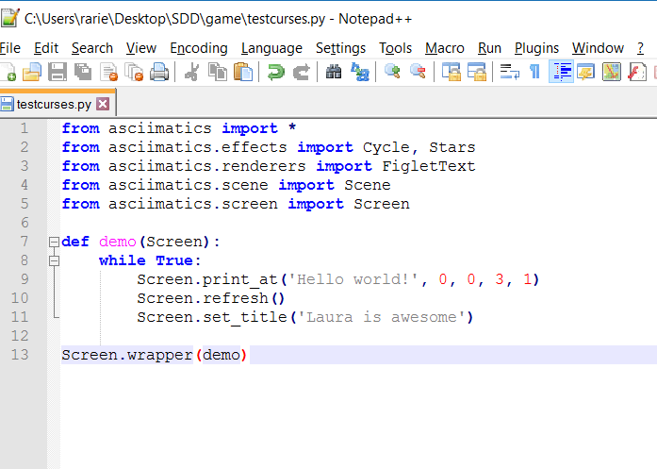
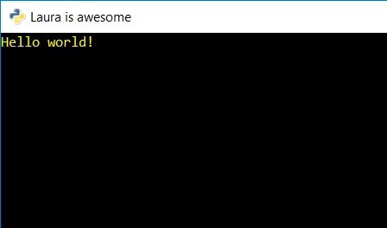
Today in SDD, we were given time to look at past projects, to give us inspiration for what we will do. Of course, since I already planned what I’m going to do, I basically just played around with asciimatics, and am starting to get the hang of it. I’ve made a little program to try different things out. At the moment it doesn’t do much of anything, but I’ll build on it, and eventually have it doing backflips (figuratively).

30/11/17
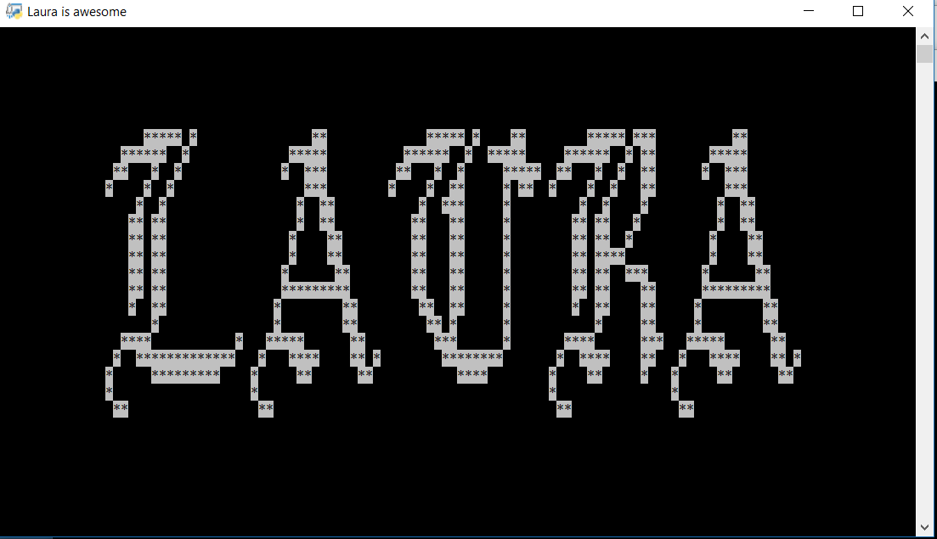
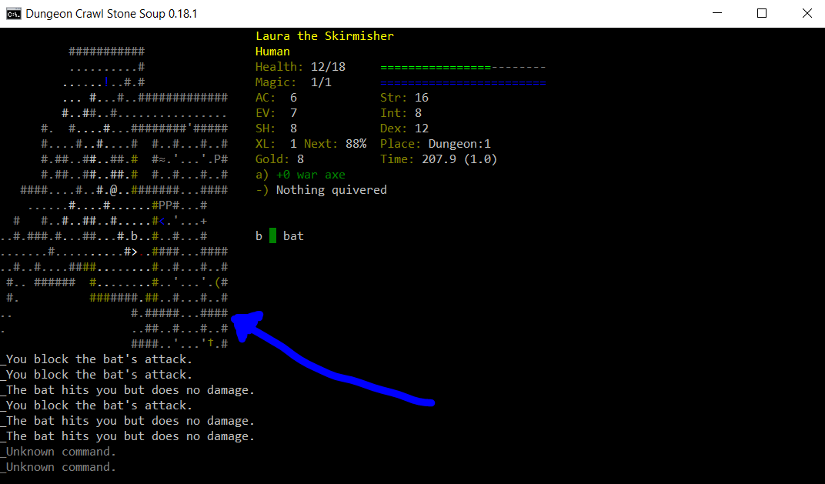
Today we got another period to check out the game folders, so I continued my work with figuring out asciimatics. Since Monday, I’ve figured out how the taller text works (FigletText), and so can now make the titles seem more dramatic (see first picture). Next I plan to figure out how to make a layout interface, particularly the map, like in the second picture.
I’m not sure how far into that I’ll be able to get before having to figure out how to use input commands, but it’s impossible to start with user commands, so there’s not exactly a way to do the user commands without the interface (unless I plan to randomly rearrange titles in response to input, though why you’d want to know how to do that is beyond me.

01/12/17
We got some more time to brainstorm our project today. For me, that meant trying to figure out how to make the map interface. Thus, my first stop was the asciimatics documentation. However, to my surprise and horror, there was no part of the documentation referencing this anywhere! Eventually, after much more research I concluded that maybe asciimatics wasn’t such a perfect tool after all for this. I was therefore back to square 1.
I proceeded to do some research on the other possible tools that I could use – these included Unicurses, and another unofficial port of curses for windows. Both would end up doing the same thing, but I ended up discovering that Unicurses has no support for x64, which was my machine (seriously???). By this point I was extremely annoyed (it was also late afternoon at this point, after spending the entire day chasing up dead ends). That isn’t particularly relevant, but in order to properly paint the picture of what occurred, you really need to appreciate my state of mind at the time. Anyway, this left the other port as my only option.
I ended up going through this whole rigmarole of having to make pip work on the command line instead of Cygwin (and I hate Command prompt with a passion!! Who even uses batch anymore?) but eventually made it work, and the module, conveniently named ‘curses’ was installed. I tested it, and everything was fine. In conclusion, it has been a very annoying and frustrating day, which has involved coding in ¾ of my periods in which I had class, and way too much hatred of the windows operating system in general. (I do not include any screenshots in this particular log, as there isn’t too much to screenshot as of yet.)
05/12/17
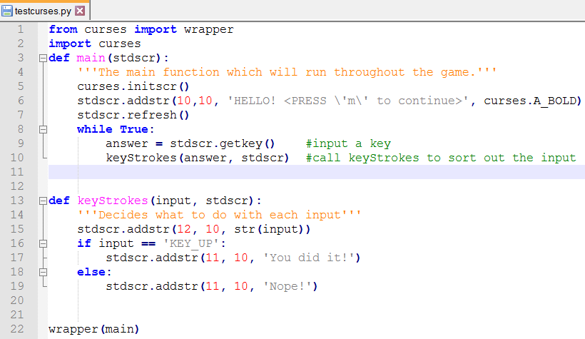
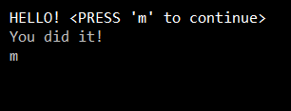
Yeah, so I kinda took the weekend off from programming, as I was still rather annoyed about it (not to mention I had ISCF day conference and had to put up the Christmas tree…). Anyway, I got back into it today during DT, when we had some free time. I began to once again figure out how everything worked, even playing around with a little user input stuff. (see below)
In the image above, the first line was the original message, the second line popped up after the user pressed ‘m’. The third line printed what the user typed.

Anyway, now we have double SDD, and so I intend to make the most of the time by doing some research about the map. I reckon that making the interactive map, with all the items and the player moving through it, will probably be the most difficult part of the game, so I want to get started on it as soon as possible. The obvious place to start would be Dungeon Crawl, the original inspiration for my game. Although it was made in C++, and mine will be in python, they both use the curses module, meaning that the general outline of the code should be the same, barring syntax changes. Thus, it’s the perfect place to go to figure out how the map works.
[EDIT] Lol, never mind, we got our assignment back instead, so I didn’t get a chance to work on this. Hopefully the next SDD lesson.
08/12/17
Over yesterday and this morning, I’ve been trying to figure out how to make this whole map conundrum thing work. I did some research, and fiddled with things, basically dumping half my code and re doing it, but I’ve made some big progress. I first made a window, and drew a box around it so I could see it. I then made stuck @ inside, representing a character. I made little functions so that they could move around with the arrow keys, and just for fun, made them leave dots wherever they went.
From there, I knew I’d need to figure out how on earth to do the whole map conundrum, especially since you apparently can’t use addstr() to print multiple lines. Or can you? I discovered that if you define the string beforehand (e.g. gamemap = ‘’’…..’’’), you can put multiline strings in a single addstr(). This of course made it significantly easier. Here’s what I have so far:
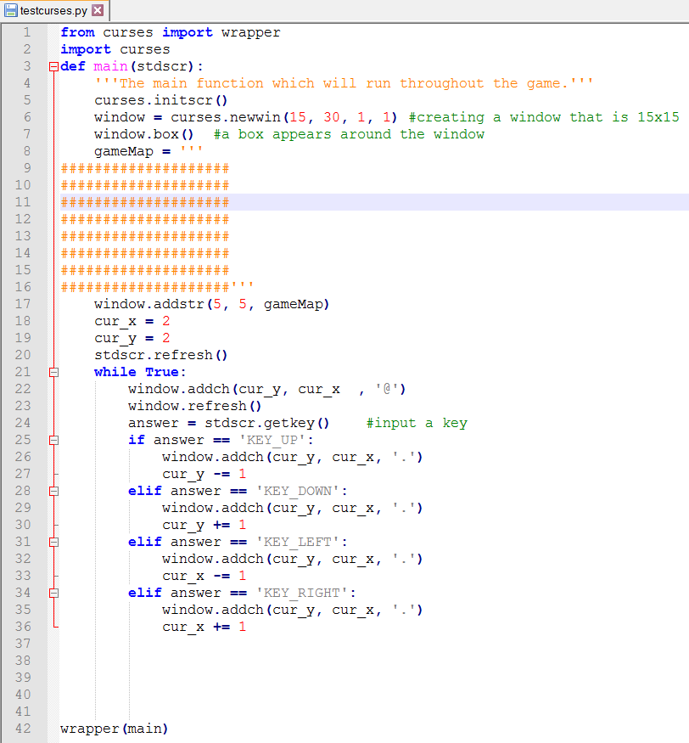
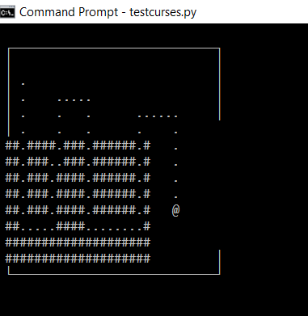
I once again have SDD in the last period of the day, so I should be able to work on this more then.
09/12/17
Lol, we didn’t exactly have a productive SDD lesson yesterday, so I got exactly zilch done. On the up side, today I managed to get loads of stuff done, until I hit the wall that is the update_panel() command. Let’s start at the beginning. I first wanted to make the code more structured, so I moved the whole if statement into a separate function.
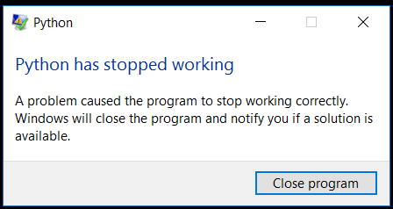
Then I began to once again work on the map conundrum. Firstly, when the character moves through the world, there are dots in between the walls representing floors. Of course, when the character moved through the world, they couldn’t just leave floor everywhere, as there are other things to consider too, like items or monster carcases. You know, the normal things you see lying around. I therefore had to figure out a way to make the character leave behind them the same tile as was there in the beginning. I made this whole weird complex solution that took ages, and was very long. But then, I was sitting there staring at the code, and I was all like ‘There has got to be an easier way to do this!’, so I went on the curses docs, and found a more elegant solution in the form of panels. The idea is that you can layer these panels, so that they wouldn’t affect one another. It was at this point that I hit the wall.
After getting rid of the chunky solution and implementing this one, for some reason python suddenly closed. I managed to narrow the problem down to one line – the update_panel() line. However, as I have no idea as to why this is, I have temporarily hit a wall. I think I’ll just try again tomorrow…

12/12/17
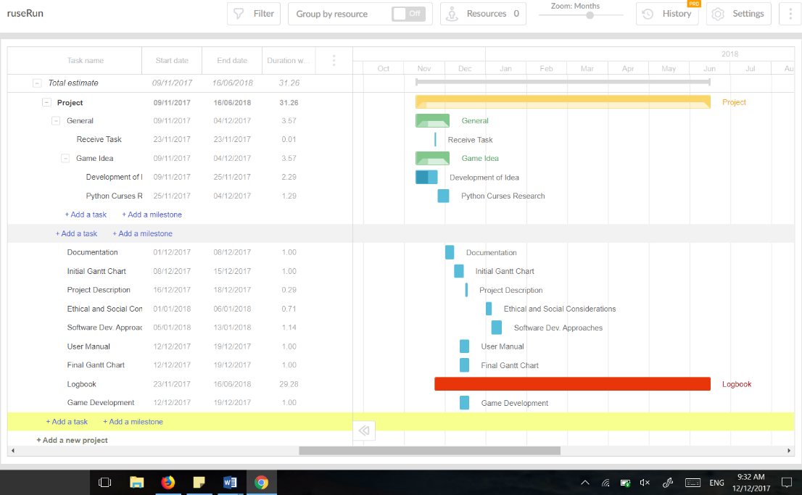
Well, nothing really ended up being done on Sunday after all. Or Monday for that matter. It is now Tuesday, and I still have no idea as to how to fix this. Luckily, my Dad’s getting back from New Zealand this afternoon, so hopefully he’ll be able to help. In the meantime, I’ve begun the Gantt Chart. It’s very annoying and stupid, and I have no clue as to which thing we’re meant to use. Despite this, I’ve gotten a good way in, though I think I’m a little too optimistic…

26/12/17
Today, after a long break which included a holiday at the beach, the end of school and Christmas, I am finally back with the intent to continue my project, especially in respects to this panels issue that I have for so long been struggling. Though my Dad returned from his travels a while ago, I didn’t get back to this until this morning, when he reminded me of it, and so we once again jumped into the wondrous world of programming.
*Phew* well that was slightly confusing and unnecessary. I wasn’t sure how to start so I just started rambling. Today I got back into programming. I enlisted my dad to help me out with my problem, and made him a collaborator on my github repository so that he could edit the game. We tried running it on his computer, and to my surprise and moderate annoyance, it worked perfectly. It seemed that there was nothing wrong with my code at all, but simply the unofficial port that I’m working with for windows doesn’t support panels. It’s not really that much of a loss. It should be easy enough to do by hand (or computer!).
As I already had my dad enlisted and on loan (so to speak) for a while yet, I decided to pick his brain as to my map conundrum. If you don’t recall, this was the fact that I had no current way of doing the whole scrolling map thing that is seen in so many roguelike games. It would be doable by hand, but it would be significantly easier if I didn’t have to make this myself, but instead used a module inside curses.
Of course, all my searches on the internet related to maps or scrolling maps and curses had turned up nothing, but my dad sits down at the computer and 10 seconds later, he’s got a solution. (Why is he so good???) By using pads (weird name, huh?), you can have a larger window, but only show a certain part of the window at a time. Using this, it should be easy to just get the part of the map shown to move when the player reaches the approximate centre of the viewpoint (not sure if that’s the right word…). I’m going to continue to peruse both this and the panels problem tomorrow.
27/12/17
Today I made tried out the pads solution. However, I hit a snag very quickly. It turns out that my port of curses for window doesn’t contain the parts for both pads and panels. (note to self: never trust anything that says ‘unofficial’ again) Here I find myself in a bit of a pickle – without pads, it is neigh impossible to go through with this – I am seriously considering finding another module for the job. But I’ve been down that road before – remember that? I really don’t want to have to go down that road before. I think I’ll sleep on it, see what else I can come up with.
28/12/17
I had a chat with my dad this morning – and we’ve come up with a plan. If I could make the game on linux, then I could bypass my crummy curses module, and the annoyingness of windows altogether. We came up with another way to do it – see email below for details. (I emailed Ms Chen (hi!) for confirmation that this is technically allowed.)
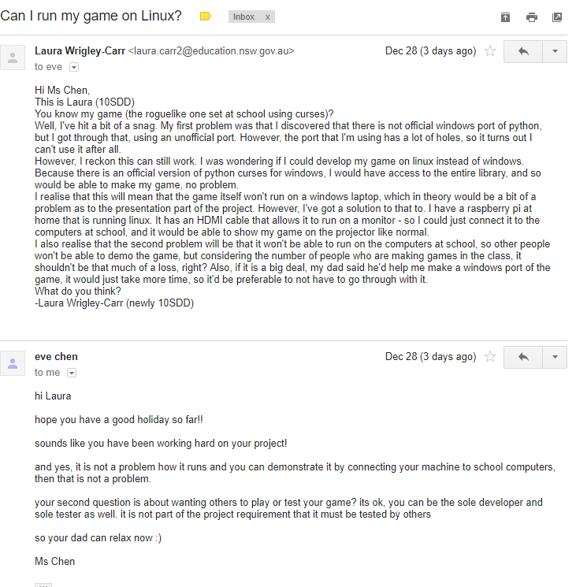
31/12/17
Today I continued (on linux!!!) on my project. In order to continue working on my laptop (it’s easier), I am using ssh and working on one of my dad’s computers. Let’s just say, a lot of things have happened today, as I have been very productive, and frankly, I don’t remember most of it. I will therefore, just this once, resort to dot point form.
- I discovered that you cannot use panels inside pads, and so decided to just use pads, and do the panels myself (easier than the alternative)
- I attempted to familiarise myself with vim (the code editor on storm, faster but I need to learn how to use it properly)
- I split the ruseRun.py file into two, one still called ruseRun, and another called interface (yes, you guessed it – to handle the interface. There’s your intrinsic documentation!!)
- I tested it, found a small issue, and, being unfamiliar with vim, I accidentally deleted the interface file.
- I did steps two and three again to make up for step four
- I wrote this log, being very sick of coding altogether
That’s about the size of it. Good night, and…… Happy New Year!!
3/1/18
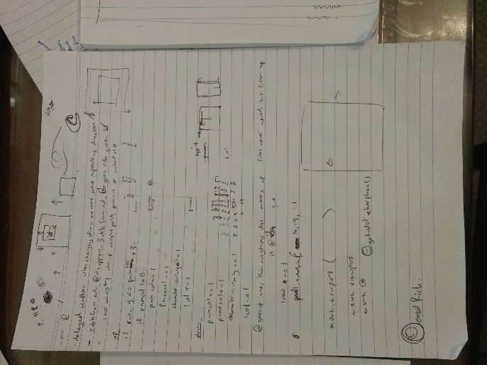
Wow, my first entry in the 2018! I took a few days off to catch my breath back (not entirely sure how that works, but oh well), but now I am back. Today I started and SOLVED my scrolling map issue. Yay! I will now run through my process for you.
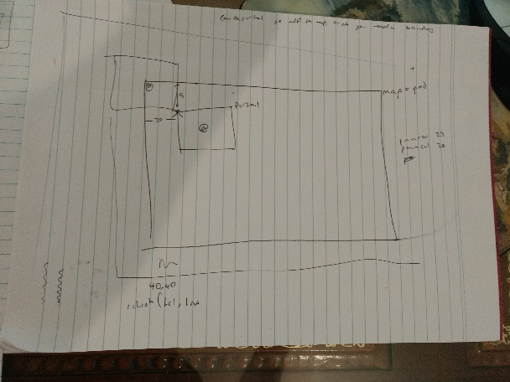
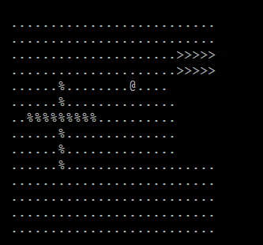
I began by creating 6 variables to represent the 6 numbers needed to update the pad – 2 for the top left point of the box that you can see, and 4 for the dimensions of the box (it makes more sense in the diagram – but not much more). Needless to say, it was very confusing, and I successfully gave myself a headache many times trying to figure out which numbers were corresponding. It of course didn’t help that for some reason curses takes their graphing points in the format (y, x) instead of (x, y), though in my opinion that kind of makes more sense. I eventually realised that the reason that it wasn’t working was that I misunderstood the purpose of the two origin numbers, so in the end it was pretty simple. Don’t you hate it when that happens?? Anyhow, I got it all working, and as I haven’t given you any fun pictures in a while, see right.

05/01/18
Today I decided to start working on item distribution. The obvious way to do it is to randomly allocate them to certain spots on the board – of course, you would need to make sure they didn’t get dropped on a wall or something, as that makes it rather difficult to get. Apparently, the way to do this is by using linear algebra (and I thought I wouldn’t have to do maths in the summer holidays!!). Basically, you’d need the basic map, and then turn it into an array (or vector) of the available squares, then allocate your items, then turn the array back into a map. I got all this info from Dad (of course), however, I have no idea as to how to do any of this whatsoever, so I asked him to give me a crash course in linear algebra, which made the solution clear as mud (so not very). I’ll have to do a little research, which will take time. Luckily, time is one of the one things I do have on my side! In the meantime, I think I should really get started on my documentation for the assignment – starting with the project description.
06/01/18
Today I decided to write my project description. I should really have gotten onto this before now. I wrote about a paragraph, and checked the assignment sheet to see if there was anything I missed – apparently, you’re meant to ‘identify your choice’. Choice of what, exactly? I decided that I should ask Ms Chen, so I emailed her. 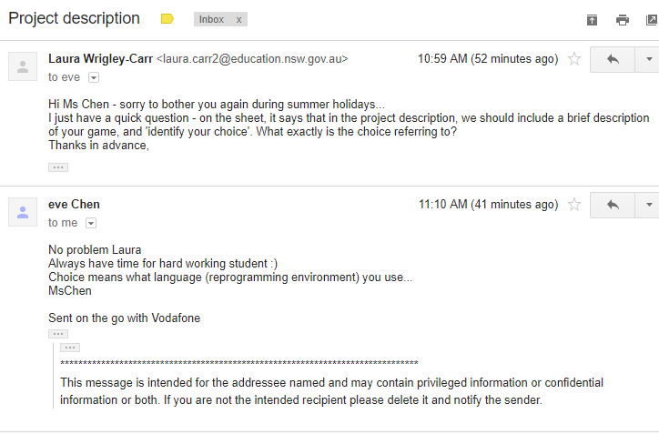
Thanks Ms Chen! I finished up my project description.
08/01/18
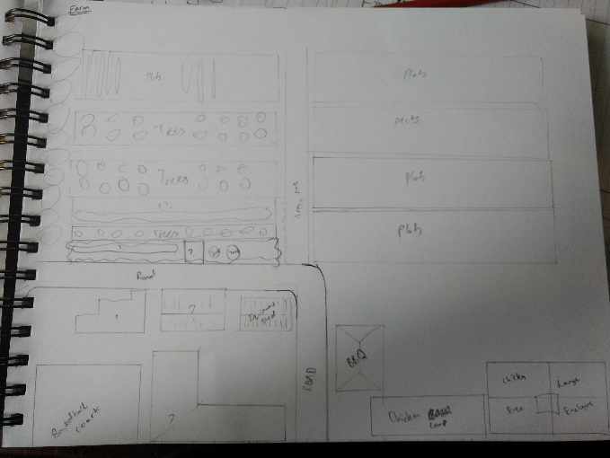
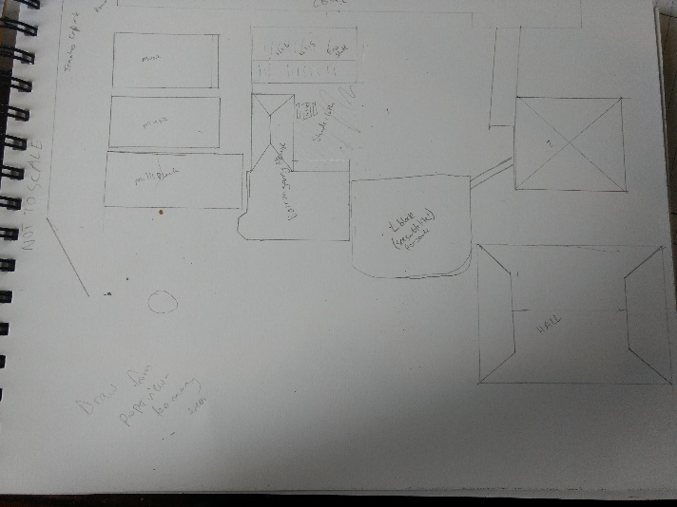
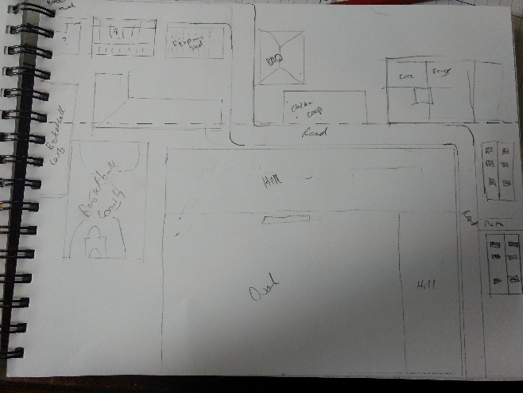
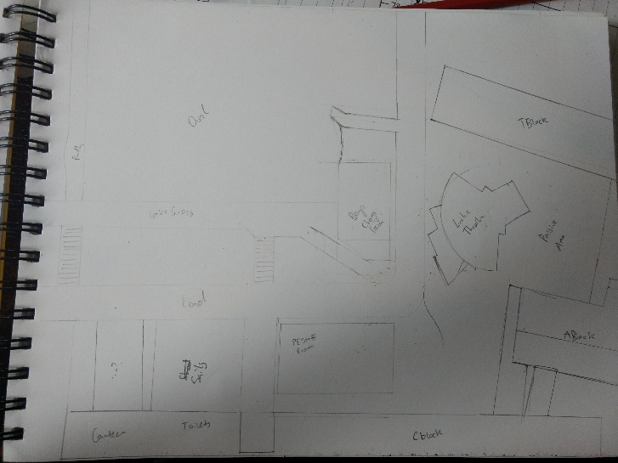
Today I drew up a map of James ruse. You may be thinking: You realise there are already maps of Ruse, right? Why on earth would you go to all the trouble to draw a map yourself? Well, yes there are, but they are really undetailed and they seem to think all students care about is the buildings (I mean, everyone cares about trees!! – right?). (They are also completely not to scale.) Therefore, I went on google maps and called up a satellite view of the school. You know, you never appreciate just how big the school is until you have to draw it. In order to get any proper level of detail, I had to separate the school into four sections and map them out individually. (See below)
10/01/18
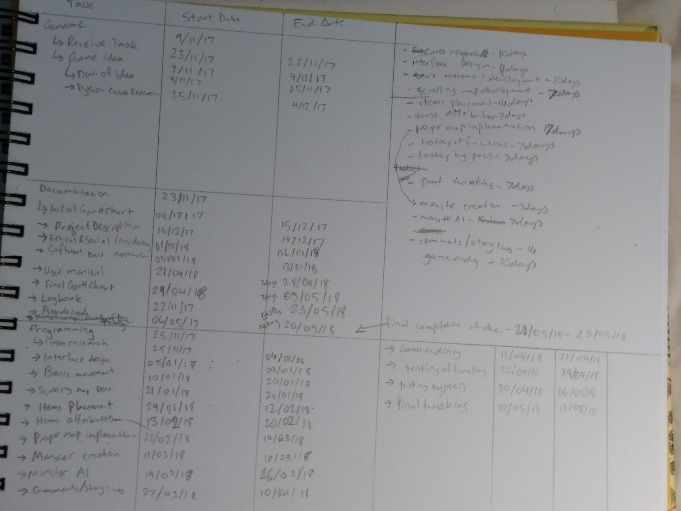
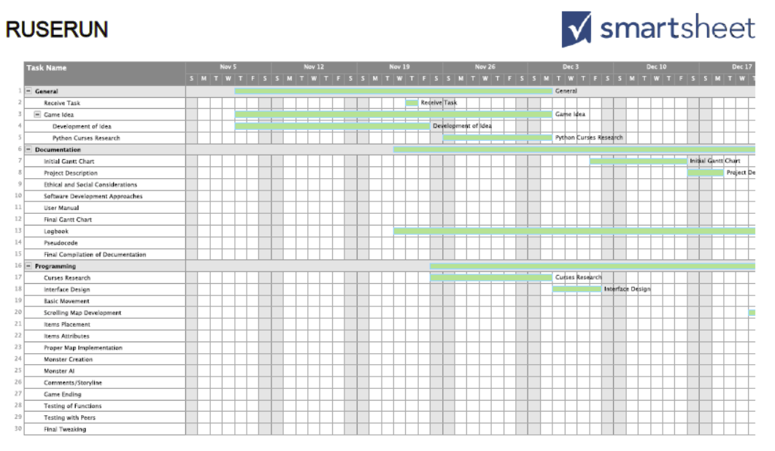
Today I finished my initial gantt chart. I had to switch to smartsheet, cause my initial choice wasn’t working properly. I first wrote everything down and then typed it all into the sheet. I then downloaded it as a pdf file so I can print it out and hand it in. (See below).

14/01/18
Today I continued with my coding. I had two aims for the day: firstly, to make the map a .txt file to allow for larger map sizes, and secondly, to make the @ unable to walk through walls (#) (It is seriously annoying!!). I did the quick thing first – I made the map a .txt file and made it load into the game as a string. Though it doesn’t seem to change anything now, it will really come in handy later when the map is really big.
Next, I tackled the larger job – making the @ unable to walk through walls. In order to do this, I added in a function to verify that the move is ‘legal’. To do this, it checks the character in the direction of the movement to see if it is a ‘.’ – otherwise, it can’t move through it. This worked out really well, and my second aim of the day was a success. (I’d put in a picture, but how exactly do you show with an image that a character can’t walk through walls? (If you can think of a way, please let me know – cause that’d be really cool!))
15/01/18
Today I worked on moving from the larger map into a room. It was actually pretty simple (well, it depends on your definition…) I first made a second map, called map2 (Aren’t my names creative!!). Then, I altered both maps so that they had a ‘+’ (a doorway) in the same place. When the character @ steps on one of them, the maps switch, so that it’s like they went through the doorway, and can no longer see the world outside. See pictures below…
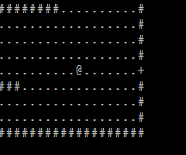
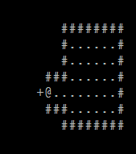
(Left is the main map, right is the smaller room)

15/01/18 (Pt.2)
I realise I already have a log for today, however, as I sat down to watch Netflix, I suddenly had the overwhelming urge to do some programming (weird…). Thus, I must once again report my progress.
The next thing I had to work on was the item allocation (yes, those annoying matrixes that don’t make any sense.) Because I didn’t understand Dads’ way, I decided to come up with a solution myself. The first thing I did was go through the pad and search for all the ‘.’ Spaces, which represented floor. I put all these into a list. I then used randint() to get a random selection of these, and put that selection into another list. This second list would be where an item would go. Also, since it was bugging me, I shortened the verify() function (that’s the one that checks if there’s a wall in the way). It was taking way too long to scroll through… I’m afraid there’re no more pics to see, as nothing has made it onto the screen as of yet. Tomorrow, I’ll work on making a few different items, so that I can place them in the rooms.
Btw, have you noticed that I accidentally did exactly what Dad had recommended I do? I found all the floor squares and made them into an array (or list), and then translated that back into the map. Odd how I accidentally to do that without realising….
22/01/18
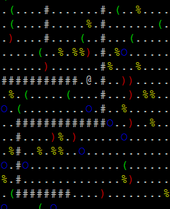
I haven’t really done that much of my game for a while now (I was at a camp), but now I’m back and all set to continue!! Today I created a few other items, and made subclasses for Weaponry, armour and food. This in itself was a cinch. The hard part came when I tried to implement colours for the different items… I had no idea why it wasn’t working, but after a lot of research, I realised you need to group the colours into pairs of foreground (the text) and background. After implementing this, I found that after the character went over an item, it changed to white.
This made a lot of sense, as before I’d just automatically made all the characters white, not having had any reason to change it. So when the screen replaced the @ with whatever symbol was previously in that place, it would automatically change it to white. In order to fix this, I had the program record both the character and the colour, so that it could re-implement this later.
See left…
Obviously, there wouldn’t really be that many items in the vicinity in an actual game. I just created more so I could check the spread of items.
25/01/18
Today I began making the proper map for the game. I decided to use an application called REXpaint, which is a free app used to make ASCII art, but it’s also used by people who make roguelikes. Of course, most don’t as there aren’t many roguelikes that use static maps. But it’s a really good application, and it made my life a lot easier.
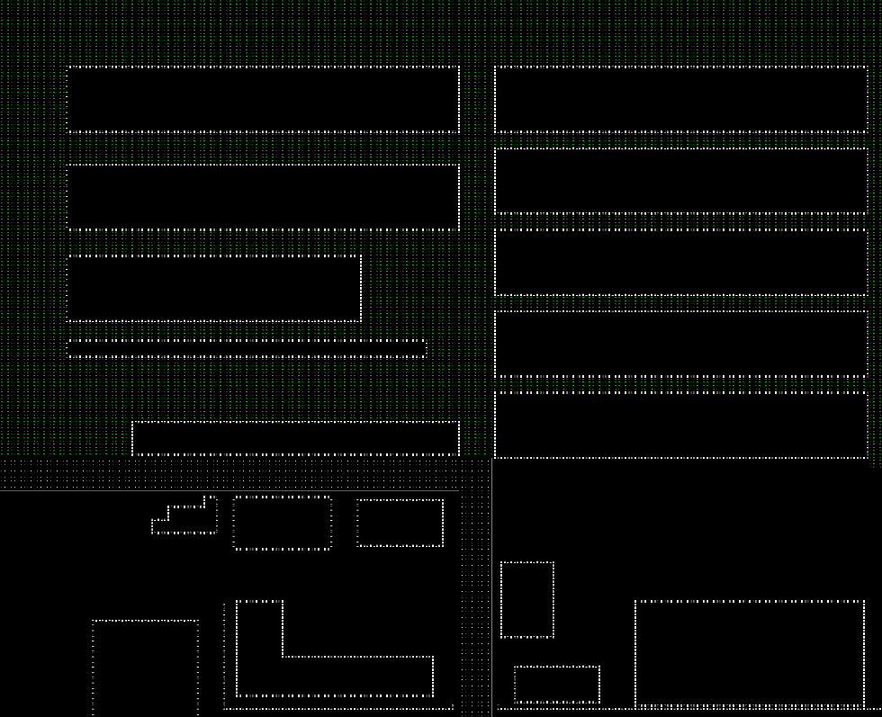
I did run into a problem with the Unicode characters I was using, and I would have needed to jump through a lot of hoops in order to use them, so I decided to just do without, as it would make the game harder to use on other computers.
So far I’ve just got the general layout, but I just wanted to get it generally working so that I can build from there.d
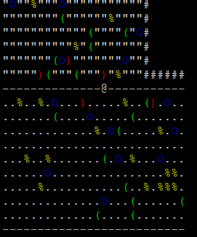
26/01/18
Today I implemented the larger map into the game. It was pretty simple – I just needed to make the pad larger, and begin reading the farm.txt file instead of map.txt. I also implemented the items allocation, and added the allocation on the grass as well as the asphalt.
So on the whole, I didn’t actually get all that much done today, but I guess we all need a day off now and then!

03/02/18
Today I added picking items up & adding them to the inventory. Firstly, I had to alter itemAdd(), so that it would store in a string the character that was previously in the spot where the item goes, so that when you put it back, it knows what to put down. I then added a get() function, to pick up an item when the player presses ‘g’ (I might later add auto-pickup for some items – depending on how much time I have). This is stored in the list character.inventory, which is part of the character object. Tomorrow, I’ll add viewing the inventory, and putting items down.
Because it was bothering me, I also made a class for colours, and for the levels – no more annoying global variables!! I can also now work at school, using my phone as a hotspot. (don’t you hate it when the school firewall doesn’t allow you to use ssh clients to access external computers? I mean, how many students would even bother doing something like that? It’s entirely illogical to block it.)
04/02/18
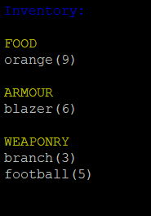
Today I added being able to show the inventory to the user. To do this, I made a new window that would completely cover the other windows. When I wanted this window to pop up, I ‘touch’ all of the window (basically, make the computer think it’s been altered), and then refresh() it. This makes curses automatically bring it to the front, so that you can’t see the other windows any more. I then simply printed the inventory, sorted by type of item (i.e. armour, weaponry and food), onto the window.
I ran into a bit of a problem with the enter key. I spent the longest time trying to figure out what it’s output was, so that I could getch() it. Each website said a different thing, so I had literally nothing to go on. I eventually made use of my colourtest.py script, and just dumped in a whole bunch of possibilities, getting nowhere. I then had the bright idea of :actually printing out the input (brain the size of a planet, much?), and discovered that the enter key returned the actual string that you get when you press enter, as in the bit between line A and line B. That quickly solved the problem.
10/02/18
Today I went onto interface.py and promptly forgot all about what I’d been planning to do. The length of the document has gotten kind of (very) ridiculous. Therefore, I decided to do some spring cleaning (in summer, ‘cause better late than never!). I first made an interface class (something I’ve been meaning to do for a while now), and wrote in it all the commands I needed for interacting with the interface of my program (e.g. getting the character in spot (y, x), writing into one of the windows, etc.). I then took all of the functions in interface.py and split them off into separate .py files according to genre (for lack of a better word for it). These included item commands, movement, checking keystrokes, etc. Then I went through all of these new files, and changed all of the curses commands for my shiny, new Interface commands. Of course, when I ran it, it freaked out on a dozen points, due to typing errors, import errors, etc. but I now have it once again working smoothly and without complaint. This will make my life significantly easier. So basically, I didn’t actually get anything done today, just cleaned up my code a little. I’ll make some actual progress tomorrow.
11/02/18
Today I decided to do something about being able to actually view items. The idea is that when you’re looking at the inventory, you can select one of the items (by pressing the letter associated), and it will open a menu for that item. Anyway, I tried a few different ways of doing this, and eventually decided to add an attribute to the items, which would be the next letter available in the alphabet. Additionally, when an item is put down, it’s letter is added to the list of available letters. At least, that’s the idea. I haven’t entirely got it working yet. Since I’m kind of tired, I think I’ll just work on it again next week.
18/02/18
Don’t you hate it when the answer to your problem is really obvious and but you can’t figure it out until someone else comes along and goes ‘over here, duh.’? ‘Cause I do!!!!! Today I was finally trying to figure out how on earth to do this open description thing and why it isn’t working. I was looking through this literally 10 line function for the best part of three hours, with a fine tooth comb, and came up with nothing. The function was perfectly fine! Eventually I gave in and came to Dad with my problem. He looked through the function and was like ‘Yeah, it’s fine. Have you tried looking at the place where you call this?’ Of course, I looked over there, and it turned out I’d added a clause there to stop it from crashing if there’s a wrong letter, and it wasn’t letting any of the letters through. I mean, come on! I’m planning on putting in a picture of the description page soon, but right now, all there is to see is a blank page saying the name of the item, so I’ll fill it up a little, and put one in with my next log entry.
21/02/18
I personally find it really hilarious when you’re doing something that’s logical to you (and if you explained it to somebody else, they’d understand to), but when you’re doing it, the uneducated populous looks at you really strangely. You know what I mean? (well, probably you don’t, cause I’m just rather odd sometimes). For the last few days, I’ve been pacing. Understand now? No? (sigh) Fine. I’ll explain.
As you know, my game is set at James Ruse. When I’m making the levels for my game, I need to have some kind of plan of the school to work from. The outside is pretty down pat (thanks, google maps!!), but sadly, google maps does not incorporate x-ray vision (there are also those pesky privacy laws to contend with). Therefore, in order to figure out the layout of the inside of the buildings, I have to roughly measure where everything is, and how things are spaced. Of course, I don’t just walk along, running a metre ruler along the ground (that would take forever, and frankly I’m not that dedicated.). Instead, I’ve devised a faster alternative – pacing. By walking with my natural gait and counting the steps, I can later figure out how long everything is. It won’t be an exact measurement, but it’s pretty good, and I only need it accurate to the half metre anyway. So, I’ve been walking up and down C block, drawing up approximate plans and noting down all the places the buildings join together. So far, I’ve only done the first floor of C block, but a lot of the staircases match up with those above or below, so it’ll make the rest a lot easier.

