Crawl
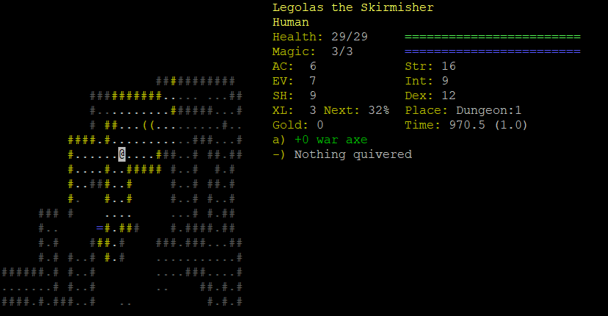
Key:
Walls: # (yellow in view or dark grey)
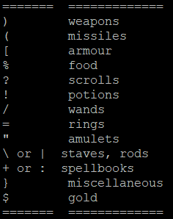
Floor: . (white in view or dark grey)
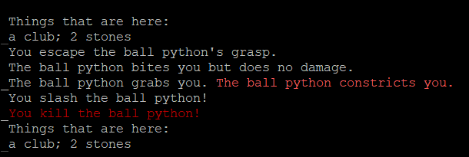
Down/Up stairs: > and < (white)

- Positives: Very good dialogue, whole game is very detailed (monster AI, items, etc.), Good use of colours to bring out certain features
- Negatives: Due to detail, can take a while to get used to – maybe tutorial would be helpful or simplify slightly at beginning – do not need that many stats. Help screen to complicated to be very helpful.
- Dialogue uses a variety of verbs in descriptions – e.g. slash, cut, (miss/closely miss)
- Dialogue describes what monster is holding – monsters hold stuff
- In fighting dialogue, each line is a turn
- Point of view (PoV) is very good for what you can see, helps focus on certain area, only within certain radius of @?

