1. Introduction
2. Objectives

* To solve a problem involving simplex tableau
* To transform the given tableau into canonical form
* To transform the given tableau into optimal form
* To get the optimal solution and value
* To check whether the problem is optimal or unbounded

1. Scope and Limitations

* The minimum number of variable input is 4
* The minimum number of constraint is 2
* The valid input should be in decimal form

1. The Program

Programming Language and/or Software used

The programming language used is Java and the software used is Netbeans IDE.

Design and Development

The design can be seen in the terminal of Netbeans IDE. The algorithm was created from scratch.

Operation

1. The program will ask the user for the number of variables they want to input.
2. The program will ask for the number of constraints.
3. The user will input the objective function followed by the constraints.
4. The program will automatically check if the user’s input is in canonical form, if not, the program will convert the tableau into canonical. The program will then attempt to get the optimal solution and value using the simplex algorithm.
5. Application

Sample Problems (at least five)

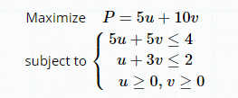

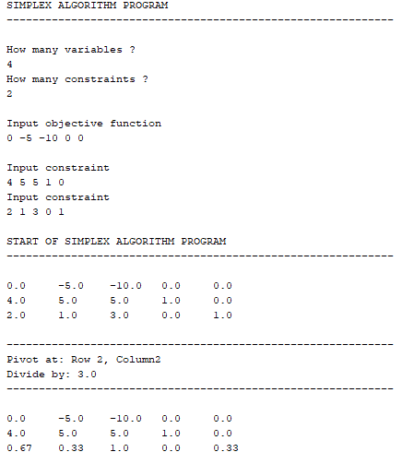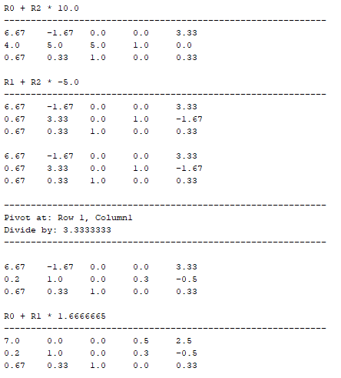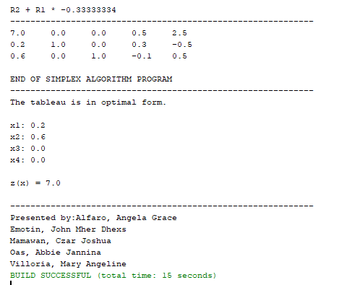

The given LPM has an objective of ‘ Maximization ‘ , converting it to its standard minimization form gives us the tableau of

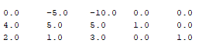

that the user entered. The program then solved for the optimal solution of the problem.

2 . 

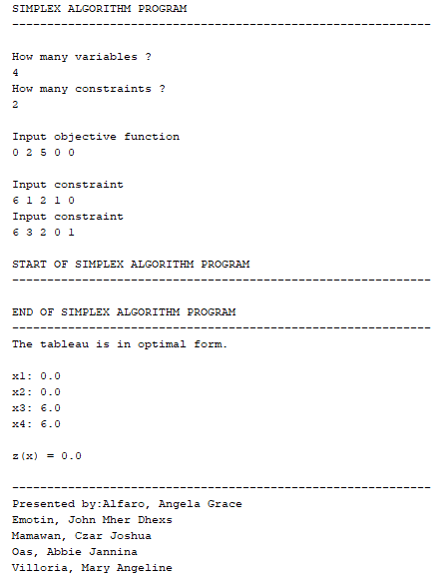

The problem is already in optimal form that is why the program automatically get the optimal value.

3.

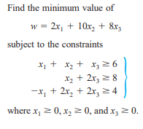

Discussion of Results of the Solution Obtained

Exercise Problems with answer

1. Evaluation and Recommendation