**Execute Nope App (Local). Should Install NODE**

1. Put 3 javaScript Files on the same directory for example financeApp/ then open command prompt or terminal and go to the directory financeApp/
2. Execute command “Node Server”

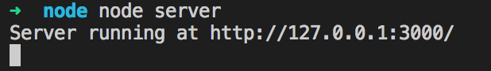

**Command CURL for testing API REST**

1. Open Command Prompt and execute this command

CURL <http://127.0.0.1:3000/symbol?symbol=value>

Example:

(This testing was with SSL y AAL values)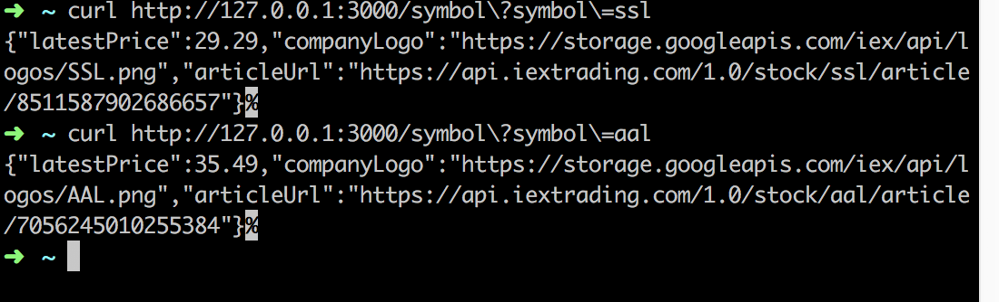

**After Testing,** go to the directory financeApp/ and then locate a new file named Log.txt.

In this file there´s all request log, check each value

Path: Path that user requested.

Request Time: request date and time in format DD/MM/YYYY HH:MM:SS.

Response Status Response to each request:

Status 200: Means Ok got the info.

Status 204: Means there is no answer, the request symbol doesn’t exist

Status 404: Means Invalid Path

