**Execute REATJS App**

1. Open Command Prompt on the App Folder (in my case SocialFeedApp/) it’s important to make sure that files package.json and src directory exists in this path.
2. Then execute npm install, this part is necessary to install all component needed to run the app.
3. Once finished, execute the app with the command npm start

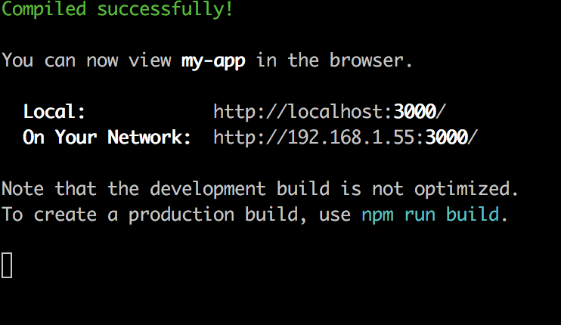

1. Then go to the URL indicated by the command prompt (By default npm start will open this page on the browser). By default, shows 5 post and each 4 minutes consume the service on the feedUrl. You can change each (Feed URL, Number of Post to display and UpdateInterval) value and check how it works.

