Machine Learning Engineering Bootcamp Capstone Project
Step 10: Deployment Architecture
Capstone: Traffic Speed Prediction Using California PeMS Data
Repository: https://github.com/rarra21/Springboard

1. Production Goal and System Inputs/Outputs
The goal is to take the scaled prototype from Phase 1 into a production-ready architecture that can generate 60-minute-ahead traffic speed predictions from PeMS traffic sensor data. The main inputs are station_id, timestamp, flow, occupancy, speed, hour, and dayofweek. The main output is a predicted value for speed_60min_ahead, returned through an API or stored as a batch prediction file.

2. Major Components and Data Flow
- Data ingestion: PeMS CSV/API/database feed is collected on a scheduled basis.
- Data storage: raw data is stored in object storage; processed features and predictions are stored in versioned folders or database tables.
- Feature pipeline: validates schema, handles missing values, creates time features, scales numeric variables, and encodes categorical fields.
- Training pipeline: runs time-series cross-validation, hyperparameter tuning, model evaluation, and artifact creation.
- Deployment service: a Flask or FastAPI REST endpoint loads the approved model artifact and returns live predictions.
- Monitoring: tracks request volume, latency, errors, data drift, and prediction quality once labels become available.

3. Architecture Decisions
Decision | Selected Approach | Justification
Model serving | FastAPI or Flask REST API | Simple, low-cost, and suitable for prototype-to-production deployment.
Data processing | Pandas for small jobs; PySpark for larger PeMS files | Allows the same pipeline to scale from sample data to larger datasets.
Model artifact | Joblib .pkl plus versioned metrics | Easy to load, rollback, and compare across model versions.
Validation | TimeSeriesSplit and holdout future data | Prevents future-data leakage in a forecasting problem.
Monitoring | Logs, latency, error rate, drift, MAE/RMSE when labels arrive | Keeps the deployed model reliable after launch.

4. Model Lifecycle, Retraining, and Evaluation
The model is retrained on a fixed monthly schedule and also when monitoring detects meaningful drift or degraded performance. Retraining uses newly labeled PeMS observations, including historical sensor readings and the corresponding 60-minute-ahead speed target. A retrained model is evaluated with MAE, RMSE, R2, correlation, training time, prediction time, and model size. The new model is promoted only if it performs at least as well as the currently deployed model on a future holdout period. Otherwise, the current model remains active.

5. Monitoring, Debugging, Edge Cases, and Cost
The deployed system will log every prediction request, input schema validation result, response latency, API errors, and model version. Edge cases include missing sensors, invalid timestamps, unexpected feature ranges, API downtime, and sudden traffic pattern shifts due to accidents, construction, holidays, or weather. The system should reject invalid inputs with clear errors, use fallback rules for missing values, and keep the previous approved model available for rollback. For a bootcamp prototype, the cost is minimal and can run locally or on a small cloud instance. A basic production version would require object storage, a small API service, scheduled training jobs, and monitoring, with an estimated implementation timeline of 1-2 weeks for a simple version and 4-6 weeks for a stronger MLOps version.

6. Architecture Diagram
Figure 1 shows the proposed deployment architecture and lifecycle for the traffic-speed prediction system.
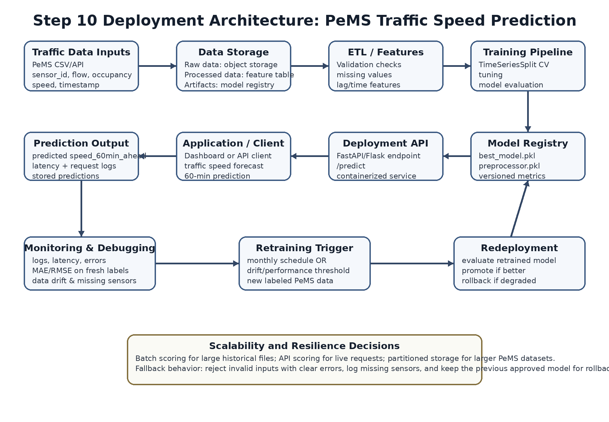
Figure 1. Deployment architecture for PeMS traffic-speed prediction, including data ingestion, storage, feature processing, training, serving, monitoring, retraining, and redeployment.

