Machine Learning Engineering Bootcamp
Capstone Project - Step 11
Deployment Implementation
Project: Traffic Speed Prediction Using California PeMS Data
Repository folder: Step11_Deployment_Implementation

1. Production Application Overview
This step converts the traffic-speed prediction prototype into a production-style application. The implementation includes a trained scikit-learn model artifact, a Flask REST API, a simple web UI, structured logging, tests, Docker containerization, and clear run instructions. The application predicts traffic speed 60 minutes ahead using PeMS traffic sensor features.

2. Major Components
Data pipeline: The sample PeMS dataset is stored in data/sample_pems_data_small.csv. The training script loads the dataset, validates fields, applies preprocessing, tunes an SVR model, and saves the final model artifact.
Model artifact: The trained pipeline is stored as models/traffic_speed_svr_pipeline.pkl. Model metadata and training metrics are stored in models/model_metrics.json.
REST API: The Flask application exposes /health, /model-info, and /predict endpoints. The API accepts JSON input and returns the predicted speed 60 minutes ahead.
Simple UI: The root route provides a basic HTML form for manually entering traffic sensor values and receiving a prediction.
Logging: The application writes successful predictions and errors to logs/app.log, including latency, payload, prediction, and exception details.
Containerization: The Dockerfile packages the code, dependencies, model training process, API, and UI into a portable container served with Gunicorn.

3. Architecture Diagram
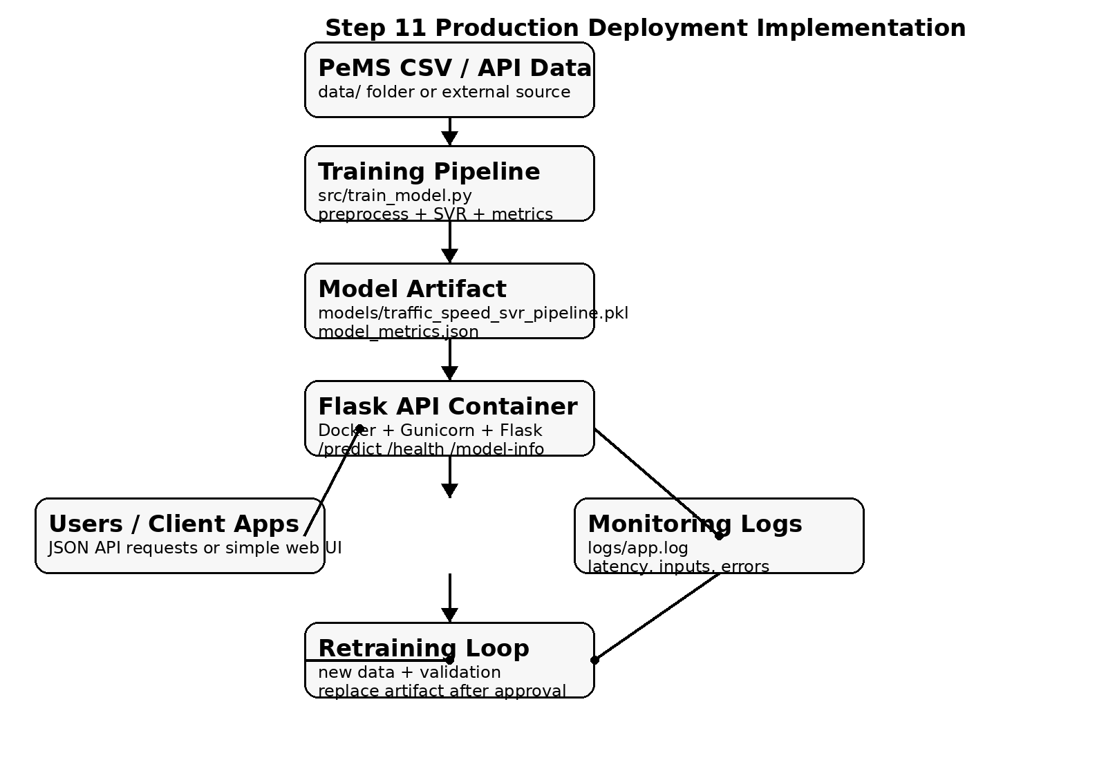
Figure 1. Production deployment implementation for the PeMS traffic-speed prediction application.

4. API Design
Endpoint | Method | Purpose
/health | GET | Checks whether the service is running and the model is loaded.
/model-info | GET | Returns target, features, model parameters, row count, and training metrics.
/predict | POST | Accepts station_id, flow, occupancy, speed, hour, and dayofweek and returns a 60-minute-ahead speed prediction.
/ | GET | Displays a simple browser-based form for UI testing.

5. Example Prediction Request
curl -X POST http://localhost:8000/predict \
-H "Content-Type: application/json" \
-d '{"station_id":"1001","flow":120,"occupancy":0.08,"speed":60,"hour":8,"dayofweek":2}'

6. Monitoring, Debugging, and Error Handling
The application validates required fields, numeric ranges, and invalid payloads before prediction. Valid predictions and errors are logged with latency to support monitoring and debugging. The /health endpoint can be used by a load balancer, container platform, or monitoring tool to confirm that the service is online.

7. Containerization and Deployment
The application is containerized with Docker. The Docker image installs dependencies, trains the model during build, exposes port 8000, and runs the Flask app with Gunicorn. This makes the application portable across local machines and cloud platforms such as AWS ECS/Fargate, Google Cloud Run, Azure Container Apps, or Kubernetes.

8. How to Run
- pip install -r requirements.txt
- python src/train_model.py
- python app/main.py
- Open http://localhost:8000
- Or run with Docker: docker build -t pems-traffic-api . && docker run -p 8000:8000 pems-traffic-api
- Run tests with: pytest tests/

9. Production Readiness Summary
This implementation satisfies the Step 11 criteria by providing a production repository structure, working API, simple UI, Docker containerization, data storage and transport, model artifact storage, logging, tests, and README instructions. The design can be extended with a cloud database, model registry, CI/CD pipeline, authentication, and automated retraining for a real production deployment.

