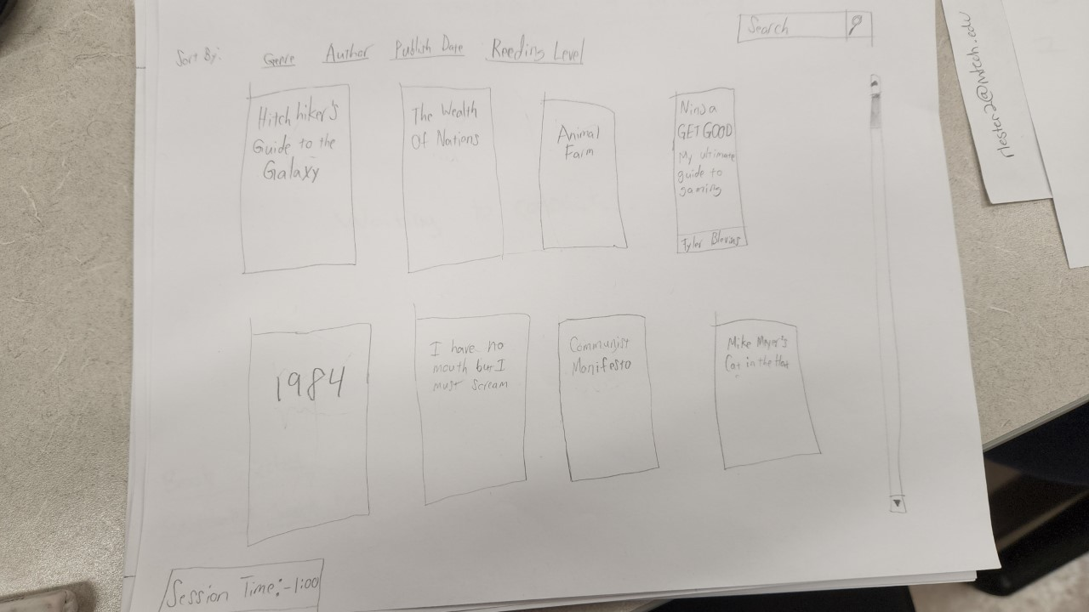

This is the inmates’ view after logging in. They are able to view a catalogue of available books to read, as well as search for specific books. They are also able to sort by various categories such as genre of books, favorite authors, publish date for if they were wanting to read older books, and reading level in case the child is too young to understand more complex concepts.

My idea for this was based on things like the Kindle library UI, where you are able to see a list of book covers.

The allocated session time is also able to be viewed at the bottom left of the screen.