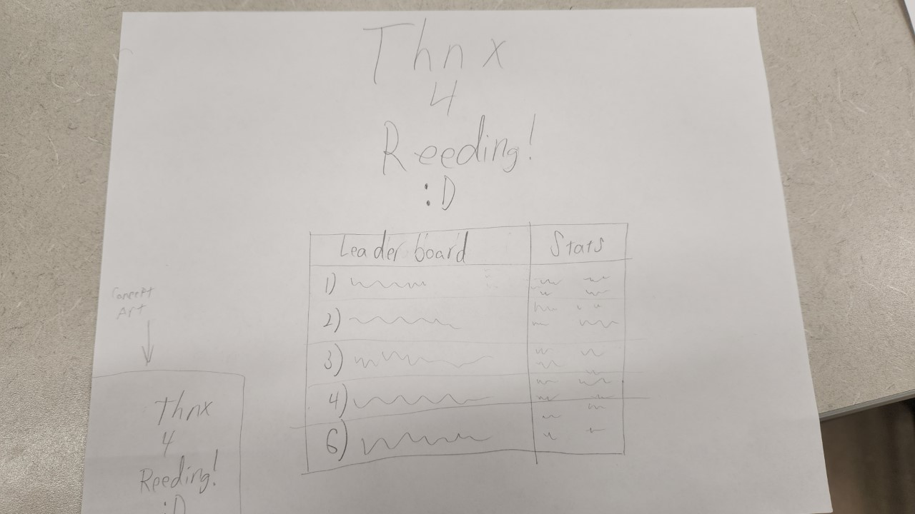

This is the screen the inmates will be brought to after logging out. The leaderboard will track things such as pages/words read, number of breaks taken, and possibly number of books read, if the inmate was reading short enough books. This is meant to entice the inmates to continue reading and attempting to boost their rankings on the leaderboard if they so choose.

The chart will show the top 5 people and their stats, and below it will be the currently signed in inmate’s rank. They will be able to scroll through the full list of inmates that have read at least once on the application.

After a few minutes, the screen will go back to the login page for the next batch of readers.