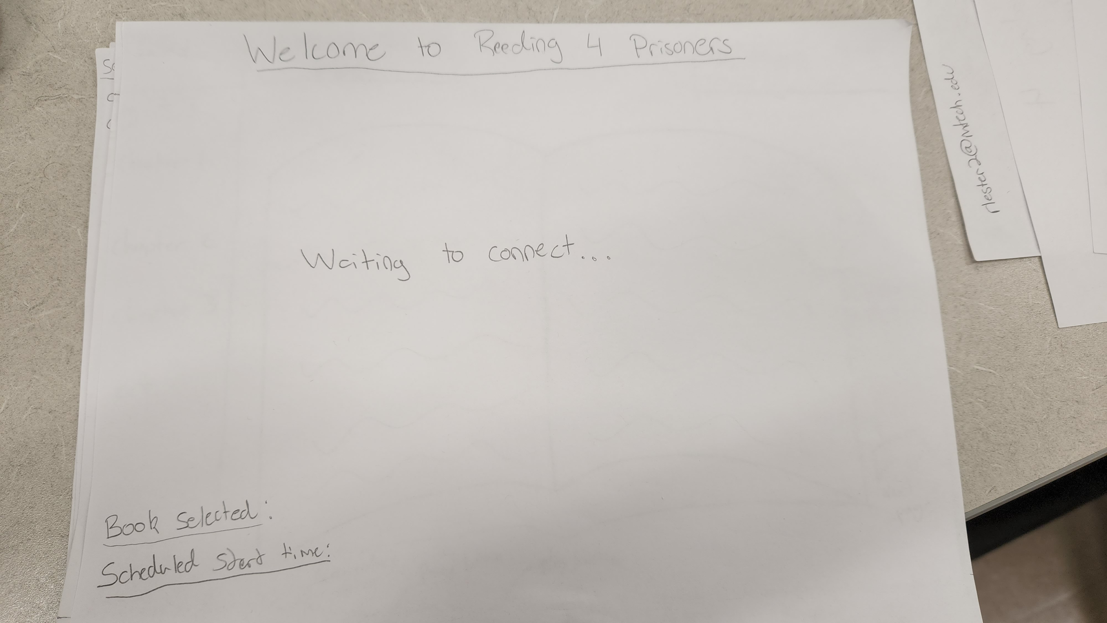

This is the screen that Family members see once they login to their account, which is waiting for the prisoner’s end to make the “call” to begin the connection.

Displayed on the screen is the text “waiting to connect” with the animated ellipses to show that it is actively looking for the connection

The screen also shows what book is currently selected (by the inmate) and what time the meeting is scheduled to start.