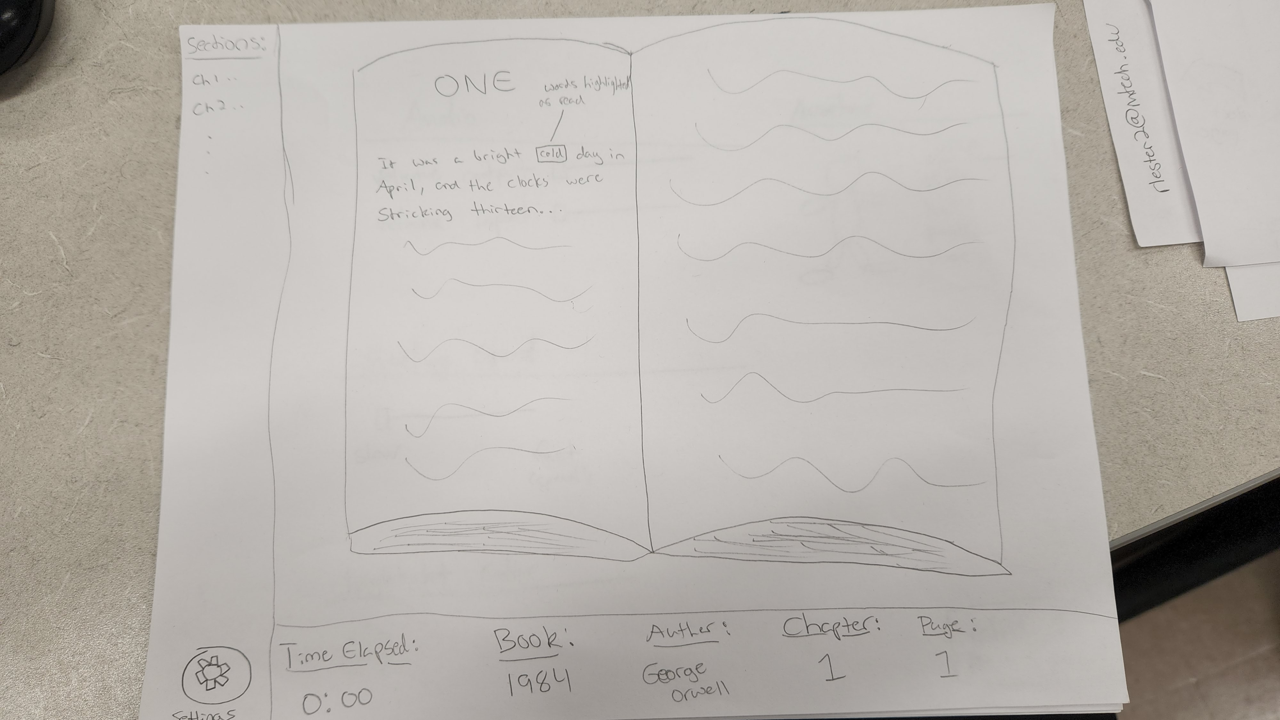

This is the Family’s side of the reading program where they watch their assigned inmate read the selected book.

On the left side of the screen, there is a section to show the sections or chapters of the book, should they want to look back for whatever reason.

Below the sections is the settings button, which when pressed, brings up the settings screen.

Along the bottom of the screen is some displayed information, including Time elapsed, the current book, the author of that book, the chapter or section, and the page number.

There is a physical animation of a book in the main part of the screen, where the current word is highlighted, and the pages turn once the inmate reaches the end of the current page.