**Flow Chart**

1. Starts with login screen

2. Software detects account type and sends to corresponding screen

2a. Prisoners get to choose book

2b. Family is brought to waiting screen in the meantime

1. Once book is chosen, they are brought to similar screens to read the book

3a. Prisoners get option to pause & play where they are reading, as well as a commentary button to comment on previous passage

3b. Family can view the book and where they are reading at

1. Settings page is available once in the reading screen, allows for audio adjustments
2. When session is ended, you are brought to disconnect screen

**Login Screen**

* Has name of software front and center (with “:D” to uplift users obviously)
* Presents you with prompt to enter in your User ID and Password
* 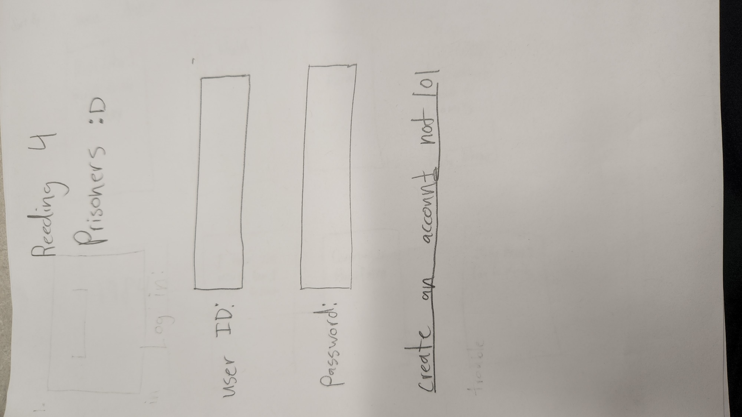It is assumed that accounts will be set up externally by the prison and thus account creation is not available as a feature

**Prisoner Reading Screen**

* Features an index on left hand side of the screen to easily jump to a specific page or chapter
* Diagram, text

  Description automatically generatedTime Elapsed counter in the upper right-hand side of the screen
* Book being read is front and center of the screen, with each word being said being highlighted in real time and a button to turn the page on the lower right-hand side of the book
* Settings button to access settings for audio adjustments
* End session button to end the reading session
* Pause and play buttons to stop reading and continue reading as needed
* Commentary button to speak freely about previously read passage
* Details regarding the book at the bottom of the screen; book title, author, chapter, and page number

**Settings**

* allows for audio adjustments: volume output & input
* Allows for adjustments to reading speed of the highlighter
* allows for adjustments to highlight color
* allows for creation of avatar ( so you can look dope while reading :cool_sunglasses: )
* 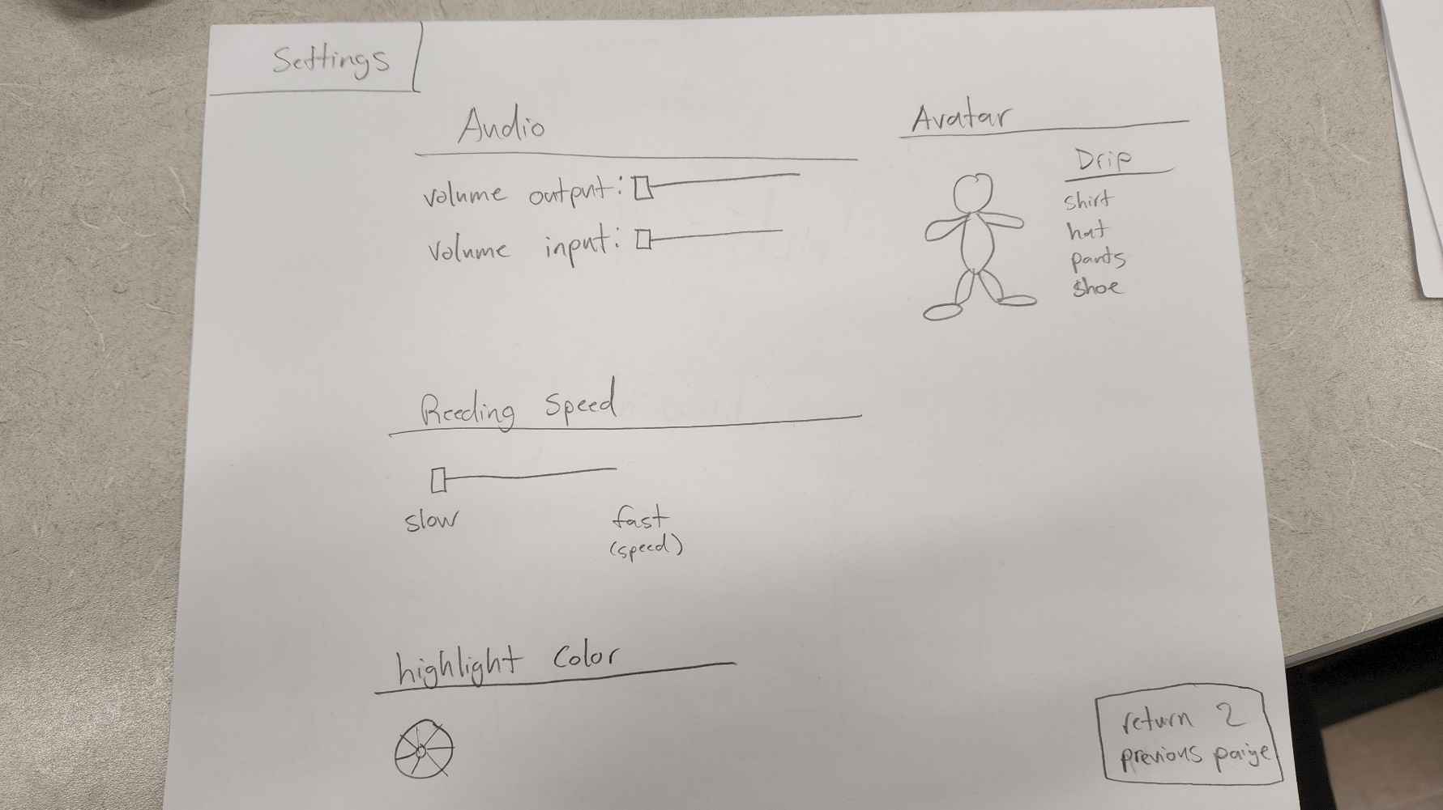has button in bottom right hand corner for returning to reading screen