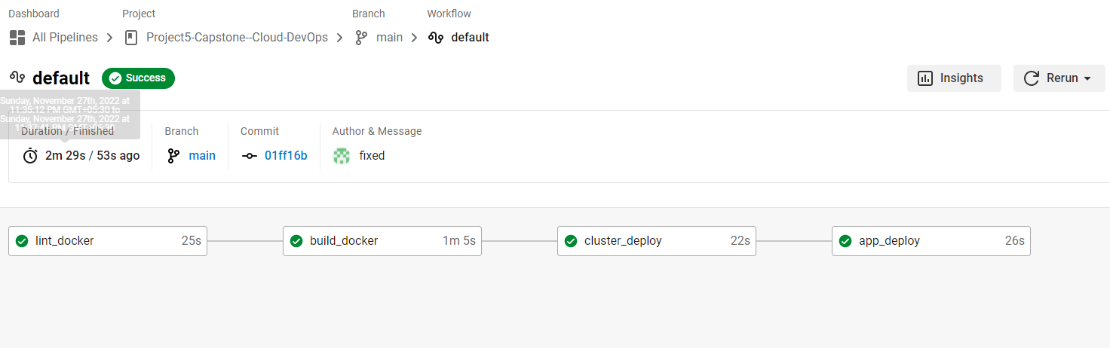

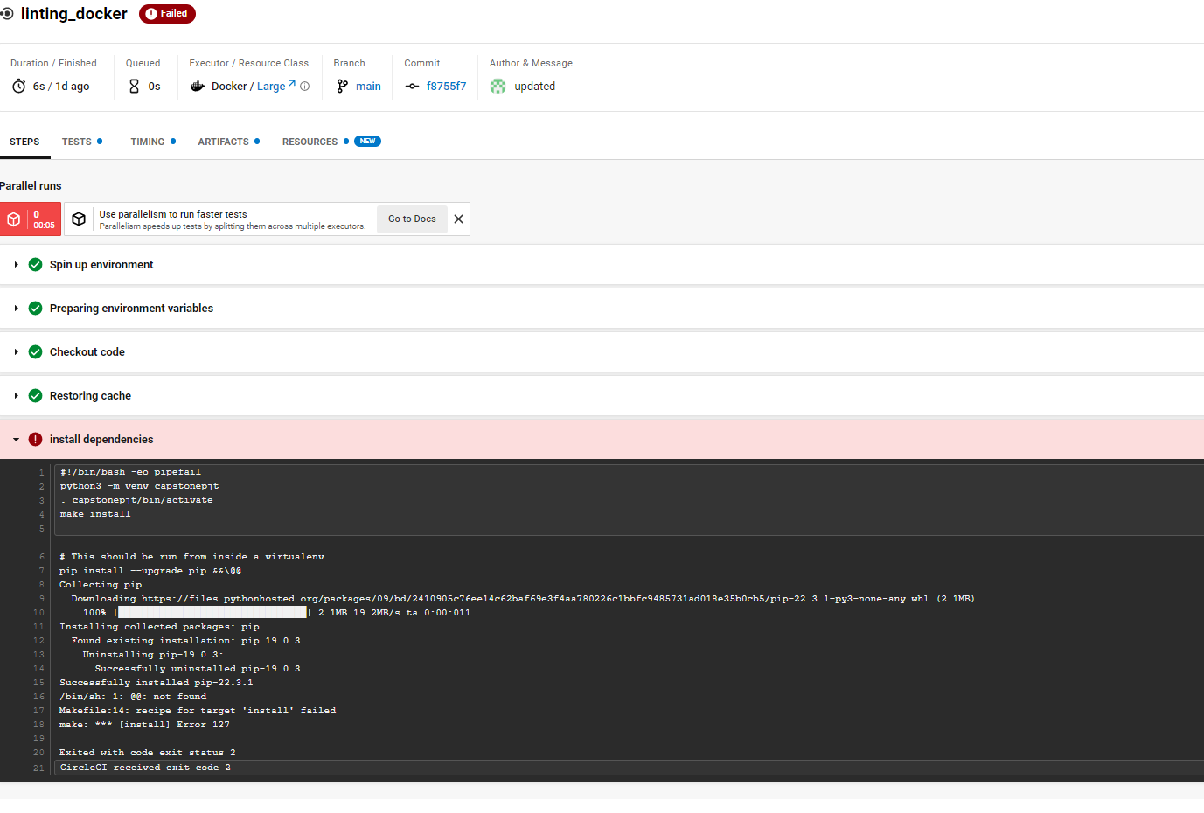

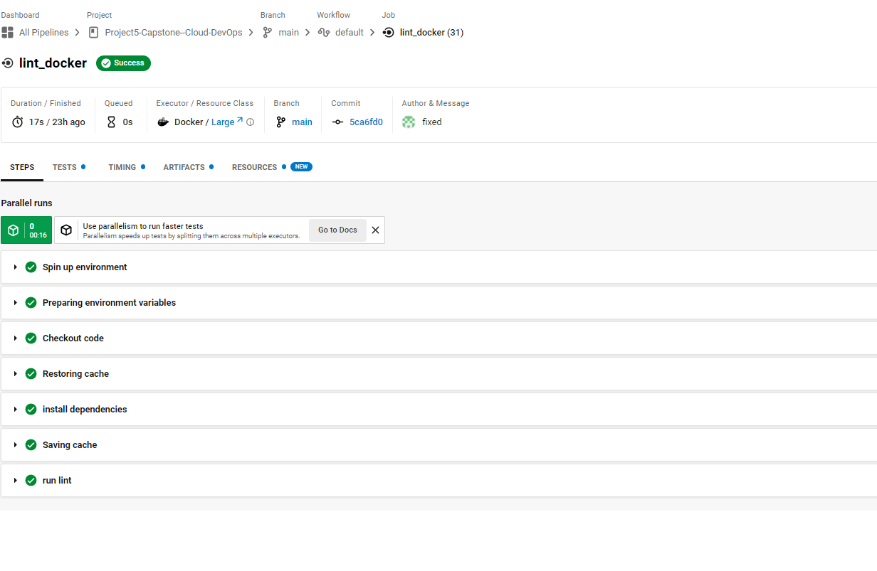

Docker Hub:

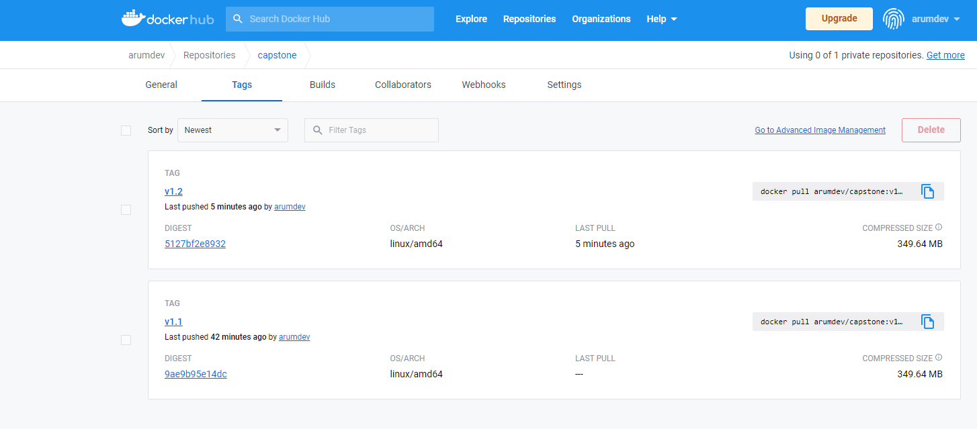

EC2 Instances:

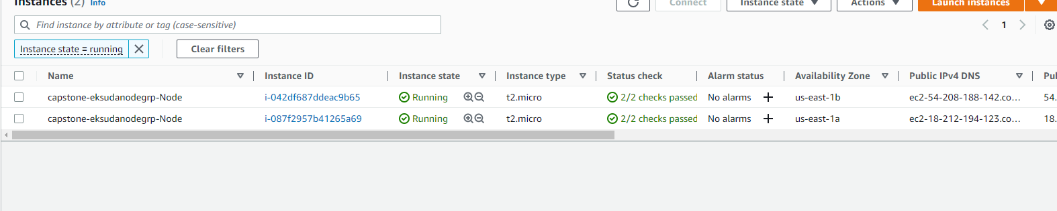

Load balancer:

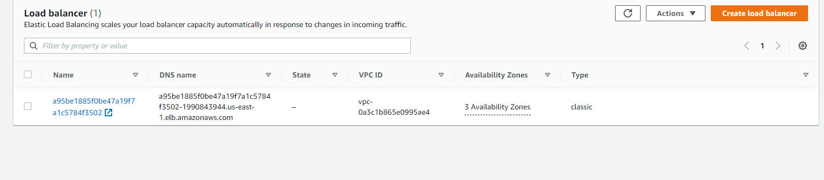

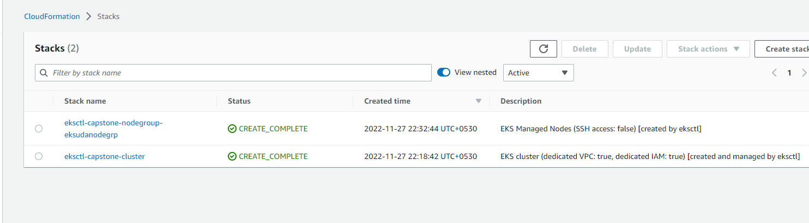

Cluster:

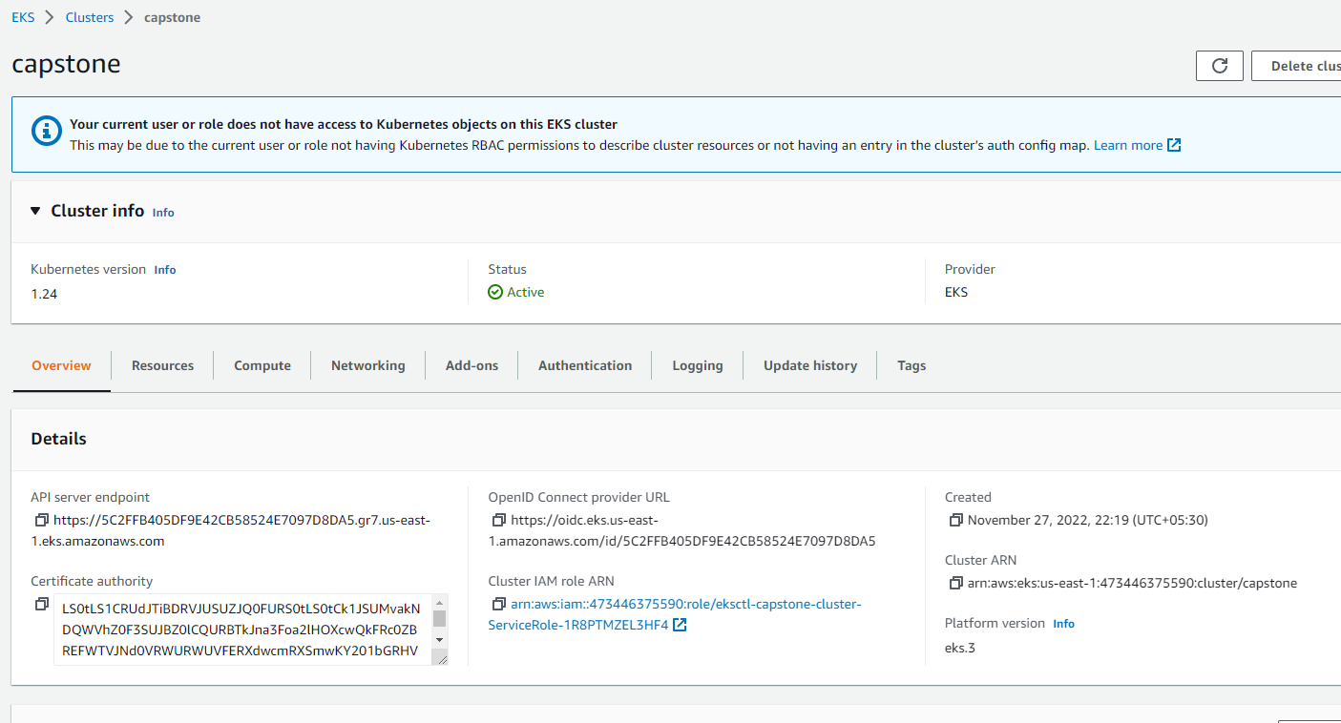

Project output:

<http://a95be1885f0be47a19f7a1c5784f3502-1990843944.us-east-1.elb.amazonaws.com:5000/>

