Part E - Polymorphism  
  
**Inheritance and Virtual Functions**

Workshop 9

In this workshop, you are to create an abstract base class out of an interface class and inherit it into two derived classes.

**Learning Outcomes**

Upon successful completion of this workshop, you will have demonstrated the abilities to:

Inherit from a class

Define a virtual base class

Call derived class functions through a virtual base class call, demonstrating inclusion polymorphism

Reflect on the concepts learned in this workshop

**Submission Policy**

The *“in-lab”* portion is to be completed **during your assigned lab section**. It is to be completed and submitted by the end of the workshop. If you do not attend the workshop, you can submit the *“in-lab”* portion along with your *“at-home”* section (a 20% late deduction will be assessed). The *“at-home”* portion of the lab is **due the day before your next scheduled workshop**

All your work (all the files you create or modify) must contain your name, Seneca email and student number.

You are responsible to regularly backup your work.

**In-Lab:**

For the *in-lab* portion, we are going to create an **interface** (an **abstract base** class with **only pure virtual methods** in it) called Vehicle. Then we will inherit a class out of Vehiclecalled Car. A Carhas general capabilities of a car but does not implement any of the Vehicle’s pure virtual methods, therefore remaining abstract.

Finally we will inherit two classed out of Car: SportCar and PickupTruck that will encapsulate the capabilities of a sport car and a pickup truck and also implement all the pure virtual methods of the Vehicle class (see the class diagram below).

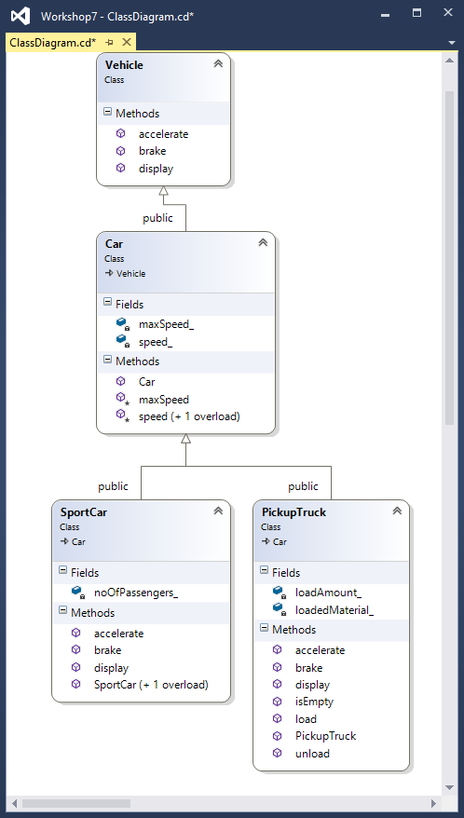

**Vehicle class:**

In Vehicle.h, add the following three member functions to the Vehicle class as pure virtual methods. By adding a virtual to the type and “**= 0**” to the end of prototype: virtual type functionName(...) = 0;

|  |
| --- |
| void accelerate();  void brake();  std::ostream& display(std::ostream& ostr) const; |

*Note that interfaces do not have “cpp” files since all their methods are pure virtual.*

**Car class:**

In Car.h and Car.cpp, complete the code of the class named Car that holds general information about a car. Car is inherited from Vehicle.

Private members:

int speed_;

int maxSpeed_;

Protected members:

void speed(int value);

* Sets the speed_ attribute to the incoming value.
* If the value is greater than maxSpeed_ attribute or less than **0**, then values are corrected to maxSpeed_ and **0** respectively.

int maxSpeed() const;

* Getter that returns the maxSpeed_ attribute.

Public members:

int speed() const;

* Returns the speed_ attribute.

Car constructor:

* Receives one argument to set the maxSpeed_ attribute. If this argument is not provided, it will set the maximum speed to **100**. It also sets the speed_ attribute to **0**.

**sportCar class:**

Complete the code for the class named SportCar to inherit from class Car and fully implement a sport car (in SportCar.h and SportCar.cpp).

Private members:

**int** noOfPassengers_;

Public members:

No argument constructor:

* Sets the number of passengers to 1.

Two integer argument constructor:

* Receives maximum speed and number of passengers; it passes the maximum speed value to its base class (Car) constructor and sets the number of passengers to the incoming value.

void accelerate();

* Implementation of Vehicle’s pure virtual method.
* Adds 40 kilometers to the speed.

void brake();

* Reduces the speed by 10 kilometers

ostream& display(ostream& ostr) const;

* Prints to ostr one of the following messages: “This sport car is carrying Pnum passengers and is traveling at a speed of Snum km/h.” if the speed is greater than zero OR “This sport car is carrying Pnum passengers and is parked.” if the speed is zero (where Pnum is number of passengers and Snum is the speed).

**PickupTruck Class:**

Complete the code of the class named PickupTruk (in files PickupTruck.h and PickupTruck.cpp) to inherit a Car and fully implement a pickup truck.

Private members:

**int** loadAmount_;

* The load amount in kilograms

**char** loadedMaterial_[**31**];

* The loaded material name.

Public members:

PickupTruck();

* Sets the loadAmount_ attribute to zero and the loadecMaterial_ to an empty C-style string.

**void** load(**const** **char**\* loadedMaterial, **int** loadAmount);

* Sets the two corresponding attributes to the incoming values through the argument list.

**void** unload();

* Sets the loadAmmount_ attribute to zero.

**bool** isEmpty() **const**;

* Returns true if the loadAmmount_ attribute is zero.

**void** accelerate();

* Adds 20 kilometers to the speed.

**void** brake();

* Reduces the speed by 5 kilometers

ostream& display(ostream& ostr) **const**;

* If the truck is not carrying any load, (isEmpty() is true), it prints to ostr “This pickup truck is not carrying any load”, otherwise it prints “This pickup truck is carrying Lnum kgs of Lname”. Then, if the speed is greater than zero it prints “, traveling at the speed of Snum km/h.”; if the speed is zero, it prints “and is parked.” (Where Lnum is load amount, Lname is loaded material and Snum is the speed.)

**w9_in_lab.cpp:**

Add two stand-alone, helper functions to this file called Drive and Stop that accept a reference to a Car as an argument:

Drive:

* Accelerates and then brakes the car. Then it will display the car.

Stop:

* Keeps breaking until the speed of the car is zero. Then it will display the car.

|  |
| --- |
| **#include** <iostream>  **#include** "SportCar.h"  **#include** "PickupTruck.h"  **using** namespace std;  **using** namespace sict;  **int** main()  {  SportCar Tesla(**240**, **2**);  PickupTruck Ford;  Tesla.display(cout) << endl;  Ford.display(cout) << endl;  Ford.load("Bricks", **3500**);  Drive(Tesla);  Drive(Ford);  Stop(Tesla);  Stop(Ford);  Ford.unload();  Tesla.display(cout) << endl;  Ford.display(cout) << endl;  **return** **0**;  } |
| This sport car is carrying 2 passengers and is parked.  This pickup truck is not carrying any load and is parked.  This sport car is carrying 2 passengers and is traveling at a speed of 30 km/h.  This pickup truck is carrying 3500 kgs of Bricks, traveling at the speed of 15 km/h.  This sport car is carrying 2 passengers and is parked.  This pickup truck is carrying 3500 kgs of Bricks and is parked.  This sport car is carrying 2 passengers and is parked.  This pickup truck is not carrying any load and is parked. |

Compile the four classes with w9_in_lab.cpp and run the resulting program. The output should be exactly as above.

Note how in drive and stop, the latest versions of accelerate, brake and display are called.

**in-lab SUBMISSION (70%)**

To submit the *in-lab* section, demonstrate execution of your program with the exact output as example above. Upload the four classes and w9_in_lab.cpp to your matrix account. Compile and run your code and make sure everything works properly. To submit, run the following script from your account (and follow the instructions):

**~profname.proflastname/submit w9_in_lab <ENTER>**

**At Home(30%)**

**Overloading operators for abstract base classes Creating Driver Class to use a car (Virtuals)**

To begin the *at-home* section, copy all your *in-lab* files, except for w9_in_lab.cpp, to the at_home project directory. Then overload the operator<< for the Car class, so the Car class cat be printed with ostream. In the implementation of operator overload for ostream, call and return the display method inherited from the Vehicle, passing the ostream argument through it.

Create a Driver class representing a driver of a car (in Driver.h and Driver.cpp). The Driver class should have the following specs:

Private members:

**char** name_[**31**];

* C-style character string to hold the drivers name.

Car& car_;

* A reference to a Car that driver is going to drive.

Public members:

Driver(**const** char* name, Car& theCar);

* Two integer argument constructor: a C-style character string to set the name of the driver to, and a reference to a Car to initialize the car_ reference attribute with.
* Note that car_ must be initialized with theCar and not “set to”. In fact this is the only possible way and any other attempt to set the car_ reference to theCar, will cause compile error.

**void** drive();

* Accelerates, brakes and then shows the status of the driver (showStatus());

**void** stop();

* Keeps braking until car_ comes to a complete stop (speed() returns **0**).

**void** showStatus();

* Frist, displays the massage “Dname is driving this car.<newline>” and then it prints the car_ attribute using the overloaded operator<< and goes to new line (where Dname is the name of the Driver).

Test your class using the w9_at_home.cpp and make sure it works. Your Driver class together with w9_at_home.cpp must produce the output below:

|  |
| --- |
| **#include** <iostream>  **#include** "SportCar.h"  **#include** "PickupTruck.h"  **#include** "Driver.h"  **using namespace std;**  **using namespace sict;**  **int main()**  **{**  SportCar **tesla(240, 2);**  PickupTruck **ford;**  Driver **john(**"John"**, tesla);**  Driver **kim(**"Kim"**, ford);**  **cout << tesla << endl;**  **cout << ford << endl;**  **ford.load(**"Bricks"**, 3500);**  **john.drive();**  **kim.drive();**  **john.stop();**  **kim.stop();**  **cout << tesla << endl;**  **cout << ford << endl;**  **return 0;**  **}** |
| This sport car is carrying 2 passengers and is parked.  This pickup truck is not carrying any load and is parked.  This sport car is carrying 2 passengers and is traveling at a speed of 30 km/h.  This pickup truck is carrying 3500 kgs of Bricks, traveling at the speed of 15 km/h.  This sport car is carrying 2 passengers and is parked.  This pickup truck is carrying 3500 kgs of Bricks and is parked.  This sport car is carrying 2 passengers and is parked.  This pickup truck is not carrying any load and is parked. |

**AT-HOME SUBMISSION (20%) and REFLECTION (10%)**

Please provide brief answers to the following questions in a text file named **reflect.txt.**

1. Explain what virtual functions are.
2. What is the difference between virtual and pure virtual?
3. What are abstract classes and interfaces?

Use this workshop for you examples.

**SUBMISSION**

To test and demonstrate execution of your program use w9_at_home.cpp.

If not on matrix already, upload **all the classes** and **w9_at_home.cpp** to your matrix account. Compile and run your code and make sure everything works properly.

Then run the following script from your account (and follow the instructions):

**~profname.proflastname/submit w9_at_home <ENTER>**