Brief Squeak Tutorial

1. Download Squeak - http://www.squeak.org/
2. Extract all files to Desktop
3. Drag .image file (Squeak3.10.2-7179-basic.image) over .exe file (Squeak.exe)
You will see the following screen:
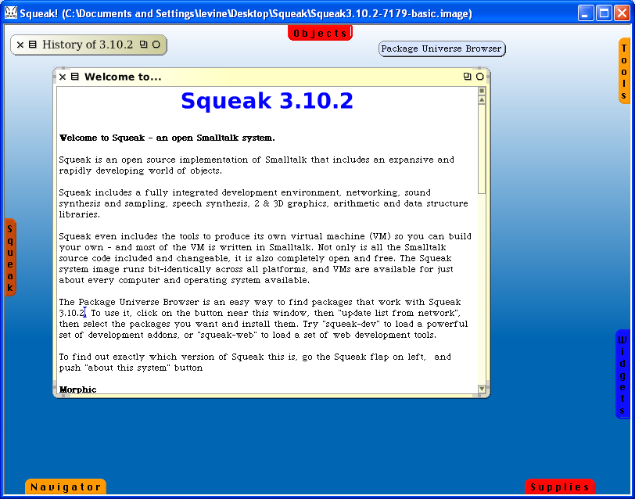

Minimize “Welcome” window and left mouse click on Tools tab, then drag the Browser to the center of the screen to open a System Browser for creating your classes for the project.

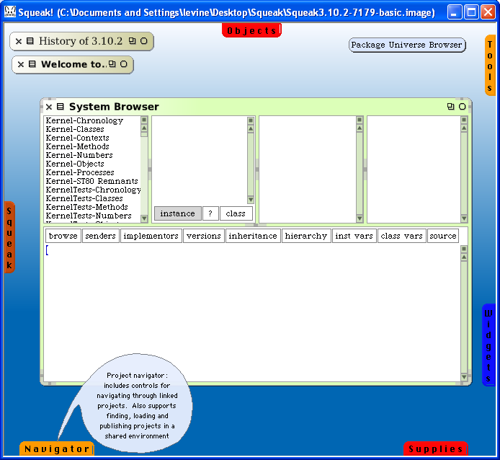
Class categories
Classes
Method categories
Methods
Pane used to type class and method definitions

Add new category for your CSC 868 project. Right click in class category area, add new item, type the new category in the popup window followed by Accept:

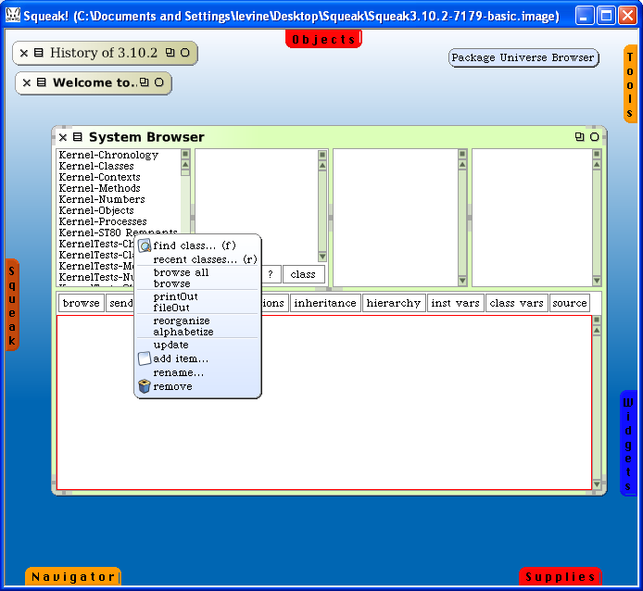

Note the template for adding a new class in the class definition pane on the bottom.

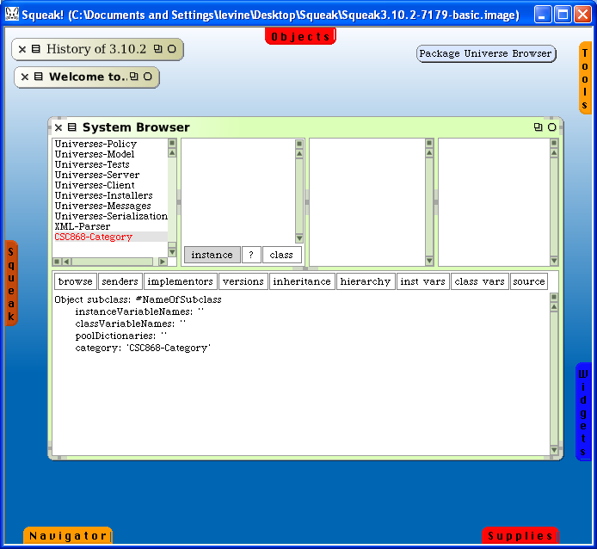
class definition template; edit this to add new class

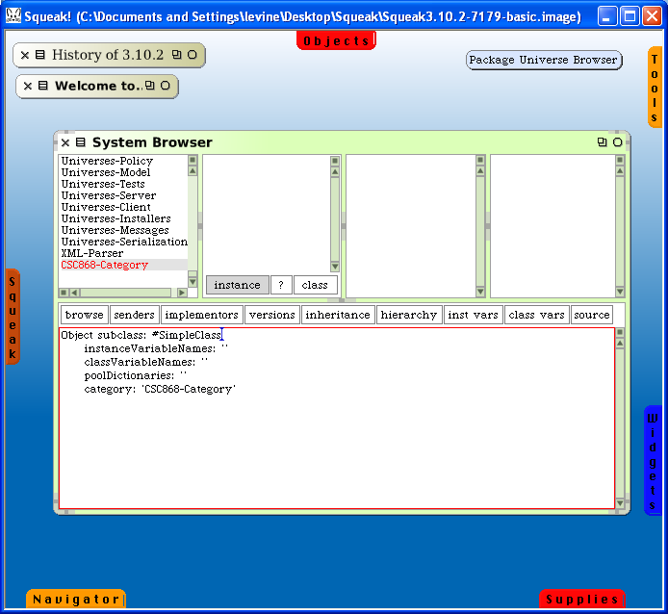

Install class by right clicking in bottom pane and selecting accept:

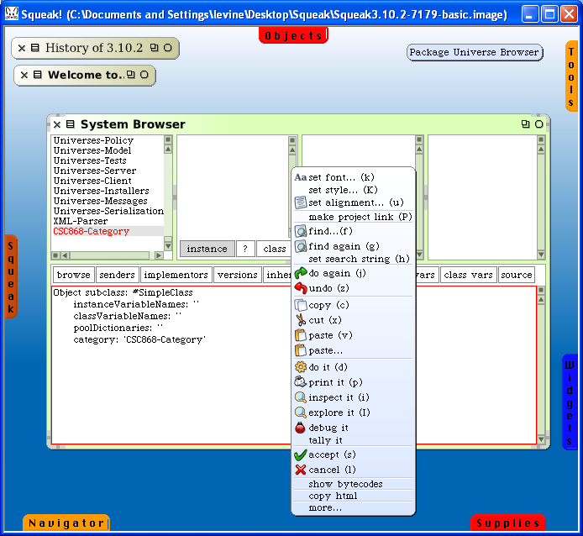

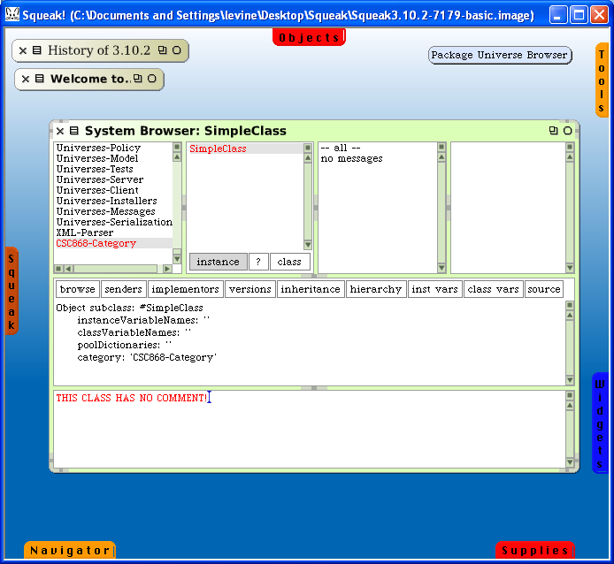
Add method category by right clicking in the method category pane and selecting new category followed by new…
Accept the new category.

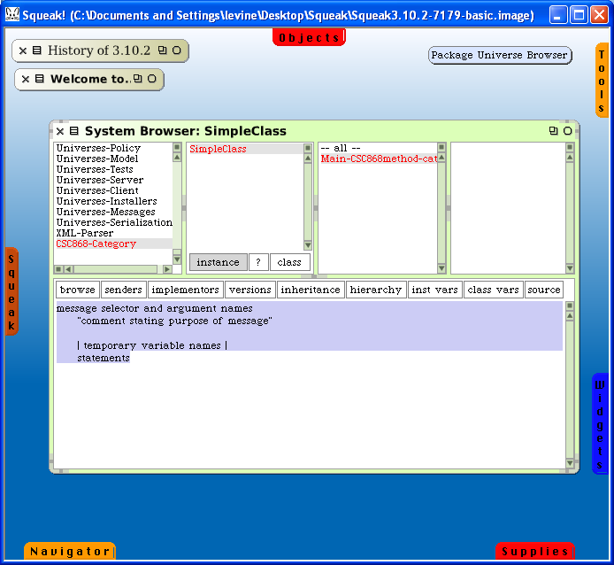

Note the method template that is displayed; you are ready to define a new method.
Add class or instance methods by selecting instance or class buttons. After you define the method(s), accept them.
Open Transcript and Workspace windows to test your code. To open windows, left click on Tools tab and drag the windows to the work area.

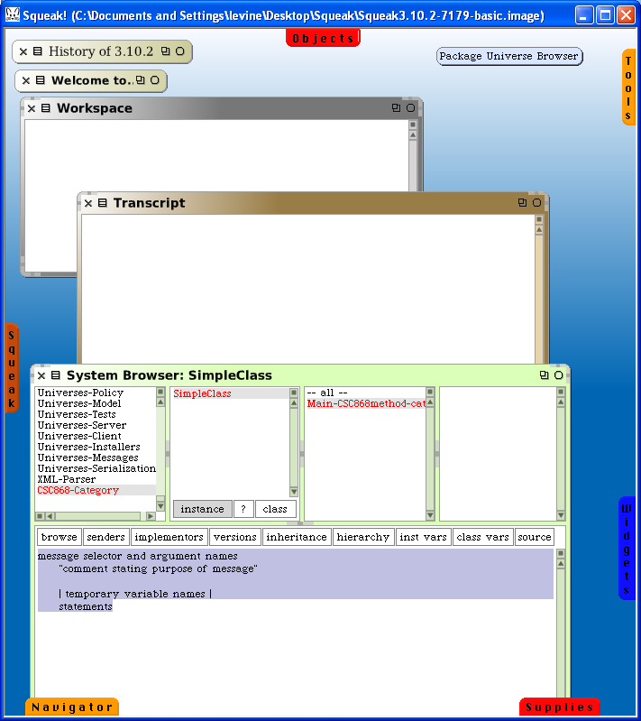

Use the Workspace window for testing. You can test by typing code in the window, select it, right click in window, select either do it to execute code (the object returned by the final expression evaluated is displayed in the Workspace window) or print it to execute code and print the result.
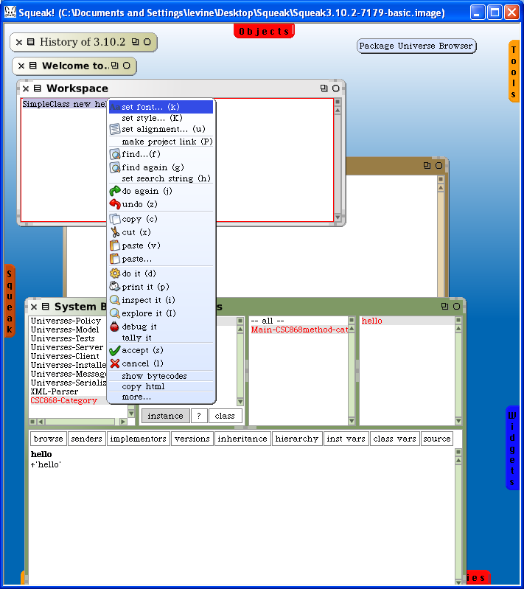

Your program should print to the Transcript window for output.

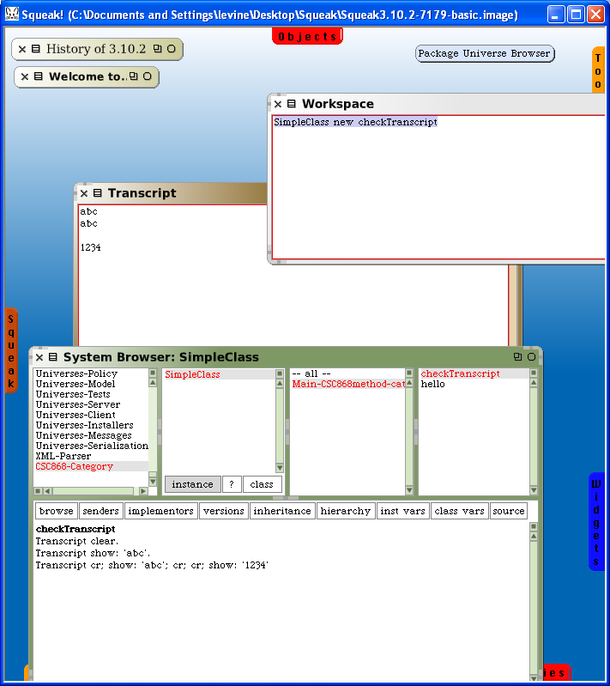

Save your work frequently. You can save your code to a text file by left clicking the class category, then right click to get menu, then select file out. The .st file is saved to the directory containing the .image file

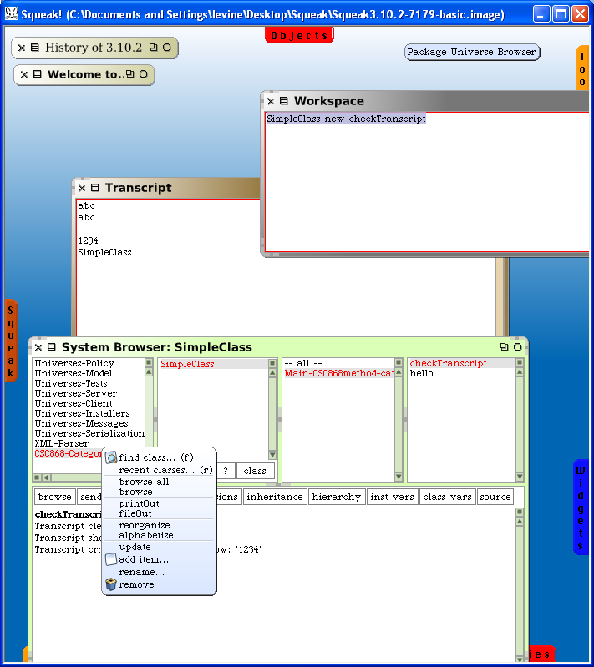

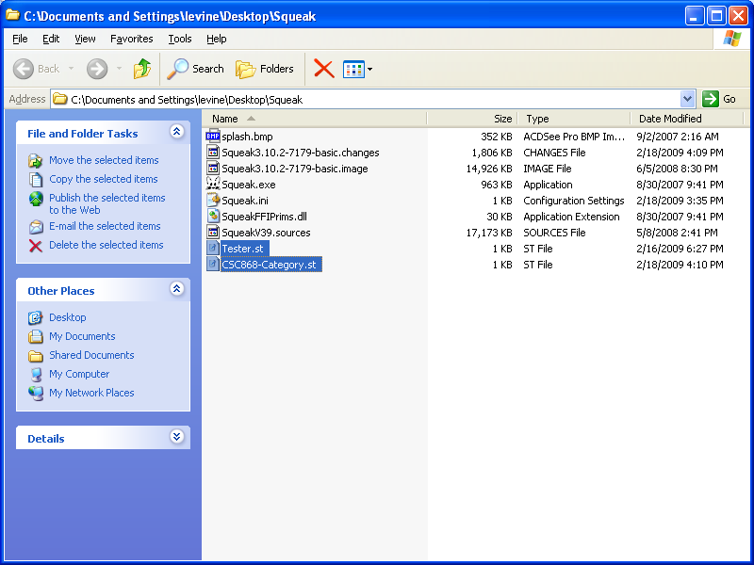
Subsequently, you can read the files produced by a file out by doing a file in, which will read in the text, create the category, compile the file and recreate the classes. This is accomplished by:
- left click in blank area of screen
- select open and then file list
- browse to the file produced from the file out
- left click on file to select it then right click and select fileIn entire file
Now, you will see the classes in the System browser:

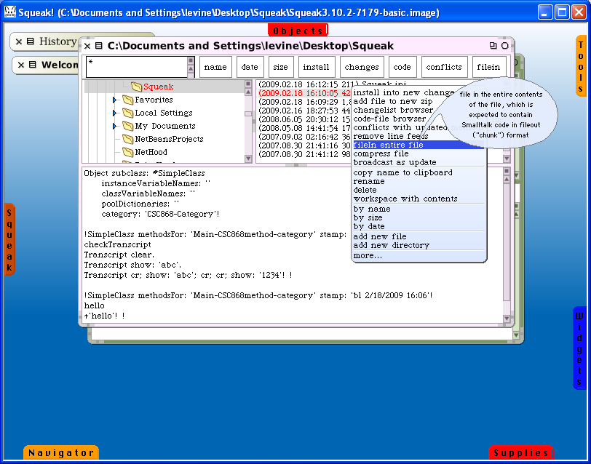

Alternatively, if you save the image when you quit Squeak then it will save the entire state of your work. Later, when you restart Squeak you should use that image for continuing your work.
Screen snapshot of Smalltalk project – this is a bit old but it serves the purpose.

