Comic Craft – AI Comic Story Creator using Gemini Models

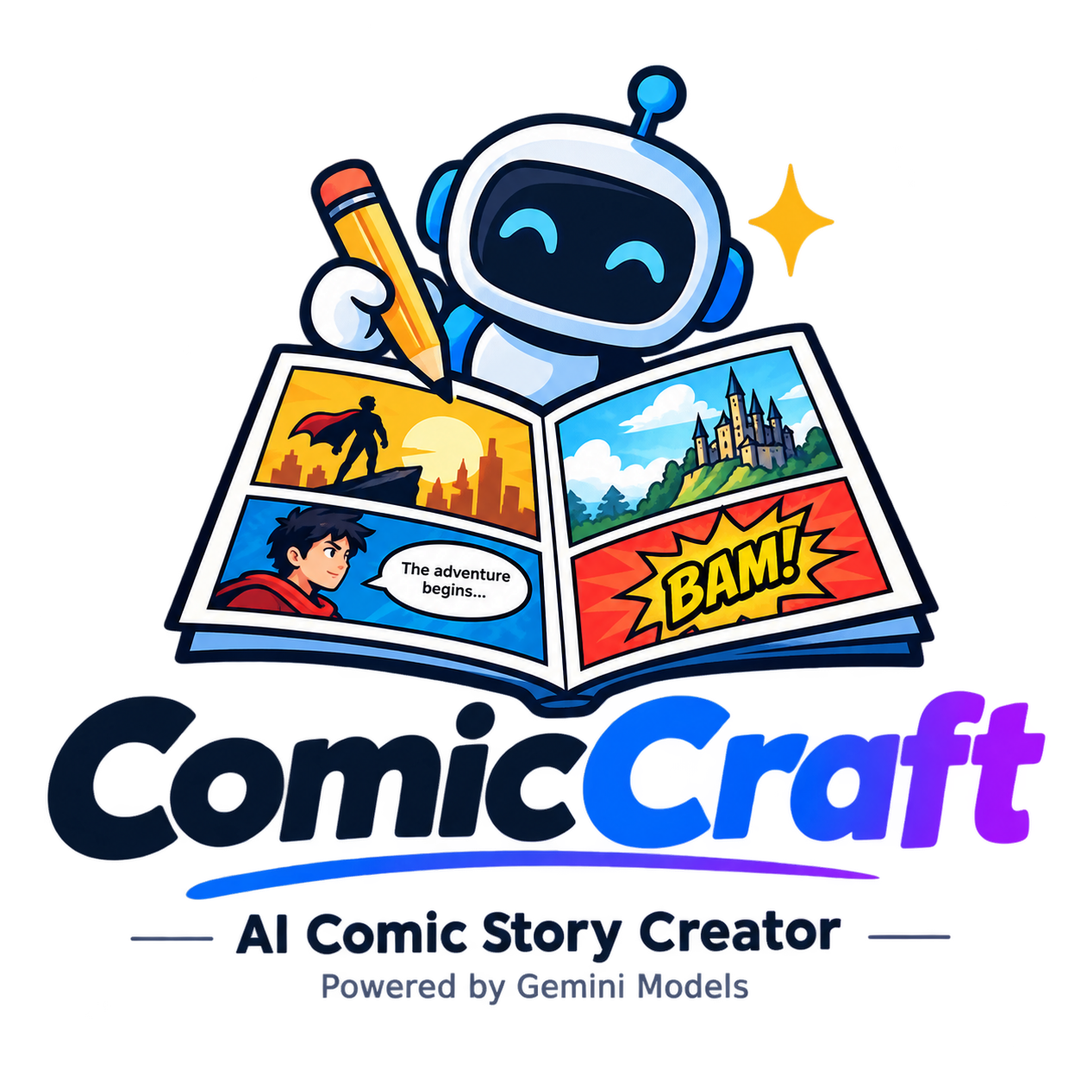

Academic Year: 2026–2027
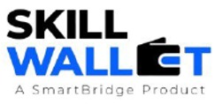

GOVERNMENT ARTS AND SCIENCE COLLEGE
WIMCO NAGAR
THIRUVOTTRIYUR, CHENNAI-19
Team ID : SWTID-2026-8418
ComicCraft - AI Comic Story Creator using Gemini Models
Team Size : 4

Team Leader : Rasa kumar N
Team member : Purushothaman A
Team member : Rahul R
Team member : Rajesh K

S.No. | CONTENTS
1 | Introduction
2 | Problem Statement
3 | Objectives
4 | Scope of the Project
5 | Existing System
6 | Proposed System
7 | Technologies Used
8 | System Requirements
9 | System Architecture
10 | System Workflow
11 | Module Description
12 | Database Design
13 | Screenshot
14 | Advantages
15 | Limitations
16 | Future Enhancement
17 | Conclusion

1. INTRODUCTION:
ComicCraft is a web-based application that uses Artificial Intelligence to generate personalized comic book stories and illustrations from user-provided prompts. The application is built using FastAPI and integrates Google Gemini AI models and Stable Diffusion to automate the creation of storylines, dialogues, and comic-style images.
The system accepts details such as the story prompt, main character name, setting, tone, and art style from the user. Based on these inputs, ComicCraft generates a panel-by-panel storyline along with corresponding illustrations. Users can preview the generated comic through the web interface and download the complete comic as a PDF containing images and narration.
The application combines Gemini models for story generation and Stable Diffusion for image generation, providing an easy and creative comic-making experience even for users without artistic or technical expertise.

2. PROBLEM STATEMENT:

Creating a complete comic traditionally requires several skills, including story writing, character development, dialogue creation, illustration, panel arrangement, and final document preparation. This process can be time-consuming and may be difficult for users who do not have artistic or technical expertise.
ComicCraft addresses this problem by providing an AI-powered web application that automates the comic creation process. The system accepts a user's story prompt, character name, setting, tone, and preferred art style, and then generates a structured five-panel storyline, narration, dialogues, and corresponding comic illustrations.
The generated content is presented as a complete comic preview and can also be exported as a downloadable PDF. By integrating Gemini AI models for story generation and Stable Diffusion for image generation, ComicCraft provides a streamlined approach for transforming a simple creative idea into a complete visual comic with minimal manual effort.

3. OBJECTIVES:

- To develop an AI-powered web application for automatically creating personalized comic stories and illustrations.
- To generate structured five-panel comic story outlines based on user-provided prompts.
- To generate detailed narration, character dialogues, and scene descriptions using Google Gemini AI models.
- To generate visually engaging comic-style illustrations for each panel using Stable Diffusion.
- To provide users with a simple and user-friendly interface for entering story prompts, character details, setting, tone, and art style.
- To display the generated comic panels sequentially with images, captions, narration, and dialogues.
- To combine the generated comic content into a structured and downloadable PDF format.
- To integrate the frontend, FastAPI backend, AI models, image generation, and PDF export into a complete end-to-end comic creation workflow.
- To make comic creation accessible to non-artists and casual users with minimal manual effort.

4. SCOPE OF THE PROJECT:

The scope of the ComicCraft project is to develop an AI-powered web application that can transform a user's creative idea into a complete five-panel comic story with illustrations and narration.
The project includes the following major areas:
- AI Story Generation
Generate structured five-panel comic outlines, scene descriptions, narration, and character dialogues based on user prompts.
- AI Image Generation
Generate comic-style illustrations for each panel based on the AI-generated image prompts.
- User Customization
Allow users to provide a story prompt, character name, setting, story tone, and preferred art style.
- Comic Preview
Display the generated comic panels sequentially with images, titles, captions, narration, and dialogues.
- PDF Export
Combine the generated images and story content into a downloadable multi-page PDF.
- Web-Based Access
Provide a simple interface using FastAPI, HTML, CSS, and Jinja2 so that users can create comics without requiring advanced technical or artistic skills.
- Future Expansion
The modular architecture can be extended in the future to support user profiles, comic libraries, and multi-page story arcs.

5. EXISTING SYSTEM:
In the existing system, comic creation is mainly performed manually. The user needs to develop the story, create characters, write dialogues and narration, design comic panels, create illustrations, and arrange all the content into a final comic format.
This process requires creativity, artistic skills, and considerable time and effort. Users without drawing or technical skills may find it difficult to create a complete comic.
The existing approach does not provide an automated end-to-end process for generating the storyline, dialogues, illustrations, and final PDF from a simple user prompt. Therefore, comic creation can involve multiple manual steps and different tools.
ComicCraft is developed to simplify this process by using Generative AI to automate story generation, illustration creation, comic preview, and PDF export.

6. PROPOSED SYSTEM:
The proposed system, ComicCraft, is an AI-powered web application designed to automatically create personalized comic stories and illustrations from user-provided prompts.
The system allows users to enter a story prompt, main character name, setting, story tone, and preferred art style. Based on these inputs, the application uses Google Gemini AI models to generate a structured five-panel comic outline, detailed narration, and character dialogues. Stable Diffusion is used to generate comic-style illustrations for each panel.
The generated comic is displayed on a web-based preview page containing panel titles, images, scene descriptions, captions, and narration. Users can review the complete comic before exporting it.
The system also provides a PDF export feature, which combines the generated images and story content into a downloadable PDF. The application is developed using FastAPI, HTML, CSS, Jinja2, Google Gemini, Stable Diffusion, and FPDF.
The proposed system simplifies the comic creation process and makes AI-assisted comic creation accessible to non-artists, storytellers, and casual users.

7. TECHNOLOGIES USED:
The following technologies are used in the development of the ComicCraft application:
- Python – Used as the primary programming language for developing the backend and AI integration.
- FastAPI – Used to develop the backend, handle API routes, process user inputs, and connect the different components of the application.
- Uvicorn – Used as the ASGI server to run the FastAPI application locally.
- HTML & CSS – Used to design the web interface and display the comic generation pages.
- Jinja2 – Used for dynamic rendering of HTML templates and displaying generated comic content.
- JavaScript – Used for frontend interaction and improving the user experience.
- Google Gemini AI – Used for generating structured comic outlines, narration, character dialogues, and story content.
- Hugging Face Diffusers – Used for integrating AI-based image generation.
- Stable Diffusion – Used to generate comic-style illustrations from image prompts.
- PyTorch – Used as the machine-learning framework required for the image-generation workflow.
- FPDF – Used to generate downloadable PDF files containing comic images and story content.

8. SYSTEM REQUIREMENTS:
Hardware Requirements
The following hardware is required to develop and run the ComicCraft application:
- Processor: A modern multi-core processor for running the FastAPI backend and application services.
- RAM: Sufficient memory to run Python, FastAPI, AI libraries, and other project dependencies.
- Storage: Adequate storage space for the project files, Python packages, generated comic images, and PDF files.
- Graphics Processing Unit (GPU): A GPU can be used to support the Stable Diffusion image-generation workflow.
- Display: A monitor or laptop display for developing and accessing the web-based ComicCraft interface.
- Internet Connection: Required for accessing Google Gemini APIs and other cloud-based services used by the application.

9. SYSTEM ARCHITECTURE:
The system architecture of ComicCraft consists of three main components: Frontend, Backend, and AI Integration. These components work together to transform the user's story idea into a complete comic with illustrations and a downloadable PDF.
- Frontend Layer
  - Developed using HTML, CSS, JavaScript, and Jinja2 templates.
  - Collects user inputs such as story prompt, character name, setting, story tone, and art style.
  - Displays the generated comic panels and story content through the comic preview page.
- Backend Layer
  - Developed using the FastAPI framework.
  - Receives and processes user inputs through application routes.
  - Coordinates story generation, image generation, comic layout creation, and PDF export.
  - Uses routes.py to manage the main application logic and routing.
- AI Integration Layer
  - Gemini Flash generates the structured five-panel comic outline.
  - Gemini Pro generates detailed narration and character dialogues.
  - Stable Diffusion generates comic-style illustrations based on image prompts.
- Comic Layout and Export
  - The generated text and images are organized into a structured comic layout.
  - layout_builder.py prepares the comic layout.
  - exporters.py uses FPDF to generate the final downloadable PDF.

System Flow
User Input → Frontend → FastAPI Backend → Gemini AI → Stable Diffusion → Comic Layout → PDF Export / Web Preview
This architecture provides an end-to-end workflow in which the frontend collects user requirements, the FastAPI backend coordinates the processing, AI models generate the story and illustrations, and the final comic is presented on the web and exported as a PDF.

10. SYSTEM WORKFLOW:
The ComicCraft system follows an end-to-end workflow that converts a user's creative idea into a complete AI-generated comic.
- User Input
  - The user enters the story prompt, main character name, setting, story tone, and preferred art style through the web interface.
- Input Processing
  - The frontend sends the submitted information to the FastAPI backend through a POST request.
- Comic Outline Generation
  - Gemini Flash processes the story prompt and generates a structured five-panel comic outline.
- Story Generation
  - Gemini Pro uses the generated outline to create detailed scene descriptions, narration, and character dialogues.
- Image Generation
  - Stable Diffusion generates comic-style illustrations for each panel using the image prompts produced during the story-generation process.

11. MODULE DESCRIPTION:
The ComicCraft application is divided into several modules, where each module performs a specific function in the comic-generation process.
- User Interface Module
  - Provides the web interface for entering the story prompt, character name, setting, tone, and art style.
  - Displays the generated comic through the preview page.
- Story Outline Generation Module
  - Uses Gemini Flash to generate a structured five-panel comic outline from the user's story prompt.
  - Organizes the story into individual panels and scenes.
- Story and Dialogue Generation Module
  - Uses Gemini Pro to generate detailed narration, scene descriptions, and character dialogues based on the generated outline.
- Image Generation Module
  - Uses Stable Diffusion through Hugging Face Diffusers to generate comic-style illustrations for each panel based on image prompts.
- Backend and Routing Module
  - Uses FastAPI to receive user inputs, manage application routes, coordinate AI services, and process the generated content.
  - The main routing logic is implemented through routes.py.
- Comic Layout Module
  - Organizes the generated panel titles, images, and text into a structured comic layout.
  - Uses layout_builder.py for layout preparation.
- PDF Export Module
  - Combines the generated images and story content into a downloadable PDF.
  - Uses FPDF through exporters.py for PDF generation.
- Comic Preview and Export Module
  - Displays the completed comic panel-by-panel on the web interface.
  - Provides the option to download the comic as a PDF and displays an export success page after completion.

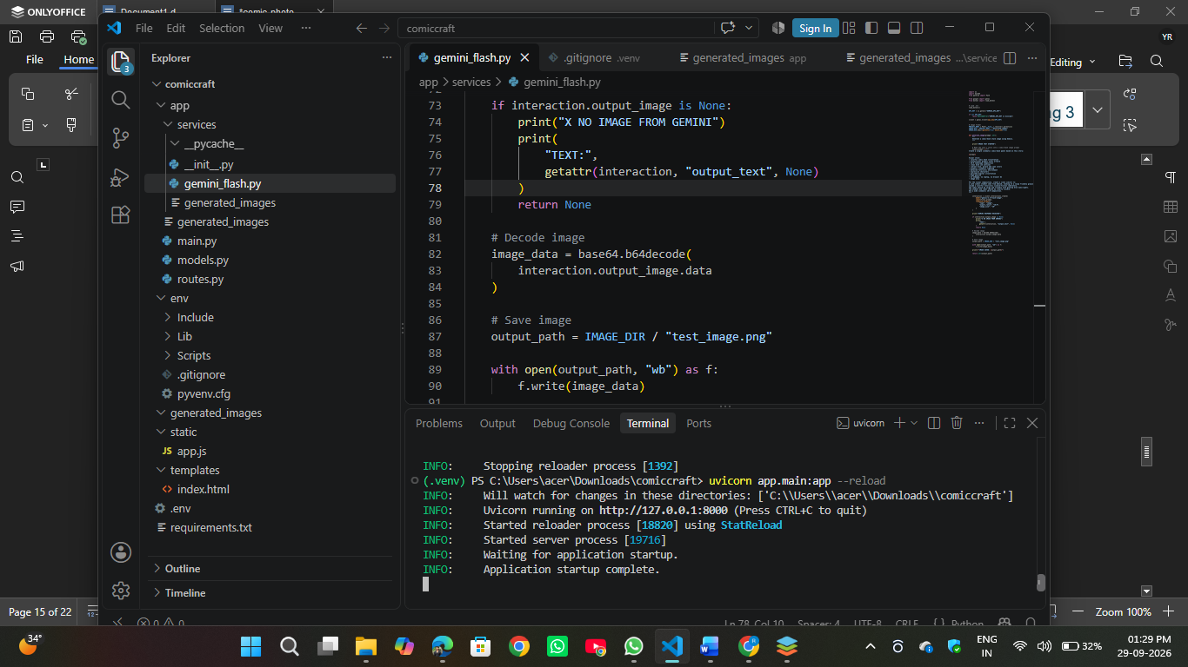

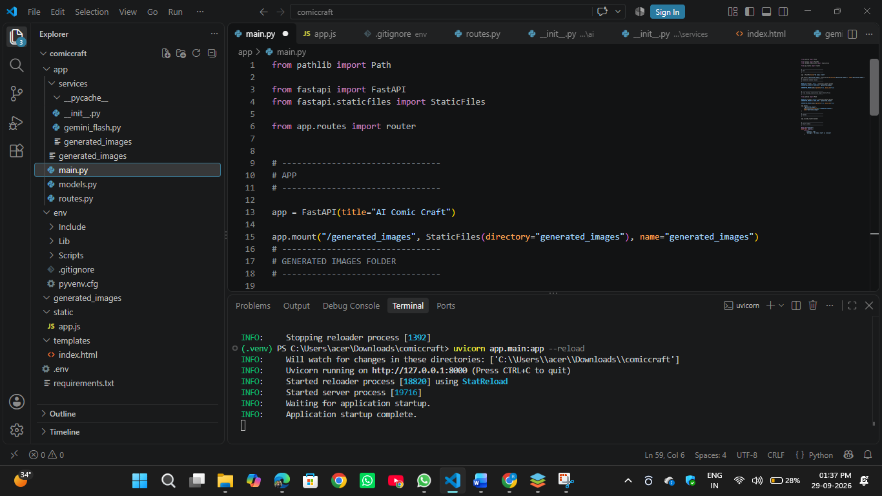

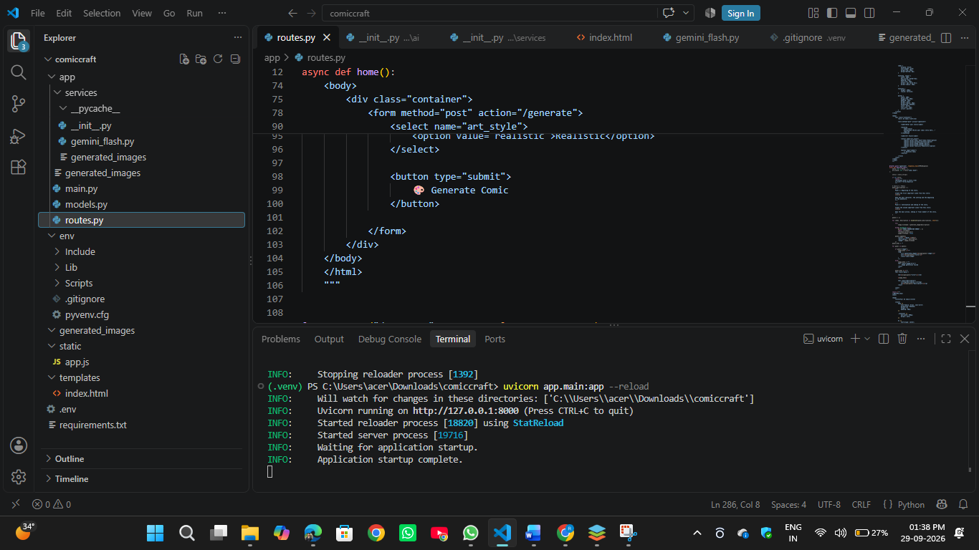

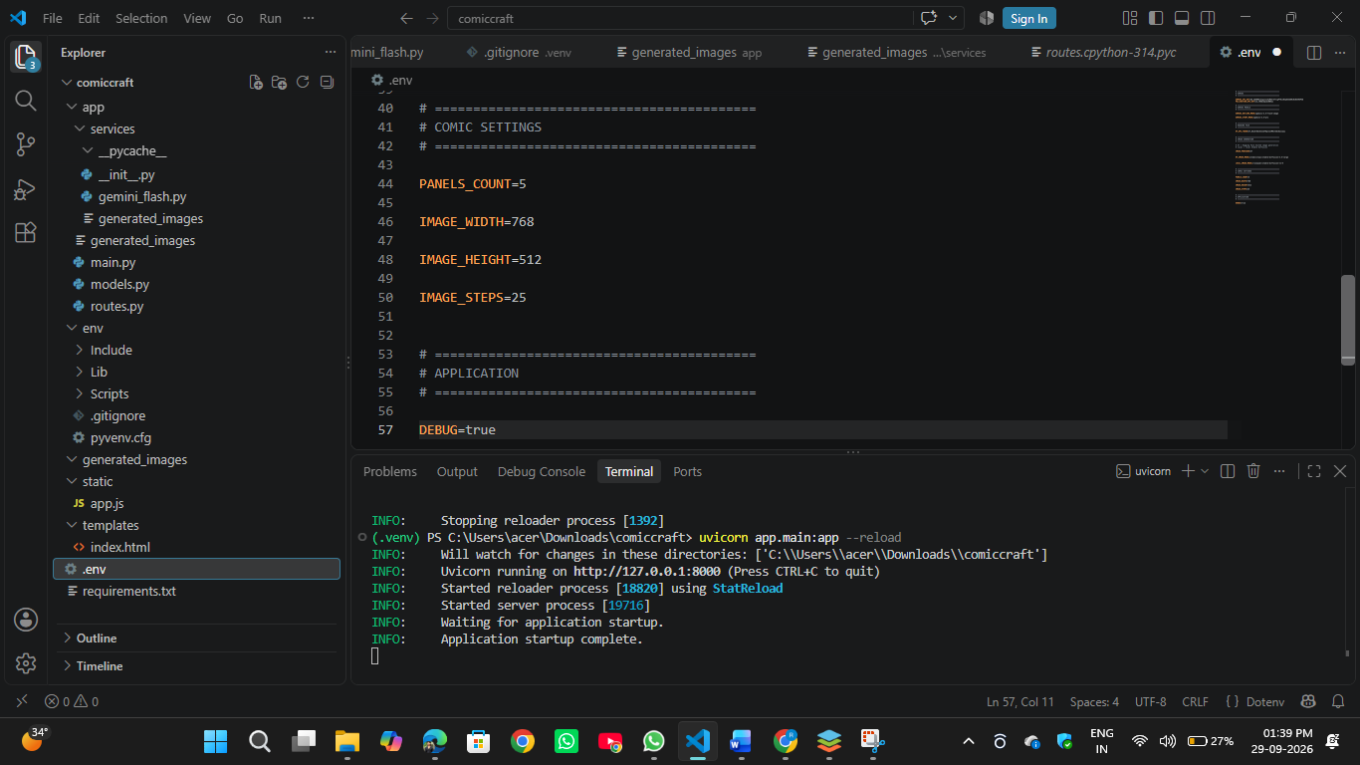

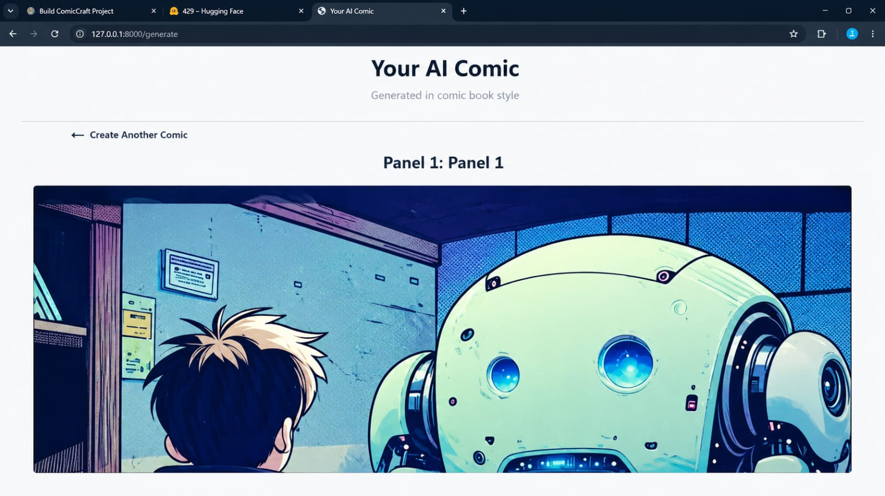

14. ADVANTAGES:
Automated Comic Creation
- ple and user-friendly web interface allows users to create comics without requiring advanced technical expertise.
- Personalized Content
Users can customize the comic using the character name, setting, story tone, and preferred art style.
- AI-Powered Storytelling
Gemini models generate structured comic outlines, creative narration, scene descriptions, and character dialogues.
- AI-Generated Illustrations
Stable Diffusion generates comic-style illustrations based on the generated image prompts.
- Comic Preview
Users can view the complete comic panel-by-panel before exporting it.
- PDF Export
The generated comic can be compiled into a downloadable PDF containing images and story content.
- Accessible to Non-Artists
The system makes comic creation accessible to non-artists, storytellers, and hobbyists by reducing the need for manual drawing and design skills.
- Customization and Regeneration
Users can change the tone and art style and regenerate the comic according to their creative preferences.

15. LIMITATIONS:
- No User Account Management
The current version does not provide user registration, login, or account management features.
- Single Comic Generation
The current system mainly focuses on generating a single comic at a time.
- No Comic Library
Users cannot maintain a personal library to store and manage previously generated comics.
- Limited Story Length
The current implementation focuses on a structured five-panel comic rather than longer multi-page story arcs.
- Dependence on AI Services
Comic generation depends on the integrated Gemini and Stable Diffusion AI services.
- Limited Current Features
Features such as user profiles, comic libraries, and multi-page story arcs are not included in the current version but can be added in future enhancements.
- AI-Generated Output Variability
The generated story and illustrations depend on the AI models and the prompts provided by the user, so the output may vary for different inputs.

16. FUTURE ENHANCEMENT:
- User Profiles
User account and profile features can be added to allow users to manage their personal comic-creation activities.
- Comic Library
A personal comic library can be developed to allow users to store, access, and manage their previously generated comics.
- Multi-Page Story Arcs
The system can be extended to support longer stories consisting of multiple pages and connected story arcs.
- Enhanced Customization
Additional customization options can be introduced to provide users with greater control over their comic stories and visual styles.
- Improved AI Integration
The modular architecture can support further improvements and integration of AI capabilities for more advanced storytelling and illustration generation.

17. CONCLUSION:
ComicCraft successfully demonstrates the use of Generative AI for creating personalized comic stories and illustrations from user-provided prompts. The system integrates FastAPI, Google Gemini AI, Stable Diffusion, and FPDF to provide an end-to-end comic creation workflow.
The application generates a structured five-panel story with narration, dialogues, and AI-generated illustrations. It also provides a web-based preview and allows the completed comic to be exported as a downloadable PDF.
The modular architecture makes the system accessible to non-artists and casual users while providing a foundation for future enhancements such as user profiles, comic libraries, and multi-page story arcs. Overall, ComicCraft provides a practical approach to combining AI-based storytelling and image generation in a web-based comic creation application.

GITHUB LINK: https://github.com/rasacalis2214-cpu/Comic-Craft-AI-Comic-Story-Creator-Using-Gemini-Model
DRIVE LINK: https://drive.google.com/file/d/1hQ8uMW1zyv7JSfMU-mo2Ql6nod29yXFh/view?usp=drivesdk

