**Where’s Waldo?**

**Introduction.**

After 5 intense lectures of computer vision (with more to come!) you must be eager to try something interesting with the skills you learned from the class!

“Where’s Waldo” is a series of Wimmelbilder books featuring Waldo [1], along with his friends who set off on “a-world-wide hike”. The books feature a series of detailed illustrations (see Fig.1 for an example) and your job is to find Waldo and his friend Wenda and Wizard (see Fig. 2 to get to know them!).

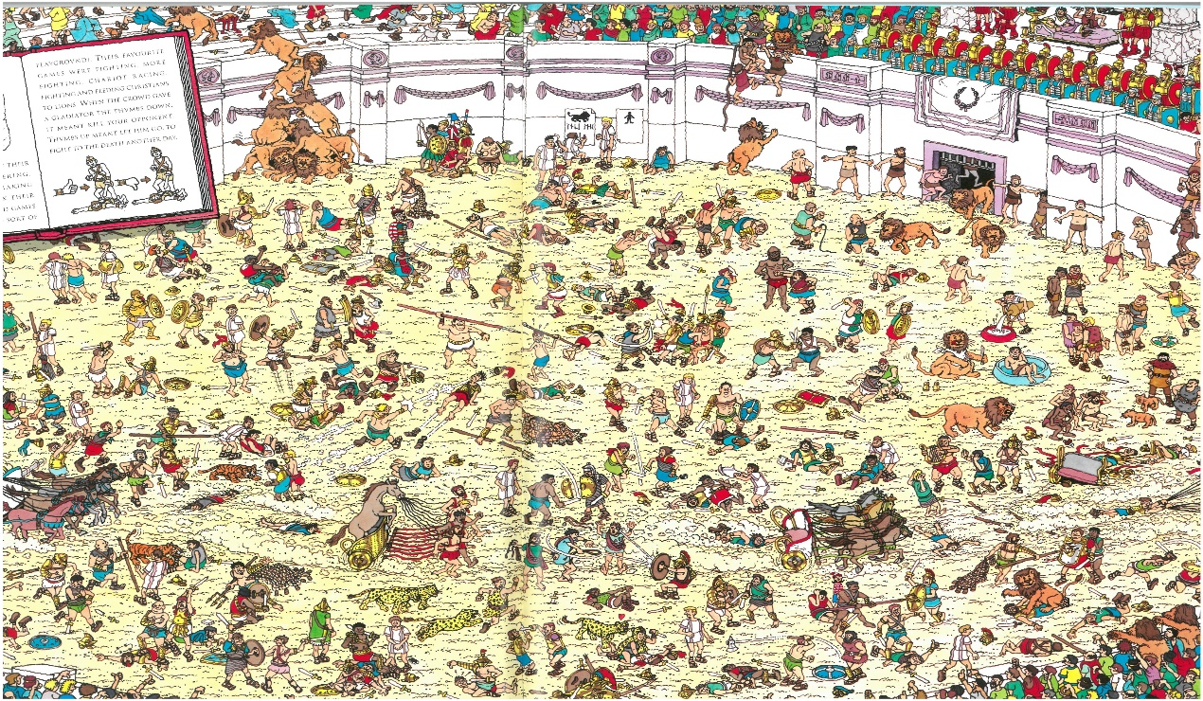

Wizard

Waldo

Wenda

Figure 1. Typical scene in the book “Where is Waldo”

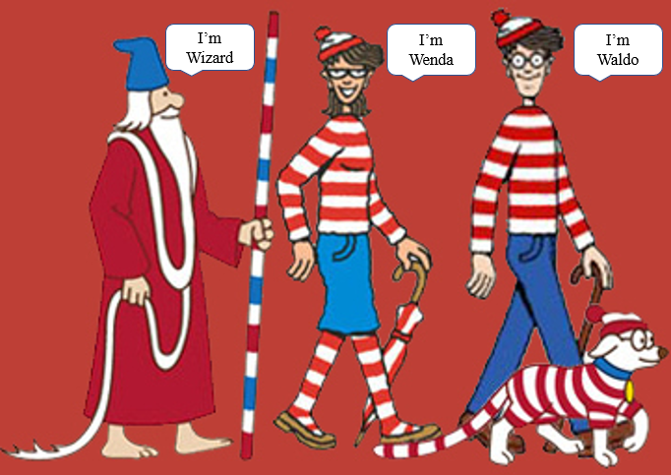

Figure 2. Wizard, Wenda and Waldo.

We have scanned the images from the books and your task is to detect three of the characters (Waldo, Wenda and Wizard) in each scene using any non-deep computer vision algorithm of your choosing.

To facilitate your job, we provide you some annotated samples, which we painstakingly hand labelled. However, the annotations are not so perfect, and certain characters are hard to find sometimes. So, you are welcome to improve the annotations yourself, or search for online resources to help you. The format of the annotations follows the Pascal VOC standard, and the location of the object is given by (xmin, ymin, xmax, ymax) which denotes the top left and bottom right of the bounding box. Please refer to the annotation file for the specifics.

**Evaluation Metric.**

We adopt the mean average precision (mAP) as metric to evaluate your algorithm’s performance. We regard the 3 characters as 3 classes and for each class, we calculate the average precision based on the ground-truth and detected characters. You can read more about mAP here:

<https://medium.com/@jonathan_hui/map-mean-average-precision-for-object-detection-45c121a31173>

We have provided the evaluation script. Note that your algorithm’s efficiency and novelty will also be counted into the final grade flexibly.

**Requirement.**

You are free to propose and implement your own algorithms to address the problem. We have a separate hold-out test set to compare your algorithm’s performance with everyone else in the class. Please submit your code and format your outputs as suggested in ‘REAME.md’ and also submit a detailed readme file to ensure that the TAs can run your code successfully.

**Don’t know where to start?**

1. Brute-force it! What about a normalized cross-correlation approach as described in Lecture 2. Hint: this method is will be very slow and unlikely to return Waldo (or Wenda or Wizard) as the top hit.
2. Interest Point Matching. What about detecting interest points and finding matches in the images? See Lecture 5 / 6, similar to Lab 3.
3. Detectors?
4. Classifiers?

**Grading Scheme**

**Mid-term Report** (10%) Due 17.10.

½ to 1 page progress report, detailing your progress to date (what have you tried so far) and the contributions of each team member to date. This is to ensure that you do not leave things to the last minute.

**Final Report** (25%) Due 07.11

* Description of rationale behind methodology,
* Theory behind the method
* experiments tried with quantitative evaluations
* contribution of each team member.
* Please also describe the experiments that you tried which did not work and explain why it fails!

**Implementation** (40%) Due 07.11 with final report.

Documented source code that runs out of the box. You can use any “non-deep” method that you want, so long as you are able to concisely explain in your report and presentation how that method works.

**Presentations** (25%) done in lab session on 12.11 and 15.11.

10-15 minutes, highlighting the main points from your final report.

**Bonuses** (tbd)

We will give bonus marks for the fastest / most innovative / most accurate solutions.

1. Waldo is international and has lots of names depending on where the books are published! Originally, his name was Wally (UK), but he also goes by