Serverless Computing
Serverless computing is the technology of abstracting the servers, operating systems and the infrastructures. It is a cloud computing execution model in which the cloud provider dynamically manages the allocation of the machine resources. Such serverless systems can grow, scale and evolve without requiring the developer’s efforts of remembering to patch the web servers again and again.
The main advantages of the serverless applications are:
- The regular maintenance of any servers is not required. Also, we there is no software or platform to install for it.
- They can be scaled automatically by adjusting the capacity of the configurations required to run the application. Ex:- Memory, processor requirement etc.
- They have inbuilt availability and fault tolerance.
- You don't have to pay for idle capacity.
Serverless computing is more cost-effective than purchasing the servers with required configurations.

Some famous platforms for serverless computing:

1.AWS lambda
- 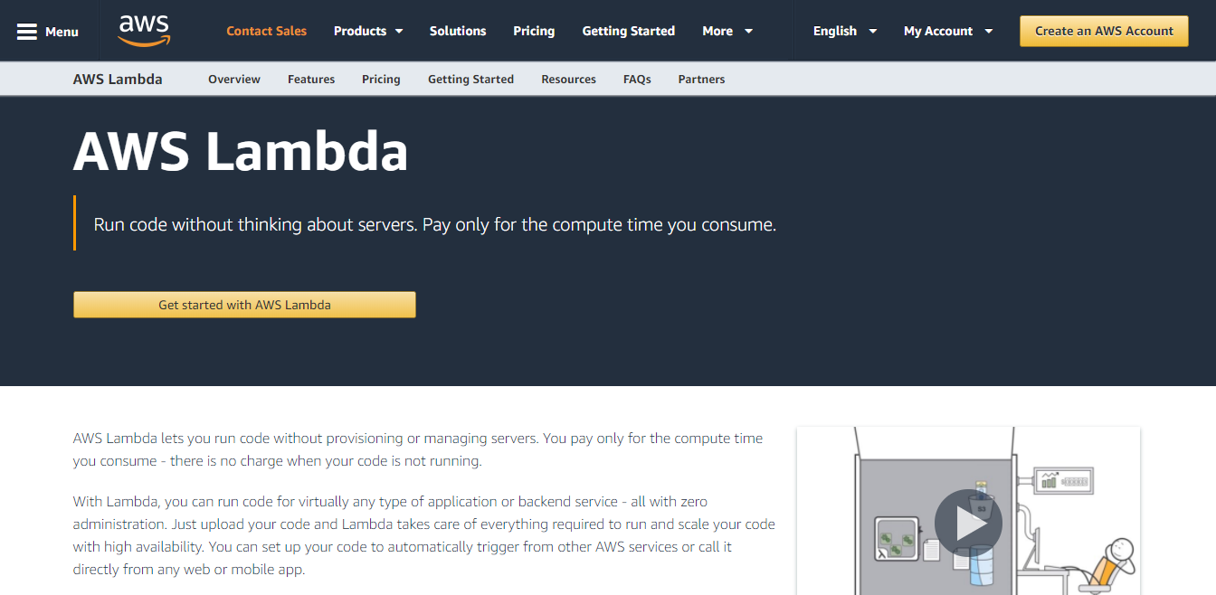
It stands for Amazon Web Services Lambda. It is the platform of Amazon that executes our code only when we need and also has the features of automatic scaling, from a few requests per day to thousands per second. We have to pay for the time we consume to use it and there is no charge when our code is not running.

Microsoft Azure
- 
This is the platform provided by Microsoft. It also provides all the features and here also we have to pay for the time we use its services. It is known to improve developer productivity, focus on business goals and building intelligent apps.

Google Cloud Platform
- 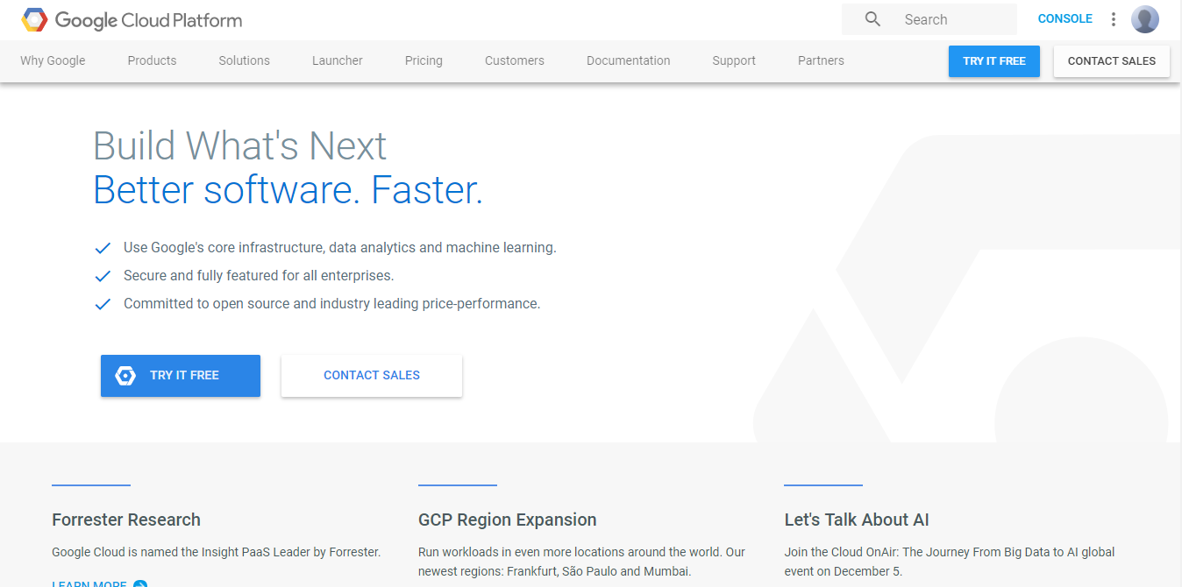
It is Google’s online platform that is based on serverless computing. It is a suite of cloud computing services that runs on the same infrastructure that is used by the Google internally for its end-user products

What is Function as a Service (FaaS)?
Function as a Service (FaaS) is a model in system design where developers write and deploy small, independent functions to perform specific tasks. These functions are typically event-driven and executed in response to triggers or requests, such as HTTP requests, database events, or time-based events.
- Developers don't have to handle infrastructure or servers while using FaaS. Instead, they focus solely on writing code for individual functions.
- The FaaS platform provides and scales the underlying resources automatically, based on the demand.
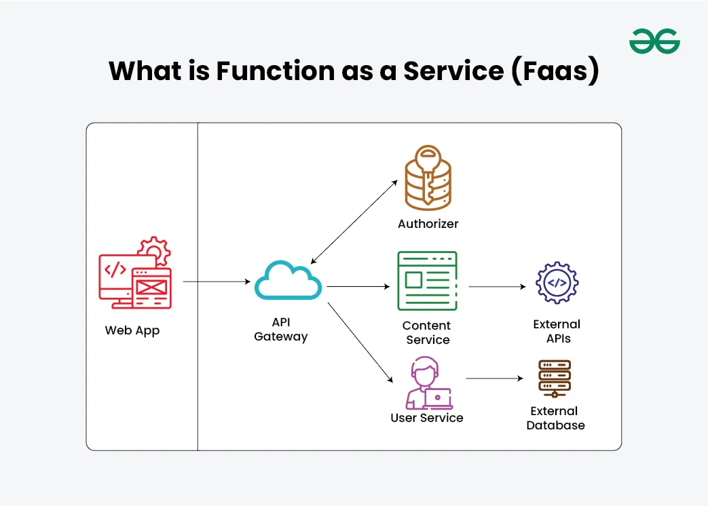

Function as a Service (FaaS) is a key component of serverless architecture. Serverless architecture, also known as serverless computing or Function as a Service (FaaS), is a cloud computing model where cloud providers dynamically manage the allocation and provisioning of servers, enabling programmers to concentrate only on creating and implementing functions as code.

FaaS Architecture and Components
Function as a Service (FaaS) architecture typically consists of the following components:
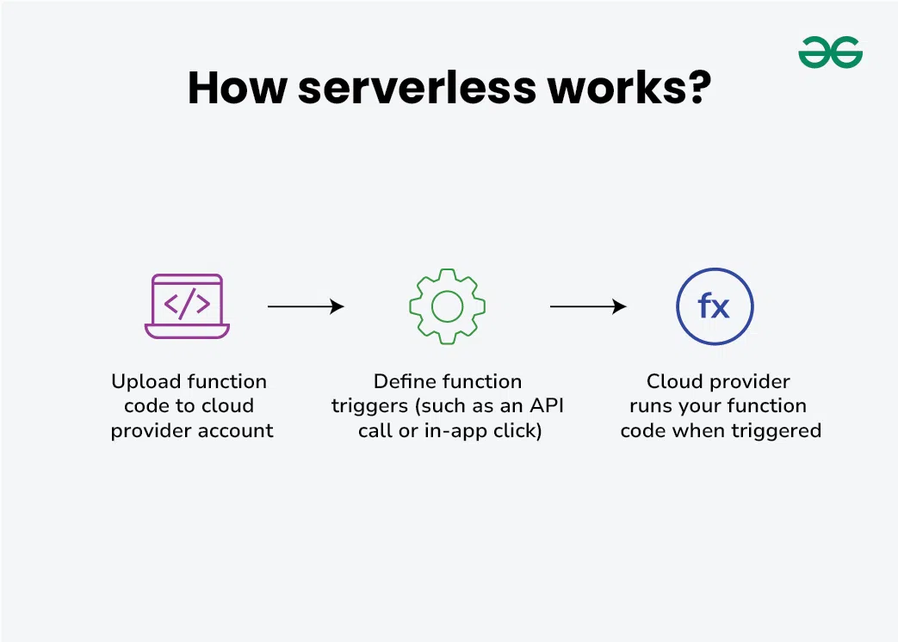
- Function:
  - A function is a small piece of code that performs a specific task or responds to an event.
- FaaS Provider:
  - The FaaS provider is the cloud service provider that offers the FaaS platform. Examples of FaaS providers include AWS Lambda
- Event Sources:
  - Event sources trigger the execution of functions.

- Function Execution Environment:
  - Each function runs in its own isolated execution environment, which includes the necessary runtime environment and dependencies to execute the code.
- Scaling Mechanism:
  - Scaling can be done horizontally (adding more instances) or vertically (adjusting resources allocated to each instance) to accommodate changes in traffic and ensure optimal performance.
- Invocation Mechanism:
  - Functions are invoked either synchronously or asynchronously based on the nature of the event. Synchronous invocation occurs when a response is required immediately, such as in response to an HTTP request. Asynchronous invocation occurs when a response is not immediately required, such as processing events from a message queue.
- Monitoring and Logging:
  - FaaS platforms provide monitoring and logging capabilities to track the performance, execution, and errors of functions.

Serverless Architecture
A serverless architecture is a cloud computing model where the cloud provider manages server provisioning, scaling, and maintenance, allowing developers to focus entirely on writing and deploying code. The code runs in fully managed, stateless environments and is triggered by events.
- Cloud providers dynamically handle infrastructure, scaling, and resource allocation.
- Code executes in event-driven, stateless compute containers.
- Developers are abstracted from server management tasks like capacity planning and maintenance.
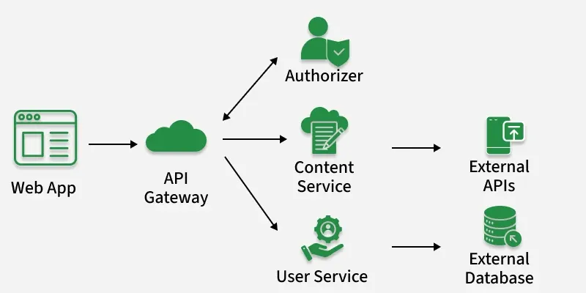

Serverless Computing Providers and Platforms
With distinct platforms and features suited to various development requirements, serverless computing has emerged as a key area of attention for numerous cloud service providers. These are a few of the top platforms and providers of serverless computing:
- AWS Lambda: Without having to provision or manage servers, developers may use AWS Lambda, perhaps the most well-known serverless computing tool, to execute code in response to events from more than 200 AWS services and SaaS apps.
- Azure Functions: With Azure Functions, a serverless compute solution from Microsoft, you can execute event-triggered code without explicitly provisioning or managing infrastructure. Azure Functions easily connects with other Azure services and supports a large number of programming languages.
- Google Cloud Functions: This is the serverless execution environment used by Google to create and link cloud services. All you have to do with Google Cloud Functions is write your code; Google handles the management, scaling, and underlying infrastructure.
- Oracle Cloud Functions: Using functions that are triggered by HTTP requests or events coming from Oracle Cloud services, developers can create apps with Oracle's serverless architecture. It is intended to provide an integrated cloud experience by integrating easily with Oracle's existing cloud products.

Serverless Application Design Patterns
Serverless architecture has introduced a variety of design patterns that help solve specific problems in the serverless environment efficiently. Here are some of the most common serverless application design patterns:

Function as a Gateway (FaG)
A serverless function acts as a gateway to route incoming requests to backend services.
- Handles HTTP requests, performs initial processing, and forwards them to appropriate services.
- Commonly used to build lightweight API gateways.

Event Stream Processing
Responding to data streams like logs, financial transactions, or social media feeds is a good fit for serverless functions.
- In this architecture, streams of events trigger functions that process each event separately.
- This is helpful in situations like logging, real-time data analytics, and processing data from the Internet of Things.

Aggregator
A serverless function aggregates data from multiple services or functions.
- Collects and combines responses from different sources.
- Returns a unified response, often used in microservices-based systems.

Strangler Fig Pattern
This pattern helps migrate legacy systems to serverless gradually.
- New features are implemented using serverless functions.
- Legacy components are slowly replaced without a full rewrite.

Circuit Breaker
The circuit breaker pattern prevents cascading failures in a serverless system by stopping repeated failed function calls.
- Breaks the function invocation chain after a predefined failure threshold.
- Allows the system to continue operating in a degraded but stable state.

Public Cloud Serverless Platforms

Example: AWS Lambda, Azure Functions, Google Cloud Functions
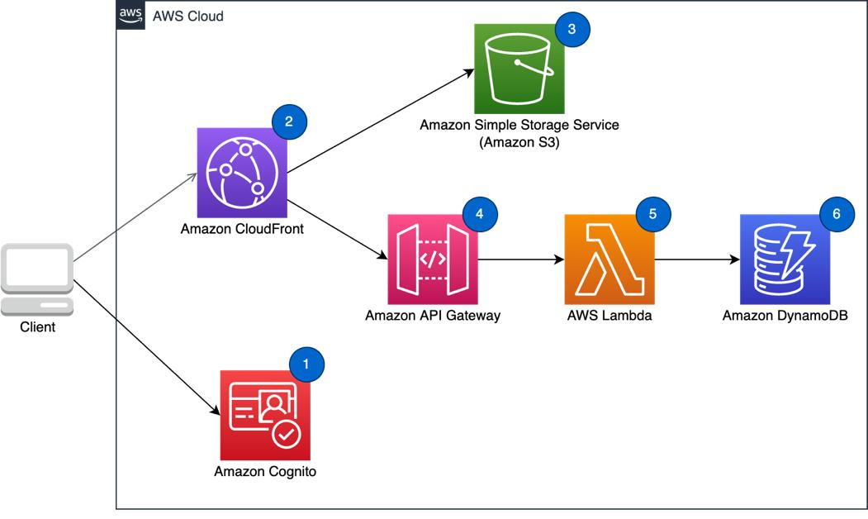
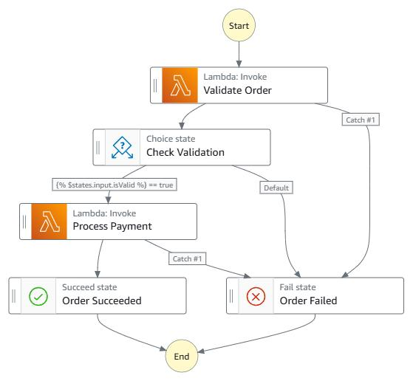
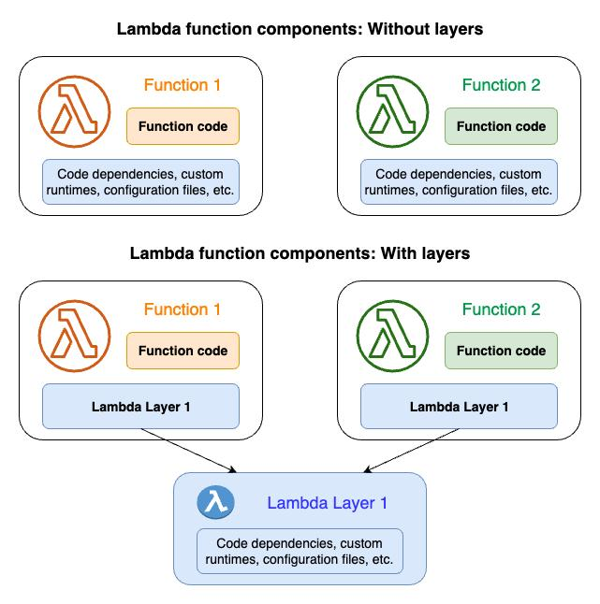
6

✔️ 2.1 Definition
Public cloud serverless platforms are serverless execution environments provided by large cloud service providers.
You simply upload code → the cloud provider automatically handles:
- Server provisioning
- Container execution
- Auto-scaling
- Load balancing
- Monitoring
- Fault tolerance
- Security patches
You never manage servers.

✔️ 2.2 How It Works (Step-by-Step)
- Developer creates a function (Python, Node, Java, etc.)
- Uploads to AWS Lambda or similar
- Defines trigger → API Gateway, S3, DynamoDB, HTTP request, etc.
- When an event occurs, the function automatically starts
- Provider allocates computing resources
- Function executes and stops
- Billing is calculated per millisecond of execution

✔️ 2.3 Key Features

🔹 Fully Managed Platform
Everything related to operations is handled by the provider.

🔹 Automatic Scaling
Can run one request or millions instantly.

🔹 High Reliability & Security
Cloud providers ensure:
- Multi-AZ availability
- DDoS protection
- Monitoring (CloudWatch)
- IAM-based security

🔹 Strong Integration
AWS Lambda integrates with:
- S3
- DynamoDB
- CloudWatch
- API Gateway
- SNS/SQS
- Step Functions
This makes it ideal for building complete serverless applications.

✔️ 2.4 Advantages
- No infrastructure management
- Fast deployment
- Pay-as-you-use pricing
- Global availability
- Enterprise-grade security

✔️ 2.5 Limitations
- Vendor lock-in (difficult to migrate code)
- Limited control over runtime
- Cold start latency
- Pricing may be high at scale

⭐ 3. Open-Source Serverless Platforms

Example: OpenFaaS, Apache OpenWhisk, Knative
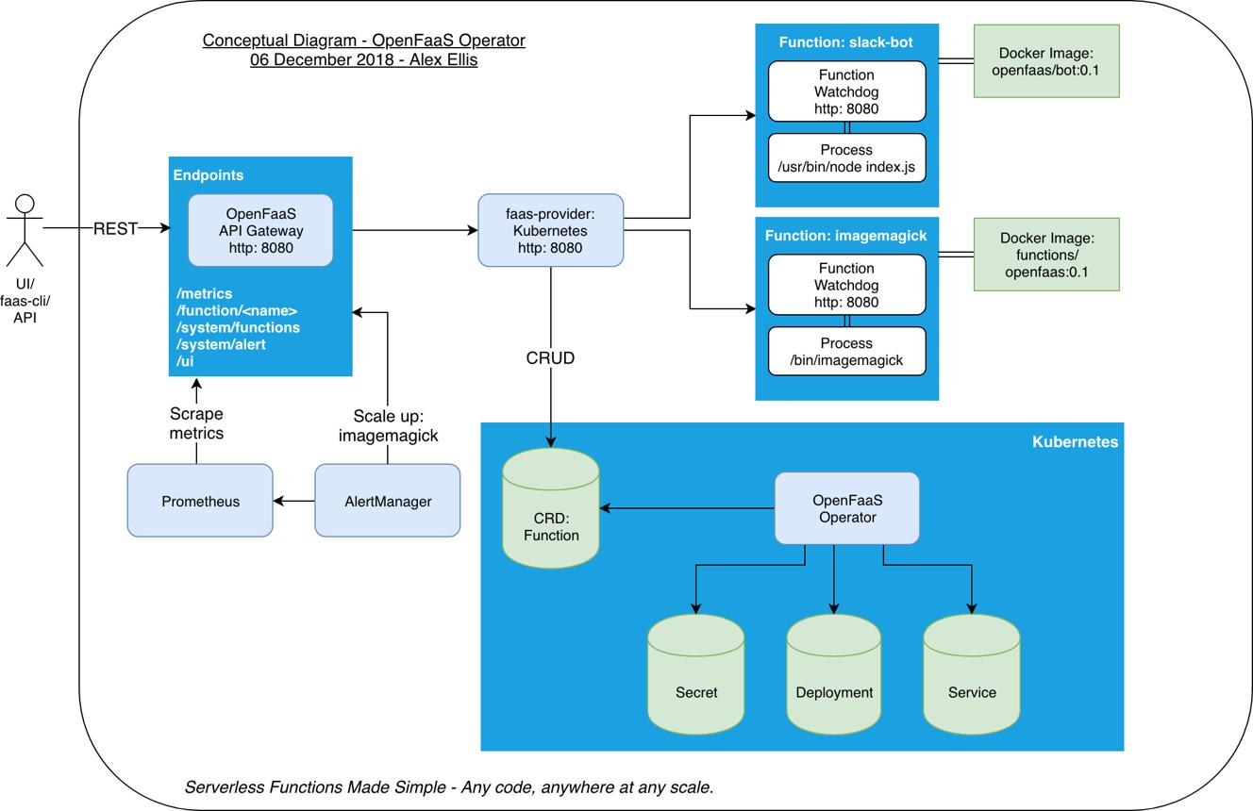
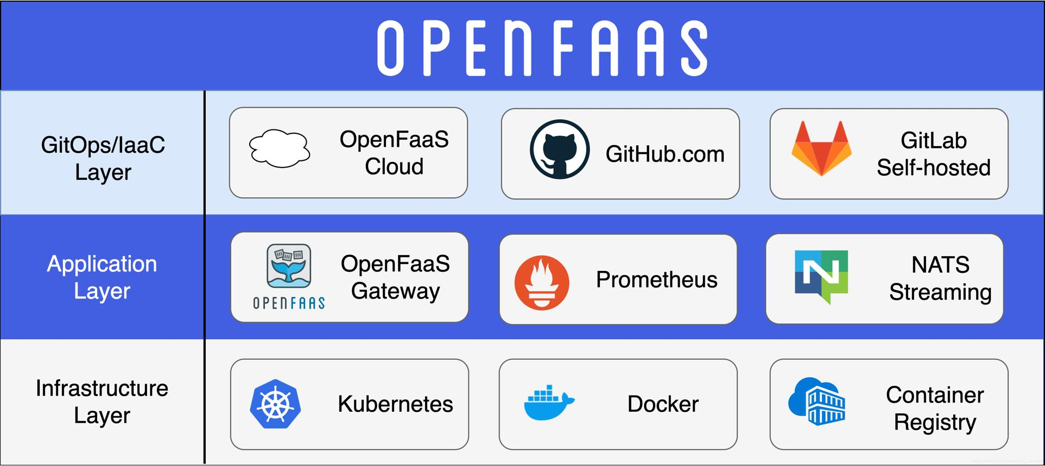
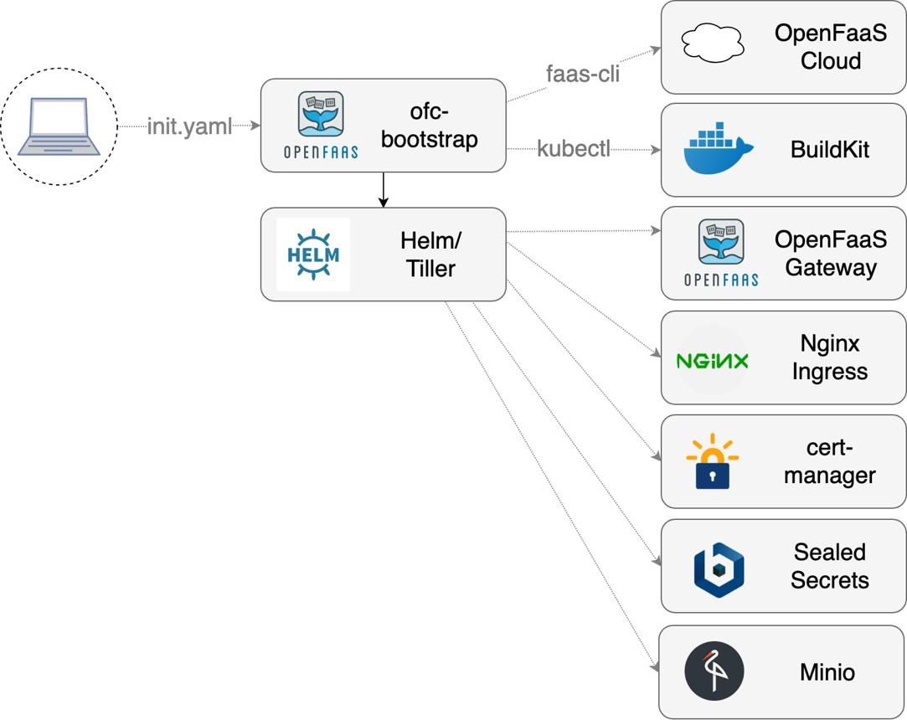
5

✔️ 3.1 Definition
Open-source serverless platforms are self-hosted frameworks that allow you to run serverless functions on:
- On-premise servers
- Kubernetes clusters
- Virtual Machines
- Private cloud
They offer complete flexibility, and you control:
- Infrastructure
- Scaling policies
- Networking
- Security
- Custom runtimes

✔️ 3.2 How It Works (Step-by-Step)
- You install OpenFaaS on Kubernetes or Docker
- Deploy functions as containers (Docker images)
- Define triggers (HTTP, message queue, cron jobs)
- OpenFaaS automatically scales functions based on requests
- Monitoring and logging are provided through Prometheus
- You manage the cluster and networking

✔️ 3.3 Key Features

🔹 Full Control
You decide everything:
- CPU, RAM
- Node count
- Scaling options
- Security settings

🔹 Custom Runtimes
You can run:
- Python
- Node.js
- Go
- Java
- C++
- ANY language that can run in a container

🔹 Works Anywhere
OpenFaaS runs in:
- On-premise data centers
- Bare metal servers
- Multi-cloud
- Edge computing devices

🔹 No Vendor Lock-In
You can migrate anytime.

✔️ 3.4 Advantages
- No dependency on a single cloud provider
- Full customization of the environment
- Can be cheaper for large-scale workloads
- Works in regulated industries (banking, healthcare)
- Ideal for hybrid cloud and edge computing

✔️ 3.5 Limitations
- You must manage servers/infrastructure
- Requires Kubernetes/DevOps expertise
- Scaling and monitoring require tuning
- Security is your responsibility

Internet of Things (IoT)
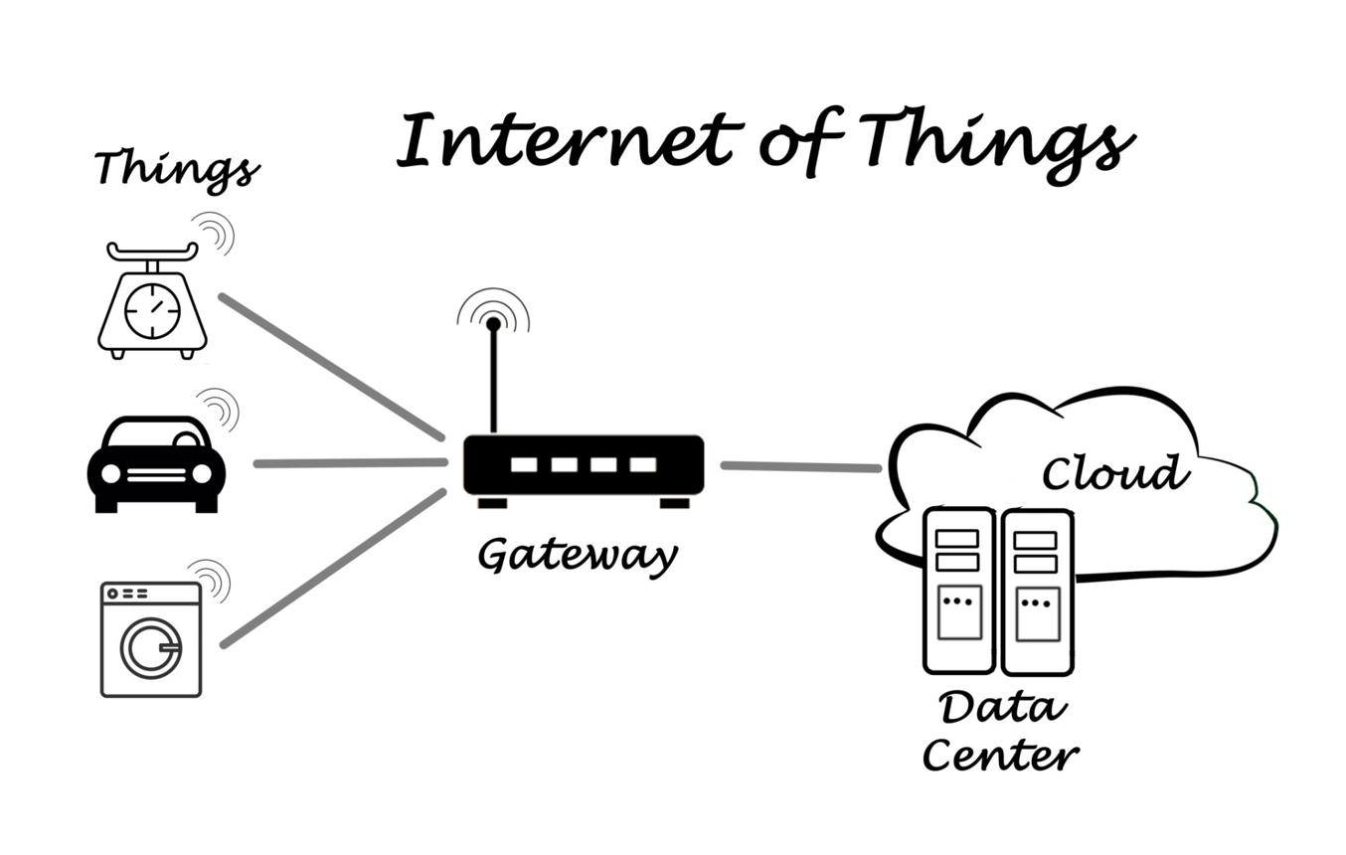
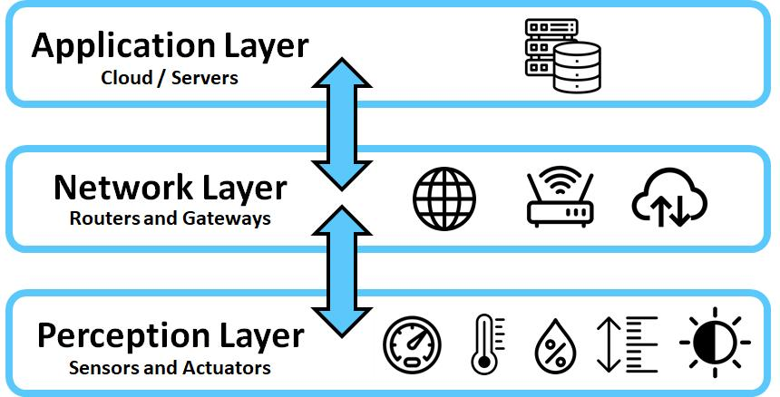
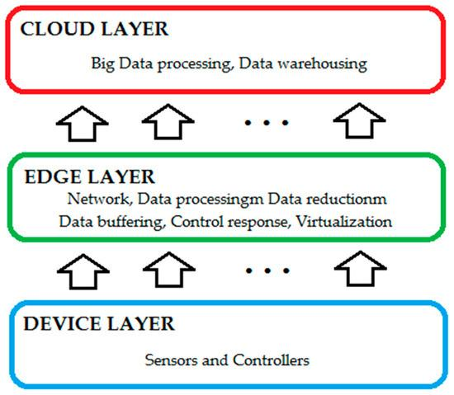
6

✅ Definition
The Internet of Things (IoT) is a network of physical devices embedded with:
- Sensors
- Actuators
- Software
- Connectivity
These devices collect and exchange data over the internet without human involvement.

✅ Examples of IoT Devices
- Smart watches
- Smart electricity meters
- Connected cars
- Smart agriculture sensors
- Smart home appliances
- Industrial robots and PLCs

✅ Key Characteristics
- Connectivity – devices communicate using WiFi, Bluetooth, 5G, ZigBee.
- Intelligence – sensors + analytics.
- Automation – reduces human effort.
- Large-scale device deployment.
- Real-time data processing.

🏭 2. Applications of IoT
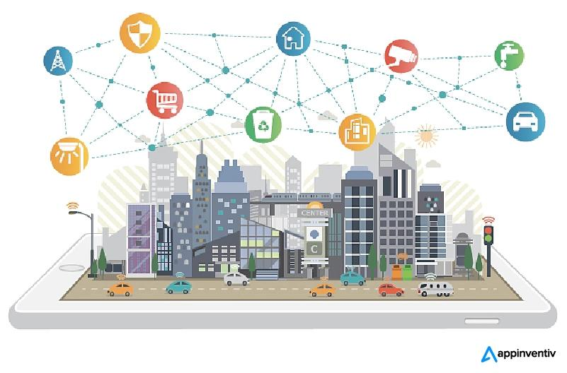
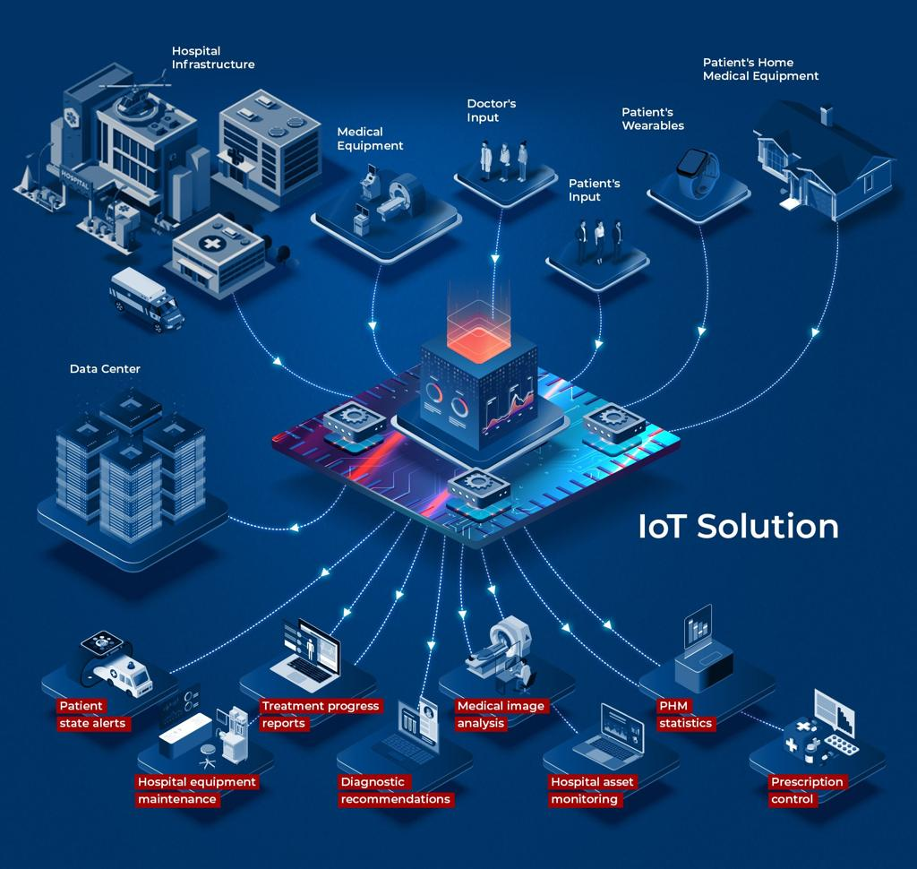

6

1️⃣ Smart Home
- Smart thermostats
- Voice assistants
- Lighting automation
- Security alarms

2️⃣ Smart Cities
- Intelligent traffic control
- Waste management
- Smart parking
- Air quality monitoring

3️⃣ Healthcare (IoMT – Medical IoT)
- Wearables to monitor heart rate, BP
- Remote patient monitoring
- Smart ambulances

4️⃣ Industrial IoT (IIoT)
- Predictive maintenance
- Robotics automation
- Supply chain monitoring

5️⃣ Agriculture
- Soil moisture sensors
- Automatic irrigation
- Crop health monitoring

6️⃣ Transportation & Logistics
- Fleet tracking
- Connected vehicles
- Goods monitoring

☁️ 3. Cloud-Centric IoT
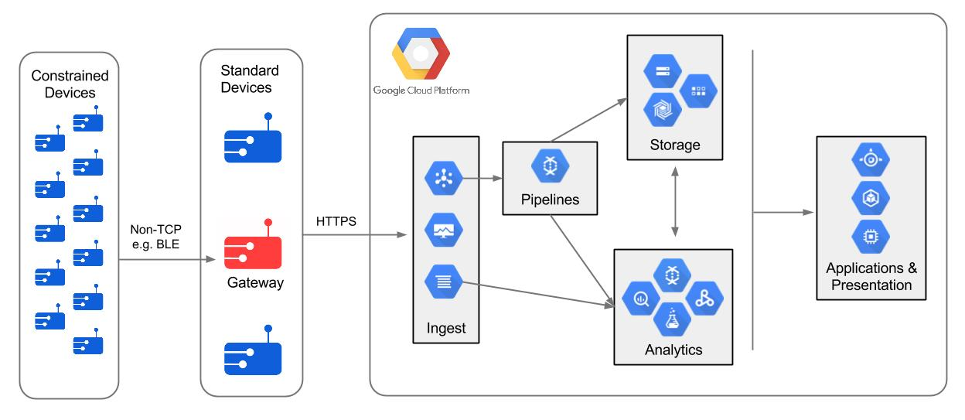

5

✅ What is Cloud-Centric IoT?
IoT devices generate huge amounts of data. Cloud platforms provide:
- Storage
- Processing
- Analytics
- Machine learning
- Application hosting
Cloud-Centric IoT = IoT devices + Cloud services.

Examples of IoT Cloud Platforms
- AWS IoT Core
- Azure IoT Hub
- Google Cloud IoT

🧩 4. Cloud-Centric IoT Architecture Layers
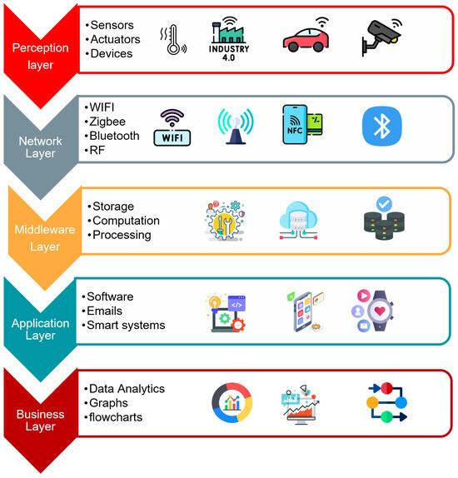
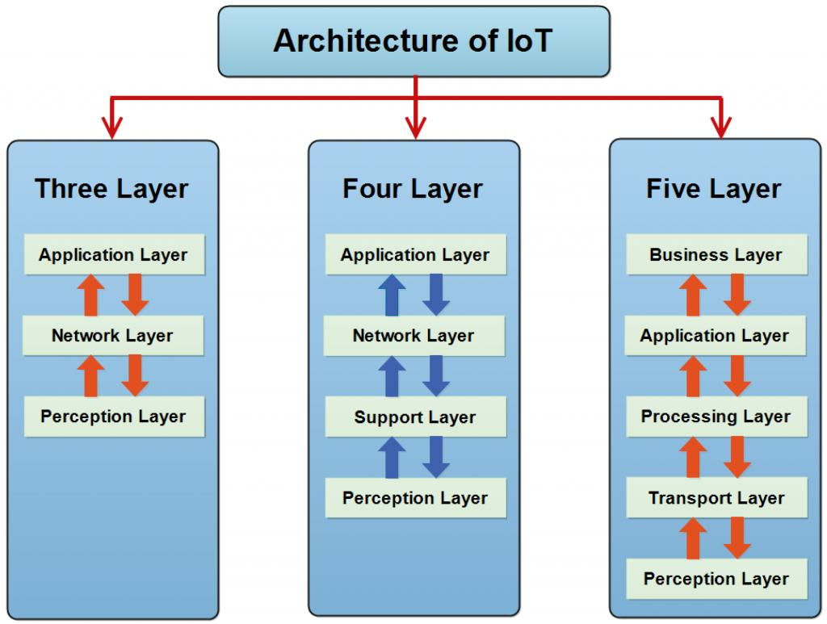

5
IoT architecture commonly contains 5 layers:

1️⃣ Perception Layer (Sensors/Actuators)
- Physical layer
- Sensors collect data
- Actuators perform actions
Examples: temperature sensor, RFID, cameras

2️⃣ Network Layer (Communication Layer)
- Transports data to cloud
- 4G/5G, WiFi, Bluetooth, ZigBee, LoRaWAN

3️⃣ Middleware Layer (Cloud Layer)
- Data storage
- Data processing
- Device management
Tools: AWS IoT, Azure IoT Hub, MQTT brokers

4️⃣ Application Layer
- Provides user-specific services
Examples: smart home app, hospital monitoring dashboard

5️⃣ Business Layer
- Business models
- Analytics
- ROI calculations
- Operational decisions

🏙️ 5. Edge and Fog Computing
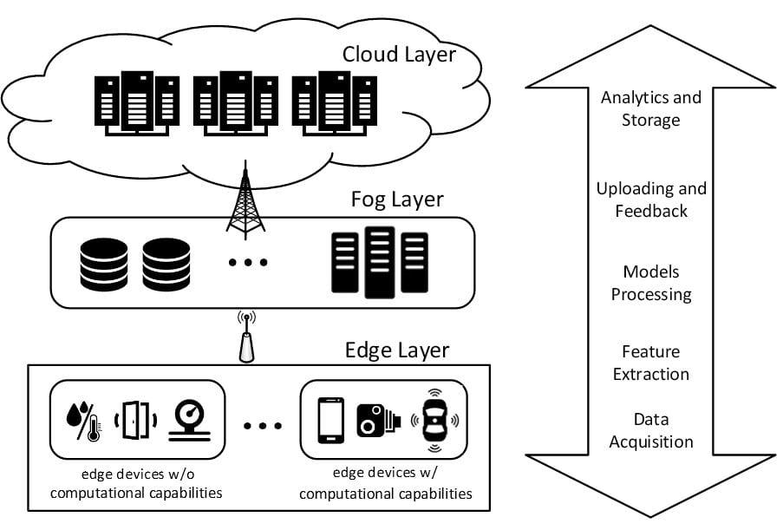

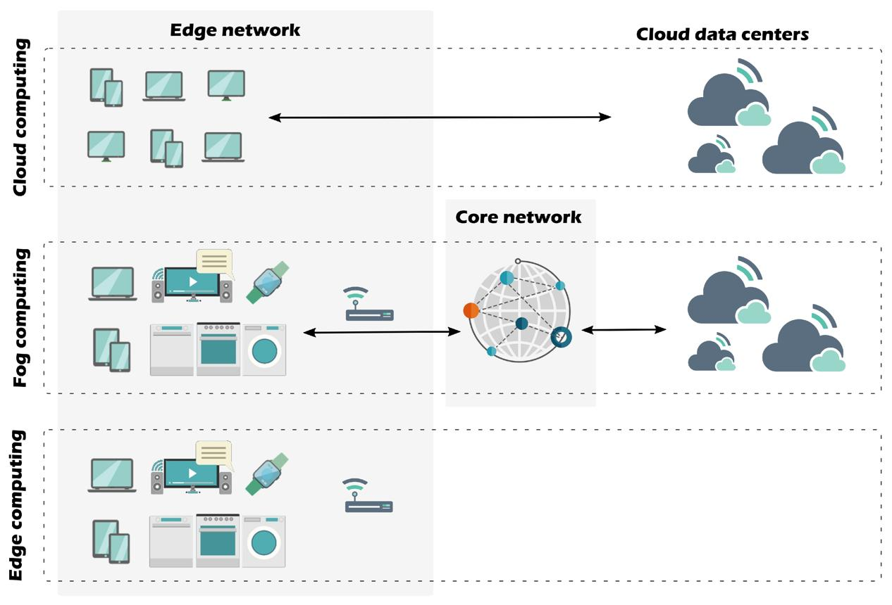
6
IoT systems generate huge data. Sending everything to the cloud causes:
- High latency
- More bandwidth use
- Slow response
So, Edge and Fog computing process data closer to devices.

🖥️ A. Edge Computing
Processing happens directly on the device or very close to it.

Examples:
- Smart cameras doing face recognition on-device
- Autonomous cars processing sensor data locally
- Routers performing data filtering

Advantages:
- Ultra-low latency
- Offline processing
- Reduced cloud load

🌫️ B. Fog Computing
Processing happens on a local intermediary node called a fog node (routers, gateways).

Examples:
- IoT gateway analyzing sensor data before sending
- Local servers in factories

Advantages:
- Faster than cloud
- More powerful than edge devices
- Distributes computing

🔍 Difference Between Edge & Fog
Feature | Edge | Fog
Processing | On device | Gateway / local server
Latency | Lowest | Low
Power | Limited | More powerful
Example | Smart camera | Industrial gateway

⚙️ 6. DevOps
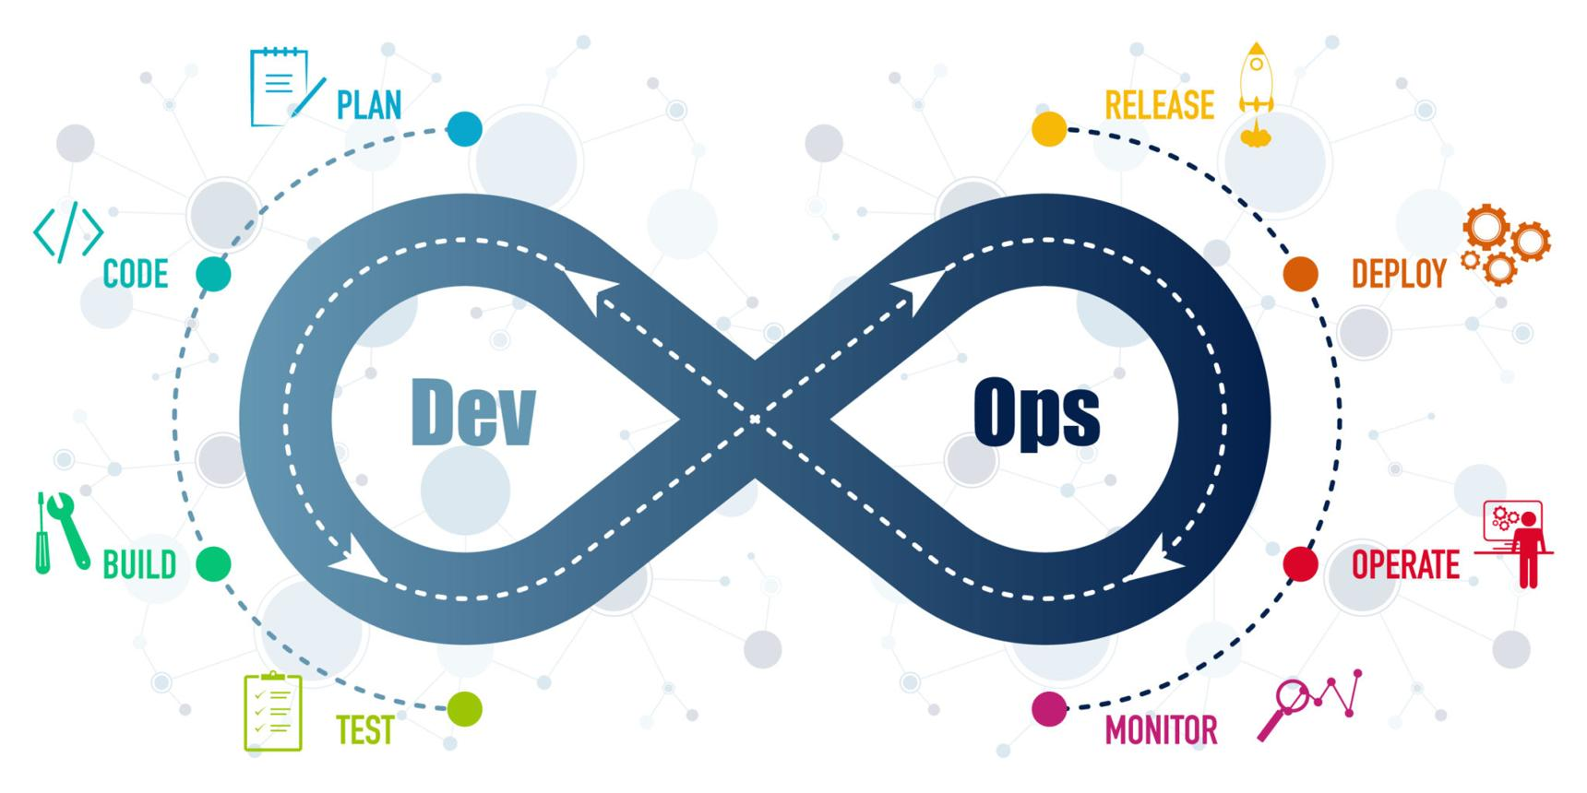
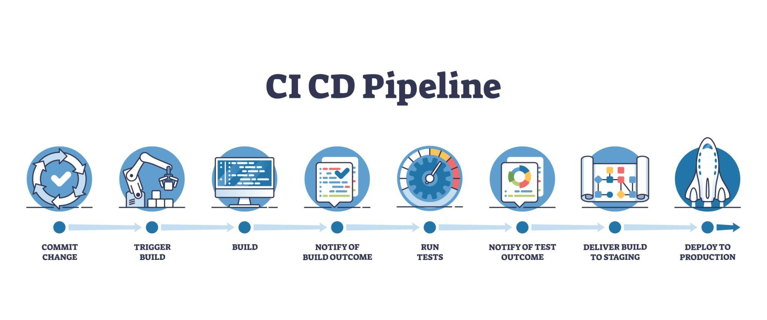
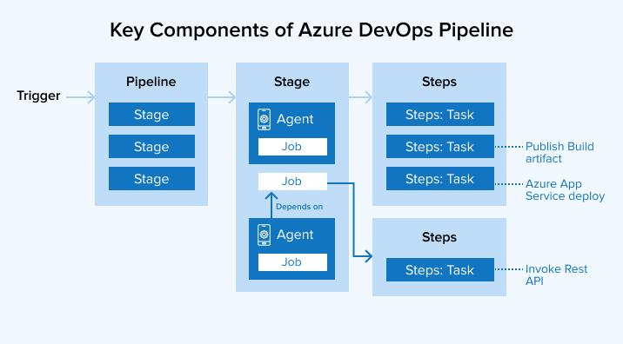
5

✅ Definition
DevOps = Development + Operations
A culture and set of practices to:
- Automate software development
- Improve deployment speed
- Enhance reliability

🔁 DevOps Lifecycle
- Plan
- Code
- Build
- Test
- Release
- Deploy
- Operate
- Monitor

🛠️ DevOps Tools
- Version Control → Git
- CI/CD → Jenkins, GitHub Actions
- Containers → Docker
- Orchestration → Kubernetes
- Configuration Management → Ansible
- Monitoring → Prometheus, Grafana

🏗️ 7. Infrastructure-as-Code (IaC)
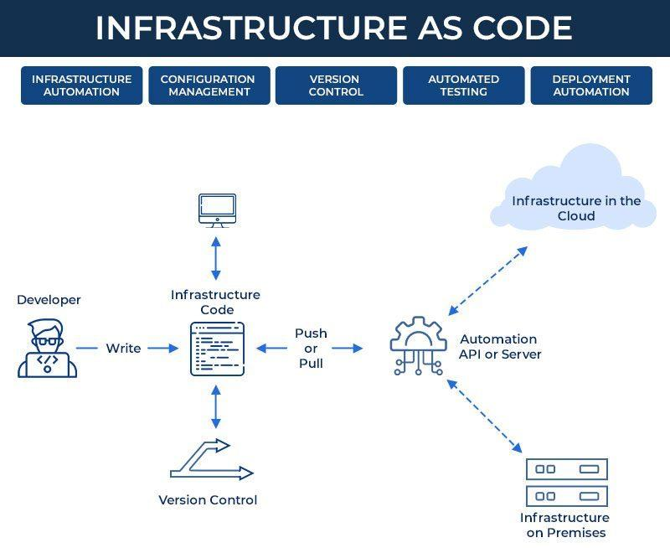

5

✅ Definition
Infrastructure-as-Code (IaC) is the automation of cloud infrastructure using machine-readable configuration files instead of manual setup.
You write code → tools create servers, networks, databases automatically.

Benefits of IaC
- Reproducibility
- Faster deployment
- Version-controlled infrastructure
- No manual errors
- Easy rollback

Tools
- Terraform
- Ansible
- CloudFormation
- Puppet
- Chef

🧬

8. Quantum Cloud Computing

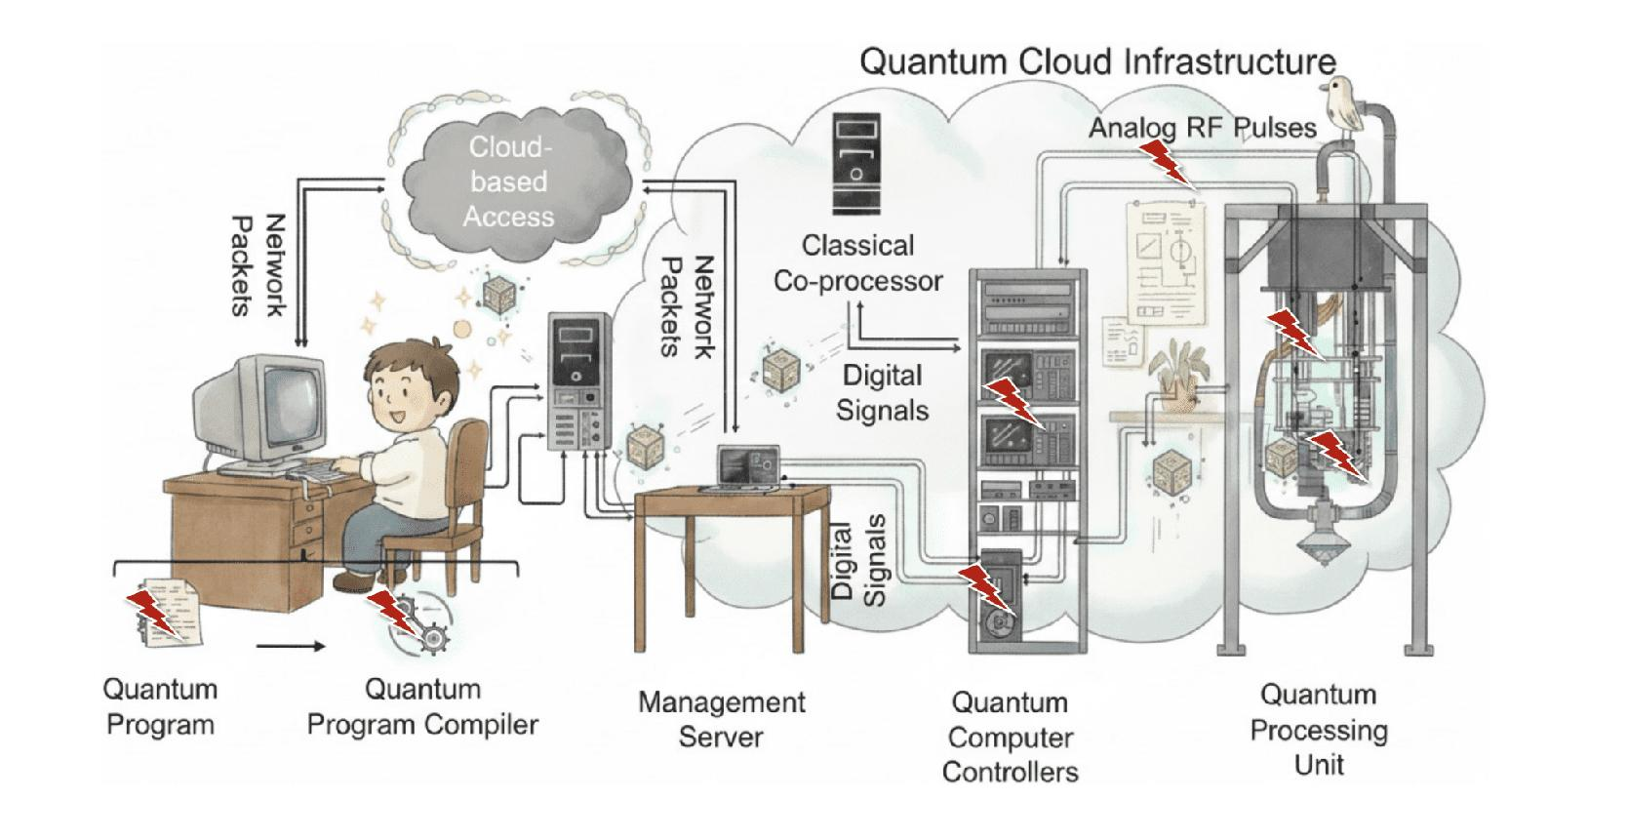
7

✅ Definition
Quantum cloud computing allows users to access quantum computers through the cloud without owning expensive hardware.

Quantum computers use qubits, not classical bits.

Cloud Providers for Quantum Computing
- IBM Quantum
- Amazon Braket
- Google Quantum AI

Why Quantum Cloud?
Quantum computers are extremely expensive and delicate.
Cloud access allows:
- Remote experiments
- Pay-per-use
- Scalable quantum simulations
- Education and research access

Applications
- Cryptography
- Optimization
- Drug discovery
- Material science
- Financial modeling

📘

