Repriori
Plan and Design — a living document, built phase by phase

Document Control
Rev | Date | Phase completed | Summary of change
0.1 | 2026-09-05 | Roadmap | Comprehensive 54-phase / 11-milestone roadmap reviewed and approved with Rasam.
0.2 | 2026-09-05 | Phase 1 | Solution skeleton created: Repriori.slnx, /src, /tests, /docs, .gitignore, README.md.
0.3 | 2026-09-05 | Design refinement | Before any workflow code was written: added concurrency rules for Host.Project, the DD↔CRCO linking/trigger model, document identity/renaming/deletion rules, an explicit R&R attribution confirmation, and Part 6 (state diagrams). Parts 2 and 3 revised; Roadmap and Phase 1 renumbered to Parts 7 and 8.
0.4 | 2026-09-05 | Roadmap alignment | Part 7 phases 11, 20 and 36 reworded so the roadmap itself matches the 0.3 design changes: Phase 11 now names concurrency-safe numbering and the DD↔CRCO link/trigger; Phase 20 adds the justified delete command; Phase 36 describes watching DD and activating a Scheduled CRCO, replacing the old one-way "CRCO waits for DD" wording.
0.5 | 2026-09-05 | Design refinement | Part 2.9 revised: a CRCO project never requires a DD project — it can be created fully standalone and linked to (or unlinked from) a DD project at any later point, in either direction; Diagram 4 redrawn to show the standalone path. New Part 2.11: a prototype-only Super Admin role that can force any gate in any workflow, always via a mandatory, permanently-logged justification commit. Roadmap phases 11, 20, 27, 32 and 33 updated to match.
0.6 | 2026-09-05 | Documentation restructure | This document stops growing a Part per phase. Part 8 (the Phase 1 walkthrough) is removed from here and now lives, expanded with full beginner-level detail, in docs/milestones/Repriori_Milestone_00_Foundations.docx alongside Phase 2. Every future milestone gets its own document the same way; this document stays the fixed index (Parts 1–7) only.

How to Read This Document
This document is the index, not the build log. Parts 1 to 6 are the fixed design chapters — written once, up front, and still revisable (as they were through revision 0.5) for as long as no workflow code has been built against them yet. Once a Part's rules are actually implemented, later changes to that rule are made as a new, dated addition, not a silent rewrite. Part 7 (the roadmap) is expected to keep changing indefinitely, via its checkbox-style status.
As of revision 0.6, each milestone's full build log lives in its own separate document, under docs/milestones/ — for example docs/milestones/Repriori_Milestone_00_Foundations.docx. This document never grows a "Part 8, 9, 10…" again; instead, Part 7 links to each milestone document as it is written. If a change is needed to something already built in a milestone, it is made inside that milestone's own document, version-controlled on its own — this document and the other milestones' documents are never touched for it.
Every milestone document follows the same shape, per phase: what you're building and why, step-by-step instructions, one heading per file created (with the full file content and a walkthrough of what it does and why), the concepts behind each step explained for a beginner, the exact commands to run to verify the phase worked, a troubleshooting section for anything that actually went wrong while building it, and an explicit list of what is deliberately not built yet.
This document lives at docs/Repriori_Plan_and_Design.docx and is versioned in Git like any other file in this repository.

Table of Contents

Part 1 — Purpose and Scope
Repriori is a small, self-hosted programme-management tool for running SaMD (Software as a Medical Device) design and change work through defined stage gates, with documents moving through a controlled lifecycle, in a way that stays audit-friendly without adopting a full commercial eQMS.
It exists because Rasam wants to run real Design & Development (DD) and Change Request / Change Order (CRCO) programmes, with their document control, gates, approvals and traceability, as working software rather than spreadsheets — while keeping every piece small enough to build, test and understand independently.

1.1 In scope
- Project: a numbered, typed (DD | CRCO | Innovation) unit of work that owns links to documents and to its own R&R (roles & responsibilities) list.
- DD workflow: a JSON-defined sequence of gates (typically PR1–PR4), each with a document stack and/or named-role approvals, each gate advance recorded as an immutable, noted commit.
- CRCO workflow: the same gate/commit mechanics as DD, started as a sibling of a DD project, optionally scheduled to begin only once DD reaches a defined point.
- DocStatus workflow: every controlled document's own lifecycle — Pre-draft (automated format check) → Draft (content approval) → Review (reviewer sign-off) → Approval — shared across every project that references that document.
- Document format checking: an automated comparison of a submitted Word document's structure, styles, fonts, tables, comments and tracked changes against a JSON "golden profile", gating entry into Draft.
- R&R: a versioned, per-project role → person list, plus an organisation-wide memory used only to suggest names, never to auto-assign them.
- A web front end that is a pure HTTP client of the above — never a second copy of the rules.

1.2 Out of scope (for this prototype)
- Innovation projects: recognised (they get a project number) but this system does not run a process for them — that process is defined later, elsewhere.
- Pixel-perfect layout checking (exact margins to the millimetre, "looks like the template") for PDF submissions — PDF format checking stays structural only.
- 21 CFR Part 11-style electronic signatures — gate and document approvals are attributed and logged, but this is not a qualified e-signature system.
- A full IEC 62304 / ISO 13485 Quality Management System — Repriori is the tool that executes a defined workflow; the QMS write-up describing how that maps to the standards is a separate, later, documentation-only deliverable (Milestone 10).

1.3 What "done" looks like for the prototype
A working DD project and a working CRCO project can each be driven end-to-end from a browser: created, moved through their gates with real document approvals gating progress, with every gate commit and document transition visible, queryable over HTTP, and never lost — running against Rasam's own Azure subscription, on Rasam's own domain.

Part 2 — The Workflow and Change-Control Policy

2.1 Project is the root
Nothing happens without a Project. Creating one assigns a permanent, never-reused number (for example PRJ-2026-00412) and a type: DD, CRCO, or Innovation. The type is exclusive and never changes — a DD project that later needs change control gets a second, linked CRCO project, not a type change.
Type | What starts | In this system
DD | One DD workflow instance, gates from that project's DD definition (typically PR1–PR4) | In scope
CRCO | One CRCO workflow instance, gates from that project's CRCO definition | In scope
Innovation | A number only — no gates, no stacks | Out of scope / free zone

2.2 Gates are commits, not labels
A DD or CRCO instance is a cursor moving across the gates its definition lists. Each gate has a document stack, a set of named-role approvals, or both. Leaving a gate requires every stack item for that gate to be satisfied, every stack item for every earlier gate to still be satisfied, and a gate commit: a decision, a required note, the signers, a timestamp, and a snapshot of the evidence. A gate commit is never edited or deleted. If an earlier document later regresses (sent back to Draft, say), the instance becomes Blocked until it is fixed and a reaffirm commit is recorded — history is never rewritten to pretend the regression didn't happen.

2.3 CRCO waits for DD — as programme policy, not a CRCO feature
CRCO must be able to run entirely on its own (so it can be tested and used standalone). The rule "CRCO may not start until its related DD is Completed or explicitly marked Not Required" is therefore enforced one layer up, by the composing host (Integration), never inside the CRCO package itself.

2.4 Documents are shared across projects
A document has its own id and its own DocStatus lifecycle, independent of any one project. A project's gate stack can point at a brand-new document or reuse one already living in Draft, Review or Approval on another project. There is exactly one lifecycle per document: if project A sends a shared document back to Draft, every other project whose gate stack depends on it can become Blocked. The GUI shows this as a badge — "also in PRJ-19 · Draft" — rather than silently duplicating the file.

2.5 Cancel means archive, never delete
Cancelling a project freezes its gates (no further commits) but nothing is removed: documents, their approval history, and every other project's links to them stay exactly as they were. A cancelled project remains fully readable for audit and DHF purposes, forever.

2.6 The document lifecycle and the format-check gate
Every controlled document moves through the same four stages, regardless of which project's stack it appears in:
Stage | What advances it
Pre-draft | Automated format check: the submitted .docx is compared against a JSON "golden profile" (headings, styles, fonts, tables, TOC, comments, tracked changes). A failed check cannot enter Draft.
Draft | One named role approves or rejects the content.
Review | A predefined list of reviewers all sign off.
Approval | One final commit — the document becomes Approved.
The format checker (Milestone 1's own document, docs/milestones/) is deliberately the very first thing built in this project — it has no dependency on Project, DD, CRCO or even DocStatus, and is genuinely useful as a standalone command-line tool on day one.

2.7 Composite and reference documents
Two distinct relationships exist between documents, and they are never mixed. "Composed of" means one document literally is several others (DOC-200 = DOC-201 + DOC-202 + DOC-203); by default a composite cannot reach Approved while any part is not Approved. "References / defers to" is a trace link only, for the DHF — it does not by itself force approval of the referenced document unless that document also separately appears as a stack requirement.

2.8 Concurrency and asynchronous access
The console and the GUI are equally first-class callers of the same commands — neither is a special path. Creating projects rapidly in a loop from the console (or from any script driving Host.Project's classes directly) must succeed exactly as reliably as one person clicking "New project" in a browser, including when both happen at the same moment.
This is a store design rule, not a UI rule: project number allocation is a single atomic operation at the database layer (an auto-incrementing key or an atomic sequence with a uniqueness constraint), never an in-memory counter guarded by application code. An in-memory counter is the one design that silently breaks under concurrent or scripted access — two requests can read the same "next number" before either writes it back, handing out a duplicate. Every host built from Milestone 3 onward is tested for this specifically: a burst of concurrent create calls must produce that many distinct, gapless-or-documented project numbers, never a duplicate and never a silent failure.

2.9 Linking a CRCO project to a DD project (optional, either direction)
A CRCO project never requires a DD project. It can be created entirely standalone — numbered, Active, running its own gates — with no DD project involved at all, ever, exactly like any other project type in Part 2.1. Separately, a DD project may choose, at creation or at any later point in its life, when — if ever — a linked CRCO project should start:
Choice | What happens
Now | A CRCO project is created immediately and starts Active, as a sibling linked to the DD project.
At a specific DD gate (e.g. PR3) | A CRCO project is created immediately in a Scheduled state, carrying a triggerGate. It automatically becomes Active the moment the DD instance's cursor reaches that gate.
Postponed / decide later | No CRCO project is created yet. The same choice is offered again at any later point in the DD project's life — there is no deadline and no default that fires on its own.
The link itself is a separate, optional, reversible action on top of either path — not a one-time decision baked into how a CRCO project came to exist. A CRCO project created standalone can be linked to a DD project later, if and when one exists. A CRCO project created via a DD's trigger can later be unlinked. Either direction, at any time, is just editing the link between two existing project numbers; it never touches either project's own gates, commits, or state.
Diagram 4 (Part 6) shows all of this as one state diagram. The important architectural point is where the rule lives: the choice, the trigger condition, and the DD↔CRCO link are all data owned by Host.Project (or Host.Integration for a live programme run) — never logic inside Workflow.DD or Workflow.CRCO. Both workflows stay fully standalone: CRCO can always be created, run and tested with no DD project in existence at all, and DD never calls into CRCO or checks whether one exists. Only the composing host acts on the link.

2.10 Document identity, renaming, and deletion
A document's id is assigned once, is permanent, and is what every gate stack, composite relationship, and reference link actually points to. A document's name (its display title) is a separate, ordinary, mutable attribute — renaming a document at any stage changes nothing else: not its id, not any link or reference to it, not its position in any project's stack.
Deleting a document is allowed at any stage, but it is a deliberate, terminal, justified action, not a quiet removal. It is recorded exactly like a gate commit: who, when, and a mandatory note stating why. The document moves to a terminal Deleted state. Nothing about its history is ever removed — its id, its full name history, and every prior approval, review and commit it ever received stay in the database permanently, exactly as a cancelled project's records do (Part 2.5). What deletion actually removes is the option to act on the document any further, and, if the decision note says so, the stored file itself; the record that the document existed, carried that id, and reached that state — with that justification, attributed to that person, on that date — never does.

2.11 Super Admin override (temporary, prototype-only convenience)
A small, explicitly designated Super Admin role can force any gate, stage, or transition in any workflow — DD, CRCO, or DocStatus — to advance, regardless of whether its normal requirements (document approvals, reviewer sign-off, named-role approvals) are actually satisfied. This exists so development and demoing are never blocked while the real approval chains around it are still being built out, phase by phase.
An override is never silent. It is recorded exactly like any other commit: who (the specific Super Admin account), when, and a mandatory note explaining why the bypass was used. It appears in that gate's history as an AdminOverride commit, permanently, alongside ordinary commits — not hidden, not reversible, and not distinguishable in the audit trail from any other recorded decision except by its type. A bypassed gate's normal requirements are never retroactively marked satisfied; the record honestly shows what actually happened: an admin overrode the gate, on this date, for this reason.
Super Admin is a system-level flag on a user account, not a per-project R&R role (Part 3) — it is never suggested by the org-memory autocomplete and never appears in any project's ordinary role list. For the prototype, until Milestone 9 brings real authentication, it is simply a short allow-list of names in each host's own config, the same identity used for the Milestone 8 dev-only login — not a full identity/authorisation system. Hardening who may hold this role, and deciding whether it survives once real approval chains are trusted end to end, is a decision for a later phase, not this one. Treat it, for now, as a deliberately blunt, fully-audited escape hatch — never a foundation to build workflow logic on top of.

Part 3 — Roles and R&R
R&R (Roles & Responsibilities) is a capability of Project, not a fourth workflow. Every project — DD, CRCO or Innovation — has its own role → person list.
Layer | Where | Purpose
Project R&R | Host.Project database | Who holds which role on this project, right now.
R&R versions | Same database | Every change is a new version (who, when, an optional note). Rows are never overwritten.
Org memory | Same database, organisation-wide | Distinct roles and names seen on any past project, used only to suggest values on a new one.
A gate commit stores its signers as plain strings at the moment of commit. If Quality changes from Alice to Bob the day after PR1 is committed, PR1's record still shows Alice signed it — R&R changes only ever affect gates ahead of the current cursor, never behind it.
Suggestions (most-used roles across all projects, most recent name used for a given role) are autocomplete only. Nothing is ever auto-assigned.

3.1 Confirmed: the project team can change; past sign-offs cannot
The project team (its R&R list) may be changed at any stage of a project's life, by any authorised edit, with no restriction — this is unchanged and explicitly confirmed. What never changes is the historical record: every gate commit and every document approval or review sign-off permanently keeps the name and role that actually signed it, at the moment it was signed. Replacing Quality's Alice with Bob the day after PR1 is committed does not touch PR1's record — it still reads Alice, forever. R&R edits only ever take effect on gates and approvals that have not happened yet.

Part 4 — Versioning
Two completely different things are called "version" in this project, and they are kept apart on purpose.

4.1 Code / release versioning
Each shippable package (a class library, a console tool, an API host, the web app) is versioned and released the same way CalcSaMD was: GitVersion computes a SemVer number from the Git history on every push to main, a GitHub Actions release pipeline builds once and promotes the same artifact through DEV → QA → UAT → PROD, and every release is appended to that package's own RELEASE_LOG.md — auto-written, never hand-edited, one entry per release with the commit SHA, the Actions run URL, and who approved each gated environment.

4.2 Workflow definition versioning
Gates and document stacks are authored as JSON files in Git, reviewed by pull request like code. Publishing a JSON definition snapshots it into that workflow's database as an immutable DefinitionVersion. A running instance is pinned to the DefinitionVersion that existed when it started and never silently jumps to a newer one.
Change | Example | In-flight behaviour
Compatible | Move a required document from PR2 to PR3; add or remove a future-gate document; change the approvers list on a gate not yet committed. | Same instance keeps running. Already-closed gate commits are untouched. From the current gate forward, the new stack applies (recorded as a DefinitionPatch).
Breaking | The number of gates changes; a gate's id or name changes; a gate that already has a commit is renamed or removed. | Never silently applied. Either the instance stays pinned to its original definition until it finishes, or an explicit supersede-and-remap is performed: the old instance is frozen, a new instance is created on the new definition, and old gate commits are copied across as historical evidence under an explicit human-supplied gate map.
The default behaviour for the prototype is: pin, apply compatible patches going forward, and never auto-migrate a breaking change. Supersede-and-remap is only implemented once it is actually needed on a live programme.

Part 5 — Technology Stack and Why
Concern | Choice | Why
Language / runtime | .NET 10, C#, nullable + implicit usings on | Same as CalcSaMD; Rasam's Visual Studio 2026 is already set up for it.
Solution format | .slnx, one monorepo | Matches CalcSaMD; each folder under /src is still independently deployable.
Backend hosts | Plain class libraries + console executables + ASP.NET Core Minimal APIs | Domain logic is written and tested first with no console or HTTP involved; a console wraps it as the first access point; a Minimal API wraps the same service calls last. Neither wrapper contains rules of its own.
Web UI | ASP.NET Core Razor Pages, calling the backend APIs over HttpClient only | Matches Rasam's preference over Angular; talking to the backend only over HTTP is what keeps the UI genuinely separate from it; the existing repriori-web HTML mockups map onto Razor Pages one page at a time.
Local database | SQLite, one file per host | Zero setup for local development; never shared between packages.
Cloud database | Azure SQL Database, one per host | Swapped in behind each host's store interface once that host is actually deployed — not a rewrite.
File storage | Local disk in development, Azure Blob Storage in the cloud | For uploaded Word/PDF documents.
Tests | xUnit, one test project per package | Matches CalcSaMD.
CI/CD | GitHub Actions, GitVersion, Terraform, OIDC login to Azure, DEV/QA/UAT/PROD environments with required reviewers, auto-written RELEASE_LOG.md | Identical, proven pattern to CalcSaMD.
Documentation | docs/Repriori_Plan_and_Design.docx (index) + one document per milestone under docs/milestones/ | CalcSaMD used one growing document; Repriori's 54-phase scope is split so each milestone is a self-contained, beginner-focused document, changed only on its own.

5.1 Package independence rules (non-negotiable)
- Every workflow package (Project, DocStatus, DD, CRCO) owns its own model, database, console, tests, version and README. None of them reference each other at compile time.
- Repriori.Contracts is the only shared, compiled package — small, versioned, additive-only nouns and shapes (ProjectRef, DocumentRef, GateCommitDto, EventEnvelope). Display text and gate labels live in a glossary JSON file, never in the compiled contract.
- Later glue between packages is HTTP calls or file-based events — never a shared database, and never passing live objects between packages.
- Every host exposes both commands (change something) and queries / a snapshot endpoint (read everything about one instance), documented with OpenAPI, so scripts, other tools, and AI agents can read state without ever touching a database directly.
- Every successful state transition writes an outbox event. Only Host.Integration ever subscribes to another package's events — a workflow package never listens to another workflow package.

Part 6 — State Diagrams
Four state diagrams covering the core mechanics described in Parts 2–3, drawn to match this document's terminology exactly. These are the reference to check any implementation against from Milestone 3 onward — if a host's actual behaviour ever disagrees with one of these diagrams, the diagram (or a documented, deliberate phase that changes it) wins, not an assumption made while coding.

6.1 Project lifecycle
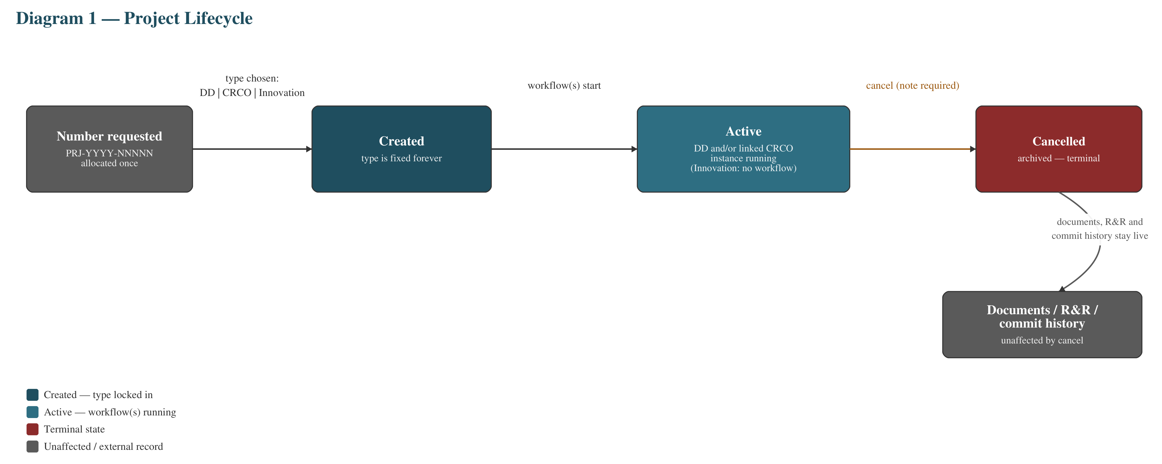
Every project, regardless of type, moves through exactly these states. Cancelling is the only transition out of Active, and it is one-directional and terminal — see Part 2.5.

6.2 DD / CRCO gate progression
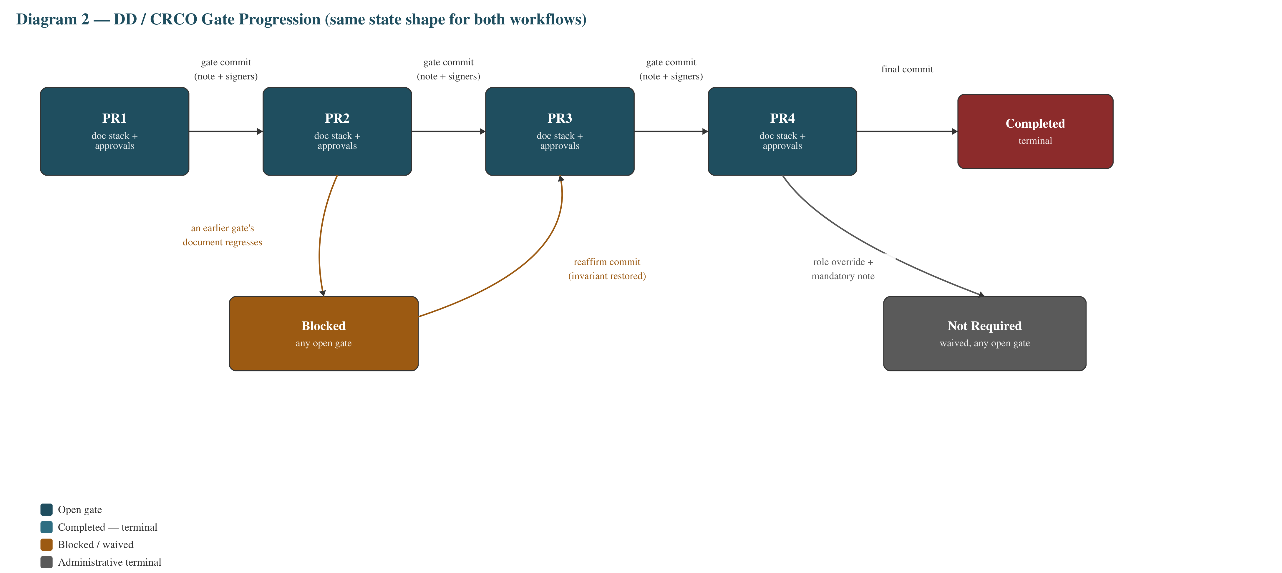
DD and CRCO are two separate packages, but they share this exact state shape. Blocked and Not Required are shown once each here as a representative transition — in reality either can be reached from any open gate, not only the one drawn (Part 2.2).

6.3 DocStatus document lifecycle
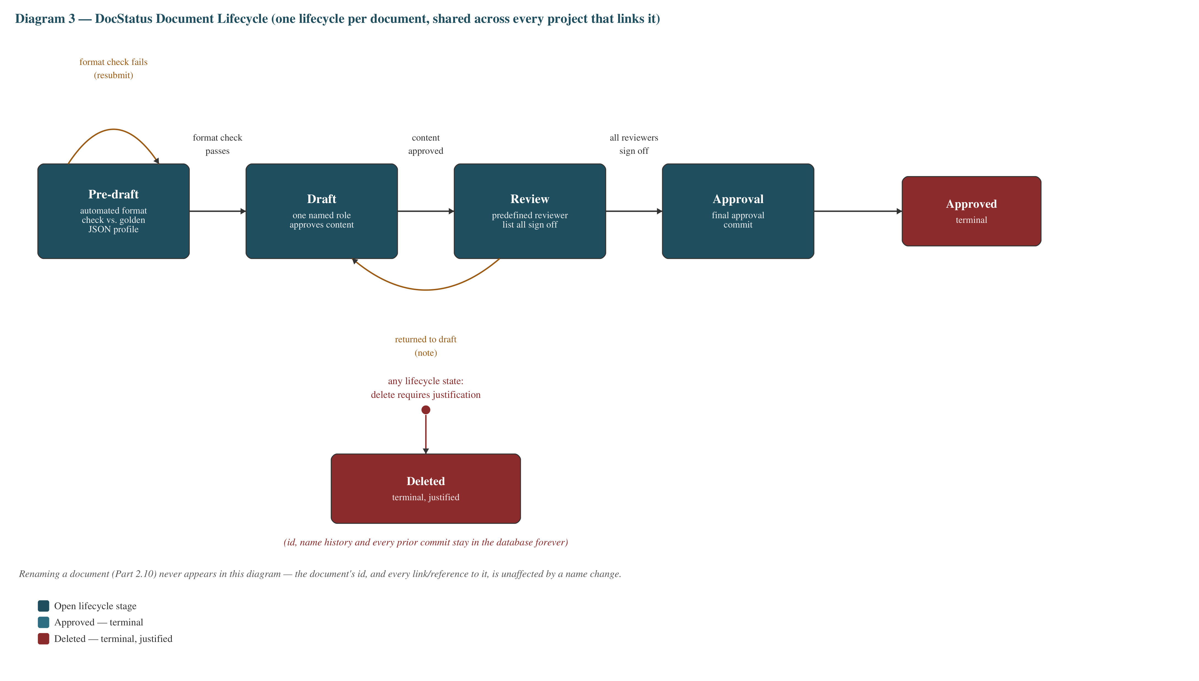
One lifecycle per document, shared by every project stack that references it (Part 2.6). Deletion (Part 2.10, added at revision 0.3) is reachable from any state on the top row, drawn once here as a single labelled transition rather than four separate arrows, purely to keep the diagram legible.

6.4 Linking a CRCO project to a DD project
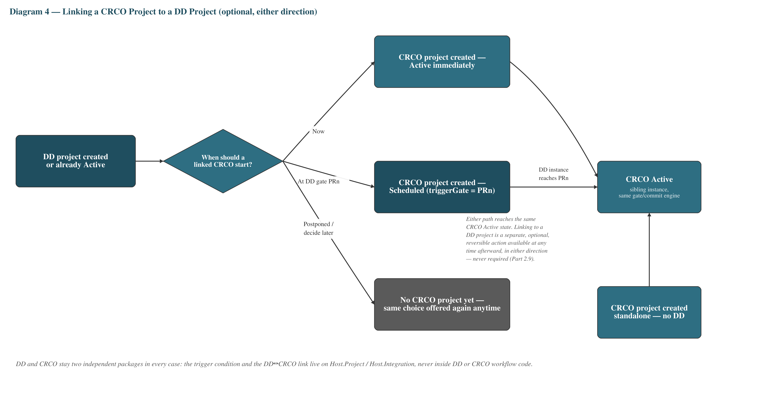
The trigger choice and the standalone entry point from Part 2.9 (revised at 0.5), replacing the earlier simple "CRCO waits for DD" assumption. A CRCO project reaches the exact same Active state whether it started standalone or via a DD's trigger — the link between the two, shown as a separate reversible action in the diagram, lives outside both workflow packages entirely.

Part 7 — The Phase Roadmap
54 phases across 11 milestones. Order reflects dependency, not a fixed calendar. Each milestone is documented in full, in its own document under docs/milestones/, only once it is actually executed — this Part is the index, kept current, not the detail.

Milestone 0 — Foundations
Done — full walkthrough: docs/milestones/Repriori_Milestone_00_Foundations.docx
1. Solution & repo skeleton — empty .slnx, /src /tests /docs layout, .gitignore, root README.md.
2. GitHub repo setup — push, branch protection on main, DEV/QA/UAT/PROD environments with reviewers.

Milestone 1 — Document Comparer / Format Profile module (ships first, zero dependencies)
3. Repriori.DocProfile class library — turn WordprofileExtractor.cs into a tested library; WordFormatComparer.json becomes the versioned profile schema.
4. Sample .docx fixtures + Repriori.DocProfile.Tests (xUnit).
5. Repriori.DocProfile.Cli console tool — extract <file.docx> -o profile.json.
6. Profile comparer / diff engine — submission profile vs. golden master, configurable pass/fail rules.
7. compare console command — human-readable diff report and exit code.
8. CI pipeline for this package alone (GitHub Actions build + test).

Milestone 2 — Shared contracts
9. Repriori.Contracts class library — ProjectRef, DocumentRef, GateCommitDto, EventEnvelope, ProjectType.
10. glossary.json + contract serialization tests.

Milestone 3 — Host.Project (numbering, type, cancel, links, R&R)
11. Domain model + SQLite store (IProjectStore) — concurrency-safe numbering (Part 2.8), exclusive type, cancel = archive, project↔project links incl. the DD↔CRCO start-trigger choice, linkable/unlinkable at any time in either direction (Part 2.9).
12. Console commands: create / list / show / cancel / link.
13. R&R domain + store — versioned role → person list, org-wide suggestion catalogue.
14. R&R console commands.
15. Minimal API (commands + queries) + OpenAPI for Project + R&R.
16. Unit + integration tests.
17. CI pipeline for Host.Project.

Milestone 4 — Workflow.DocStatus (wires in Milestone 1)
18. Domain state machine + SQLite store.
19. FormatChecker gate — wires Repriori.DocProfile compare into the Pre-draft transition.
20. Console commands: submit / format-check / draft / review / approve / reject / delete (justification required, Part 2.10) / admin-override (Part 2.11) / export.
21. HTTP API + OpenAPI + outbox events (file-based).
22. Tests.
23. CI pipeline.

Milestone 5 — Workflow.DD (PR1–PR4 gates, doc stacks, immutable gate commits)
24. JSON gate/stack definition schema + publish → immutable DefinitionVersion snapshot.
25. Domain: instance cursor, gate commit (immutable), blocked/invariant rule.
26. SQLite store.
27. Console commands: init / plan / specify / design / implement / verify / export / commit-gate / admin-override (Part 2.11).
28. HTTP API + OpenAPI + outbox events.
29. Compatible-vs-breaking definition changes (DefinitionPatch; supersede + remap).
30. Tests.
31. CI pipeline.

Milestone 6 — Workflow.CRCO (same shape as DD, plus Scheduled/startAt)
32. Domain + JSON definitions + SQLite store — creatable and fully runnable with no DD project linked (Part 2.9).
33. Console commands + HTTP API + outbox events. Includes admin-override (Part 2.11).
34. Tests + CI pipeline.

Milestone 7 — Host.Integration (the only host allowed to know about the others)
35. Config/adapters calling Project/DocStatus/DD/CRCO APIs; --dry-run when a neighbour is absent.
36. Programme policy engine — watches DD gate commits and activates a Scheduled CRCO project the moment its linked DD instance reaches the chosen trigger gate (Part 2.9).
37. Scenario console (DD export → DocStatus submit → CRCO create) + run-report JSON.
38. Event relay reading each host's outbox (still local files).
39. Tests + CI pipeline.

Milestone 8 — Host.Web (Razor Pages UI, from the repriori-web mockups)
40. Razor Pages skeleton + typed HttpClient per host + CannedData fallback.
41. Sign-in + Projects list + New project pages → Host.Project API.
42. DD board page → Workflow.DD API.
43. CRCO + Innovation pages.
44. Documents pages (incl. format-check upload) → DocStatus + DocProfile.
45. R&R + Definitions + Connections pages.
46. Dev-only login + CI pipeline for Host.Web.

Milestone 9 — Azure infrastructure & deployment
47. Terraform skeleton — resource group, Azure SQL server, Blob Storage, App Service plan, reusable module.
48. Per-host App Service across DEV/QA/UAT/PROD, OIDC auth.
49. GitVersion + release/hotfix GitHub Actions per host, auto RELEASE_LOG.md.
50. Swap SQLite → Azure SQL behind each store's port interface; local files → Blob Storage.
51. Custom domain + managed TLS.
52. Scale-out validation — 2–3 instances per host.

Milestone 10 — Optional / any time after Milestone 2
53. Docs.SaMD.QMS — the IEC 62304 / ISO 13485-aligned SOP write-up (documentation only).
54. MCP adapter over the snapshot endpoints, so AI agents can query workflow state directly.

