Session 0: Navigating R and RStudio
Roy Sanderson, Will Reid
Table of contents
1. Learning objectives 1
2. Modify RStudio default settings 3
3. R packages 8
4. RStudio projects 10
5. Navigating RStudio 14
6. Download files from Canvas and import data 18
7. Working with data 23
8. Importing and exporting data 29
9. Getting help 31
10. Final steps before you finish 34
11. Take home messages from today’s practical 36
12. In your own time 37
Try to complete sections 1 to 10 of this introductory practical. Some sections are mainly reading material, so should not take too long. Please ask Demonstrators or Staff during the practical if you have any problems.

1. Learning objectives
The overall aim of this practical is to help you become more familiar with RStudio, what its main panels are for, how to download data from Canvas, and import it into R. Specific objectives include:
- explain the concept of RStudio projects to allow you to store data, files containing R commands (known as scripts), and the four main panels in RStudio
- demonstrate the value of .csv files (comma separated files) as these can be read / written by both R and Microsoft Excel, and the functions to do this.
- understand free R packages to extend the power of R. How to install and load packages for use.
- how to calculate simple summary statistics of the data you have imported into R

1.1 R vs RStudio
R is the basic underlying computer software you use to undertake analyses of biological data. RStudio is a separate programme that creates an “Integrated Development Environment” (IDE) that makes it easier to do data science. Think of the differences between doing arithmetic on a hand-calculator vs Microsoft Excel. RStudio defaults to automatically uses R, but can handle other computer languages such as C++, HTML and Python.

1.2 Starting RStudio
Campus computers have the software installed and NES2504 assumes you will be using an NUIT-managed PC. Both R and RStudio are free download from download the R software and Download the R Studio desktop software respectively. However, if you run it on your own laptop or MacBook we will not provide you with any technical support as there is too much variation between operating systems, PC configuration etc. When attending practicals you will ONLY get help for using an NUIT machine.
You should have a ‘search’ bar at the bottom left of your NUIT Windows PC, labelled Type here to search. In it type RStudio and the launch icon should be displayed for you to click on:
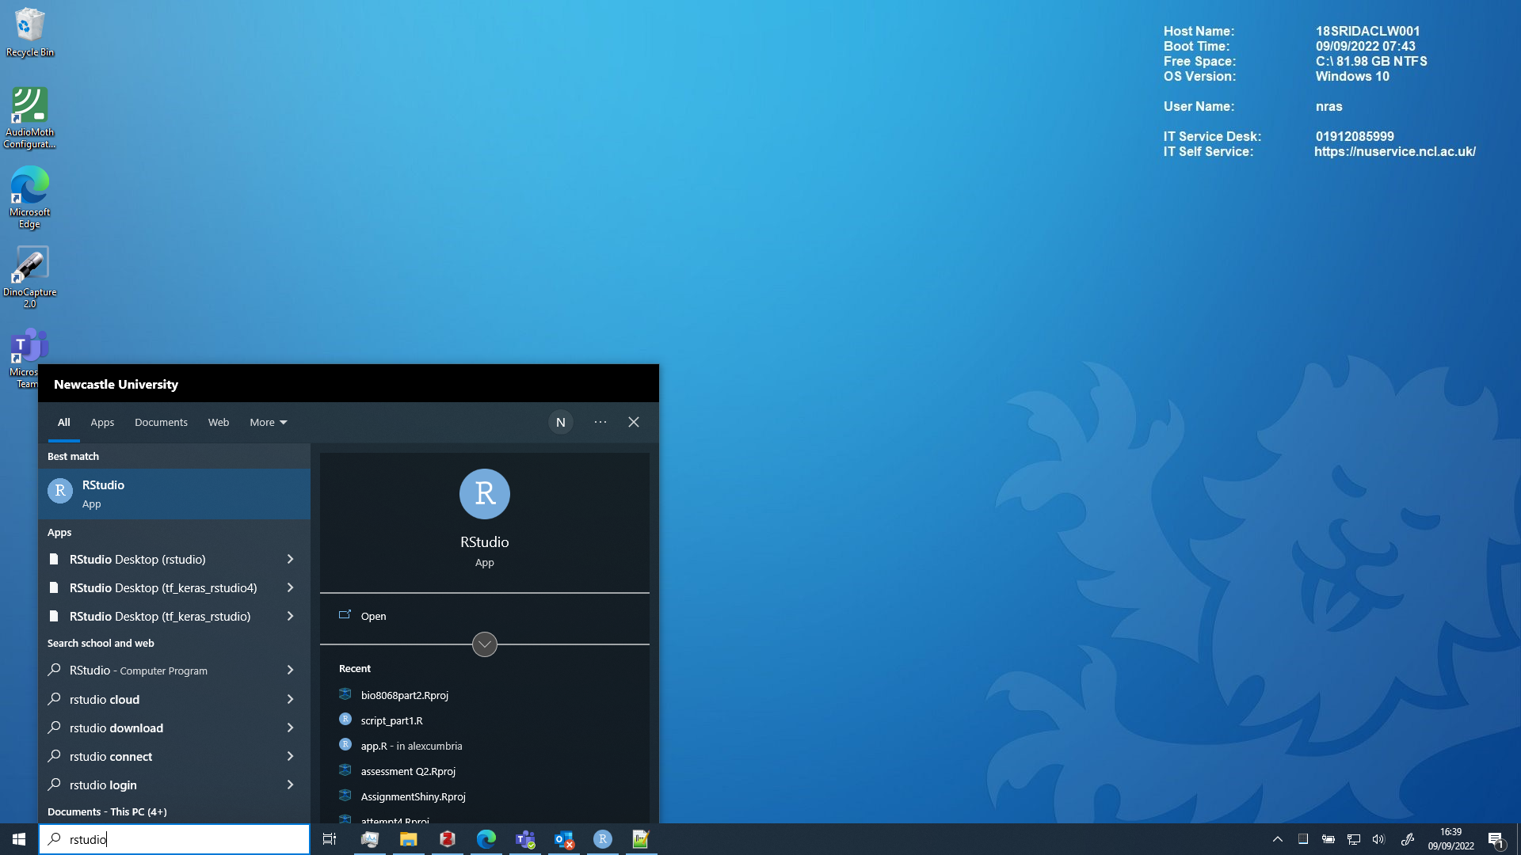
(If you do not have a search bar, click on the Windows icon, navigate to Programming and Databases or RStudio and click on the RStudio icon. Do not click on the icon labelled R i386 or R x64 )
IMPORTANT: If a popup window appears when you start RStudio click “Ignore Update”
Once RStudio has started up you can get to work.

2. Modify RStudio default settings
On opening R Studio you should see something like this
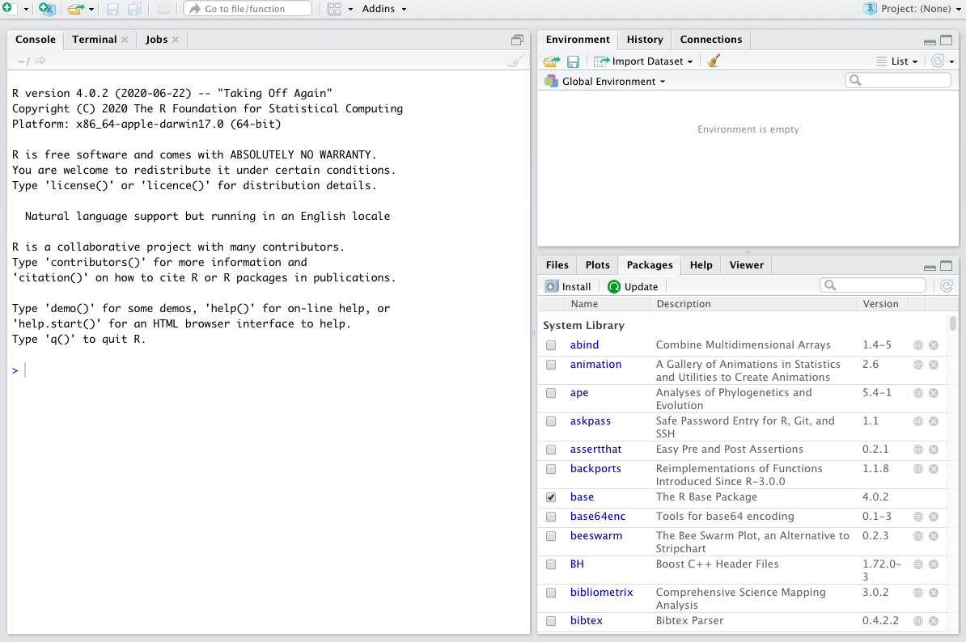
Unfortunately RStudio has a number of default settings which from past experience is confusing for students. If you suffer from dyslexia or have poor eyesight there are several other settings you may want to change.

2.1 Startup and close defaults
By default RStudio tries to re-open everything you last worked with (even if you are analysing new data), prompts you to store data (even when you have it stored already) etc. Let’s switch off those annoying defaults. From the main menu click on Tools -> Global options
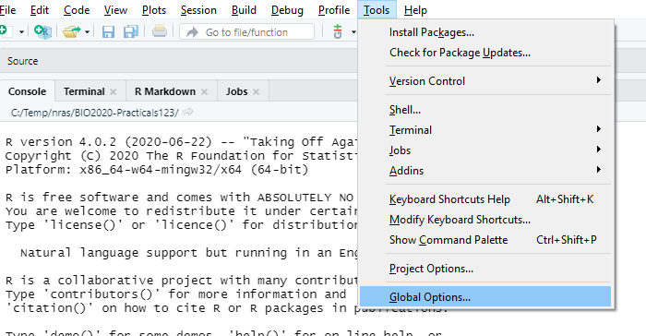
Make sure that the following boxes are unticked or changed (see below):
- Restore previously opened source files at startup
- Restore .RData into workspace at startup
- Save workspace to .RData on exit. Change to never
- Always save history (even when not saving .RData)
- Remove duplicate entries in history
Click on ‘OK’ once you have done this.
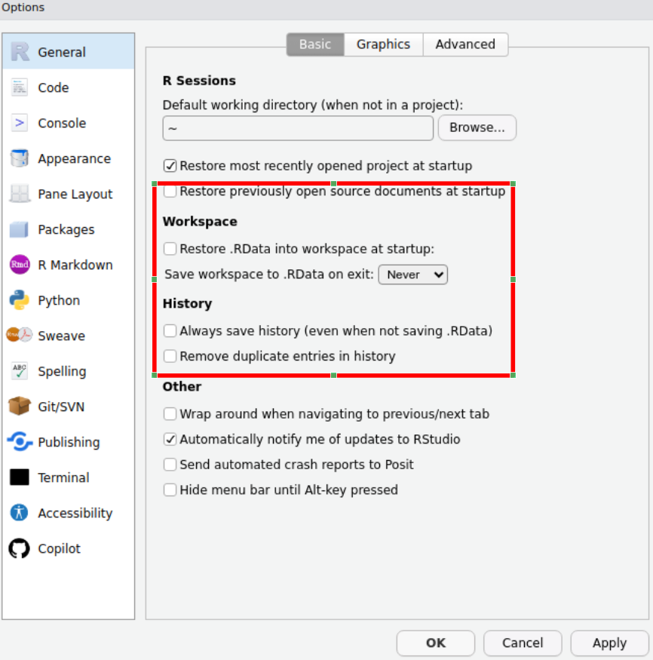

2.2 Change appearance (optional)
If like me you have poor eyesight, or e.g. have dyslexia and find some fonts difficult to read, you can modify the RStudio appearance. Again click on Tools -> Global options but click on the Appearance icon on the left. You should see something similar to below:
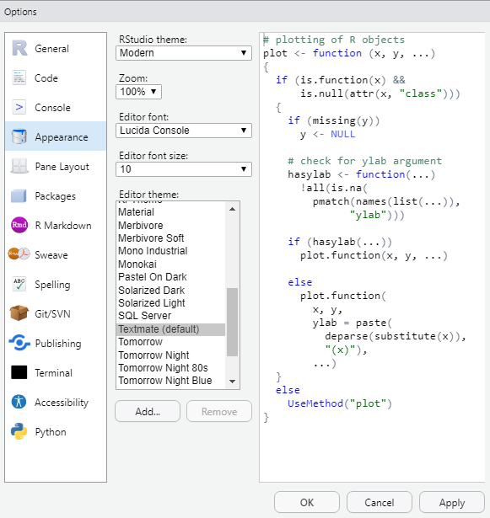
The default ‘Editor theme’ appearance is called Textmate, which I find rather harsh on the eyes. Preview other appearance options by clicking on them (personally I like the ‘Tomorrow Night bright’ theme which has a black background). You can also change the font size to make it bigger, or the Zoom ratio.
Next week: Unfortunately the NUIT computers can be unreliable in retaining user settings. If possible, try to use the same computer next week and there is a higher chance of these settings being retained. This is not an issue on personal laptops or MacBooks.

3. R packages
A package is an additional ‘plug-in’ for R that can extend its capabilities. When R was originally created there were only about 10 add-on packages, but now there are over 20,000. This is one of the reasons why it is so popular amongst scientists: it is easy to adapt, modify and improve. Here are some of the things I’ve seen people use packages for:
- create maps of satellite data
- analyse GPS animal movement data
- visualise genome sequences
- analyse next-generation sequence MinIon data
- create phylogenetic trees
- plot citizen science species records
- model flood risk
- artificial intelligence on wildlife camera trap
- analyse songbird audio
- model disease spread in humans and wildlife
- scrape data from Twitter for ‘sentiment’ analysis
- write books and reports
- create websites
Packages are hosted on the Comprehensive R Archive or CRAN. As there are now so many R packages they have been organised into Task Views on CRAN to help you navigate them.

3.1 How to install and activate a package from CRAN (Only needed for your own laptop)
Using a package is a 2-step process:
- Install a package. This downloads software from the internet onto your computer. It only has to be done once. If you use NUIT cluster room PCs the packages you need for NES2504 should already be available so you can skip this step. Use install.packages("package_name") to install a package.
- Activate a package. This makes the extra R commands available for you to use. It has to be done every time you use R. Use the command library(package_name) to activate a package.
A common mistake is to forget to use the library() command. I try to remember to use it first in any R session.

3.2 Installing the R packages needed for NES2504 (Only needed on your own laptop)
NUIT clusters should have the key packages installed, so you should be able to skip this step. You need three R packages installed initially for this module. You should only need to do the installation once on an NUIT networked PC. The three packages are:
- mosaic : this does a goal-oriented approach for plots and models
- car : this makes the output of some analyses easier to understand
- tidyr : useful for tidying up date
Console which will contain introductory text about the R version you are usin etc. On my PC it shows as version 4.0.2 but you may have a more recent version:
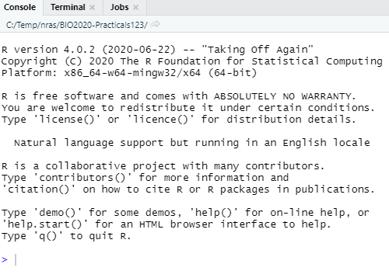
Do NOT do the following if using an NUIT machine. ONLY needed on your own laptop.
ONLY if using your own laptop: install mosaic, car, tidyr by typing the text below into the Console followed by the Enter key:
install.packages("mosaic")
install.packages("car")
install.packages("tidyr")
Normally lots of output is generated as packages are downloaded from the internet and stored on your computer. You will often see other packages being installed at the same time. This is nothing to worry about.

3.3 Activating an R package (Needed for every practical on both NUIT and personal laptops)
Use the library() function to activate an R package. Installing an R package simply puts the extra software on your PC, but it does not make it available for use. This is because you may have many packages eventually installed, that might have commands with identical names but which do different things. To take a simple example, in some packages the plot command will create a map, whereas in other packages it might display a genome phylogeny, and you would not want to confuse them. Therefore, in any R session you generally only make available the packages you need. To make the commands from a package available to use, enter the library command followed by the package name, for example as follows do not type the following yet:
library(mosaic)
library(car)
library(tidyr)

4. RStudio projects
An RStudio project is a special folder where you can safely keep all the commands for your analyses and your data files together. I generally create a separate RStudio project folder for each experiment or survey that I am involved in.

4.1 Create an RStudio project (Just needed once in this first practical)
We are going to start by creating an RStudio Project called ‘NES2504’ to keep all of our work relating to the ‘NES2504’ Data Analysis course together in one place. Later in your degree you will want to create new RStudio projects for other experiments or work.
To create a new project click on the main menu on File > New Project
You should now see this popup window, on which you should select New directory
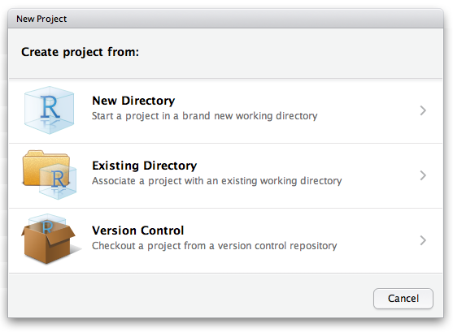
then a Project Type window like the following should appear, from which you should select New Project:
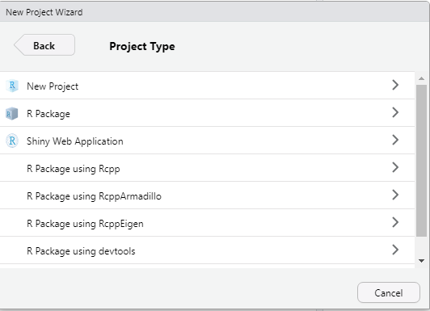
Finally, the following window, entitled Create New Project should appear:
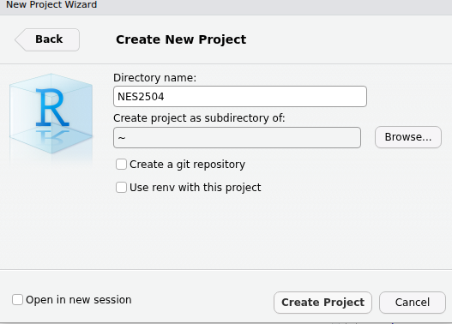
In this window complete two sections:
- The Directory name. This is the name of the folder to store your files containing records of your analyses and your data . For convenience, call it NES2504.
- The section Create project as subdirectory of: Click on the Browse button and navigate to you OneDrive folder. This will typically be called “OneDrive - Newcastle University” with a blue Cloud icon. You should store all your folders and files here so they are backed up.
Finally, click on the Create project button at the bottom and you should now see the name of your project displayed in the top right hand side of your R Studio window.

4.2 How to start RStudio with your project (all future practicals in NES2504)
Once you have created a project, all you need to do in is:
- Start RStudio
- It should automatically open your NES2504 project. If not, then: Click on File -> Recent projects… and select NES2504 from the list

5. Navigating RStudio
In the top left click:
File -> New file -> R script
and now you should have four windows that look something like this:
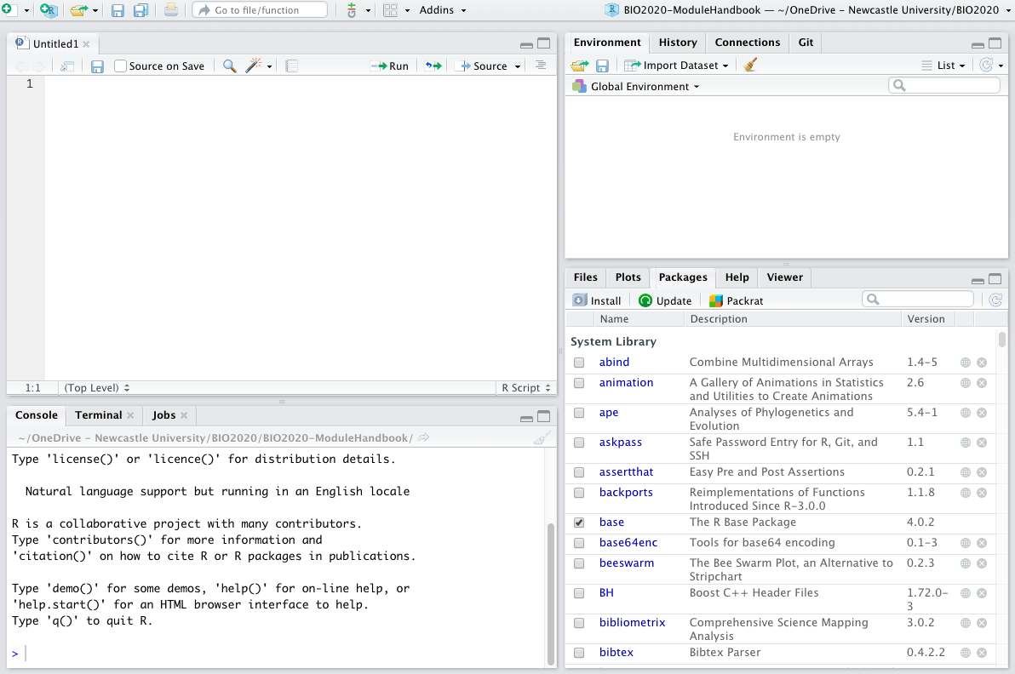
You should now have Four panes in your R Studio window, you might notice that some of them have multiple tabs as well. Let’s run through the meaning of each of the panes, and the tabs that we are going to be using:

5.1 Scripts
The pane in the top left contains your scripts. A script is a plain text file that should be saved with the extension .R and it contains a list of all the commands you use to import, summarise, display, analyse, plot or export data.
One of the key reasons that R is so popular is because it allows us to make our work reproducible. By writing down each bit of our analysis and saving it in a script we can reproduce our work with ease. Future you will thank past you for saving your code in scripts when you are making last minute edits to your dissertation and you need to remember exactly what the analysis methods you used were!

5.2 Environment
The pane in the top right has a couple of tabs but the one that we need to know about is the Environment tab. The Environment pane tells us what objects R has loaded in to its memory (we’ll touch on this a bit more later on), these might be data files that we have imported or the results of some analyses. This pane shows us the objects that R has available for doing useful stuff.

5.3 Console
The pane in the bottom left also has several tabs and the one that we use is called the console. This pane is the ‘doing pane’ when we want to run bits of code that we have saved in our script we send them to the console to be executed - which means R does what our code tells it to do and we get some output. You have already directly typed commands into the Console to setup some intial packages. In future strongly advise against doing this, it is much better to write your code in a script that you can save and come back to for future reference.

5.4 Files/Plots/Packages
Bottom right pane has several tabs that give the pane different functions that can be of use.
The Files tab can be used a bit like windows explorer/finder to navigate through the files on your computer.
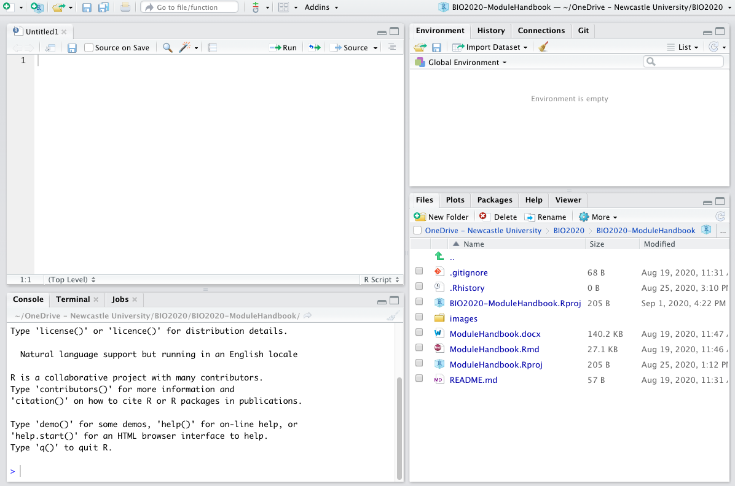
Here the files tab shows us that within the folder that we are working in there are several different files associated with the module handbook as well as a folder of images
The Plots tab is where the plots that you create using the code written in your script will appear. It has an export button that you can use to save your plots or to copy them to your clipboard so that you can then insert them into documents or presentations.
The Packages tab shows you the packages that are installed on your computer, the ones with ticks in the boxes are ones that are loaded and ready for you to use. Packages are collections of code and/or data that other people have written that we can use. Packages mostly contain bits of code called functions which we will cover in a bit more depth in the ‘working with data’ section.
The Help tab offers you an interactive window through which you can use the help files for R functions. You can use the search bar at the top of the pane to search for the help files associated with a given package or function. We will cover the help files in more detail once we have got a bit more of an understanding of some of the R lingo
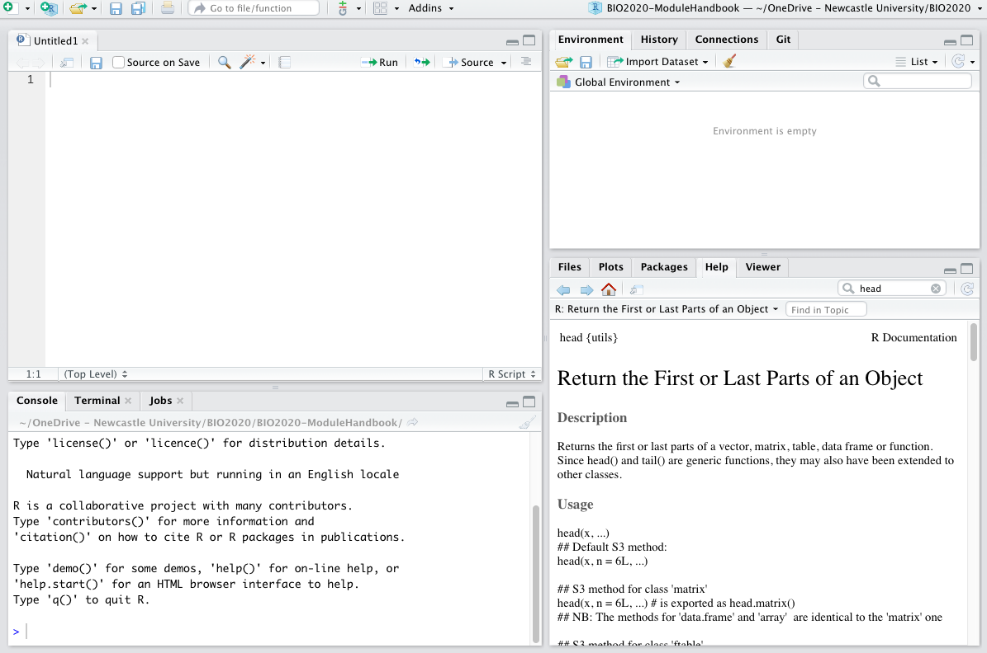
Think of R as your Kitchen
Using R can be thought of similar to using a kitchen to cook.
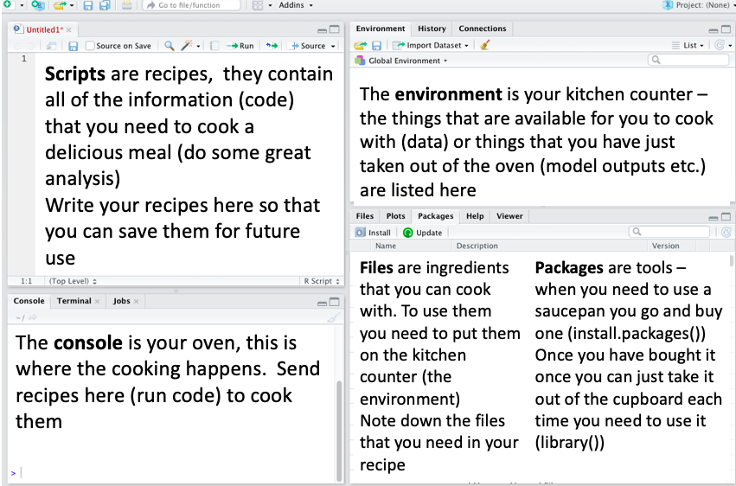
There are loads of really great chefs (coders) in the world who have already figured out a lot of techniques and gadgets that can be used to make some great food. You don’t always have to cook everything from scratch - you can use the information and tools that other people have provided to make your cooking experience easier and more enjoyable.

6. Download files from Canvas and import data
In NES2504 all of the data will be provided for you on Canvas for import into R. When you work independently, you will probably be entering data in Microsoft Excel. Either way there are a couple of ‘gotchas’ to look out for. Download the Excel File yield.xlsx from Canvas - you can open it in Excel and look at it, but don’t edit it or make any changes to it. The file contains crop growth in three different soil types.
Now, in your Script window (top left) which is probably headed Untitled1 type the following text:
library(mosaic)
pract0_dat<-read.csv("Data/yield.csv")
summary(pract0_dat)
mean(yield~soil,data=pract0_dat)
A few key points:
- Line 1: Whenever you start RStudio you will need to activate the relevant packages, so library(mosaic) ensures we can use extra functions
- Lines 2 to 4: Some R functions to read in your data file and save it in a temporary table within R called pract0_dat, produce a summary and display averages.
This is a very short piece of R commands but it is really hard to understand! Imagine iftextiswrittenlikethis then it would be hard to understand. Whereas if text is written like this it now makes sense. So we will add spaces, blank lines and comments. A comment is anything that follows the # symbol and is ignored by R, but helps you understand what you have done.
So before going further, edit your script as below to make it more readable, with comment lines, blank lines, and a space around the <- symbol, and spaces in the mean line between yield, ~, soil etc.:
# Practical 0: Revision and R basics
# Activate the mosaic package so extra commands available
library(mosaic)
# Import crop yields for different soils into a table pract0_dat
pract0_dat <- read.csv("Data/yield.csv")
# Print out a summary of the data held in pract0_dat
summary(pract0_dat)
# Obtain the mean yield for each soil type
mean(yield ~ soil, data = pract0_dat)
Now save your R script. Click on File -> Save from the RStudio main menu, or if you prefer the save icon, and save the script as practical0.R.
Next run each line of your script. Click on the library(mosaic) line and hit the Ctl-Enter keys simultaneously (on a MacBook it might be Ctl-Shift-Enter). This key combination sends a line from your script to the Console window where it is executed. The command should run without displaying anything as mosaic is probably already activated. Your cursor should jump to the read.csv line.
However, when you hit Ctl-Shift-Enter on the read.csv line you should get the following error:
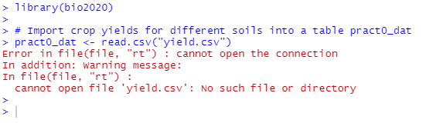
What has gone wrong? We’ve just downloaded the file from Canvas yet R claims it is missing? The problem is that when you downloaded the data file from Canvas, it placed it into your Downloads folder. You need to move it to the NES2504/Data folder, that already contains your project settings file, and your practical0.R file:
- Start up the File Manager either from the main Windows menu, or by entering “File Manager” in the search bar
- Navigate to your Downloads folder
- Locate the yield file in your Downloads folder
- Right-click on your yield file and select Copy
- Navigate to your NES2504 folder, Right-Click inside it and select New Folder. Call your new folde Data
- Double-click on the Data icon to navigate into it
- Right-click and select Paste
- Go back to RStudio, and in the Files tab (bottom right) click on the “refresh” button (a small circular arrow on the right of the files tab). You should see the Data subfolder, and if you look inside it, you’ll see the yield file listed.
Now go back to your R script and try re-running the read.csv command by clicking on the line, and hitting the Ctrl-Shift-Enter key combination again. BUT it does not work. You get the same error message!! Why??
This is such a common error, that I thought it worth emphasising it. Some of you may even have already worked out what has gone wrong. The clue is in the name of the command read.csv which is to read a CSV file. What is this:
- CSV stands for “comma separated value” and is a plain text, simple file, that can be read by hundreds of different programs and apps
- A standard Microsoft Excel file is a commercial-format file, that can be imported by a more limited range of software. It is much more complex as it can contain multiple tables, forumlae, graphs etc.
So, finally we need to convert our Microsoft Excel file. Go back to your File Manager, navigate to the NES2504/Data folder (it might already be open) and double-click on the yield file to open it in Microsoft Excel. Then click on the File -> Save As option, and in the drop-box below the filename, select the CSV option, to save it in your Data folder:
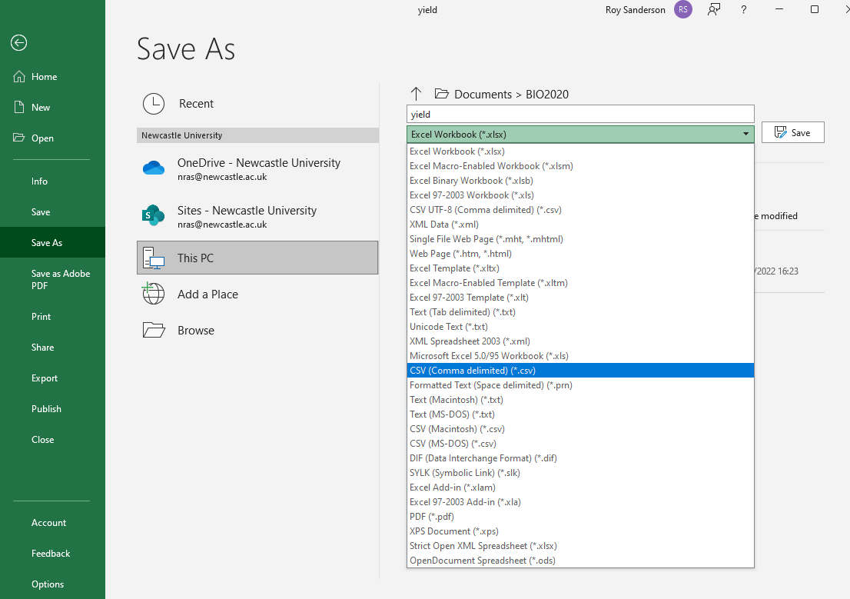
Now close Excel; you may get a warning claiming you haven’t saved your file (you have!), but Microsoft gets cross if you don’t use its commercial file formats. Go back to your File Manager and you should see two files called “yield” inside your Data/ folder
There are four files listed, although the default settings in File Manager does not give their full names (last few letters are omitted) which can cause confusion
- yield which is yield.csv in Comma Separated Value format
- yield which is yield.xlsx in Microsoft Excel format
Look very carefully and you can see that the icons for the two yield files are slightly different, as one has ,a in it. You can change the settings in File Manager so that full file names with the final “extension” are showing. For the bulk of the NES2504 course all the files will be CSV format, so you will not have this problem. But sometimes data will be in Excel format so it is essential you know how to convert to CSV.
Stay in the File Manager and navigate one level higher to the NES2504 folder. You should see 3 items
- Data folder you’ve just created with your two yield files
- NES2504 which is actually NES2504.RProj and contains your RStudio project settings
- practical0 which is actually practical0.R and contains your script with R commands
Go back to RStudio and re-run your read.csv line.
If it is successful, nothing will be displayed in the console, but in your Environment window (top right panel) you should see the table (data frame) pract0_dat listed, and when you run the summary(pract0_dat) and mean(yield ~ soil, data = pract0_dat) commands you should see:
soil yield
Length :30 Min. : 3.00
N.unique : 3 1st Qu.: 9.25
N.blank : 0 Median :12.00
Min.nchar: 4 Mean :11.90
Max.nchar: 4 3rd Qu.:14.75
Max. :18.00
clay loam sand
11.5 14.3 9.9
Success! Important Please speak to staff or the demonstrators know if you have problems with this step.

6.1 Where to store your CSV files?
You can store them either in your main project folder or your Data folder but if you have lots of data files this can get confusing, so we recommend creating a folder called Data inside your NES2504 project folder, and putting your CSV files there.

7. Working with data

7.1 Using R as a calculator
You probably won’t use this very often, but you can easily enter values into the Console window if you need to do some quick arithmetic:
7 * 3
log(24)
4^2
7 / 3
pi * 3 ^ 2
As you have typed the above into the Console window it isn’t saved after you finish today’s practical, but it doesn’t matter for some quick temporary calculations. Individual numbers, columns, rows, or tables of data, the results from calculations, statistical analyses and graphs are all R objects and the ones you have created in your current RStudio are shown in the top right Environment panel.
As mentioned before R is a programming language, as with any language there is some vocab that needs to be covered in order to help your understanding of what is being described.

7.2 Creating Objects
Although you have done some arithmetic above, it is much more useful to assign the results to an R object, so you can re-use them later. You do this using the assignment symbol <- which looks like a left arrow. If you are having trouble finding the < and - keys, a handy shortcut is to press
typing Alt + - (push Alt at the same time as the - key) will write <- in a single keystroke.
Now you can assign a value(s) to an object so that R remembers it. You need to come up with a name for your object. Come up with a good name!
Good names:
- my_height
- bird_weights
- bacteria_growth
Poor names:
- my_dat You will soon forget what this contains
- Bird_wght You will forget the upper-case B and whether it is wght, Wght, weight etc.
- bacterialgrowth Rather long and difficult to read
For example, if you are 175 cm tall, you can assign your height to an R object, and display it again easily. Type the following into your RStudio script editor (top left) at the bottom of your practical0.R script:
# Assign my height in cm to R variable (object) called my_height
my_height <- 175
# Display the contents of my_height (it will show in the R Console)
my_height
[1] 175
Now that you have stored your height in the my_height object we can do some arithmetic with it. Add the following code to your practical0.R script and run it to convert your height from cm to inches
[1] 68.89764
Look in the Environment window (top-right of RStudio): notice that the value of my_height is still in cm, why? Because we didn’t store your height in inches as an object, let’s do that now. Amend your practical0.R script to read:
# Assign my height in cm to R variable (object) called my_height
my_height <- 175
# Calculate height in inches and assign to new R object my_height_inch
my_height_inch <- my_height/2.54
# Display the value of the object my_height_inc
my_height_inch
Look in your Environment window (top right of RStudio) and notice how the new R objects are listed. These are not saved after you exit RStudio, but can be quickly regenerated by re-running your practical0.R script.

7.2.1 Comments
The comment character in R is #, anything to the right of a # in a script will be ignored by R. It is very useful to leave notes and explanations in your scripts, we highly recommend that you get into the habit of commenting your code as it will help you to remember what you have done AND it will help us to help you if you encounter problems. R Studio makes it easy to comment or uncomment a paragraph: after selecting the lines you want to comment, press at the same time on your keyboard Ctrl + Shift + C. If you only want to comment out one line, you can put the cursor at any location of that line (i.e. no need to select the whole line), then press Ctrl + Shift + C. Comments are the most important lines in any R script!!

7.3 R Functions
Almost all or our R coding uses functions, which are essentially bits of code that have been written to do something. When we refer to functions we will generally do so following the convention functionname() the brackets are a giveaway that we are referring to a function. Functions take arguments, the arguments (inputs) are specified within the brackets. We have already used the read.csv function, and gave it the argument “yield.csv” to import some data into R.
Lets use the function sqrt() as an example. The argument to this function is a value (or an object that contains a value) for which we want to calculate the square root. When we run a function it returns an output that is the square root of the input value. Edit your practical0.R script to add the following lines at the bottom, and run them:
# Run the function on a number, to find square-root of 10
sqrt(10)
# Run the function on object my_height that contains a numeric value
sqrt(my_height)
Functions may “return” numbers (e.g. sqrt()), tables of data (data.frames), summaries of statistical analyses and models, and even graphs. Functions generally have “arguments”. For the sqrt() function you had a single argument containing a number. Arguments can be anything, not only numbers or filenames, but also other objects. Exactly what each arguments are needed and mean differs per function, and can be further investigated using the help files (Remember the help pane, bottom left) which we will explain further later on.

7.4 Data types
R can deal with many different types of data and where it recognizes differences in data it may treat it differently. It is helpful to understand the different types of data that you will most commonly encounter in R:
Numeric
Numeric data are numbers
1, 2, 3, 4.5, 6.78
Character
Character data contain non numeric characters and are most often words. R understands character data to be everything enclosed within the quotation marks ““.
"lion", "tiger", "bear"
When we use this type of data in R we have to remember the “” otherwise R will assume that we are referring to objects (that may not have been created) of the same name and it likely to return an error.
Factors
These are useful in data analysis. If your data are already in character format, then R will automatically treat them as factors. However, you might have experimental treatments coded “1”, “2”, “3” and you would want to force R to recognise that they are categorical factors, not continuous numbers. R has a special as.factor() function to do this.
Logical
R understands logical data as TRUE FALSE, different from character data so no “” required and note that it is case sensitive.
TRUE, FALSE
Case sensitivity in R
R is case sensitive, we created an object called `my_height`, if we were to ask R for the value of the object `My_height` with a capital M we would see R return an error (unless we also have a variable called My_height stored in our environment)

7.5 Data structures
We have already learned how to assign a value to an object but to do more complicated things in R we often need to store more than one value in a single object.

7.5.1 Vectors and the c() function
A vector is the most common and basic data type in R, a vector is composed by a series of values, which can be either numbers or characters. We can assign a series of values to a vector using the c() function which stands for “concatenate” or join several items (numbers, words etc.) into a single R object. For example we can create a vector of animal weights and assign it to a new object weight_kg, and the common names of each species in animal_name. Look at the following code, but don’t type it in yet:
# Weights of 15 animals
weight_kg <- c(190, 192, 189, 180, 185, 278, 310, 300, 294, 312, 400, 450, 500, 510, 425)
# Species names; three species, 5 animals per species
animal_name <- c("lion", "lion", "lion", "lion", "lion", "tiger", "tiger", "tiger", "tiger", "tiger", "bear", "bear", "bear", "bear", "bear")
Now, it is a bit of a pain having to type each species name in 5 times, and even copy-paste with the mouse is difficult with all the " and , symbols. So R offers a shortcut via the rep() function that allows you to repeat something multiple times. Go to your practical0.R script and add the following at the end, and run the lines:
# Weights of 15 animals
weight_kg <- c(190, 192, 189, 180, 185, 278, 310, 300, 294, 312, 400, 450, 500, 510, 425)
# Species names; three species, 5 animals per species
animal_name <- rep(c("lion", "tiger", "bear"), each = 5)
# Display the contents of weight_kg and animal_name, their type length
weight_kg
animal_name
length(weight_kg)
length(animal_name)
class(weight_kg)
class(animal_name)
Your vectors weight_kg and animal_name each contain 15 items of data, one numeric, the other character (text) information. A vector can only contain items of the same type of data.

7.5.2 Data frames
This is the best R object for storing your data in. It is basically a table of data, with columns of numbers or text so is useful for different data types that we want to keep together. We will now combine weight_kg and animal_name into a single table (data frame) using the data.frame() function. Add the following lines to your practical0.R script:
# create an R table (data frame) to store all the animals data
animals_df <- data.frame(animal_name, weight_kg)
# Display the contents data frame
animals_df
You can also display the contents of animals_df by double-clicking on its name in the RStudio Environment window (top-right). We now have something that might look more familiar to those of us that are used to working with data in Microsoft Excel.
If we want to extract a specific column of a data frame we can do so using the $ operator. To extract a specific value we can index it using the square brackets [] to specify the position by location using dataframe_name[rownumber,columnnumber]. Edit your practical0.R script by adding the following at the end:
# Display a single column; it will show as a row in the R Console
animals_df$animal_name
# Use the [row, column] suffix
# Display first column
animals_df[, 1]
# Display second row
animals_df[2, ]
# Display single elements
animals_df[1,2] # First row, second column
animals_df[2,1] # Second row, first column
These operations can be useful when we are dealing with small data frames but often when we are working with data we have large datasets, perhaps contained in spreadsheets on your computer or downloaded from the net. Such information needs to be imported into R before we can start to interrogate the data frame. Remember the kitchen analogy - Data contained in a file on your computer is like an ingredient in your cupboard, to be able to use it you first need to put it on the kitchen counter, which means we need to import it in to R and assign it to an object so that it appears in our environment pane.
You might be wondering why we entered our animals_df such that the names of the 3 species are repeated multiple times. This is called long data format and is the best format for data summaries, plots and statistical models. It aligns with the goal-oriented philosophy we use:

goal ( y ~ x , data = mydata, … )

where:
- goal = What you want to do; a statistical summary, data analysis, or graph
- y = the name of the column containing the response variable
- x = the name of the column containing an explanatory variable
- mydata = name of your table of data, known in R as a data.frame
So let’s think about it again for our animal weights. Suppose our goal is to calculate the average weight of each of the three species, stored in the data.frame (table object) animals_df which has two columns animal_name and weight_kg. The weight of the animal is the response so is place on the left of the ~ symbol, as it will be determined by the species of animal, which is the explanatory placed on the right of the ~ symbol:

mean ( weight_kg ~ animal_name , data = animals_df)

Now you can translate this directly into R. Add the following line to the bottom of your R script in top left of RStudio and run it:
# Calculate average weight of each animal species
mean(weight_kg ~ animal_name, data = animals_df)
This gives you a clear summary of your weights. In future practicals we will change mean to other “goals” including plotting and analysing your data.

8. Importing and exporting data
To be able to analyse our data in R we first have to import/read it in to R so that it is available to us in our environment (Taking it out of the cupboard and placing it on the counter). How we go about this varies slightly depending on the file that we are going to be using. In all cases we need to assign the information in the file to an object so our code will start with the name of the object we are creating and the <- symbol

8.1 Importing tables of data via CSV files
We have already looked at CSV files, which you can export from Microsoft Excel using Excel’s “Save As” option. This makes them the most useful “general” format for storing data.

8.2 Saving (exporting) outputs

8.2.1 Saving data objects
Once we have manipulated our data we may want to save it as a file that we can then share with others. Data can be saved to .csv files using the write.csv function.
The code is similar to that used to read data in, it requires the filepath specifying where you want to save the file which includes the name that you want to give to the file, and it requires the name of the object that is being written (saved). Suppose you want to use your animals_df data or anything else you generate in R in Microsoft Excel. Add this to the end of your practical0.R script:
# Save contents of animal weights data to csv file
write.csv(animals_df, file = "Data/animals.csv")
Open up your Windows File Manager and navigate to your NES2504\Data folder. Double-click on the “animals” icon and it should open for you in Microsoft Excel. WARNING Sometimes NUIT PCs are badly configured and may open CSV files in Minitab. Please ask if this happens.

8.2.2 Saving plots
We will create various graphs of data in the next practical. Once you have created beautiful plots that support your analysis you will want to be able to copy them into your reports. The easiest way to do this is to use the dropdown Export menu in the plots pane.
You can copy plots to the clipboard or save them as a file (specifying the file type, .png/.jpg/.tiff etc.)
The popup preview that appears when you choose to copy a plot to the clipboard or to save it as an image allows you to specify the size that you want the image to be. Altering the size of your plot here will give you a much clearer plot than if you re-size a copied or saved plot after adding it to your destination document.
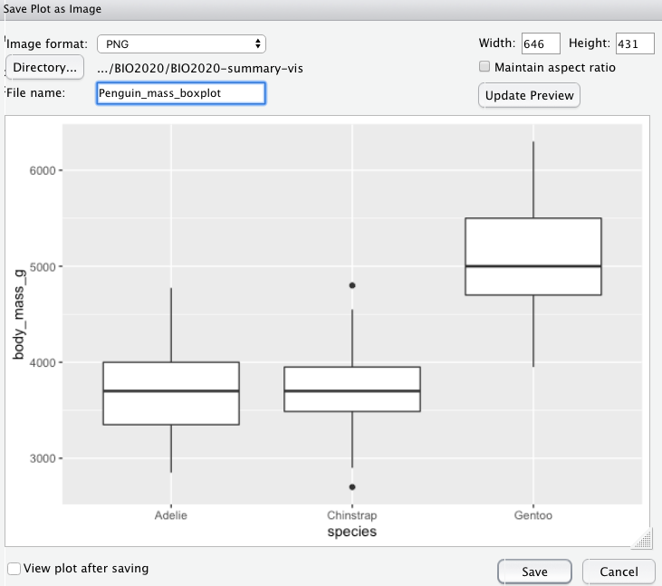
You can specify the image size using the numbers or you can grab the plot by the triangle in the bottom right corner of the preview pane and drag the plot to the desired size.

9. Getting help
Using the help function Functions are documented in R’s help system, you can access the help file for a function by typing in the search bar of the help pane.
These help files can be quite daunting (and difficult to understand) but they do all follow the same structure. The image below breaks this down a bit to try and make the it a bit easier for you to actually understand how to use the help files to actually help!
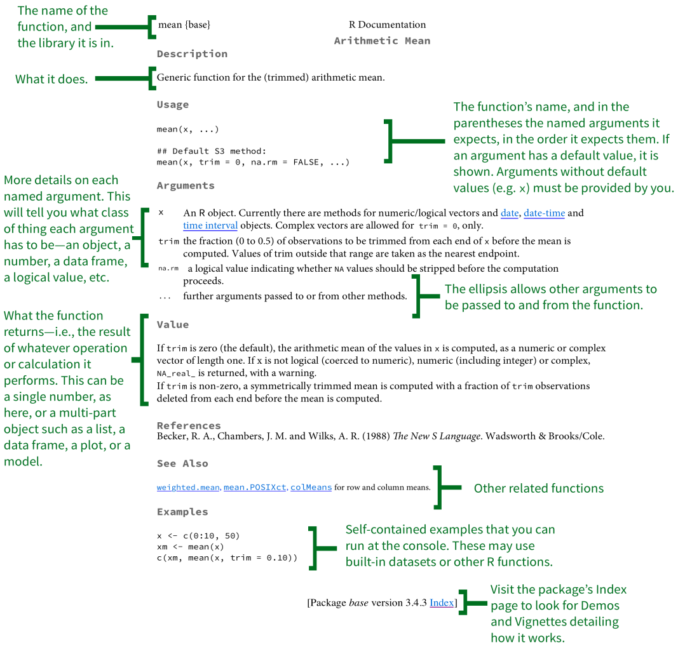
More detail about the sections of the help files can be found here
Error messages
Error messages can be difficult themselves to decode, and you will definitely get some. Scroll up in your Console and find the error messages you obtained on your first attempts to read yield.csv. The below graphic breaks things down a bit and explains the difference between Warnings (probably OK) and Errors (always a problem):
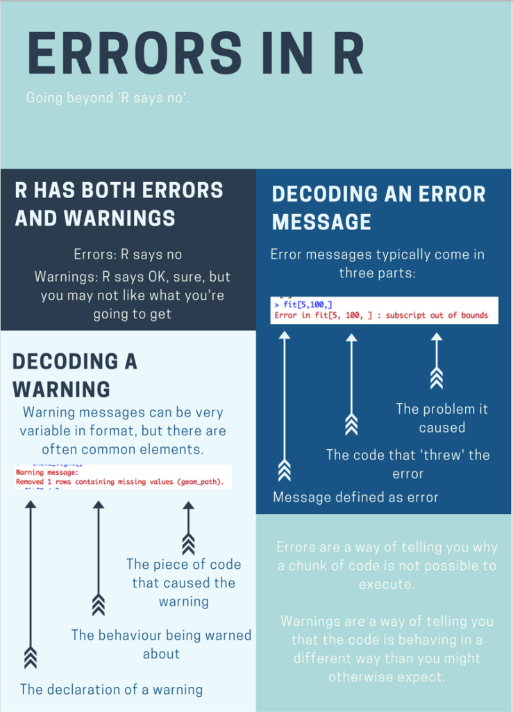
you can try Googling them, use ChatGTP or searching Rseek a search engine specifically for R related materials. Still stuck? Please do not worry. R has a steep initial learning curve, so expect to hit problems. The community or R users are extremely welcoming and supportive so just remember you’re not alone!

10. Final steps before you finish
Before you finish today, please remember to Save your practical0.R script. It should have the following contents. NOTE There is a subtle difference in the layout of the final script. I’ve added the following lines:
# Crop yields example ####
# Person heights in cm and inches example ####
# Big fierce animal weights example ####
As you will discover, R scripts can get quite long, so it is useful to have subheading comments. Note that these three comments all end ####. If you click on the Outline button at the top right of your R practical0.R editor screen, a side-panel will open, which allows you to navigate to any of these sub-headings with one click, so you don’t get lost!
# Practical 0: Revision and R basics
# Activate the mosaic package so extra commands available
library(mosaic)
# Crop yields example ####
# Import crop yields for different soils into a table pract0_dat. The yield.csv
# is exported from Microsoft Excel and stored in the Data sub-folder
pract0_dat <- read.csv("Data/yield.csv")
# Print out a summary of the data held in pract0_dat
summary(pract0_dat)
# Obtain the mean yield for each soil type
mean(yield ~ soil, data = pract0_dat)
# Person heights in cm and inches example ####
# Assign my height in cm to R variable (object) called my_height
my_height <- 175
# Calculate height in inches and assign to new R object my_height_inch
my_height_inch <- my_height/2.54
# Display the value of the object my_height_inc
my_height_inch
# Run the function on a number, to find square-root of 10
sqrt(10)
# Run the function on object my_height that contains a numeric value
sqrt(my_height)
# Big fierce animal weights example ####
# Weights of 15 animals
weight_kg <- c(190, 192, 189, 180, 185, 278, 310, 300, 294, 312, 400, 450, 500, 510, 425)
# Species names; three species, 5 animals per species
animal_name <- rep(c("lion", "tiger", "bear"), each = 5)
# Display the contents of weight_kg and animal_name, their type length
weight_kg
animal_name
length(weight_kg)
length(animal_name)
class(weight_kg)
class(animal_name)
# create an R table (data frame) to store all the animals data
animals_df <- data.frame(animal_name, weight_kg)
# Display the contents data frame
animals_df
# Display a single column; it will show as a row in the R Console
animals_df$animal_name
# Use the [row, column] suffix
# Display first column
animals_df[, 1]
# Display second row
animals_df[2, ]
# Display single elements
animals_df[1,2] # First row, second column
animals_df[2,1] # Second row, first column
# Calculate average weight of each animal species
mean(weight_kg ~ animal_name, data = animals_df)
# Save contents of animal weights data to csv file
write.csv(animals_df, path = "Data/animals.csv")

10.1 Check your NES2504 folder contents
Double-check the contents of your data analysis folder (which might be NES2303 or NES2504 depending on how you have labelled it). Open it in Windows File Manager:
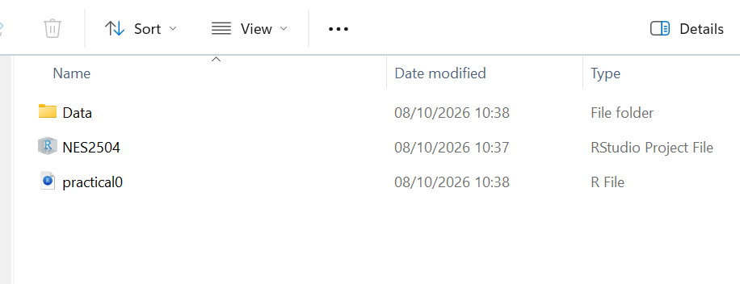
You should see the name of your RStudio Project File (NES2504), the name of your R script (practical0) and your Data folder. This should contain your CSV data file from today, as well as its Excel equivalent.

11. Take home messages from today’s practical
R and RStudio can be intimidating at first, but take your time and understand its structure. In particular:
- Always use an RStudio project as it makes file management simpler. Create a separate project for each Module in your degree where you have to analyse data
- If you download Data files from the internet, you need to move them from the default Downloads folder to the project Data folder
- Remember to convert conventional Microsoft Excel files to CSV files before importing them into RStudio
- The R “script”, practical0.R is all you need to save. Add lots of comments so it is easy to understand months later.
- You can run lines sequentially from top to bottom in your practical0.R script to regenerate your entire workflow automatically

12. In your own time
Sometimes Microsoft Excel files can look clear and attractive, but then prove difficult to use inside R. Download the ‘awkward.xlsx’ Excel file from Canvas and open it in Excel. It contains seed production weights, and the plant root sizes, under two different grazing regimes. At first sight it looks fine, with 4 columns of data for the root lengths and seed weights under the two grazing regimes:
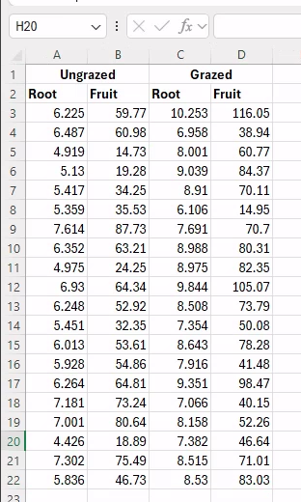
As usual, export it from Excel using the ‘Save As’ option as a CSV file inside your NES2504/Data folder. Now add the necessary R code, to import your CSV file:
# Import CSV from badly structured Excel file
seeds_dat <- read.csv("Data/awkward.csv")
No errors, so presumably everything is OK? Not so fast! Add a summary command to have a look at your data and you’ll spot there is a problem:
# Import CSV from badly structured Excel file
seeds_dat <- read.csv("Data/awkward.csv")
# Check data format with summary
summary(seeds_dat)
Ungrazed X Grazed X.1
Length :21 Length :21 Length :21 Length :21
N.unique :21 N.unique :21 N.unique :21 N.unique :21
N.blank : 0 N.blank : 0 N.blank : 0 N.blank : 0
Min.nchar: 4 Min.nchar: 5 Min.nchar: 4 Min.nchar: 4
Max.nchar: 5 Max.nchar: 5 Max.nchar: 6 Max.nchar: 6
You seem to have gained 2 mysterious columns called X and X.2 which aren’t in the original dataset, and there is no indication of which columns are Root or Fruit. Also look carefully at the summary() results: there are no means, medians, min, or max etc. as you would expect. What has gone wrong? Let’s look at the first few lines using the head() function:
head(seeds_dat)
Ungrazed X Grazed X.1
1 Root Fruit Root Fruit
2 6.225 59.77 10.253 116.05
3 6.487 60.98 6.958 38.94
4 4.919 14.73 8.001 60.77
5 5.13 19.28 9.039 84.37
6 5.417 34.25 8.91 70.11
Now the problem is clear. There were of course two header rows in your Excel file; the read.csv() has accidentally imported the second header row containing Root or Fruit into the first row of data. This has confused R, which now has a mixture of text and numbers in the same data.

12.1 Where have X and X.1 appeared from?
Open your original Microsoft Excel spreadsheet (not the CSV) and look carefully at the two cells which contain Ungrazed and Grazed. Notice how the width of these cells is twice that of the rows below them: they are merged cells. This is quite common in Microsoft Excel, but generates a column with no header when converted to CSV, which R auto-names X, X.1, X.2, X.3 etc.
There are two solutions to this problem, and we’ll try both:
- Restructure the data in Excel first. This is probably the simplest method for small datasets like this one.
- Import into R and then restructure. This is more complicated, but is reproducible and ideal for big datasets.

12.2 Restructure in Microsoft Excel
Look at your .xlsx spreadsheet in Microsoft Excel, and ensure the ‘Home’ tab is selected. Make a note that the first 2 columns are Ungrazed, and the Second 2 columns are grazed. Also look at how many rows of data you have; the final set of data is on Row 22 so with 2 header columns you have 20 rows of data. The steps to follow are:
- Delete the first row containing Ungrazed and Grazed by Right-Click on the 1 in the margin (which will highlight the entire row) and select Delete. The first row will be deleted, and the entire set of data will move up by one row.
- Select all the numbers (but not the headers) in Columns C and D from the Grazed treatment, and drag them with the mouse to be immediately below the existing data for Ungrazed.
- Right-Click on Column D, which highlights the whole column, and select Delete
- In Column C, change the title from “Root” to management. I suggest you rename columns A and B from Root and Fruit to “root” and “fruit” (lower case) to avoid confusion in R.
- In the management column, enter the word ungrazed in cell C2, and drag this down as far as cell C21; Excel will auto-fill the empty cells for you. Remember you have 20 replicates of each management treatment
- In cell C22 enter the word grazed. Double-click on the corner, and it will auto-fill to the end of the table.
You should see something similar to the following:
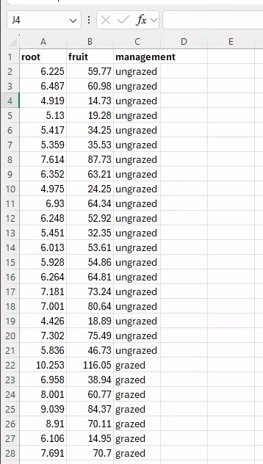
You can now export this revised file to file cleaned.csv inside your Data folder. When you read this in and check it, the data look fine:
# Read and check pre-cleaned data
seeds_clean_dat <- read.csv("Data/cleaned.csv")
# Check it looks OK
summary(seeds_clean_dat)
root fruit management
Min. : 4.426 Min. : 14.73 Length :40
1st Qu.: 6.083 1st Qu.: 41.15 N.unique : 2
Median : 7.123 Median : 60.88 N.blank : 0
Mean : 7.181 Mean : 59.41 Min.nchar: 6
3rd Qu.: 8.510 3rd Qu.: 76.19 Max.nchar: 8
Max. :10.253 Max. :116.05
head(seeds_clean_dat)
root fruit management
1 6.225 59.77 ungrazed
2 6.487 60.98 ungrazed
3 4.919 14.73 ungrazed
4 5.130 19.28 ungrazed
5 5.417 34.25 ungrazed
6 5.359 35.53 ungrazed
dim(seeds_clean_dat) # 40 rows by 3 columns
[1] 40 3
You can now correctly see the right column headings, and the summary() is correctly treating all the data in root and fruit as numeric.

12.3 Restructure in RStudio
One problem with “manual” restructuring in Excel is that it can be time-consuming, and it is very easy to make a mistake, e.g. by over-writing data when dragging and dropping columns, or miscounting data etc. An alternative is to restructure your data in R. We will import it directly from your original awkward.csv but skipping rows, then apply our own column headers, and finally stack the last two columns under the first two.
# Read in messy data skipping first row that had merged cells
seeds_dat <- read.csv("Data/awkward.csv", skip = 1)
# Assign unique columnames, with _u or _g to indicate ungrazed or grazed, as
# RStudio does not permit duplicate column names
colnames(seeds_dat) <- c("root_u", "fruit_u", "root_g", "fruit_g")
# Check data format with summary
summary(seeds_dat) # Note how data are correct with means, medians etc.
root_u fruit_u root_g fruit_g
Min. :4.426 Min. :14.73 Min. : 6.106 Min. : 14.95
1st Qu.:5.402 1st Qu.:33.77 1st Qu.: 7.614 1st Qu.: 49.22
Median :6.119 Median :54.23 Median : 8.511 Median : 70.86
Mean :6.053 Mean :50.88 Mean : 8.309 Mean : 67.94
3rd Qu.:6.598 3rd Qu.:64.46 3rd Qu.: 8.978 3rd Qu.: 82.52
Max. :7.614 Max. :87.73 Max. :10.253 Max. :116.05
Now we simply stack the last two columns on top of the first two using rbind() which means “bind rows together”. Recall that we can use the $ symbol to access individual named columns. In effect we create two unamed data.frame objects, one for ungrazed, the other grazed, then immediately bind their rows together.
# Stack columns on top of each other
seeds_clean_dat <- rbind(
data.frame( # First temporary data.frame for ungrazed
root = seeds_dat$root_u,
fruit = seeds_dat$fruit_u,
management = "ungrazed"
),
data.frame( # Second temporary data.frame for grazed
root = seeds_dat$root_g,
fruit = seeds_dat$fruit_g,
management = "grazed"
)
)
# Check it is all as expected
summary(seeds_clean_dat)
root fruit management
Min. : 4.426 Min. : 14.73 Length :40
1st Qu.: 6.083 1st Qu.: 41.15 N.unique : 2
Median : 7.123 Median : 60.88 N.blank : 0
Mean : 7.181 Mean : 59.41 Min.nchar: 6
3rd Qu.: 8.510 3rd Qu.: 76.19 Max.nchar: 8
Max. :10.253 Max. :116.05
head(seeds_clean_dat)
root fruit management
1 6.225 59.77 ungrazed
2 6.487 60.98 ungrazed
3 4.919 14.73 ungrazed
4 5.130 19.28 ungrazed
5 5.417 34.25 ungrazed
6 5.359 35.53 ungrazed
dim(seeds_clean_dat)
[1] 40 3
Again you can see clean output. Whilst there is more R code, it is easier to do long-term as it is more reproducible, and especially with big Excel spreadsheets avoids errors due to mis-placed cut and paste.

