Practical 2: Getting started with linear models
Roy Sanderson, Will Reid
Table of contents
1. Introduction 1
2. Aims and objectives 2
3. Linear models with continuous explanatory variables: Regression 3
4. Linear models with categorical explanatory variables: ANOVA 16
5. Working with large biological datasets (Complete in your own time before next week) 27

1. Introduction
In this practical you will be introduced to linear models which provide a way to assess the relationships between a response variable and one or more explanatory variable(s). You will recall that we are trying to use a “goal-oriented” approach where possible in NES2504:

goal ( y ~ x , data = mydata, … )

So far your goals have been simple summary statistics (mean, median, standard deviation), or different types of plots (boxplot, scatterplot etc.). In both cases the response variable is y, typically placed on the vertical axis in a graph, and x is the explanatory variable(s) on the horizontal axis. A linear model is a way of formally testing whether there is really a relationship between your response and explanatory variables. You can access a linear model using the lm() function in R:

lm ( y ~ x , data = mydata, … )

Important Commonly used names in textbooks for linear models like this differ depending on the explanatory variable. We make life easier by using the lm() function for both types of analysis:
- Regression - when you have one or more continuous explanatory variables
- Analysis of Variance (ANOVA) - when you have one or more categorical explanatory variables

2. Aims and objectives
The overall aim of this practical are to show you how to use the lm() function, using datasets that you should already have seen on the interactive websites at linear models with continuous explanatories and linear models with categorical explanatories. Please work through these websites before attempting this practical. You will also have the opportunity to gain confidence using linear models with a new dataset. Specific objectives are to:
- understand how to interpret results from linear models with continuous explanatory variables
- learn the use of linear models with categorical explanatory variables, and explore multiple comparison tests, to compare different treatment levels
- apply these ideas with a large biological dataset.
Inherent in the idea of linear models is the idea of cause and effect, i.e. your explanatory variables cause some sort of change in your response variable. How do you know which is the response and which is the explanatory? In a “designed experiment”, e.g. a laboratory experiment or field plot experiment, the response and explanatory is usually obvious, but sometimes it is less obvious. Take the following examples:
Response | Explanatory | Explanatory type
Plant pathogen gene regulation | Fungicide concentration (mg/l) | Continuous
Mean bird population size | Habitat type (Garden, Arable, Woodland, Heath) | Categorical
Benthic invertebrate diversity | Depth to sea floor | Continuous
All linear models have a continuous response variable. By “continuous” the response can be any number (3.4, 1.9, -3 etc., rather than Yes/No, Dead/Alive, or only whole numbers permitted). In the above 3 examples note the following:
- the gene regulation has a continuous explanatory fungicide concentration
- the average bird population at a site across all surveys has a categorical explanatory habitat type, with four ‘levels’ for the 4 different habitats
- Pollinator diversity and benthic invertebrate diversity are both continuous. It is reasonable to assume that the biodiversity of wildflowers will have a big effect on the pollinators out there, so wildflower diversity is shown as the explanatory variable. However, some scientists have shown that if the pollinator biodiversity declines sharply, this has a negative effect on the biodiversity of some wildflowers. So in this example the response and explanatory terms are a little more ambiguous.

3. Linear models with continuous explanatory variables: Regression
Linear models with continuous explanatory variables are often called “regression analyses”. If you have two or more continuous explanatory variables you may see them called “multiple regression”.

3.1 Before you begin
We will start by looking at the caterpillars data set that we were using in the interactive website for linear models with continuous explanatory variables. The caterpillars.csv data file is available on Canvas and should be downloaded. Remember that this will end up in your “Downloads” folder: you will need to move it from Downloads into your NES2504 folder before you can read it into R. After you have downloaded the file:
- Download the caterpillars.csv from Canvas; you can open the file in Microsoft Excel to have a quick look at it, but ignore any requests to save it in Excel format.
- Use File Explorer to copy caterpillars.csv from your Downloads folder to your NES2504 folder
- Start RStudio. Select File -> Open project… and navigate to the RStudio project you created in the first practical session. This should be a file called NES2504; open it and when RStudio starts check that NES2504 is showing in the top right corner of the RStudio window. This is ESSENTIAL! If you are unsure if you have opened your NES2504 project you must check with a demonstrator before proceding.

3.2 Create a new R script and import the data
You now want to import the data, and check the first few rows to ensure it’s been read into RStudio correctly, and has the right number of rows and columns. In the example below note the use of comments, preceded by # symbols, and the use of blank lines. Four comments #### auto-creates a table of contents (ToC) for your script (ask a demonstrator if unsure how to open the ToC),
- In RStudio select File -> New File -> R Script. It is good practice to save your script immediately by going to File -> Save and give it a sensible name, e.g. Practical2.R.
- Now start writing the contents of your script, with a title line, explanation of what your script is doing, etc. Note: some of you are storing all your CSV files in a Data subfolder, others are storing them in the main NES2504 folder. It does not matter which one you choose, but adjust the read.csv() call below accordingly:
# Practical 2. Examples of linear models for continuous and categorical data ####
# 1. Introduction ####
# This practical introduces linear models where the explanatory variable can
# be either continuous or categorical.
#
# 2. Aims and objectives ####
# Get used to using R's lm() function, and learn how to interpret output
# Activate the mosaic and car R packages
library(mosaic)
library(car)
# 3. Linear models with categorical explanatory variables
## 3.1 Read in the caterpillars.csv file (omit Data/ if not using a subfolder to store data) ####
caterpillar_dat <- read.csv("Data/caterpillars.csv")
If RGui or RStudio does not find the file caterpillars.csv check that you correctly copied the CSV from Downloads to NES2504, that there are no spelling errors, or whether you need to omit the Data/ if you are not using a subfolder called Data within the NES2504 folder.
Using the functions that you learned in the first practical familiarise yourself with the caterpillars data.
# display the first 6 rows of the data frame
head(caterpillar_dat)
# check the dimensions of the data frame (numbers of rows and columns)
dim(caterpillar_dat)
We can see that this data set contains 2 continuous variables; growth (mg/day) and tannin (mg). What is the mean, minimum, maximum value of these two variables (look back to Practical 1 if you have forgotten how to obtain these data).

3.3 Simple visualisation of caterpillar data
It is essential to plot your data, to gain an understanding of its characteristics, before running a linear model. As you have two fairly simple variables, a scatter plot, also known as a “point plot”, with our explanatory variable of tannin on the x axis and growth on the y axis is required. So thinking about our “goals” here:

scatterplot ( y ~ x , data = mydata)

which for your caterpillar data can be considered as:

gf_point ( growth ~ tannin , data = caterpillar_dat)

We now need to translate this goal into R via the following steps:
- In the RStudio code editor (top left of RStudio), at the bottom of your Practical1.R enter a blank line, then a line that says # 3.2 Plot caterpillar data ####. This makes your code easier to read and helps you navigate with a table of contents.
- Use the gf_point() function to create your scatterplot with tannin on the x-axis (explanatory) and growth on the y-axis (response)
- Add a second row to your R code with command gf_labs() to label the x- and y-axes as shown below. Us %>% at the end of the preceding line so that the gf_labs() command is actioned. Remember that %>% indicates to R to continue adding features to your plot
- Add a third row to your R code to change the theme from the nasty grey background etc. using gf_theme(), remembering to add %>% to the end of the second row.
- Your graph should appear as shown below. Check with a demonstrator to ensure you have done it correctly. Look at your script from Practical 1 Data visualisation for futher reminders:
# 3.22 Plot caterpillar data ####
gf_point(growth~tannin, data = caterpillar_dat) %>%
gf_labs(x = "Dietary tannin (mg)", y = "Caterpillar growth rate (mg/day)") %>%
gf_theme(theme_classic())
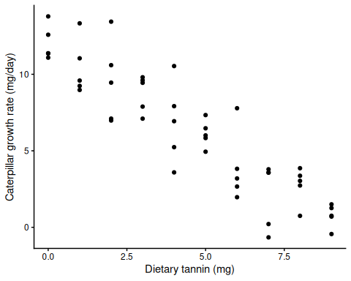
From this plot answer the following questions and check your answers with a demonstrator before continuing:
- Will the fitted line have an intercept? If it does, will it be positive or negative?
- If there is an intercept, roughly what do you think the value of the intercept is?
- Will the gradient of the fitted line be positive or negative?
It is always worth doing this visualisation step. Sometimes you will see your scatter of points form a distinct curve, in which case your linear model might need both $x$ and $x^{2}$ explanatory variables to fit a curve rather than a straight line. It may seem odd that you can fit curves with linear models. The word “linear” simply refers to the fact that you add the various terms together.

3.4 Linear model (regression) of caterpillar growth data
Now create a linear model (regression) to see if our expectations were correct. We can adapt the standard syntax for a linear model to indicate that it is using continuous explanatory variable (tannin)

regression ( y ~ continuous x , data = mydata, … )

The syntax with the lm() function is the same, as the lm() function is flexible and can be used for regression analysis:

lm ( growth ~ tannin , data = caterpillar_dat)

Using this template, it is easy to create a linear model for the relationship between tannin and caterpillar growth using the lm() function, storing the output of the linear model in an R object called growth_lm:
- we add a comment line beforehand to explain what we are doing
- To the left of your ~ put your response variable, to the right the explanatory
- use the <- symbols to assign the results of your linear model to growth_lm. A useful shortcut for the <- symbol is to press the Alt and - keys on your keyboard simultaneously.
## 3.3 Create a linear model to test relationship between growth and tannins ####
growth_lm <- lm(growth ~ tannin, data = caterpillar_dat)
Now that you have created your linear model, use the summary() function to investigate the outputs of your linear model
# Check the output from the linear model
summary(growth_lm)
Call:
lm(formula = growth ~ tannin, data = caterpillar_dat)
Residuals:
Min 1Q Median 3Q Max
-3.8296 -1.1315 0.1207 1.0832 3.9695
Coefficients:
Estimate Std. Error t value Pr(>|t|)
(Intercept) 11.98793 0.45649 26.26 <2e-16 ***
tannin -1.25945 0.08551 -14.73 <2e-16 ***
---
Signif. codes: 0 '***' 0.001 '**' 0.01 '*' 0.05 '.' 0.1 ' ' 1
Residual standard error: 1.737 on 48 degrees of freedom
Multiple R-squared: 0.8188, Adjusted R-squared: 0.8151
F-statistic: 216.9 on 1 and 48 DF, p-value: < 2.2e-16
Were your expectations correct? Using the summary information from your model answer the following questions:
- What is the intercept of the fitted line?
- What is the gradient of the fitted line?
- Is the relationship between the explanatory and response variable significant?
- What proportion of the response value can be explained by the explanatory value?
- Using the sqrt() function can you calculate the correlation coefficient between the variables?
- Is the overall model significant?
- What are the p-values for the intercept and slope. How would you write them?
Now some answers (please think about the above questions before reading these!!):
- The column headed ‘Estimate’ gives the estimated value of your intercept and slope. So your intercept is 11.988 which you were probably able to “guesstimate” by eye from the scatterplot as being around 12.0
- The slope is harder to guesstimate, and is -1.259. Notice that it is negative because the scatter of points declines from left to right on your graph
- You may know that R-squared ($R^{2}$) is the proportion of variation explained by your linear model. What is a little confusing is that two $R^{2}$ values are given, one called Multiple and the other Adujusted. Always refer to the Adjusted R-squared which is 0.815 i.e. 81.5% of the variation in caterpillar growth rate can be explained by tannin
- You can enter the sqrt() function directly in the Console. Again, used the adjusted $R^{2}$ which should give you a correlation coefficient of 0.903. There is also a separate cor() function to calculate the correlation between any two variables should you need it.
- Overall model significance is shown by the F-statistic. The higher the F-statistic, the greater the “significance” of the model, which is reflected by a lower p-value. You would write something like:
“Overall there was a significant negative relationship between caterpillar growth and tannin ($F_{1,48}$=216.9,p<0.001)”.
Note: by convention you provide the degrees of freedom as subscripts when reporting F-values, and 3 decimal places when reporting p-values.
- The p-value for tannin is given as <2e-16. This “exponential” format is a short-hand method of referring to very small numbers, using e- or very big numbers, using e+. So here we have a very small number, with sixteen zeros, i.e. 0.0000000000000002. To three decimal places, this is zero, but in reality you never have a p-value of zero, there will always be a positive value. So by convention, to three decimal places you would report this as p<0.001 which can be interpreted as “p is less than 0.001”. This is highly significant.

3.4.1 Interactive demonstration of SS, slopes, intercepts
You may find it useful to look at this Interactive demonstration of the tannin and caterpillar growth data. It first shows you how sums of squares (SS) are calculated, then (scroll down) you can tweak the “noise” in the data to see what happens.

3.4.2 A note on t-statistics
You will see in the above summary table a column headed t value. A brief description of the rather strange t-distribution can be found on the first few pages of this interactive website that includes t-statistics . The t-distribution is like a fat-tailed normal distribution, and of particular value is the one-sample t-test. This checks whether an estimated value, here your Intercept and slope, is different to zero. If the p-value is low then there is a high probability that your estimate is not zero.

3.4.3 How to write up the linear model in a report
Unfortunately R is the same as most statistics packages, in that the way it reports data analyses is messy, and is not how you would present it in a report. The linear model you have just created is often called a regression because the explanatory variable (only one explanatory, tannin in this example) is continuous, not categorical. Which two of the following is the correct way of writing the analysis in a report and why? Check your answer with a demonstrator before continuing:
- The linear model showed a highly significant relationship between tannins (mg) and caterpillar growth (mg/day) with p = 2-e16.
- There was a negative relationship between tannin concentration (mg) and caterpillar growth rate (mg/day) (t = -14.73, p < 0.001) with 81.5% of the variation in growth rate explained by tannin concentration.
- The regression between tannins (mg) and caterpillar growth rate (mg/day) was significant (p=0.000) and explained 81.5% variation in the data
- There was a strong negative relationship between tannins (mg) and growth rate (p<0.001) with 0.815% of the variation explained.
- The overall linear model for caterpillar growth rate (mg/day) and tannin concentration (mg) was significant and showed a negative relationship ($F_{1,48}$=216.9,p<0.001)

3.5 Plotting the fitted line
You can add the fitted line from the linear model to your scatterplot using the gf_lm() function. Remember that when adding an extra feature layer to your plot you will need to use the pipe %>% which can be created using the keyboard shortcut Ctrl + Shift + m in the practical2.R script window.
Using the lessons learned in the last practical can you improve the plot. First, add one extra lines using the %>% symbol to add the fitted line. Then a second to change the axis labels. Then a third to get rid of the grey background. Finally tweak the second line to change the colour of the fitted line. Re-run the lines of commands each time to watch your graph gradually improve in quality.
- Add a fitted line using gf_lm()
- Change the axis labels to “Tannin concentration” and “Caterpillar growth”. Hint: gf_labs()
- Remove the grey plot background. Hint: gf_theme() with theme_classic()
- Change the colour of the fitted line to green. Hint: add a colour= option to gf_lm()
Refer back to your script from the previous practical if you need a reminder of how to do this. To do the first of the four steps listed above you can add the fitted line with gf_lm():
## 3.4 Plotting the fitted line ####
gf_point(growth~tannin, data = caterpillar_dat) %>%
gf_lm()
Edit the R code to modify the axis labels, replot your graph, then the modify the background etc. Replot your graph every time you tweak your code and it is easier to spot errors. You should end up with a graph similar to this:
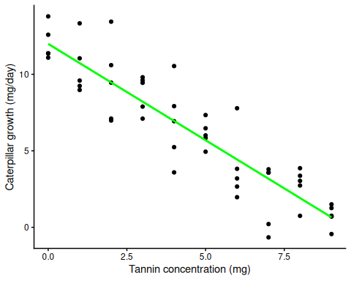
We need to illustrate some form of uncertainty around the regression line. The most appropriate method is to add the 95% confidence intervals around the fitted line. We can do this by editing the gf_lm() function by adding interval = "confidence", level = 0.95 to the brackets. When you replot your figure, you will see a grey band appear around the line. This represents the range in which the true regression line can be plotted. In other words, any intercept and slope is potentially possible within this grey area.
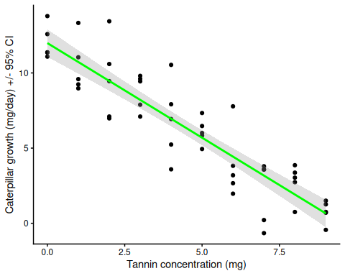
If you have any problems producing the above plot then speak to a demonstrator. Do not continue unless you have completed this step successfully, and confirmed with a demonstrator that you understand the output.

3.6 Calculate predicted values of growth for new values of tannin
You will remember from the online website tutorial that the fitted or “predicted” values for each of the observed tannin concentrations are those along the straight line that you have plotted using gf_lm() and that these values are stored in the model output under the fitted.values option which you can access by typing growth_lm$fitted.values once you have created your model object.
You can calculate predicted growth values for any tannin concentration by using the information about the intercept and slope. Using the model that you have created, let’s calculate the predicted value for a caterpillar with a tannin level of 3.5 mg. Note that we didn’t actually take an observation at 3.5, so this is a predicted value.
Use the R Console as a calculator to work out the predicted growth value when tannin is 3.5 using the formula; replace intercept and gradient with the values from the output of summary(growth_lm) and replace new_value with 3.5:
intercept + (gradient * new value)
or given that you have a negative slope in your plot, that declines from left to right, you can think of it as:
intercept - (gradient * new value)
since the gradient is negative. You will need to go back to the output from summary(growth_lm) earlier to see the values for intercept and slope (re-run summary(growth_lm) if needed). The intercept and slope are shown under the Estimate column, on the rows headed (Intercept) and tannin. What value do you get for predicted growth rate with a tannin concentration of 3.5? Does it look sensible based on the line on your graph?
Having to enter the values for intercept and slopes manually into the R Console is a bit clunky, and it is easy to make errors, especially with more complex linear models that might have multiple explanatory variables. You will be relieved that we can automate the procedure using the makeFun() function to create our own special function which we will call predictor. The argument to makeFun() is simply the name of your linear model. Then you can put 3.5 into your new predictor() :
## 3.5 Predicting growth rate for any tannin value ####
growth_lm <- lm(growth~tannin, data = caterpillar_dat)
predictor <- makeFun(growth_lm) # Make your own special predictor function
predictor(3.5) # Predict the growth rate at tannin 3.5 mg
1
7.579855
Is the value that you obtained from your predictor function the same as when you calculated it manually in the R Console? If the values are not exactly the same can you think why that might be? Hopefully you can see that the ability to create your own functions to predict values from any linear model is straightforward, and powerful.

3.7 Checking the assumptions of the linear model

3.7.1 Revision: what are linear model residuals and why do they matter?
All models are simplifications of reality, and thus make various assumptions about your data. You will remember from the online interactive website tutorials Checking model assumptions that one of the key assumptions of linear models is that the residuals are from a normal distribution. Residuals are the “noise” in your data. In a ‘perfect’ set of data all your observations would fall exactly on the fitted line. But look at the graph with your fitted line: only one observation (tannin concentration 7.0) lies very close to the fitted line. The others are all slightly above or below the line. A normal distribution is a bell-shaped curve, so if the model is a good one, if you create a frequency histogram of the residuals you should see (roughly) that sort of curve. Note: “residuals” are sometimes referred to as “errors” and represented by the Greek letter Epsilon ($ϵ$).
Key point: The residuals above and below the line should average around zero, and their frequency histogram produce a rough bell-shaped curve.

3.7.2 Residuals from the caterpillar linear model
You can extract the residuals using the residuals() function which takes the argument of your model object. Assign the extracted residuals to a variable so that you can plot them. Plot a histogram of the residuals using the gf_histogram() function, remember when plotting a single variable you can use the formula gf_histogram(~variable) You will note here that you don’t need to specify the data because in this case the variable is stored as single numerical “vector” rather than a column within a table of data (“data frame”).
## 3.6 Checking caterpillar model assumptions ####
# Extract residuals and assign them to an object
growth_resids <- residuals(growth_lm)
gf_histogram(~growth_resids)
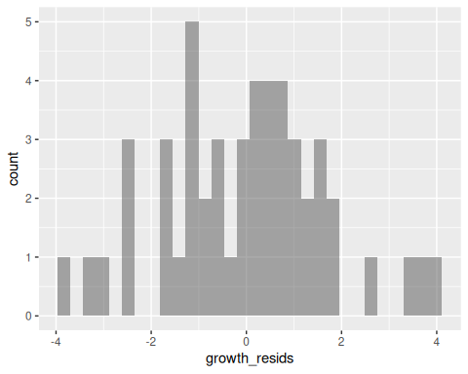
With 50 observations your frequency histogram of the residuals looks roughly bell-shaped, but with smaller sample sizes we need a better method to determine if they are normally distributed. Two good things to check are a) that the residuals are similar in spread for low and high tannin levels (x-axis predictor), and b) use a QQ plot (quantile-quantile plot) of your residuals. The latter ranks your residuals from lowest to highest, and compares them with what would have been expected if your residuals are from a normal distribution.
Both these “diagnostic” plots can be created directly from your model output. R actually produces four diagnostic plots, but we are only interested in the first two, using the which = c(1,2) option. Note: After the first plot has displayed you will have to hit the Enter key in the RStudio Console (bottom left) to display the second plot:
plot(growth_lm, which=c(1,2))
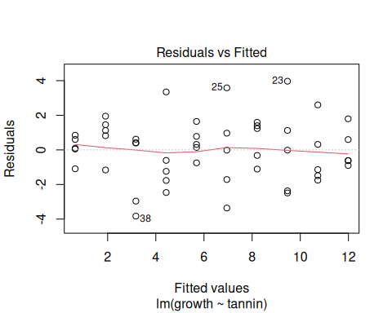
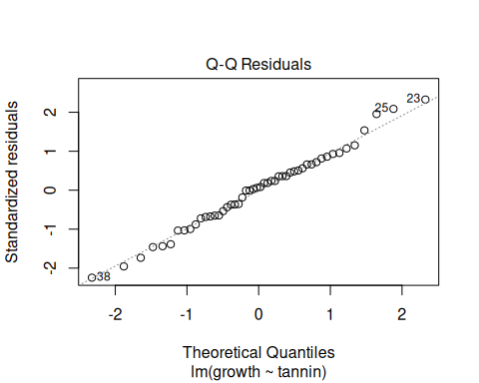
In the plot headed ‘Residuals vs Fitted’ you can see that the size of the residuals is roughly the same for the full range of predicted values. The Normal-QQ plot shows a rough straight line between the ranked expected (theoretical; horizontal axis) and observed (vertical axis) residuals. If the line formed an S-shape then your model would not be valid. Personally I find the QQ plot the most useful diagnostic plot to check that your model assumptions have been satisfied.

3.8 Reporting data analyses and results
Imagine you had done this caterpillar experiment as part of your final-year research project or on another module. How would you write up the “Data Analysis” part of your Methods? How would you write up your Results? Do a rough draft of what you might include and discuss it with a demonstrator.

4. Linear models with categorical explanatory variables: ANOVA
When your linear model has categorical explanatory variables it is often called “Analysis of Variance” or ANOVA. If you have only one categorical explanatory, it might be called “One-Way ANOVA”, with two categorical explanatory variables “Two-Way ANOVA” etc. Today you just have one explanatory.

4.1 Download and check the data
Download crop_growth.csv from Canvas and open it in Excel to have a quick look at its contents (don’t edit it - ignore any requests to save it in Excel format). Remember that you have to use File Explorer to copy it from your Downloads folder to your NES2504 folder. Depending on whether you are saving your CSV files in a Data subfolder, or keep them in your NES2504 folder, adjust the following code. This imports the data, and allows you to look at its structure. Remember to add comment lines as shown below to help you when you look at your script when revising for your assessment in January. Execute each line sequentially as usual by hitting the Ctrl+Enter key combination. This may be shown as Ctrl+ ↵ on some keyboards:
# 4 Linear models with categorical explanatory variables ####
## 4.1 Example linear model with categorical explanatory data ####
## crop growth on three different soil types.
# Read the CSV file; omit Data/ if not using a subfolder
crop_growth <- read.csv("Data/crop_growth.csv")
# Gain an understanding of the dataset
head(crop_growth) # Shows the first few lines
dim(crop_growth) # Numbers of rows and columns
summary(crop_growth) # Basic information
The summary() function gives minimum, maximum, mean, median values for the column of yield but the information on soil is simply listed as “character”. This is a text variable. It is often easier when working with linear models to formally define this type of variable as a “factor” and it will then automatically show the individual “levels”. This is not essential, but makes the output from summary() easier to interpret. As we only want to define as.factor() for the soil column, we make use of the $ symbol to access just that column in the crop_growth table of data.
# Convert the soil column from a character to a factor
crop_growth$soil <- as.factor(crop_growth$soil)
summary(crop_growth)
yield soil
Min. : 3.00 clay:10
1st Qu.: 9.25 loam:10
Median :12.00 sand:10
Mean :11.90
3rd Qu.:14.75
Max. :18.00
This is easier to understand. You can see that we have three soil types, clay, loam and sand, and 10 observations in each soil type. As we have the same number of observations in each soil type this is known as a “balanced” dataset which are generally easier to analyse.
We have one continuous response variable yield, and one categorical explanatory variable soil, the latter with three “levels” for the different soil types.

4.2 Explore the data
Let’s start by calculating some summary statistics for each type of soil.
Remember that we can use a consistent syntax when working with summary statistics, of

simple statistic ( y ~ x , data = mydata, … )

where
- y = response variable = crop yield
- x = explanatory variable = soil type with 3 different levels, each 10 replicates
- data = the crop_growth table (data frame) you have just imported into R
Thus, to calculate the mean crop yield for each of the three different soil types, simply issue the command:
## 4.2 Explore the data ####
mean(yield ~ soil, data = crop_growth)
clay loam sand
11.5 14.3 9.9
Using the same idea, calculate the:
- minimum, maximum and standard deviation of the yield for each soil type;
- standard error of the yield for each soil type. Hint: look back at practical schedule 1 and Standard Error website to remind yourself how to calculate this. Conveniently, the number of replicates $n$ is the same for each soil type at 10.

4.3 Visualise your data
When you are working with a categorical explanatory variable, a good starting point is a boxplot:
## 4.3 Visualise the crop yield data via a boxplot ####
gf_boxplot(yield ~ soil, data = crop_growth)
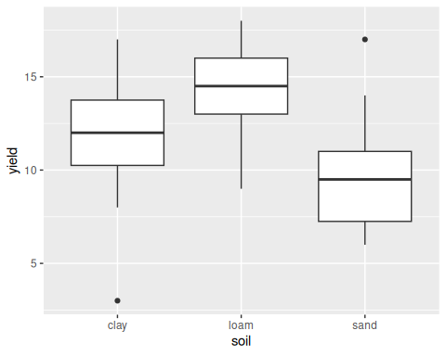
This shows you that the yield data are reasonably well-spread around the median for all three soil types, although there are a couple of outlier observations for clay and sand. Now add two extra lines to the gf_boxplot() function to get a graph similar to the following:
Hints:
- Use %>% (the “pipe” or “then” command)
- Use gf_labs() to modify x and y labels. Always add units to axes if possible
- Use gf_theme() to modify the default grey background
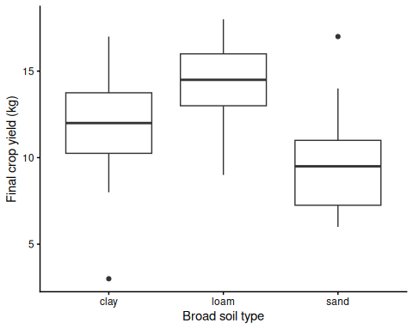

4.4 Analyse and interpret the linear model
The format of the lm() function is identical syntax as with a continuous variable. We stick to our same basic template:

ANOVA ( y ~ categorical x , data = mydata, … )

The syntax with the lm() function is the same:
lm(response_variable ~ categorical_explanatory_variable, data = dataframe_name)
We will save our results from the lm() function in an R objected called soil_lm and then use the Anova() function which is conventional way of displaying the results of linear models with this type of structure:
## 4.4 Analyse and interpret soil linear model ####
# Create linear model and store the results in soil_lm
soil_lm <- lm(yield ~ soil, data = crop_growth)
# Display the output of the linear model as an ANOVA table (full details)
anova(soil_lm)
# Display the output of the linear model as an ANOVA table (simplified)
Anova(soil_lm)
Analysis of Variance Table
Response: yield
Df Sum Sq Mean Sq F value Pr(>F)
soil 2 99.2 49.600 4.2447 0.02495 *
Residuals 27 315.5 11.685
---
Signif. codes: 0 '***' 0.001 '**' 0.01 '*' 0.05 '.' 0.1 ' ' 1
Anova Table (Type II tests)
Response: yield
Sum Sq Df F value Pr(>F)
soil 99.2 2 4.2447 0.02495 *
Residuals 315.5 27
---
Signif. codes: 0 '***' 0.001 '**' 0.01 '*' 0.05 '.' 0.1 ' ' 1
You might be wondering how we can test the effect of an explanatory variable using variances. In this course you will mainly use the “simplified” display of an ANOVA table, using the Anova() function from the car package. This is more robust to missing data values and its output generally easier to interpret. Here, we also look at the traditional “full” output from an ANOVA table, using the anova() function from “basic” R. It includes a column headed “Mean Sq”. These are “Mean Sums of Squares” which is another name for “variance”. The F-value is calculated by dividing the variance for soil, but the unknown Residual variance. Think of the F-value as the signal:noise ratio. The bigger the F-value, the more important is soil. See my Ten-Minute Video and play with an interactive that allows you to adjust the number of replicates and how noisy your data are, go to this Interactive demo of crop yield data (scroll down to see both demos)
You can see that the F-value is 4.2447 and the p-value is 0.02495. Which of the following best describes the results of the linear model?
- The p-value is significant (p<0.05). This proves that soil type affects yield ($F$=4.2447)
- With a p-value of 0.02495 and $F$ of 4.245 there was a significant difference in yield with soil type.
- There was a highly significant effect of soil type on yield ($F$=4.245, p=0.025)
- There was a significant difference in crop yield in response to soil type ($F_{2,27}$=4.245, p=0.025)
Which of the four is the best description of the results and why? Discuss your thoughts with demonstrators and your fellow students.
You might be wondering why we used the Anova() function rather than summary(). The latter can be a little confusing at first sight:
summary(soil_lm)
Call:
lm(formula = yield ~ soil, data = crop_growth)
Residuals:
Min 1Q Median 3Q Max
-8.5 -1.8 0.3 1.7 7.1
Coefficients:
Estimate Std. Error t value Pr(>|t|)
(Intercept) 11.500 1.081 10.638 3.7e-11 ***
soilloam 2.800 1.529 1.832 0.0781 .
soilsand -1.600 1.529 -1.047 0.3046
---
Signif. codes: 0 '***' 0.001 '**' 0.01 '*' 0.05 '.' 0.1 ' ' 1
Residual standard error: 3.418 on 27 degrees of freedom
Multiple R-squared: 0.2392, Adjusted R-squared: 0.1829
F-statistic: 4.245 on 2 and 27 DF, p-value: 0.02495
Comments
- The F-statistic and p-value printed at the end are identical to what you obtained with the Anova() function and give the overall statistical significance of the model.
- There are three numbers in the Estimate column, but only two soil types (loam and sand) are mentioned.
- The estimate value of 11.500 may look familiar to you. What was the mean yield you calculated earlier for each of the three soil types? The 11.500 is for clay
- R has put clay as a “baseline” to compare the others with, simply because when the three levels of clay, loam and sand are ordered automatically in alphabetical order, and the one first in the alphabet is used as a baseline. It is possible to manually change the baseline using the relevel() function, but this is rarely needed.
- The estimates for loam and sand are actually the differences in yield for loam and sand compared to clay. Cross-check with your calculated means to confirm this is true.
- The Anova() and summary() functions do not provide an easy way of comparing each soil type with the other two soil types.

4.5 Multiple comparison tests
To compare the differences between each soil type we actually need to do comparisons of:
- clay vs loam
- clay vs sand
- loam vs sand
We could break our data down into 3 smaller subsets, then re-run 3 separate linear models and check the results. There are two big problems with this:
- It will be very time-consuming. If you have 4, 5 or 6+ categories (levels) in your categorical explanatory variable, the number of sub-comparisons you need to make rapidly becomes unmanagable.
- The conventional level of statistical signficance is 0.05 or 1 in 20. So if your data are fairly random, with no experimental effect, but you end up doing 10 or more pairwise tests, you have a greater than 50:50 chance of mistakenly saying something is significant, when in reality it is not.
What we need therefore is a way of easily doing multiple comparisons between each of our soil types (levels), without distorting the conventional p=0.05 statistic by running lots of separate linear models. Multiple comparison tests provide a solution, as it is a single test, which does all the separate comparisons, and automatically avoids mistakes in the calculation of your p-values. The most commonly used one is the Tukey Honest Significant Difference or HSD test:
## 4.5 Multiple comparison tests ####
# Compare each soil type in turn with the others via pairwise tests
TukeyHSD(soil_lm)
Tukey multiple comparisons of means
95% family-wise confidence level
Fit: aov(formula = x)
$soil
diff lwr upr p adj
loam-clay 2.8 -0.9903777 6.5903777 0.1785489
sand-clay -1.6 -5.3903777 2.1903777 0.5546301
sand-loam -4.4 -8.1903777 -0.6096223 0.0204414
You have two sets of outputs here, one a table and the other a plot, but they both show the same information. First the table:
- The column headed diff shows the difference in the mean crop yield for each comparison of soil types
- The columns headed lwr and upr give the lower and upper 95% confidence intervals of this difference. See Confidence intervals on the Canvas website if you need a refresher
- The column headed p adj gives the adjusted p-value for this mean, such that:
  - if p is less than 0.05 then we assume that the difference between the two soil types being compared is statistically significant
  - it is an “adjusted” p-value to automatically correct for the multiple tests (3 in this example) that are being done.
# Plot the Tukey pairwise tests
plot(TukeyHSD(soil_lm))
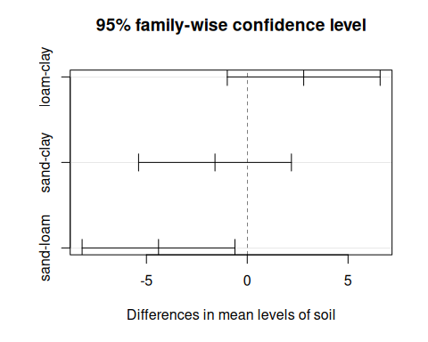
The plot of the Tukey HSD test shows the same information as the earlier table, but is easier to understand. The horizontal x-axis shows the differences in yield on each soil type +/- the 95% confidence intervals. If the line representing the 95% CI crosses zero then there isn’t a difference in the mean yield. In both the Tukey table and plot you can see that the only significant pairwise difference is that between sand and loam, where the yield on sand is significantly lower than that on loam. The sand vs loam comparison is the only one where the 95% confidence intervals around the difference between the means does NOT overlap zero. Look at your boxplot plot earlier to help you understand this.

4.5.1 Reporting multiple comparison tests
It is essential to explain these in your written work, both in the Methods and Results sections. In the Methods explain that you’ve used Tukey HSD to undertake pairwise comparison tests between different levels of your factor (here, the different soil types). In your Results, give both the p-values, and magnitude of the differences for each pairwise comparison. You can report this in a table, but remember to cross-reference to your Table Number in your text.

4.6 Check the assumptions of your linear model
Just as you did with the earlier example for the caterpillar growth and the continuous explanatory variable, so you should check model assumptions by examining the residuals (unexplained noise) from your expectations. Try and produce a quantile-quantile (QQ) plot similar to below for the soil linear model. The closer the residuals are to a straight line the more the assumption about normally distributed (bell-shaped) errors is accepted. Hint: To only display the QQ plot of your observed and predicted residuals, include which = 2 instead of which = c(1 ,2) in your plot() of the soil_lm object:
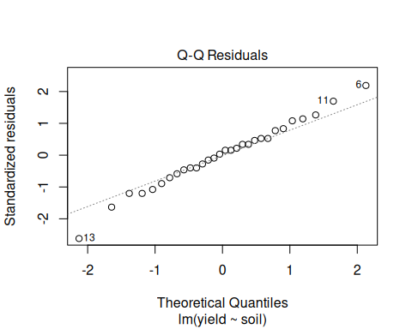
As you can see, nearly all of the observed residuals fall nicely along the expected pattern of the residuals (centred around zero), suggesting that a key assumption of a linear model, that the residuals are roughly normally distributed, has been met.
We can look to see whether our next important assumption, equal variances for each level, has been met by plotting up the residuals for each level.
# Extract model residuals (unexplained noise) and plot
soil_resid <- residuals(soil_lm)
gf_point(soil_resid ~ crop_growth$soil) %>%
gf_theme(theme_classic())
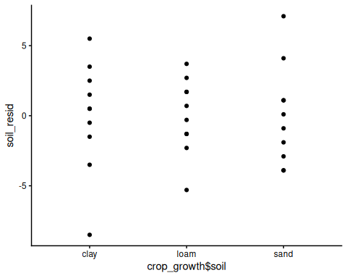
We can see that the spread of data points is relatively similar across each of the levels in the analysis. This would suggest that we have met our assumption of homogeneity of variance. When we have much larger sample sizes we could look at the residuals using a boxplot. See if you can produce a boxplot of the residuals, overlay the individual residual points and colour those individual points red. You should see that the median value of the boxplots is very close to zero which is good. The graph below uses gf_jitter() rather than gf_point() to offset the points from each other slightly. You will find this trick useful when you have a lot of data:
gf_boxplot(soil_resid ~ crop_growth$soil) %>%
gf_jitter(soil_resid ~ crop_growth$soil) %>%
gf_labs(x = "Soil type", y = "Model residuals") %>%
gf_theme(theme_classic())
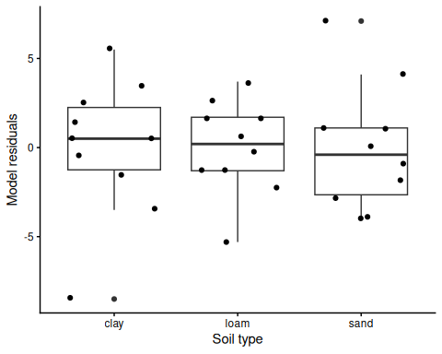

5. Working with large biological datasets (Complete in your own time before next week)
Modern biology, zoology and marine bioscience generates big datasets that at first glance can be challenging to understand. Luckily, you can use the skills you’ve just learnt to summarise, visualise and analyse them. We will now do this with a dataset of over 300 observations!
The data are morphological measures of three species of Antartic penguins, although we will initially focus on their body mass. Key things for you to answer:
- What are typical body mass means for each species?
- Is body mass explained by the species of penguin?
- Are there differences in body mass between each pairwise comparison of species?
Download the penguins.csv data set from Canvas and copy it to your NES2504 or NES2504/Data folder. If you want, open it in Microsoft Excel to see what it contains. If you have not already done so, you may find it helpful look at Interactive website on how to visualise data which uses this dataset as an example.
Read in the dataset in the usual way via the read.csv() function, storing it in a table (data frame) called penguins.
# Read in the CSV file. If not using a Data subfolder, then remove Data/
penguins <- read.csv("Data/penguins.csv")
Using the methods described above, investigate the relationship between body mass and species, where species is the explanatory variable and body mass is the response variable. I’m not giving you the R code for this, but you have sufficient skills to do it!
There are 5 things you must do:
- Produce a box plot to show the variation in body mass in the 3 species of penguin
- Create a linear model and summarise it. Is there a significant effect of species on body mass?
- Check the assumptions of your linear model
- If there is a significant difference, complete a Tukey Honest Significant Difference to look at the differences in body mass between each pair of species and plot it
- Interpret your results

5.1 Create the boxplot
Use your skills to create the following boxplot:
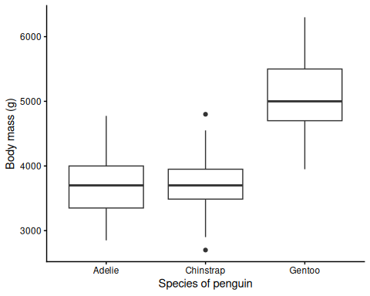

5.2 Linear model (ANOVA)
This linear model will be an “ANOVA” since species is a categorical explanatory variable. Use it to see if species has a significant effect on body mass. Hints:
- Use lm() function to create your linear model with the data stored in penguins. Think about which variable is your response, and which is your explanatory.
- Store the results of your lm() function in penguin_lm by using the <- symbol
- Display the analysis of variance of penguin_lm using the Anova() function
- Does species have a significant effect on body mass? How would you write the F and p-values in a written report Hint: not quite the same as shown in the table.
The results of your linear model should be displayed as below:
Anova Table (Type II tests)
Response: body_mass_g
Sum Sq Df F value Pr(>F)
species 146864214 2 343.63 < 2.2e-16 ***
Residuals 72443483 339
---
Signif. codes: 0 '***' 0.001 '**' 0.01 '*' 0.05 '.' 0.1 ' ' 1

5.3 Check the assumptions of your analysis
The “errors” or “residuals” which is the “unknown variation” from your analysis are assumed to come from a normal, or bell-shaped, distribution. You can check this by plotting them on a frequency histogram, and also a diagnostic plot, for example a QQ plot.

5.4 How do species body mass differ between pairs?
You have three species of penguin, and your ANOVA merely indicates that species type has an effect on body mass. It doesn’t tell you if all three are different from each other, or if two of them are the same. Do a multiple comparison test to do pairwise comparisons in body mass between two species at a time. Which species are the same, and which differ? Hint: use the TukeyHSD() function with your penguin_lm model:
Tukey multiple comparisons of means
95% family-wise confidence level
Fit: aov(formula = x)
$species
diff lwr upr p adj
Chinstrap-Adelie 32.42598 -126.5002 191.3522 0.8806666
Gentoo-Adelie 1375.35401 1243.1786 1507.5294 0.0000000
Gentoo-Chinstrap 1342.92802 1178.4810 1507.3750 0.0000000
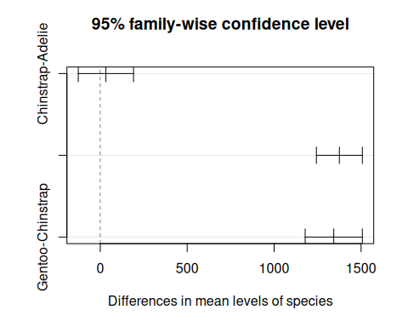

5.5 Interpretation
How might you write up these results in a report? Compare your ANOVA and Tukey results to your boxplot. Also look at this section of the NES2504 Data Analysis Handbook on easy approaches to report-writing.

