**DANIEL RODRIGUEZ SANCHEZ**

UNIX

* How many packets were transferred between the source and destination **(5%)**

20 packets were transferred

* What is the type for the request packets and what for a reply packet **(5%)**

The type of both, request and reply packages are ICMP

* Write the MAC address of the network card on the destination computer **(5%)**

74:ac:b9:54:18:d7

* How many bytes are in the field "Data" and what is the content of this field **(5%)**

There are 48 bytes, the content of this field is just half decoded so we cant just see those symbols and numbers at the right side.

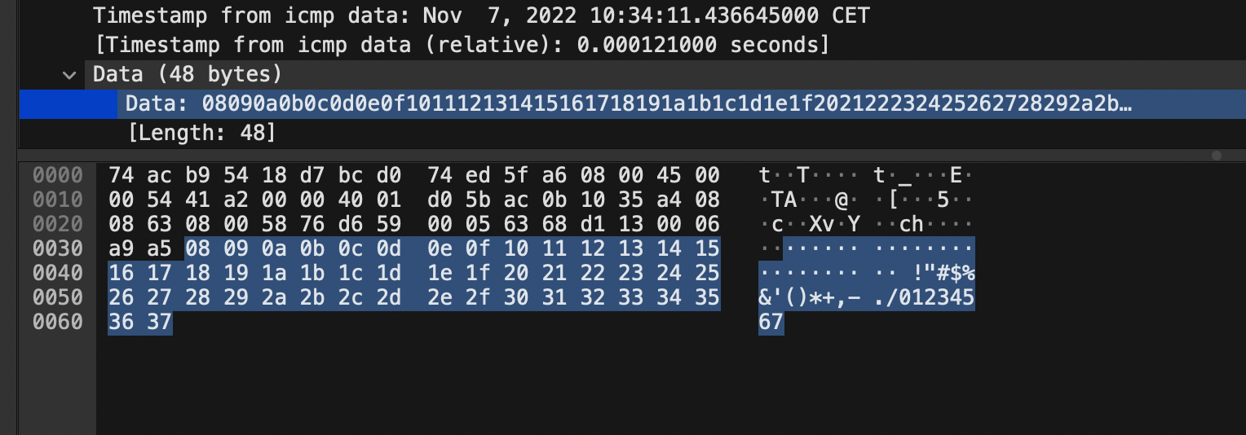

WINDOWS

* How many packets were transferred between the source and destination **(5%)**

20 packets were transfered

* What is the type for the request packets and what for a reply packet **(5%)**

Both of them use the ICMP protocol

* Write the MAC address of the network card on the destination computer **(5%)**

00:1c:42:00:00:18

* How many bytes are in the field "Data" and what is the content of this field **(5%)**

There are 32 bytes on the field data and the content of it are the first 23 letters from alphabet skiping “x”, “y” and “z” and completing until 32 bytes starting again from “a” to “i”.

