**Functional Group Chemistry Applied to Rotational Constants… Maybe?**

For the next person working on this project:

This document shows what I was going to work on next in building the rovibrational structure.

I might be completely wrong, and this approach will likely not work, however, in the slim chance that some patterns are detected, I think it would be really useful in making approximations.

I have started the work on this document and so hopefully you can see how I have been sorting out the functional groups and calculating the rovibrational structure. In order to help you with this part of the project, you will need access to Gaussian, Avogadro (free app also really useful for visualizing), and the Gaussian cheat sheet.

Note: as the molecules get bigger, the time it takes for the rovibrational constants to be calculated increases a lot (I’ve already had to wait for almost an hour for a 4 carbon chain, but perhaps this is just my computer). Therefore, it might be necessary to change to runtime in your .pbs files to be longer than 1 hour for certain molecules.

If this doesn’t make sense at any point, I’d be happy to answer any questions and you can easily contact me at znheussen@gmail.com

**________________________________________________________________________________**

Thought process: We need to get rotational constants for all molecules going through RASCALL. However, in the context of RASCALL, it doesn’t make much sense to calculate all of them.

1. **It takes up computing time and power.** The whole point of RASCALL is to use approximations in order to save computing time. More rigorous physical chemistry models have the ability to calculate more precise results, however they take a lot more time/computing power and therefore the spectrum of far fewer molecules can be calculated. Alternatively, while RASCALL isn’t able to compete with the accuracy of other models, it allows for a much greater number of molecule spectra to be found in a much shorter amount of time. Since this approach is used in order to get the main features on the spectrum, it would make sense to explore ways to use approximations in finding the rotational constants as well (if possible)
2. **We can’t have the numbers used in creating a rovibrational spectrum to be of higher accuracy than the spectral features themselves.** Since RASCALL uses functional group theory to find where possible spectral features are, it does not make much sense to use a much more accurate model in producing the rovibrational spectrum than the spectral features. Therefore, as functional group theory is used in determining where spectral features are, perhaps a similar approach can be used in creating a rovibrational structure.

Below I have explored this approach. First, I found all the functional groups in the RASCALL database. I then separated the functional groups into a list of what I considered to be functional groups and a list of what I do not consider to be functional groups. They are listed below:

* Functional Groups in RASCALL: Alkanes, Alkenes, Alkynes, Aromatics, Alcohols, Phenyl (called Phenols in RASCALL), Ethers, Amines, Aldehydes, Ketones, Carboxylic Acid, Nitriles, Phosphonate, Lactone, Aliphatic, Isothiocyanate, Isocyanate, carbodiimide, ketenimine, Azide, Ester, Acyl Halide, Halo Compound, Alkyl Halides, Acyl Chorides, Thiocarbonyl, Nitro Compounds, Ketenes, Allene, Amine Oxide, Imines (written Oxime in RASCALL), Amides, Arenes, Nitroso, Diimides

(red)- still must be sorted and decided- sort out into the categories below

* Functional Groups in RASCALL that aren’t functional groups: carbon dioxide, Phosphoramide, Phosphine, Lactam, Cyclopentanone, Phosponic Acid

Then I decided to take each functional group and add different amounts of molecules onto the functional group as required by each functional group (ie. Alkanes are CH chains so I varied the length of the chain). Then I decided to see if there was a correlation between the rotational constants and length of the chain. If so, perhaps one rotational constant can be worked out per functional group and then an equation can be applied to get the rest.

________________________________________________________________

Adding a Longer Chain (ie more CH bonds):

Functional Group List: Alkanes (add more CHs), Alkenes (add more CHs), Alkynes (add more CHs), Alcohols (add more CHs), Aldehydes (add CHs), Carboxylic Acid (add CHs)

Alkanes Functional Group: CnH2n+2

|  |  |
| --- | --- |
| Name, Formula of Chain | Rotational Constants A, B, C (MHZ) |
| Methane, CH4 | 157374.4741133 157373.8052397 157373.8052397 |
| Ethane, C2H6 | 80147.8583821 19964.7474726 19964.7194936 |
| Propane, C3H8 | 29373.4393168 8429.9884278 7461.6354589 |
| Butane, C4H10 | 13153.2113705 4788.0253984 4059.5114339 |

Below, I have plotted the A rotational constant, B rotational constant and C rotational constant as the chain of Cs gets longer.

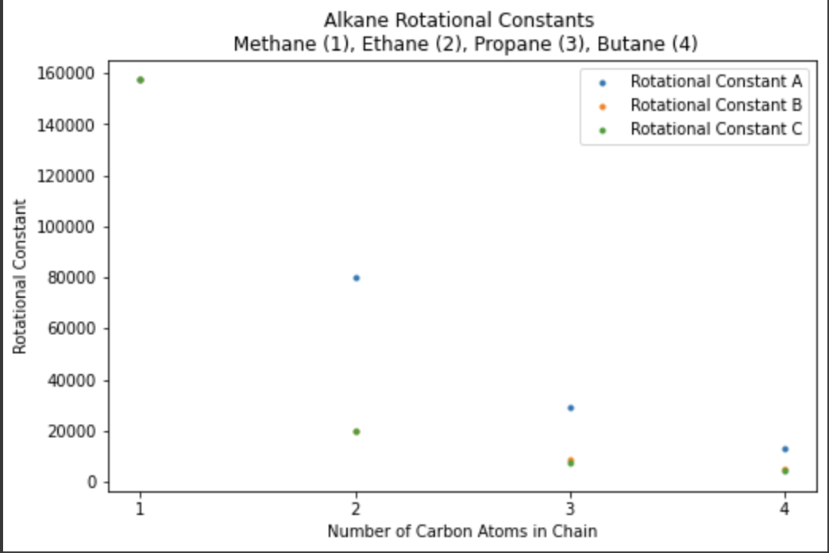

As shown in both the table and the graph, all three rotational constants start at the same number, 157374.4741133.

* For rotational constant A, every time a carbon atom gets added to the chain, A seems to halve.
* For B, there is no apparent correlation between having 1 and 2 carbon atoms on the chain. However, from a 2 carbon atom chain, the rotational constant seems to halve with every carbon atom added. C follows similarly.

I also decided to plot the sum of all rotational constants as a function of the number of carbon atoms in the chain. This line also shows a strong correlation.

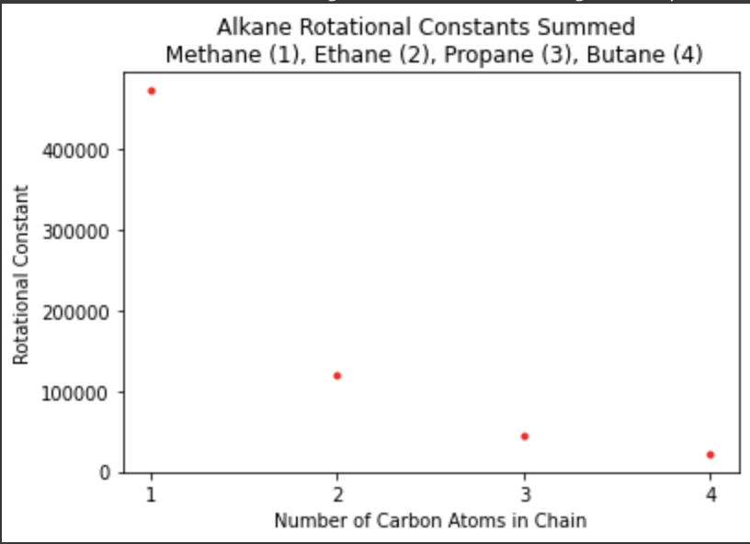

Perhaps with more testing with even longer chains, an equation can be found in order to write each rotational constant as a function of the number of carbon atoms.

Alkenes Functional Group: CnH2n

|  |  |
| --- | --- |
| Name, Formula of Chain | Rotational Constants (MHz) |
| Ethene, C2H4 | 146450.0590768 30097.7763429 24966.7242480 |
| Propene, C3H6 | 46698.5314593 9275.8200136 8128.5327093 |
| Butene, C4H8 | 15394.2545304 5548.6275401 4294.9402684 |

All three rotational constants look like they are divided by 3 as a Carbon Atom is Added.

Alkynes Functional Group: CnH2n-2

|  |  |
| --- | --- |
| Name, Formula of Chain | Rotational Constants (MHz) |
| Ethyne, C2H2 |  |
| Propyne, C3H4 |  |
| 1-Butyne, C4H6 |  |

etc….

if patterns keep emerging, I would test to larger molecules in each family and for all functional groups above. This can be used to possibly create an equation relating the number of Carbon atoms to the rotational constants of each functional group.

________________________________________________________________

Single Bond Missing

Functional Group List: Phenyl (bond anything to the ring), Aromatics (add more CHs or more rings), Ethers (add Alkyl or Aryl), Ketone (add CHs, rings, etc.)

Phenyls: Phenyls are characterized by having a hydroxyl group attached to a carbon atom part of an aromatic ring. The ring can be bonded to any other molecule physically viable. Therefore, molecules with this functional group will be much more varied than those in a CH chain such as Alkanes. This variation will likely lead to rotational constants that are less predictable with less of a pattern. I expect that functional group theory to predict rotational constants will not work with any molecules past functional groups that exist in CH chains.

|  |  |  |
| --- | --- | --- |
| Name, Formula | Number of non Hydrogen Atoms | Rotational Constants (MHz) |
| Phenol/Hydroxybenzene | 7 |  |
| Hydroquinone | 8 |  |
| Resorcinol | 8 |  |
| Meta- Cresol | 8 |  |
| Thymol | 11 |  |
| Eugenol | 12 |  |

Complete the rest of the functional groups.

________________________________________________________________

Different Amounts of Bonds in one Functional Group:

Functional Group List: Amine- Primary Amine, Secondary Amine, Tertiary Amine (add alkyl or aryl group)

Find different versions of each functional group and find rotational constants. Try finding patterns.

Other possible categories for functional groups I haven’t used yet:

Adding Different Molecules to Make Functional Group (like different Halogens):

__________________________________________________________________________________

Double Bond Missing

Functional Group List:

**Adding 2 single bonds**

**Adding 1 double bond**

**__________________________________________________________________________________**

Triple Bond Missing

Functional Group List:

**Adding 3 single bonds**

**Adding 1 single bonds and 1 double bond**

**Adding 1 triple bond**