**Results**

b. This study looked to assess whether children who experience a psychological trauma resulting in PTSD exhibit similar behavioral symptoms to those with ADHD. Further, this study tested whether hyperactive behavior exhibited by a combined ADHD and trauma group would exhibit greater hyperactivity than neurotypical children. To test behavioral differences, outcomes on a hyperactivity sub-scale of the BASC were collected from children with PTSD, ADHD, and those experiencing neither PTSD or ADHD.

c. A one-way ANOVA between subjects was conducted to compare the effect of the independent variable, mental health, on the dependent variable, hyperactivity scores. This was followed with the two planned tests using linear contrasts to test the aforementioned hypotheses.

One-Way ANOVA Results

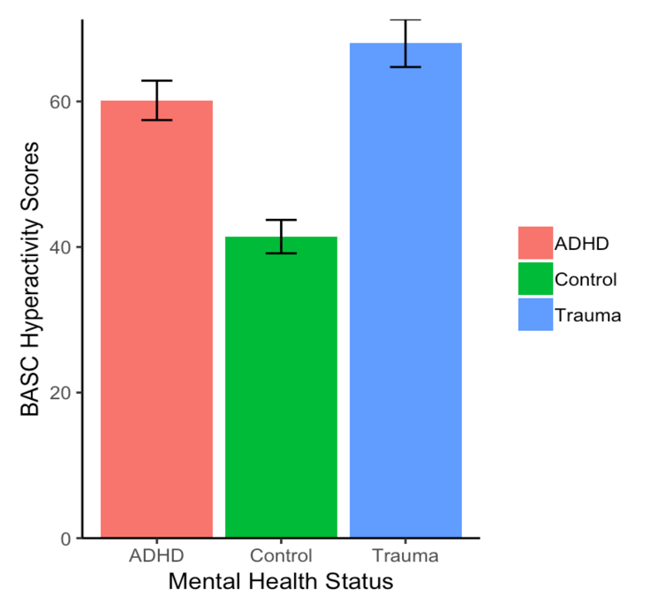d. The one-way ANOVA produced a significant effect of mental health status on hyperactivity scores, *F*(2,39) = 23.99, *MSW* = 108.75, *p* < 0.000 (Figure 1). The planned linear contrast showed no significant difference between children with diagnoses of PTSD (*M* = 68.00, *SD* = 12.25) and ADHD (*M* = 60.14, *SD* = 10.13), *t*(39) = 1.99, *p* = 0.05, *d* = -0.70. In a planned linear contrast, a combined group of children with PTSD and ADHD were significantly different than the children without a mental health diagnosis (*M* = 41.43, *SD* = 8.53), *t*(39) = 6.63, *p* <0.0001, *d* = -2.51.

e. The test between children with PTSD and ADHD failed to reject the null hypothesis, supporting the hypothesis that these two groups of children exhibit similar behaviors on a measure of hyperactivity. In a test that combined data from children with PTSD and ADHD and compared their behavioral scores to children with neither diagnosis, the null hypothesis was rejected. This indicates that children with a mental health diagnosis had a higher score on a measure of hyperactivity than children without a mental health diagnosis, reflecting higher parental reports of the child’s hyperactivity.

*Figure 1.* Mean BASC hyperactivity scores

f. Confirmatory follow-up tests were performed to test whether children with ADHD were different from children without a mental health diagnosis and, similarly, whether children with PTSD were different from children without a mental health diagnosis. To guard against inflated Type 1 error, the unplanned tests were performed using linear contrasts with Sidak correction. Children with ADHD (*M* = 60.14, *SD* = 10.13) had significantly higher hyperactivity scores than children without a mental health diagnosis (*M* = 41.43, *SD* = 8.53), *t*(39) = -4.75, *p* <0.0001, *d* = -1.99. Children with PTSD (*M* = 68.00, *SD* = 12.25) had significantly higher hyperactivity scores than children without a mental health diagnosis (*M* = 41.43, *SD* = 8.53), *t*(39) = -6.74, *p* <0.0001, *d* = -2.51.