Introduction

a. This study looked to compare the effects of scent marking by other animals on exploratory behaviors of kangaroo rats. In their natural habitat, kangaroo rats use scent markings to establish territories. It is unknown whether the kangaroo rats explore new burrow systems differently depending on age and familiarity of odor. This study tested two age groups of kangaroo rat: young and adult, and three explore conditions: Control (no scent), Unfamiliar Odor, and Familiar Odor. Each condition contained seven rats with 60 minutes to explore the environment (N=42).

Methods

b. A 3x2 ANOVA design was used to compare the independent variable, age of rat, with the dependent vairable, time spent exploring. Two hypothesis were tested. Hypothesis 1, the hard-wired hypothesis, tested the possiblity that rats have an evolutionary avoidance strategy that limits exploration when expecting to encounter another rat. In this hypothesis only scent condition, not age, would not show an effect of exploratory behavior, and only limited exploration would be measured. Hypothesis 2, the learned hypothesis, investigated whether rats learn to avoid potentially hostile rats via scent. If true, younger rats would be more cautious when exposed to the scent of another rat, exhibiting less exploratory behavior when compared to adult rats.

c. Analyses were conducted in R (3.5.1) with the emmeans, car, afex, dplyr, and ggplot2

Two-Way ANOVA Results

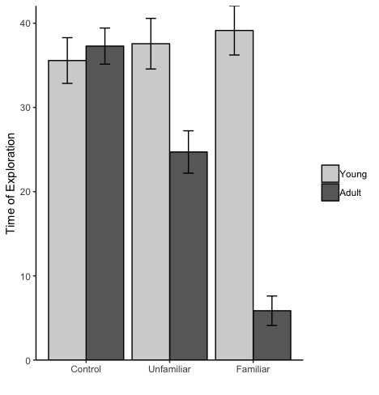packages (Lenth, 2018; Fox et al., 2018; Singman et al., 2018; Wickham et al., 2018; Wilke, 2016).

The test of the hypotheses was conducted using a planned pairwise analysis of the effect of age on the amount of time spent exploring.

Results

d. The two-way ANOVA produced significant effects of age *F*(1, 36) = 50.74, *MSW* = 45.39, *p* <.001, η2 = .58, and scent *F*(2, 36) = 15.25, *MSW* = 45.39, *p* <.001, η2= .46 (See *Figure 1*). Additionally, a significant interactio was found *F*(2, 36) = 23.84, *MSW* = 45.39, *p* <.001, η2 = .57.

e. Follow up tests were used to investigate the two stated hypotheses revealing no significant difference within the Control scent condition, *t*(36) = -.48, *p* = .637. However, significant differences were found between the Unfamiliar and Familiar scent conditions, *t*(36) = 3.57, *p* = .001; *t*(36) = 9.24, *p* < .0001.

*Figure 1.* Mean Time of Exploration

per Condition

f. According to the hard-wired hypothesis, age should not have an effect on the amount of time spent exploring and rats will only spend a decreased about of time exploring their burrow if they smell another rat. Animals behaved similarly in the Control condition, but in both the Unfamiliar and Familiar scent coditions Adult rodents spent significantly less time exploring their burrow system. During these conditions, the young rats continued to explore their burrow despite the presence of another rat’s scent. Therefor, the learned hypothesis, which predicted that rats learn avoidance behaviors over time leading the adult rats would display more avoidance behavior, was supported.

References

Lenth, R. (2018). Emmeans: Estimated marginal means, aka least-squares means. R Package Version 1.2.3.

Fox, J., Weisberg, S., Price, B., Adler, D., Bates, D., Baud-Bovy, G.,… & R-Core. (2018). car: Companion to Applied Regression. R package version 3.0-0.

Singmann, H., Bolker, B., Westfall, J., Aust, F., Højsgaard, S., Fox, J., ... & Love, J. (2018). afex: analysis of factorial experiments. R package version 0.21-2.

Wickham, H., Francois, R., Henry, L., & Müller, K. (2018). dplyr: A Grammar of Data Manipulation. R package version 0.7.6.

Wilke, C. O. (2016). cowplot: Streamlined Plot Theme and Plot Annotations for ‘ggplot2’. R package version 0.7. 0.