**Two-way Within Subjects ANOVA Homework**

a. This study investigated the perception of morality as effected by actors’ intent and actors’ behaviors. Researchers used four vignettes, varying the intent of the actors between positive and negative, as well as their behaviors, between positive and negative. The researchers hypothesized that if the actor had negative intentions, the outcome would be rated negatively regardless of the actual behavioral outcome. If the actor’s intentions were positive, then the outcome would matter and would be rated less moral when the outcome was negative and comparatively more moral when the outcome was positive.

**Methods**

b. This study included a total of 60 observations, with 15 participants per condition. A 2x2 Repeated Measures ANOVA was used to compare the independent variables, intent and behavior of the actor, with the dependent variable, rating of morality. To test the hypothesis regarding whether outcomes difference between groups, the interaction term of the RM ANOVA was investigated in a planned follow-up.

c. The follow-up test of the interaction was completed using a planned pairwise comparison between the intention of the actors and comparing positive versus negative behavioral outcomes. Levene’s test was used to evaluate violations of homogeneity of variance and was nonsignificant (*p*=.09). Satterthwaite correction was applied and partial degrees of freedom will be reported. Analyses were conducted in R (3.5.1) with the emmeans, car, afex, dplyr, and ggplot2 packages (Lenth, 2018; Fox et al., 2018; Singman et al., 2018; Wickham et al., 2018; Wilke, 2016).

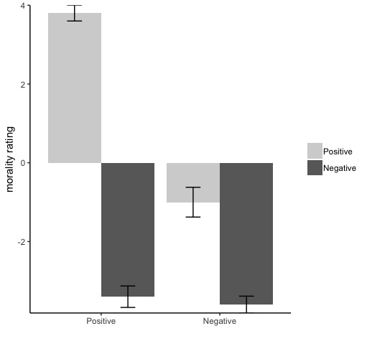**Results**

Two-Way RM ANOVA Results

d&e. The RM ANOVA produced significant effects of intent, *F*(1, 14) = 175.00, *p* <.001, η2=.98, outcome, *F*(1, 14) = 622.48, *p* <.001, η2=.93, and the interaction between intent and outcome, *F*(1, 14) = 39.82, *p* <.001, η2=.74 (See *Figure 1*). The planned pairwise comparison follow-up of the interaction revealed significant differences between positive and negative outcomes at positive intent, *F*(1, 21.02) = 136.68, *p* <.001. The comparison between positive and negative outcomes at negative intent was non-significant, *F*(1, 21.02) = .237, *p* =.631.

f. Findings showed that if actors had positive intent and did something positive, they had a high rating. If actors had negative intent and did something negative they had a low rating. If actors were positive and did something negative, their rating was low but not as low as those who were negative and did something negative. Follow-up testing of the interaction supported the hypothesis stating that if the actor had negative intentions, regardless of their behavior their outcome rating of morality would be lower than that of the positive group.

*Figure 1.* Mean morality rating per condition

**References**

Lenth, R. (2018). Emmeans: Estimated marginal means, aka least-squares means. R Package Version 1.2.3.

Fox, J., Weisberg, S., Price, B., Adler, D., Bates, D., Baud-Bovy, G.,… & R-Core. (2018). car: Companion to Applied Regression. R package version 3.0-0.

Singmann, H., Bolker, B., Westfall, J., Aust, F., Højsgaard, S., Fox, J., ... & Love, J. (2018). afex: analysis of factorial experiments. R package version 0.21-2.

Wickham, H., Francois, R., Henry, L., & Müller, K. (2018). dplyr: A Grammar of Data Manipulation. R package version 0.7.6.

Wilke, C. O. (2016). cowplot: Streamlined Plot Theme and Plot Annotations for ‘ggplot2’. R package version 0.7. 0.