**Mixed ANOVA Homework**

1. Previous studies have shown that newborn babies prefer the sound of their mother’s voice over that of another woman. This discrimination between voices aids in the formation of the mother-infant bond. To test the degree to which infants prefer the sound of their mother’s voice to that of another woman, babies’ sucking activity on a nonnutritive nipple was measured then manipulated by playing recordings of mothers’ voices. Baseline measurements of the infants’ median interburst interval (IBI), a measure of time between the end of one burst of sucking and the beginning of the next, were compared after hearing the vocal feedback. Infants either heard their mother’s voice after longer-than-median IBIs or shorter-than-median IBIs. The researchers' hypothesized that if infants recognized their mother's voice, then they would adapt their IBI, either making it longer or shorter, to increase the production of their own mother’s voice.

**Methods**

1. This study included a total of 20 observations, with 10 participants in each condition. A 2x2 Mixed ANOVA was used to compare the independent variable, longer or shorter IBI length for maternal voice reinforcement, with the dependent variable, IBI. Since the interaction term is of interest in order to address the hypothesis, the interaction was investigated in a planned follow-up.
2. 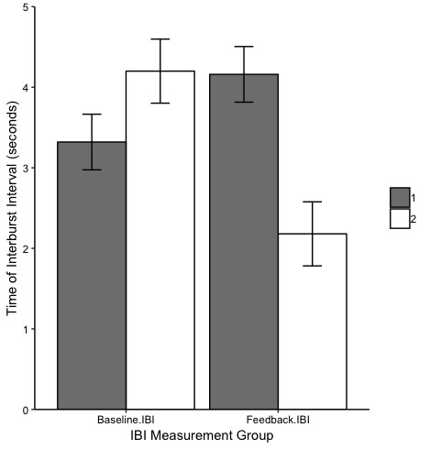The follow-up test of the interaction was completed using a planned pairwise comparison between longer or shorter IBI length for maternal voice reinforcement and the effect on infant IBI. Levene’s test was used to evaluate violations of homogeneity of variance and was nonsignificant (*p*=.39). The planned follow-up was limited to two tests and therefore was uncorrected. Analyses were conducted in R (3.5.1) with emmeans, heplots, car, afex, dplyr, ggplot2, effsize, and tidyr packages (Lenth, 2018; Fox, Friendly, & Monette, 2009; Fox et al., 2018; Singman et al., 2018; Wickham et al., 2018; Wilke, 2016; Torchiano & Torchiano, 2017; Wickham, 2016).

Two-Way Mixed ANOVA Results

**Results**

d&e. The Mixed ANOVA produced nonsignificant main effects of group, *F*(1, 8) = .63, *p* =.45, η2=.06 and IBI condition, *F*(1, 8) = 2.51, *p* =.15, η2=.07. The interaction between group and IBI condition was significant, *F*(1, 8) = 14.74, *p* =.005, η2=.29 (See *Figure 1*). The planned pairwise comparison follow-up test of the interaction revealed significant differences within group 2 between baseline (*M* = 4.20, *SD* = .89), and feedback IBI (*M* = 2.18, *SD* = .89), *t*(1, 8) = 3.84, *p* =.005, but not within group 1 between baseline (*M* = 3.32, *SD* = .77), and feedback IBI (*M* = 4.16, *SD* = .77), *t*(1, 8) = -1.60, *p* =.15.

*Figure 1.* Mean IBI measurement per group

f. Findings supported the hypothesis that if infants recognized their mother's voice, then they would adapt their IBI, either making it longer or shorter, to increase the production of their own mother’s voice. Infants in group 1 increased their IBI to hear their mother’s voices more frequently and infants in group 2 decreased their IBI to hear their mother’s voices more frequently. The significant interaction was driven by the infants in group 2.

**References**

Lenth, R. (2018). Emmeans: Estimated marginal means, aka least-squares means. R Package Version 1.2.3.

Fox, J., Friendly, M., & Monette, G. (2009). Visualizing hypothesis tests in multivariate linear models: The heplots package for R. *Computational Statistics*, *24*(2), 233-246.

Fox, J., Weisberg, S., Price, B., Adler, D., Bates, D., Baud-Bovy, G.,… & R-Core. (2018). car: Companion to Applied Regression. R package version 3.0-0.

Singmann, H., Bolker, B., Westfall, J., Aust, F., Højsgaard, S., Fox, J., ... & Love, J. (2018). afex: analysis of factorial experiments. R package version 0.21-2.

Wickham, H., Francois, R., Henry, L., & Müller, K. (2018). dplyr: A Grammar of Data Manipulation. R package version 0.7.6.

Wilke, C. O. (2016). cowplot: Streamlined Plot Theme and Plot Annotations for ‘ggplot2’. R package version 0.7. 0.

Torchiano, M., & Torchiano, M. M. (2017). Package ‘effsize’. R package version 0.7. 1.

Wickham, H. (2016). Easily Tidy Data with’spread ()’and “gather ()” Functions. *CRAN R Package http://cran/R-projectorg/package= tidyr version*, *41*.