**Exercise – 1**

**Question :**

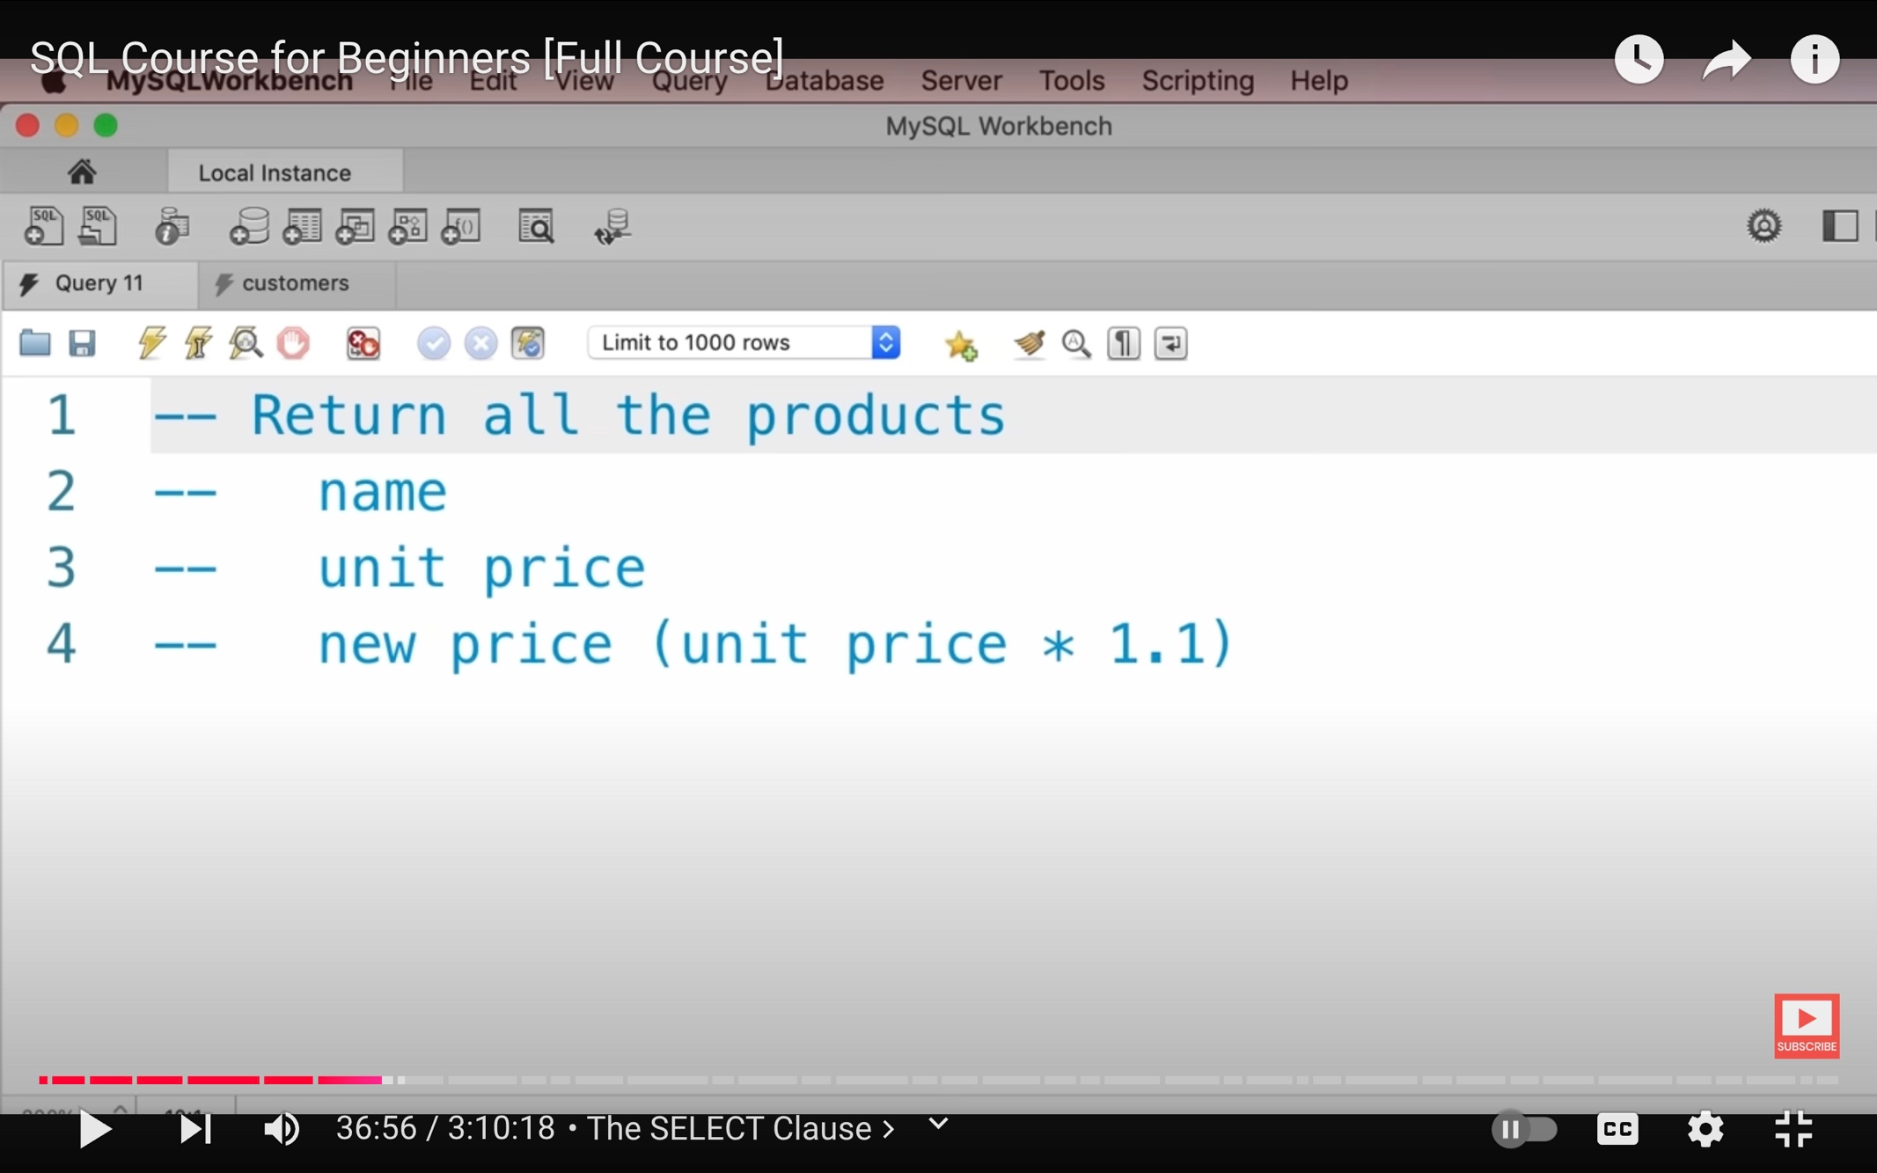

**Answer :**

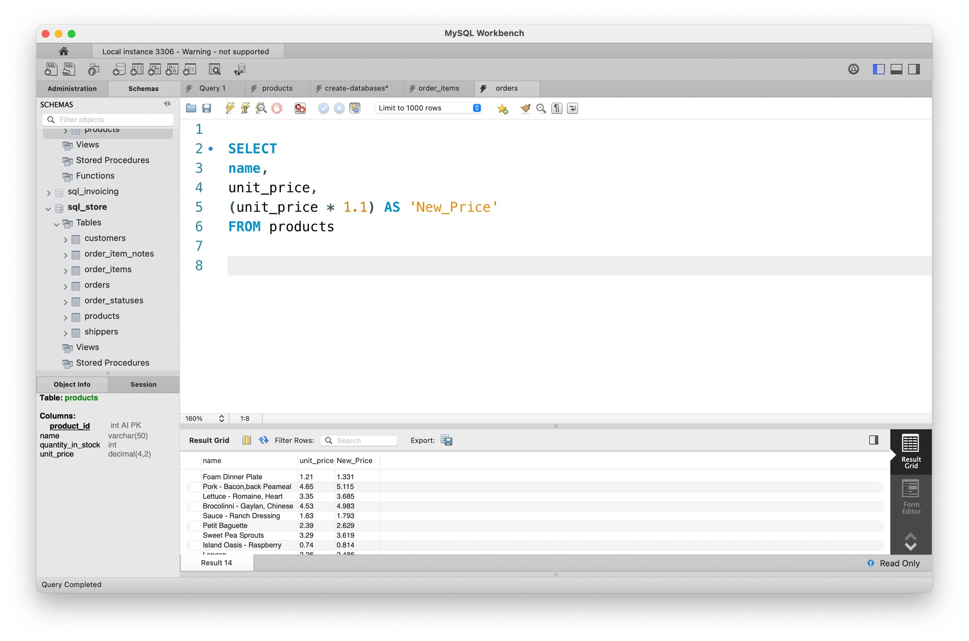

**Exercise – 2**

**Question :**

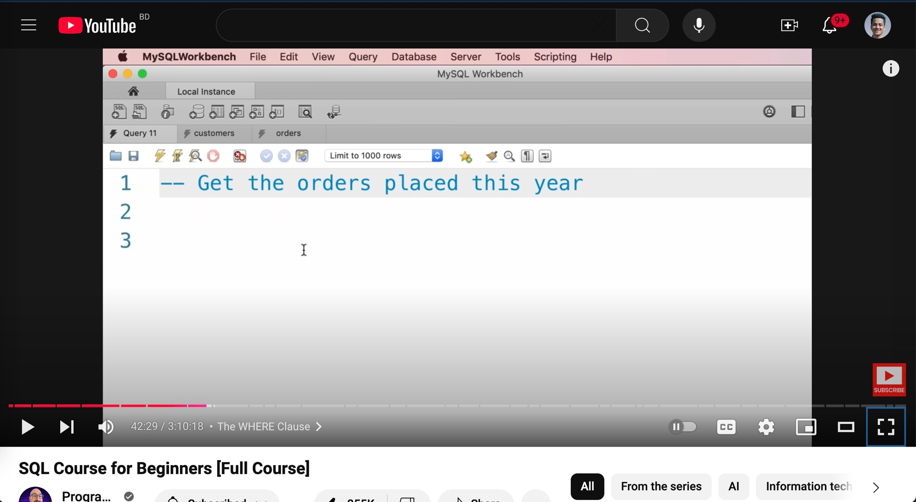

**Answer:**

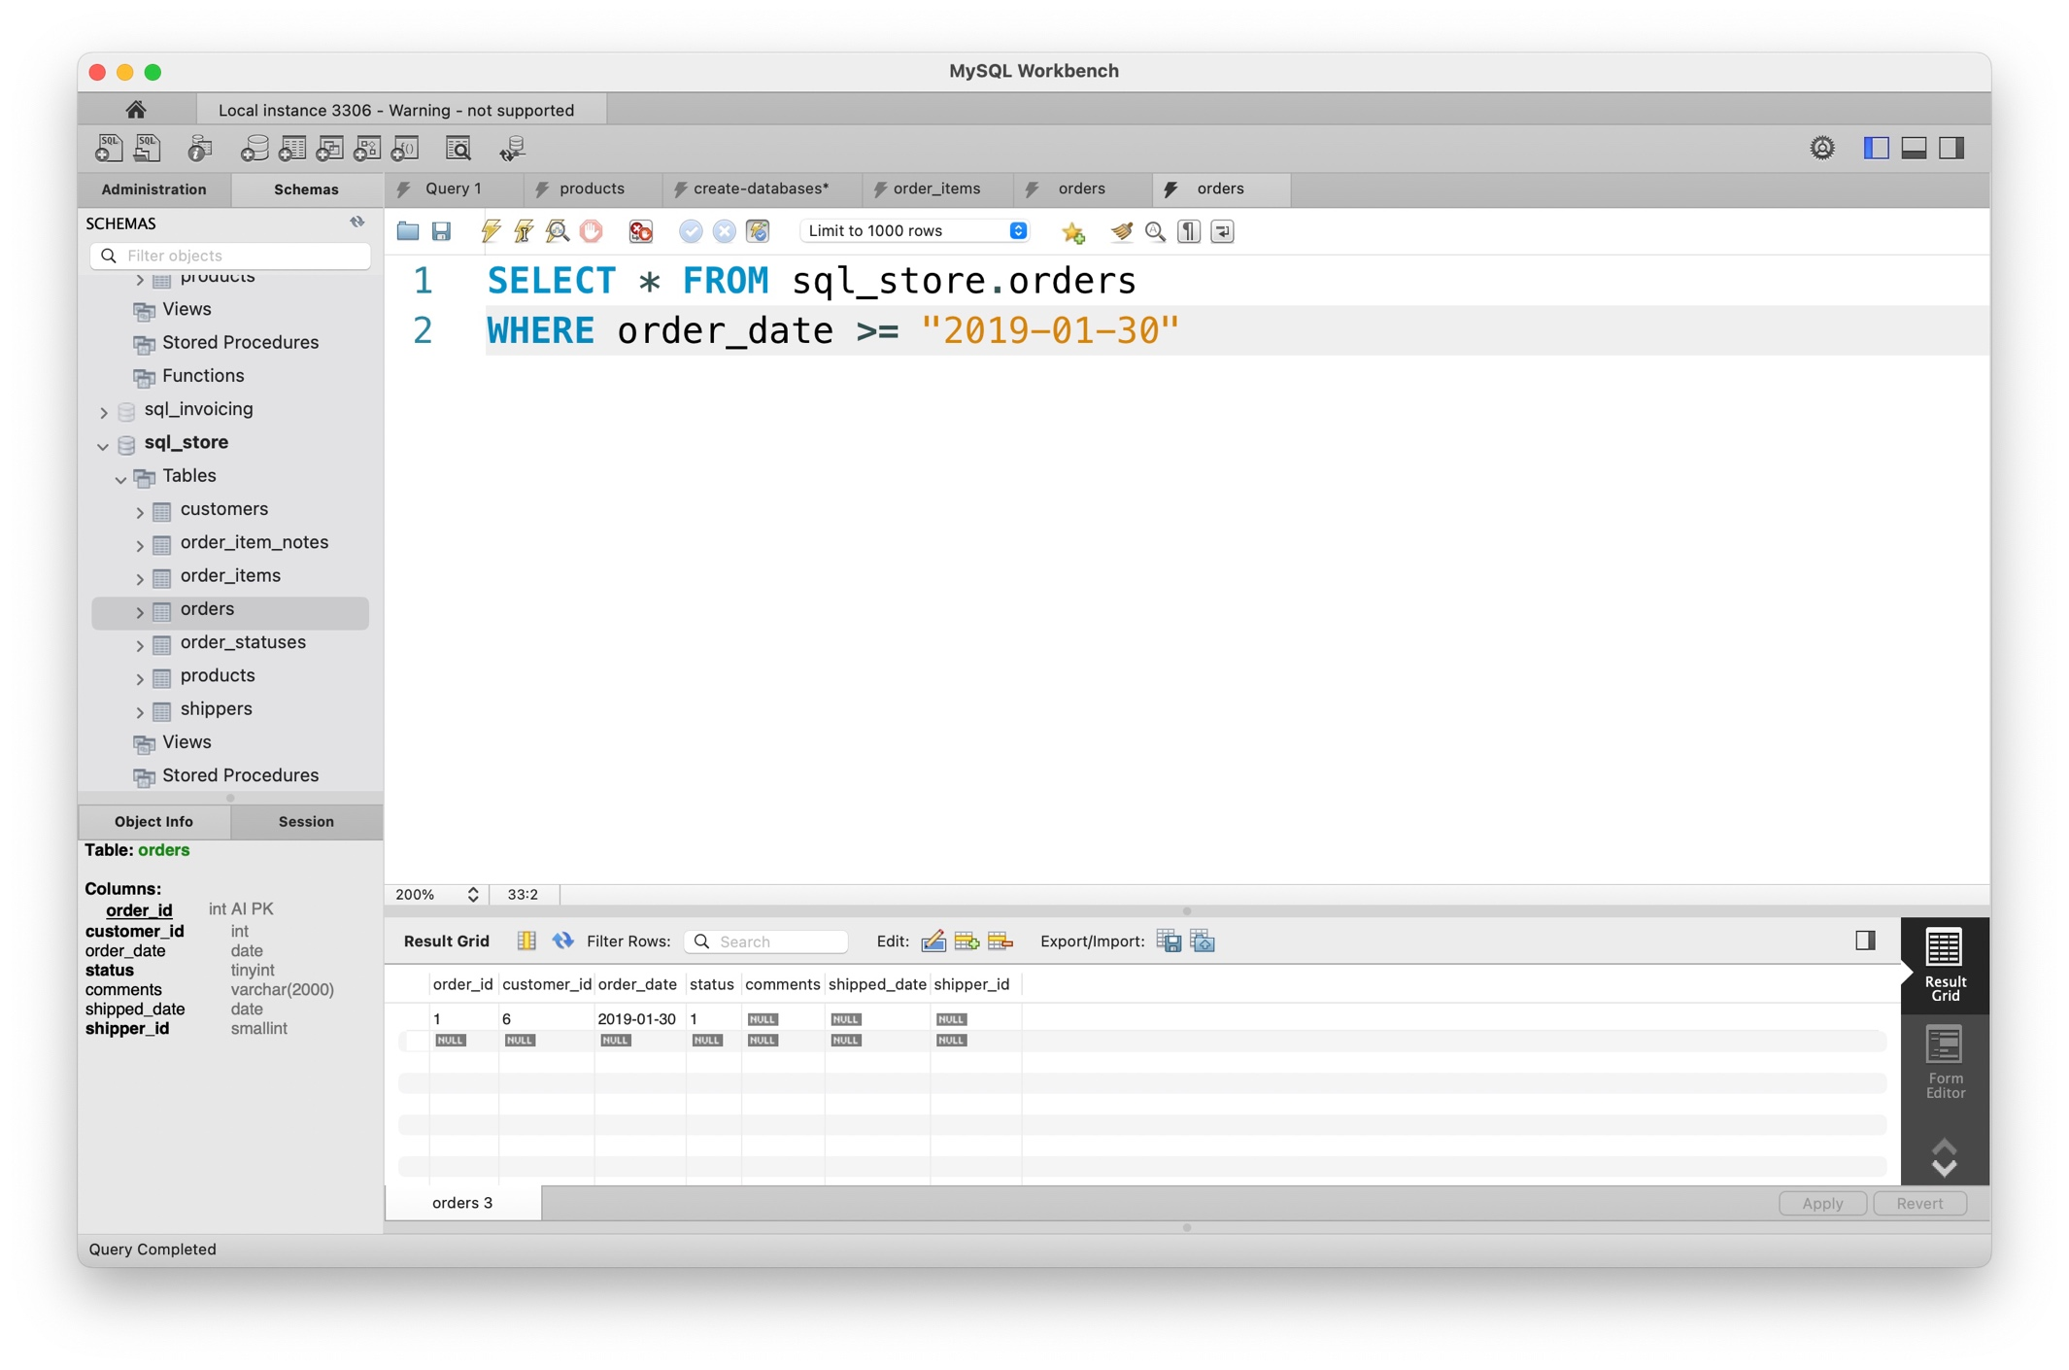

**Exercise – 3**

**Question :**

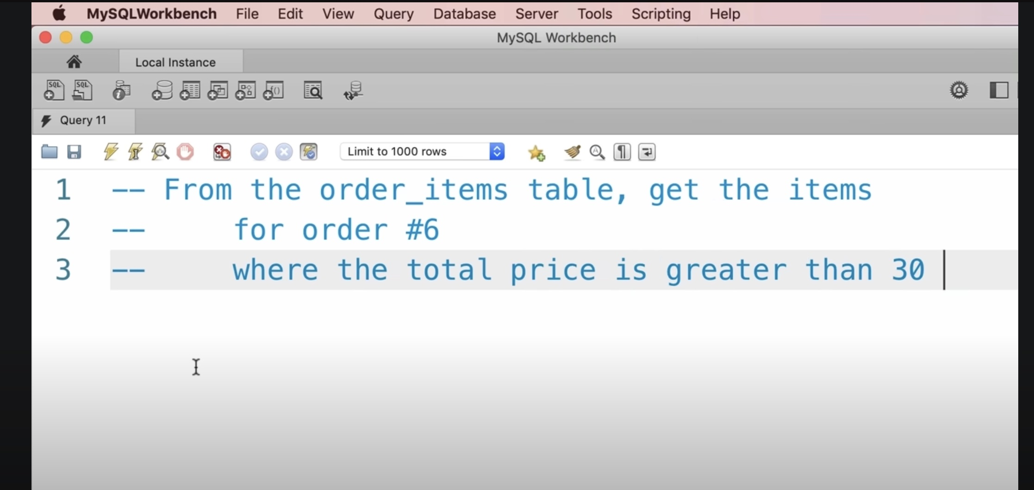

**Answer :**

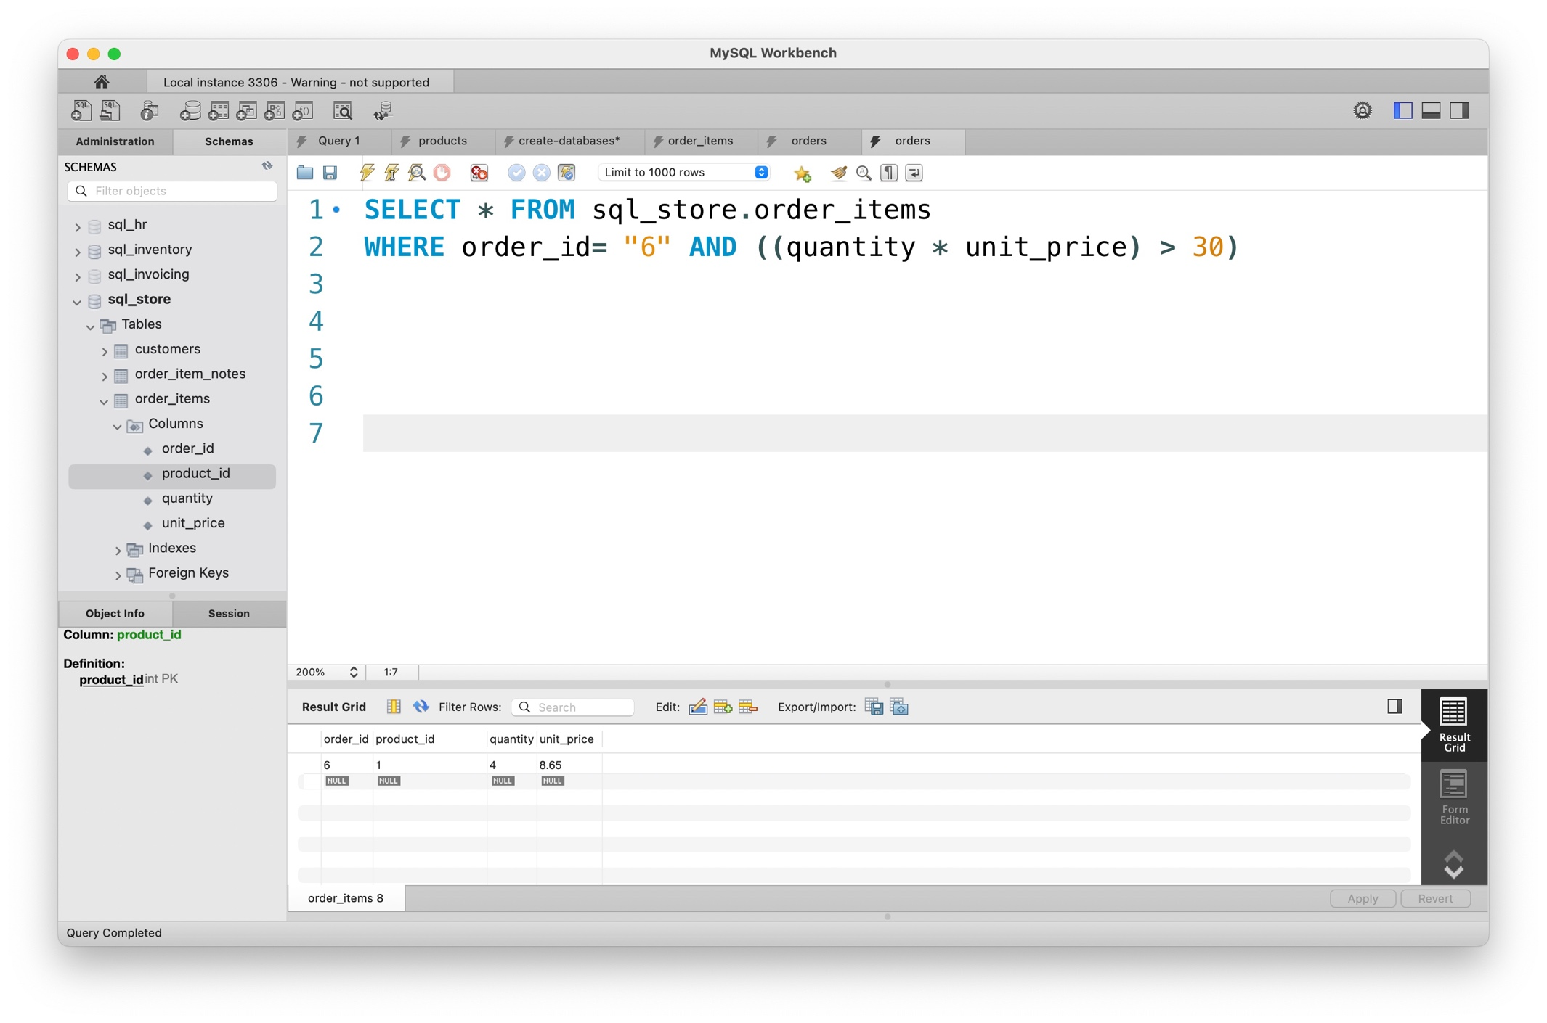

**Exercise – 4**

**Question :**

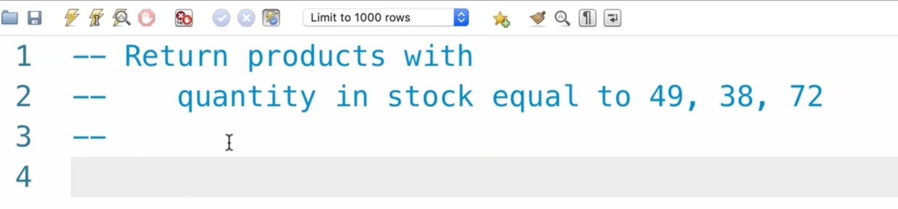

**Answer :**

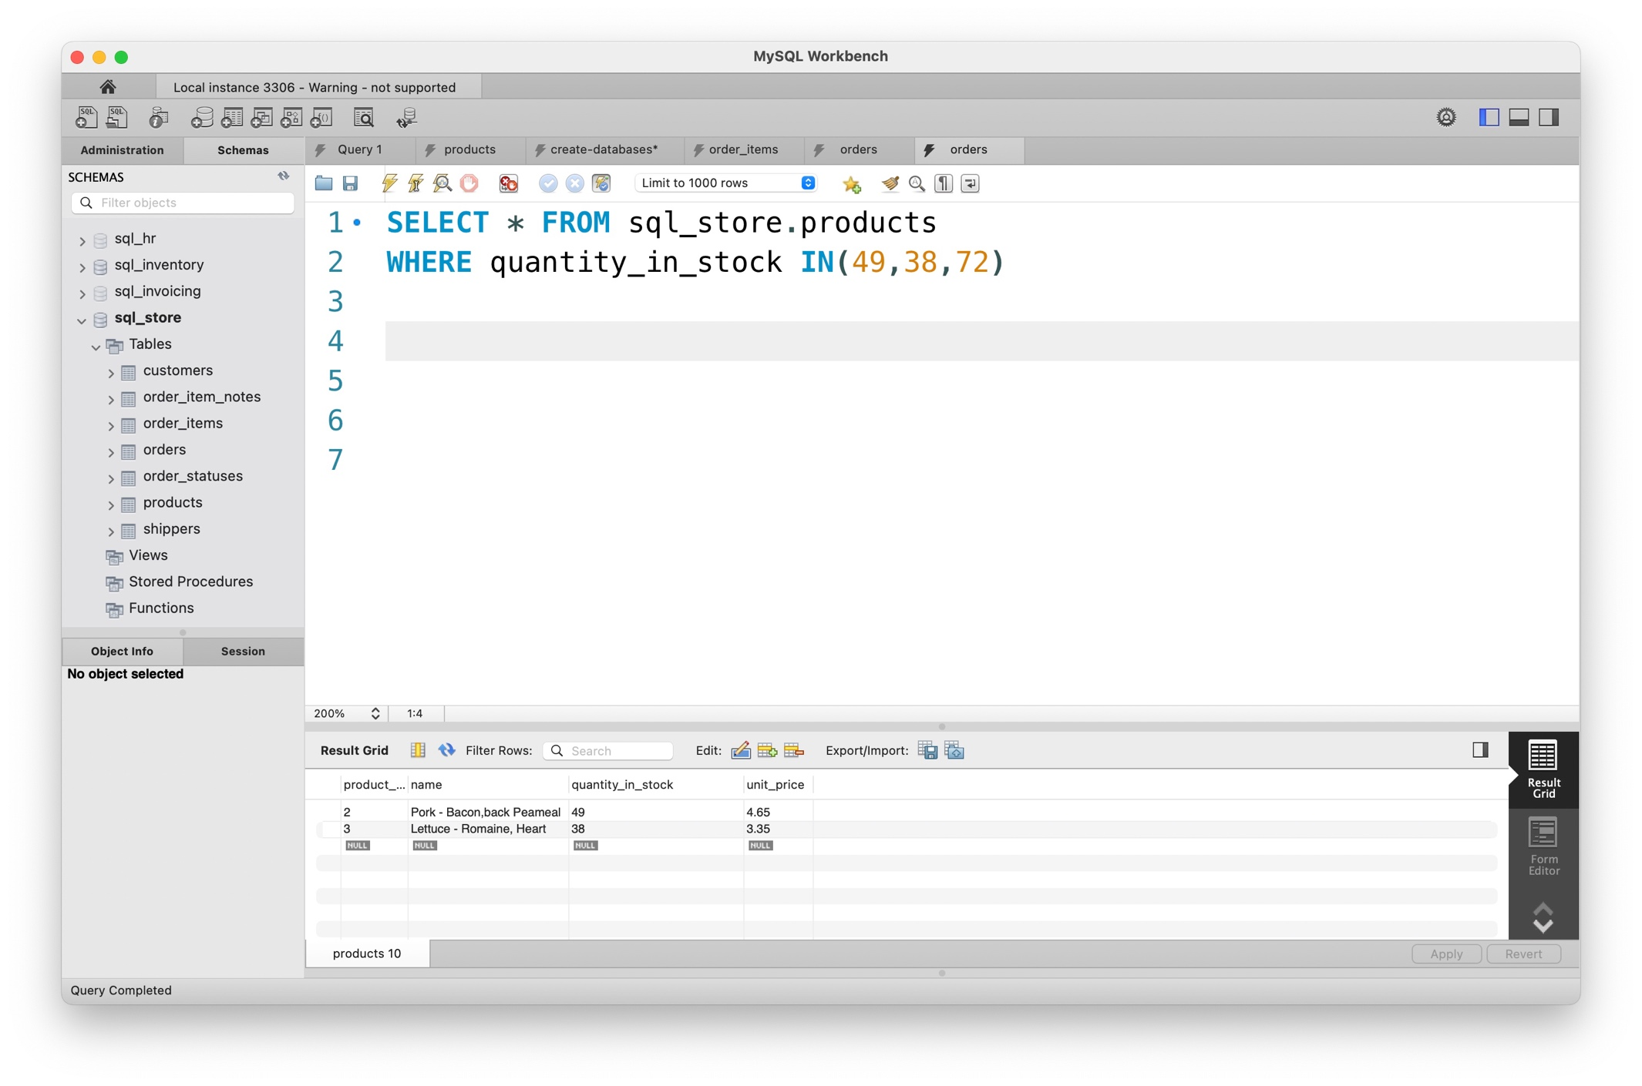

**Exercise – 5**

**Question :**

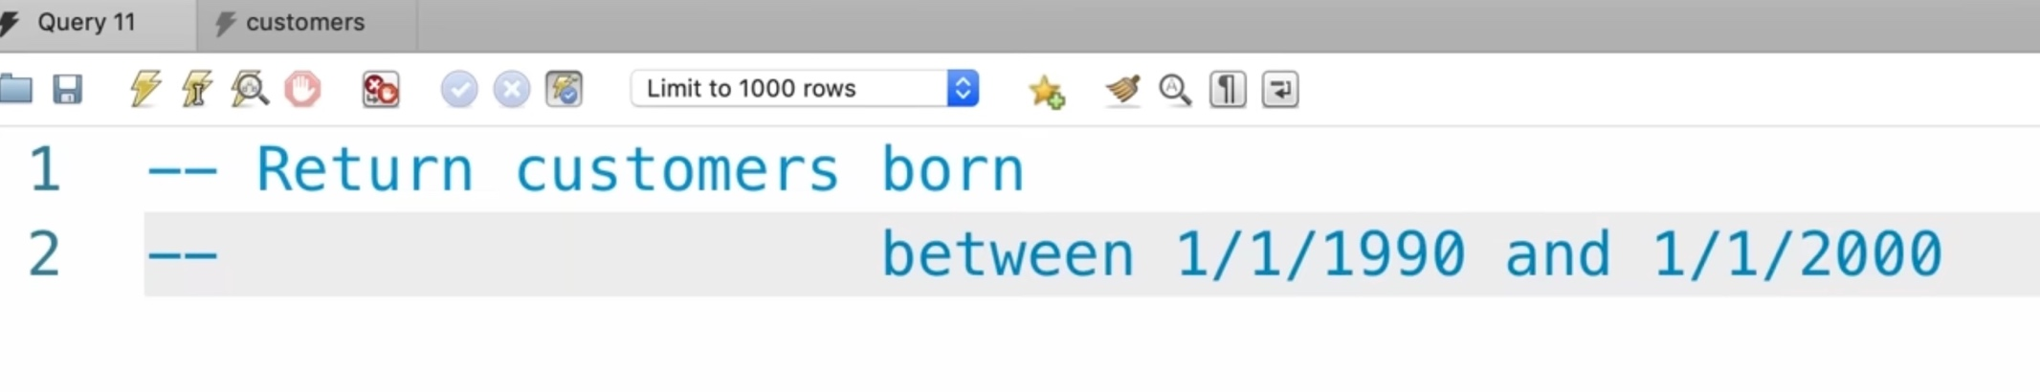**Answer :**

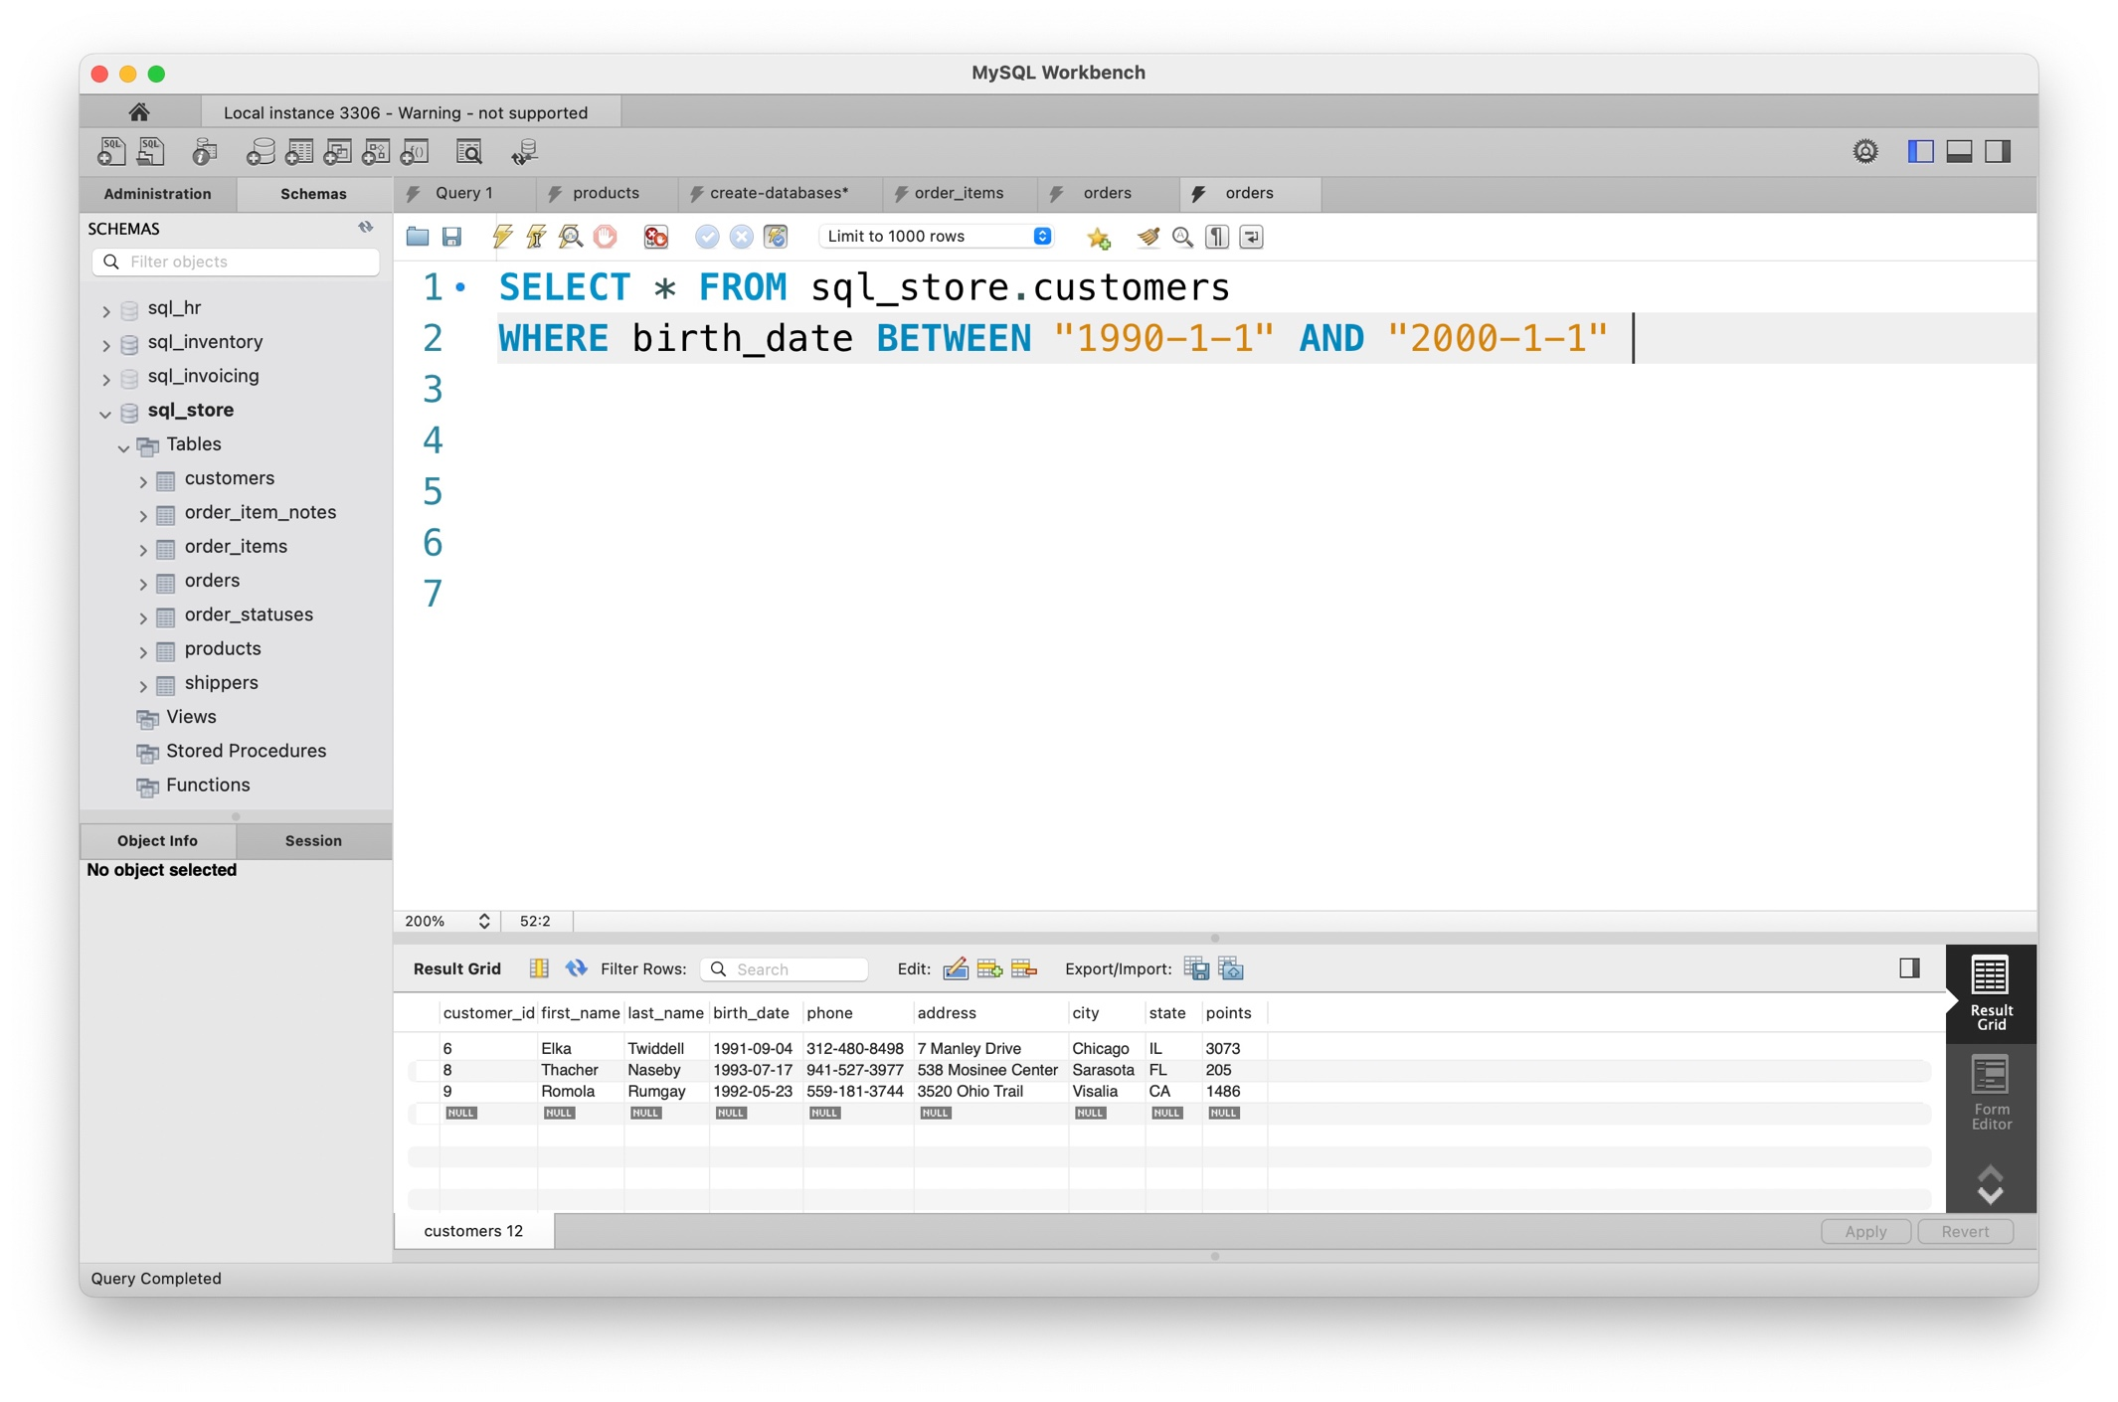

**Exercise – 6**

-- *QUESTION :*

-- *Get the customers whose*

-- *addresses contain TRAIL or AVENUE*

-- *phone numbers end with 9*

-- *ANSWER :*

SELECT * FROM sql_store.customers

WHERE address LIKE "%trail%" OR

address LIKE "%avenue%" or

phone LIKE "%9"