Rivers In Bangladesh

In Bangladesh, there are many rivers, and Shariatpur is a special place with its own rivers. Bangladesh is called the "land of rivers" because there are about 800 big and small rivers that cover a big area. Some of the big rivers are Padma, Meghna, Jamuna, Karnafuli, Gomati, Brahmaputra, and Shitalakshya. There are also smaller rivers like Tista, Arial Khan, Dhaleswari, Bhairab, and more. All these rivers flow into the Bay of Bengal and make Bangladesh a beautiful and fertile country.

Now, let's talk about Shariatpur, our district. Here, we have rivers like Kirtinasha, Kusha, Chor Hogla, Joyonti, Dhengarbari (a small river from Padma), Doimi Chorvoya, Naogaon, Padma, Palong, Boyra, Binodpur, and the big Meghna river. These rivers, big and small, are like the veins of Shariatpur. They make our district special and add to its beauty. In this assignment, we will explore each of these rivers, learn their stories, and understand why they make Shariatpur unique. Let's dive into the tales of our local rivers and discover the wonders they bring to our own part of the "land of rivers."

PADMA RIVER:

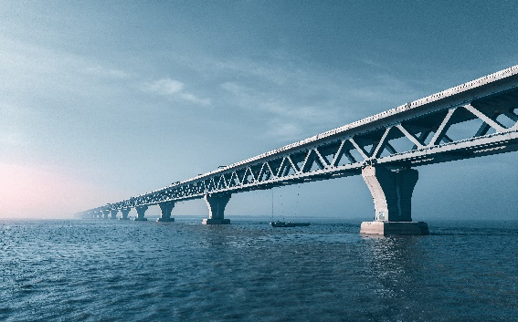

**Overview of Padma River:**

The Padma River, a mighty and revered waterway, flows through the heart of Bangladesh, etching its course across the landscape and leaving an indelible mark on the nation's identity. As one of the primary distributaries of the Ganges River, the Padma weaves through the vast delta, influencing not only the physical geography of the region but also the cultural and economic tapestry of Bangladesh.

**History of Padma River:**

The history of the Padma River is intertwined with the rich historical narrative of the Indian subcontinent. Its waters have mirrored the journey of civilizations, witnessing the evolution of cultures and the ebb and flow of historical events. The river has played a crucial role in the sustenance and livelihoods of communities settled along its banks for centuries.

During the Bangladesh Liberation War in 1971, the Padma River bore witness to a pivotal chapter in the nation's history. The riverbanks became a silent observer to the struggles and sacrifices of the Bangladeshi people as they sought independence. The Padma's currents, laden with historical significance, reflect the resilience and determination of a nation striving for freedom.

**Size and Flow of Padma River:**

Size:

The Padma River is expansive, ranking as one of the largest rivers in Bangladesh and the Indian subcontinent.

It is formed by the confluence of the Ganges and Brahmaputra rivers, a juncture that marks the beginning of its monumental journey through the deltaic landscape.

Flow:

The flow of the Padma River is characterized by its dynamic nature, influenced by seasonal variations and the convergence of multiple tributaries.

During the monsoon season, the river swells, carrying a voluminous flow of water from the upstream Himalayan regions. This annual surge is a vital contributor to the fertility of the surrounding agricultural lands.

The slow, majestic movement of the Padma River is a spectacle that defines the rhythm of life in Bangladesh. Its meandering course creates intricate networks of channels and tributaries, nurturing the fertile plains that have sustained generations of farmers. The river serves as a lifeline for agriculture, providing vital irrigation and facilitating the transportation of goods and people across its vast expanse.

In conclusion, the Padma River is not merely a geographical feature; it is a symbol of continuity, endurance, and the interconnectedness of human lives with the natural world. Its history, size, and flow contribute to the narrative of Bangladesh, shaping the destinies of those who dwell along its banks and weaving a timeless tale that spans the epochs of the subcontinent's history.

**NARIA RIVER**:

A river in the Shariatpur area of southwest Bangladesh is known as the Nadia River or Nadia Canal. It is a calm river with a length of 13 kilometers and an average width of 48 meters.

The Padma River, which flows through Kedarpur Union, Naria Upazila, and Shariatpur District, is the source of the Naria River. After that, the river's water stream runs up to the Palong River in the district and upazila of Domsar Union. As of right moment, the river is practically dry. There are no boats travel on the river.

**Kirtinisha River :**

The Kirtinasha River, located in the district of Shariatpur, Bangladesh, is a significant watercourse that contributes to the local landscape and plays a vital role in the lives of the people in the region.

**History of Kirtinasha River :**

While specific historical details about the Kirtinasha River may not be widely documented, the river has been an integral part of the local ecosystem for generations. Over time, it has witnessed the cultural and agricultural practices of the communities along its banks, shaping the history and traditions of the Shariatpur district.

The historical importance of the Kirtinasha River likely extends to the various settlements and activities that have thrived along its course. Local communities may have relied on the river for irrigation, transportation, and other essential aspects of their daily lives.

**Size and Flow of Kirtinasha River**:

**Size:**

The Kirtinasha River is a tributary or distributary in the Shariatpur district, and its size may vary based on seasonal changes and geographical conditions.

**Flow:**

The flow of the Kirtinasha River is influenced by factors such as monsoon rains and its connection to larger river systems in the region.

Like many rivers in Bangladesh, the Kirtinasha may experience fluctuations in flow during different seasons, affecting its depth and width.

While specific quantitative details about the size and flow of the Kirtinasha River may require local measurements and data, its importance lies in its contribution to local agriculture, irrigation, and the overall ecological balance of the Shariatpur district. The river is likely a lifeline for communities along its banks, serving as a source of sustenance and a means of connection with the natural environment.

**Palang River:**

The Palang River flows through the districts of Madaripur and Shariatpur in southwest Bangladesh. The river is 40 kilometers long, 48 meters wide on average, and has a meandering character. The Palong River in the southwest has identification number 54, which is assigned by the Bangladesh Water Development Board.

The Arial Khan River, which flows in the Jayanagar Union region of Jajira Upazila in the Shariatpur District, is the source of the Palang River. After that, the river's water flow ascends to the Ariyal Khan River in Joynagar Union in Madaripur Sadar Upazila of Madaripur District. For present, the river is mainly dry. The river's restricted range is impacted by tides.

Ref:

[https://bn.wikipedia.org/wiki/](https://bn.wikipedia.org/wiki/%20) পালং_নদী

**Meghna River**

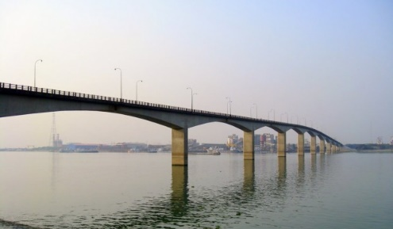

**Overview of Meghna River:**

The Meghna River, a colossal waterway coursing through the heart of Bangladesh, is a pivotal component of the country's landscape and identity. As part of the Ganges-Brahmaputra-Meghna river system, it stands as one of the largest and most significant rivers in the region. The Meghna's journey, from its origins to the vast delta it forms before merging with the Bay of Bengal, shapes not only the physical geography but also the cultural and economic fabric of Bangladesh.

**History of Meghna River:**

The history of the Meghna River is a narrative woven into the very fabric of the Indian subcontinent. Its waters have flowed through epochs, bearing witness to the rise and fall of empires, the ebb and flow of trade, and the evolving societal tapestry of the region. Along its banks, ancient civilizations thrived, leaving behind traces of their existence in the form of archaeological remnants.

During the Bangladesh Liberation War in 1971, the Meghna River played a strategic role. Its waters became a lifeline for the movement of people and essential supplies, reflecting the river's enduring significance in times of national struggle. The war left an indelible mark on the Meghna's history, symbolizing the resilience and determination of the Bangladeshi people.

**Size and Flow of Meghna River:**

Size:

The Meghna River is a colossal watercourse, ranking among the largest rivers not only in Bangladesh but globally.

It is formed by the confluence of various tributaries, including the Ganges and Brahmaputra rivers, giving it a sizeable and influential presence in the region.

Flow:

The flow of the Meghna River is dynamic, characterized by seasonal variations influenced by monsoon rains and the melting of Himalayan snow.During the monsoon season, the river swells, carrying a massive volume of water through its channels, impacting the surrounding landscape and supporting the region's extensive agricultural activities.

The Meghna River serves as a crucial distributary, providing an outlet for the combined flows of the Ganges and Brahmaputra. Its slow, meandering journey through lush landscapes not only sustains agriculture but also facilitates trade and transportation, connecting numerous communities along its banks. The river's strategic importance extends beyond its natural beauty, making it a vital artery in the intricate network of rivers that defines Bangladesh.

In essence, the Meghna River is more than a watercourse; it is a living testament to the history, resilience, and vitality of the land it traverses, shaping the destiny of those who depend on its waters for their livelihoods and cultural identity.

**NARIA RIVER**:

A river in the Shariatpur area of southwest Bangladesh is known as the Nadia River or Nadia Canal. It is a calm river with a length of 13 kilometers and an average width of 48 meters.

The Padma River, which flows through Kedarpur Union, Naria Upazila, and Shariatpur District, is the source of the Naria River. After that, the river's water stream runs up to the Palong River in the district and upazila of Domsar Union. As of right moment, the river is practically dry. There are no boats travel on the river.