**Robotics**

Robotics is an interdisciplinary branch of electronics and communication, computer science and engineering. Robotics involves the design, construction, operation, and use of Robots. The goal of robotics is to design machines that can help and assist humans. Robotics integrates the fields of mechanical engineering, electrical engineering, biomedical engineering, computer engineering etc.

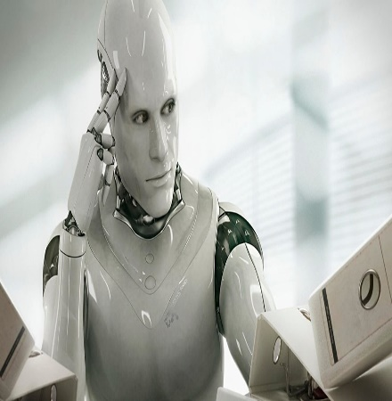

**Cancer Disease**

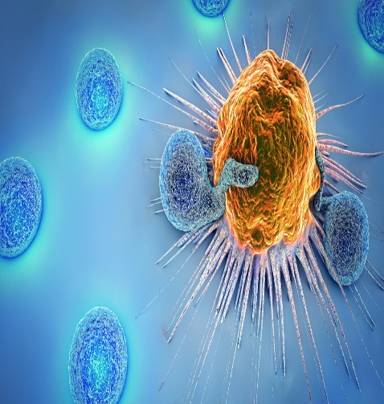According to National Cancer Institute (NCI), Cancer is disease in which some of the body cell’s grow uncontrollably and spread to parts of the body. Cancer can Start almost anywhere in the human body, which is made up of trillions of cells. Normally, human cells grow and multiply to form new cells as the body needs them. When cells grow old or become damaged, they die, and new cells take their place. Sometimes this orderly process breaks down, and abnormal or damaged cells grow and multiply when they shouldn’t.

**Entrepreneurs of Bangladesh**

**Entrepreneurship in Bangladesh is not just about the large -sized RMGs, pharmaceuticals, and technology compare. Rather, the true spirit of entrepreneurship runs among our rural MSME as well -ones we often neglect. They play a dominating role in Bangladesh’s Growth story.**

**Bangladesh Cricket Team**

**The Bangladesh National Cricket Team (BNCT), popularly known as The Tigers, is administered by the Bangladesh Cricket Board (BCB). It is a full Member of the International Cricket Council (ICC) with Test, One -Day International (ODI) and T20 status. It played its first Test match in November 2000 against India with a 9-wicket loss in Dhaka, becoming the tenth Test-playing nation. Bangladesh become an associate member of the ICC in 1977.**

**Mathematics**

**Mathematics is an area of knowledge that include the topic of number, function and related structure, shape and spaces in which they are contained, and quantities and their change. These topic are represented in modern mathematics with the major subdisciplines of number theory, algebra, geometry and analysis, respectively. There is no general consensus among mathematics about a common definition for their academic discipline.**

**Cox’s Bazar Railway Station**

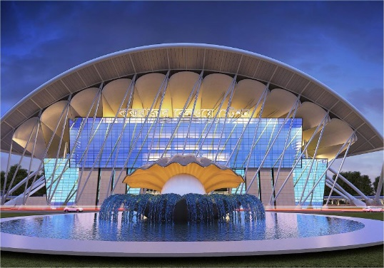**Cox’s Bazar Railway Station is an under-construction railway station in Bangladesh. It is being built the bus terminal of the city is likely to end in 2023. Bangladesh Government planned to extend the rail track from Dohazari of Chittagonng to Gundum of Bandarbans. The government also planned to build another railway track from the proposed Ramu railway station to cox’s bazar city in the purpose of boosting the tourism in cox’s Bazar. Therefore, construction started in August,2017. The architect of the station, Mohammd Foyez Ullah(BUET) took inspiration from the shape of an Oyster for its exterior, which symbolize the beach. The foundation stone of the station building was laid on 14 January 2021. Its construction cost is TK 214 crore.**