
AMERICAN INTERNATIONAL
UNIVERSITY-BANGLADESH
Choose an item.

Choose an item.

Assignment Title: | Computer Networks Manual
Assignment No: | 01 |  | Date of Submission: | 19 November 2025
Course Title: | Computer Networks
Course Code: | Click here to enter text. |  | Section: | F
Semester: | Fall | 2025-26 | Course Teacher: | DR. RAJARSHI ROY CHOWDHURY

Declaration and Statement of Authorship:
- I/we hold a copy of this Assignment/Case-Study, which can be produced if the original is lost/damaged.
- This Assignment/Case-Study is my/our original work and no part of it has been copied from any other student’s work or from any other source except where due acknowledgement is made.
- No part of this Assignment/Case-Study has been written for me/us by any other person except where such collaboration has been authorized by the concerned teacher and is clearly acknowledged in the assignment.
- I/we have not previously submitted or currently submitting this work for any other course/unit.
- This work may be reproduced, communicated, compared and archived for the purpose of detecting plagiarism.
- I/we give permission for a copy of my/our marked work to be retained by the faculty for review and comparison, including review by external examiners.
- I/we understand that Plagiarism is the presentation of the work, idea or creation of another person as though it is your own. It is a formofcheatingandisaveryseriousacademicoffencethatmayleadtoexpulsionfromtheUniversity. Plagiarized material can be drawn from, and presented in, written, graphic and visual form, including electronic data, and oral presentations. Plagiarism occurs when the origin of their arterial used is not appropriately cited.
- I/we also understand that enabling plagiarism is the act of assisting or allowing another person to plagiarize or to copy my/our work.

* Student(s) must complete all details except the faculty use part.
** Please submit all assignments to your course teacher or the office of the concerned teacher.

Group Name/No.:

No | Name | ID | Program | Signature
1 | MD. ABRAR RAFID SHARIAR | 22-48055-2 | CSE
2 | S.M. RASEL | 22-48039-2 | CSE

Faculty use only
FACULTY COMMENTS | Marks Obtained
 | Total Marks

Lab -1:
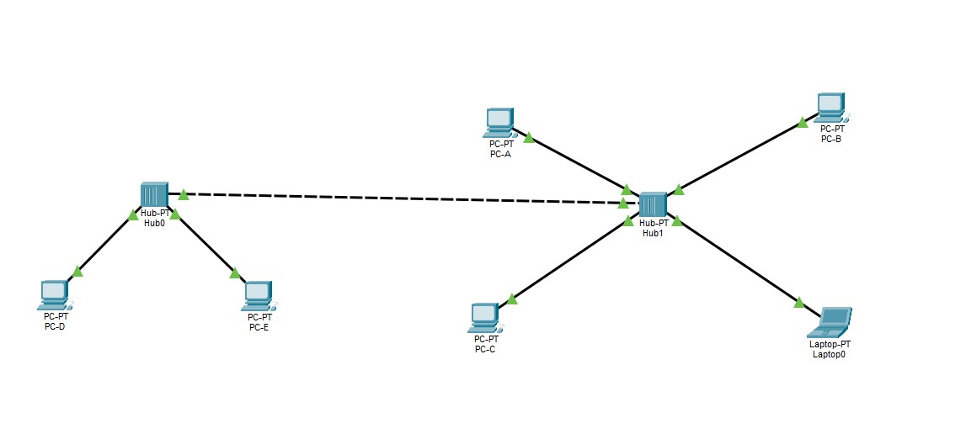
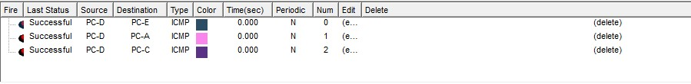

In this lab task, I created a basic computer network using two hubs connected together. Multiple PCs and a laptop were linked to the hubs to form two small network segments. I then connected both segments with a crossover link to allow communication between all devices.

Lab-2 Task-1:
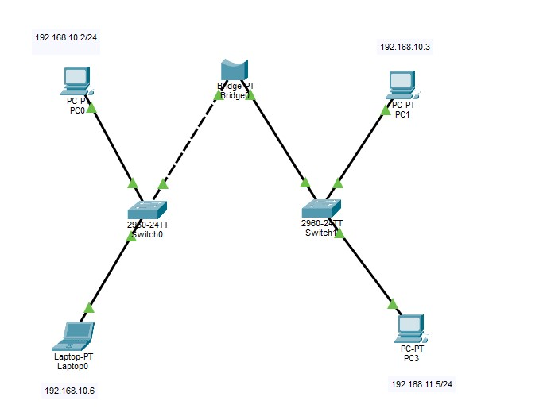

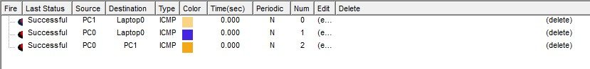

In this lab task, I designed a network using two switches connected through a PT-Bridge. I connected multiple PCs and a laptop to the switches, assigning them IP addresses from two different subnets. The bridge was used to link the two network segments, allowing devices from both subnets to communicate. Configuring end devices and verifying connectivity across the network.

Task-2:
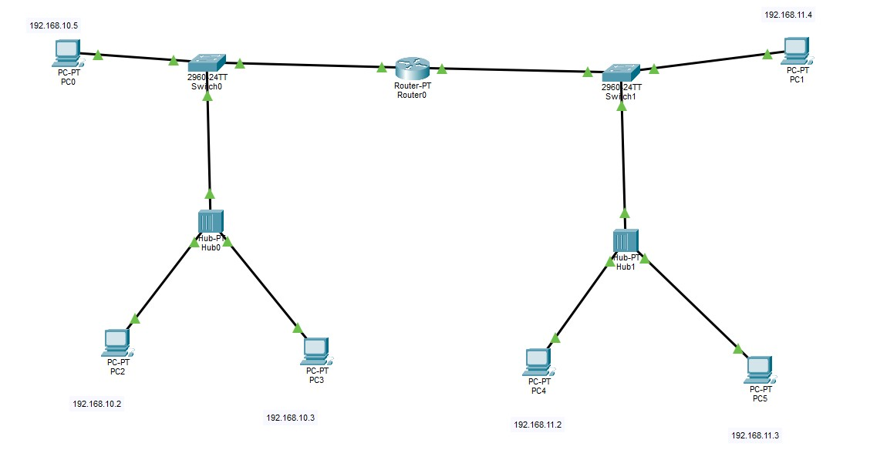

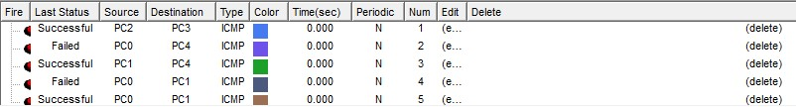

In this lab task, I created a network consisting of two separate LANs connected through a PT-Router. Each LAN contains a switch linked to a hub, which then connects to multiple PCs. I assigned IP addresses from two different subnets to the devices on each side. The router was configured to enable communication between the two networks.

Lab-3 Task-1:
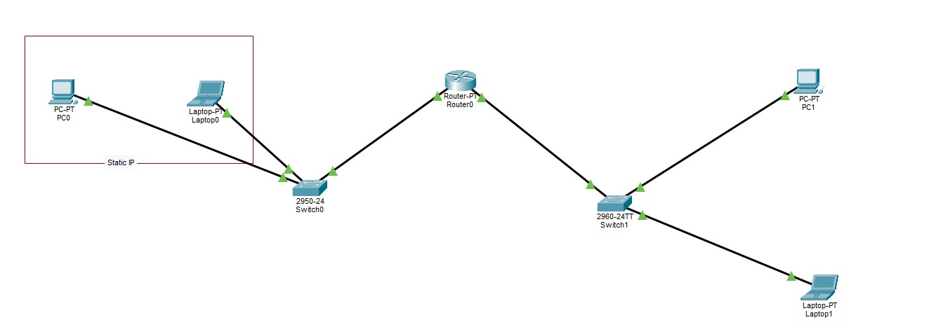
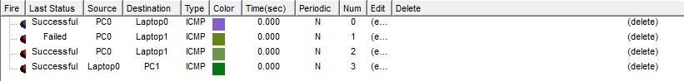

In this lab task, I built a network using two switches connected through a PT-Router to allow communication between different segments. On the left side, I configured a PC and a laptop with static IP addresses and connected them to Switch0. On the right side, another PC and laptop were connected to Switch1. The router was placed between the two switches to enable inter-network communication.

Task-2:
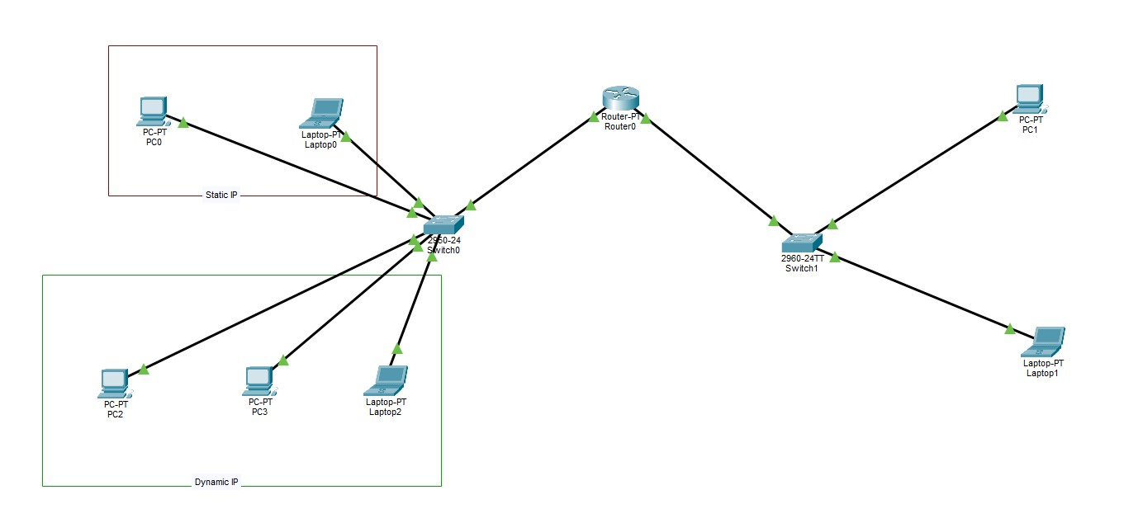

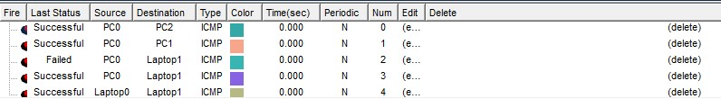

In this lab task, I created a mixed network setup that uses both static and dynamic IP addressing. On the left side, I configured a PC and a laptop with static IPs, while the lower section contains multiple devices that receive their IPs dynamically through DHCP. All devices are connected to Switch0, which is linked to a router for wider network communication. On the right side, another switch connects additional PCs and a laptop. And all the PCs, Laptops and switches connected with a PT-Router.

Task-3:
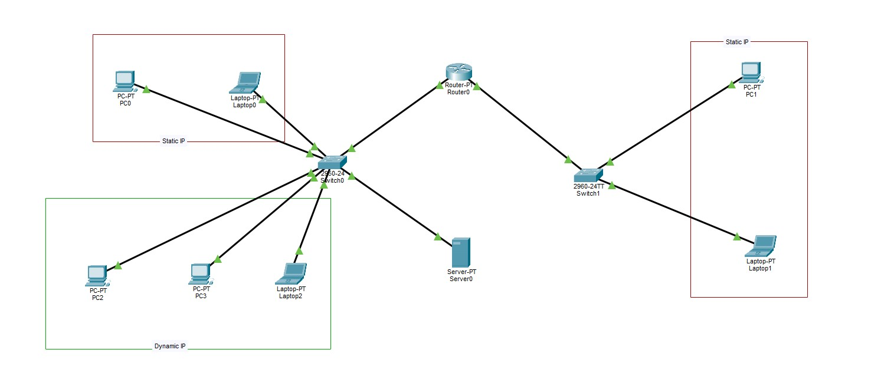
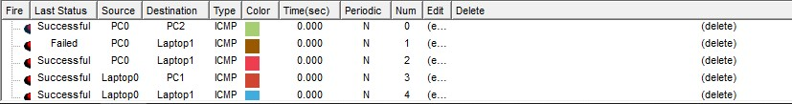

In this lab task, I set up a network that includes both static IP devices and dynamic IP devices. On the left side, a PC and laptop were configured with static IP addresses, while the lower section contains multiple devices that receive their IPs automatically through DHCP. All these devices connect to Switch0, which is also linked to a server for additional network services. The router connects Switch0 to another switch on the right side, which supports more static-IP devices.

Task-4:
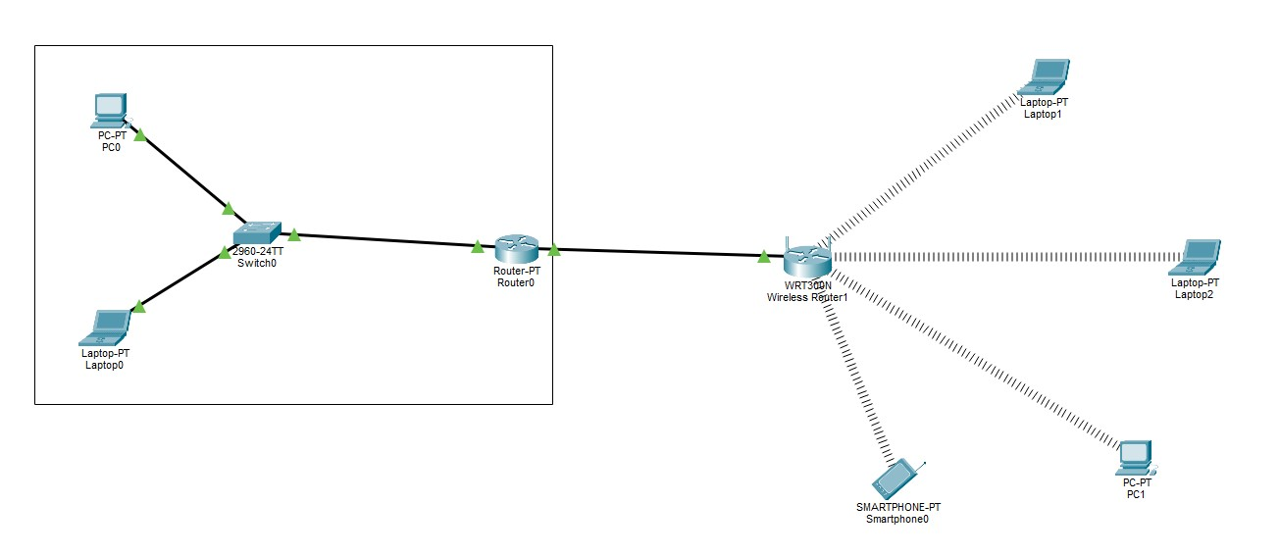
In this lab task, I created a hybrid wired and wireless network. On the left side, a PC and a laptop were connected through Switch0, which is linked to a router for network routing. The router is then connected to a wireless router (WRT300N), which provides Wi-Fi connectivity to multiple wireless devices. Several laptops, a smartphone, and a PC connect wirelessly to the access point.

Task-5:
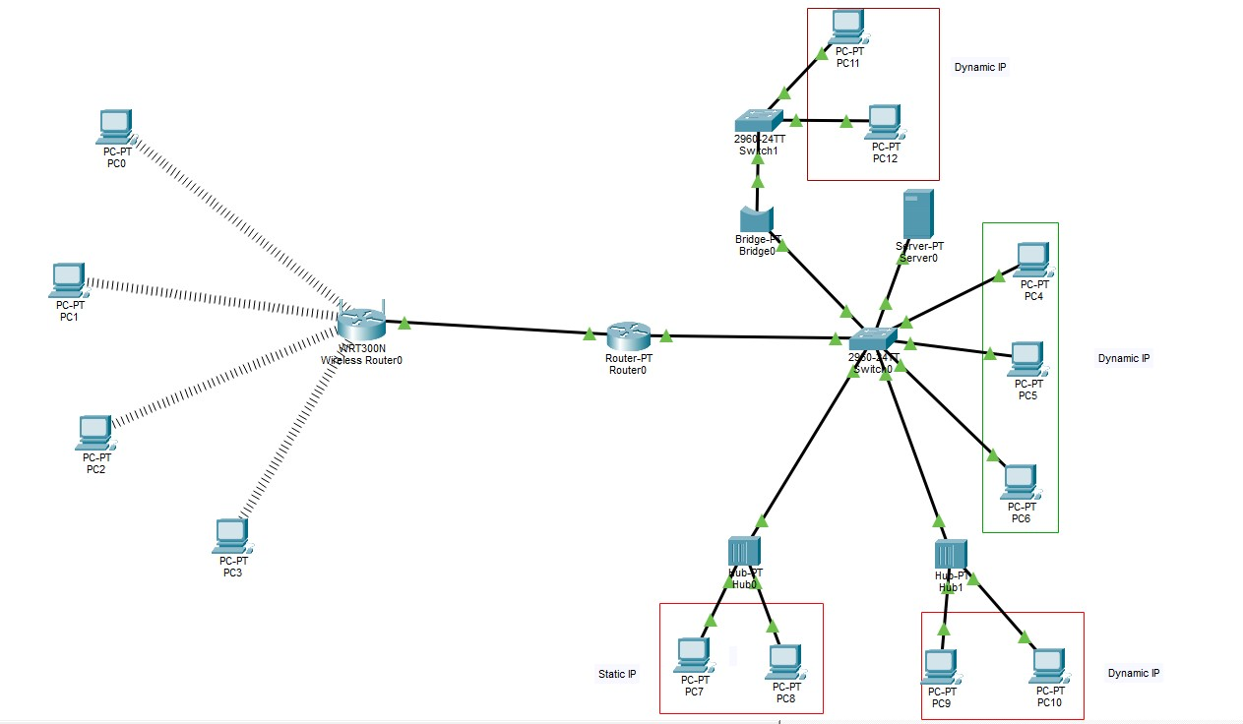
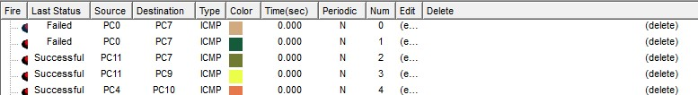

In this lab task, I designed an extended network that includes wired, wireless, static IP, and dynamic IP configurations. Multiple wireless PCs connect to a wireless router (WRT300N), which is linked to a main router for overall network routing. The main router connects to Switch0, which distributes connections to several dynamically-assigned IP devices, a server, and additional hubs. I also connected static-IP PCs through Hub0 and Hub1. A bridge and a second switch were used to extend the network further and connect more dynamic-IP devices.

Lab-4 Task-1:
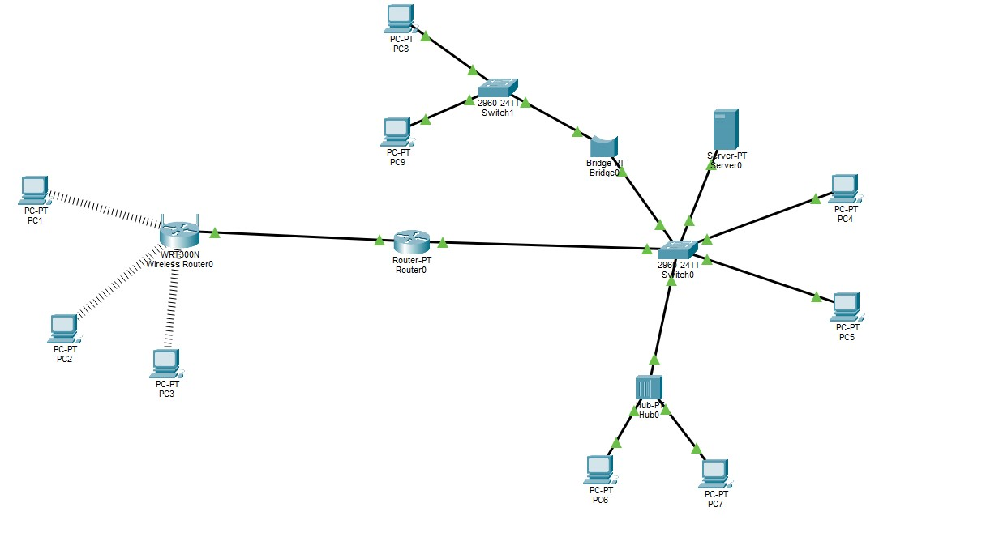

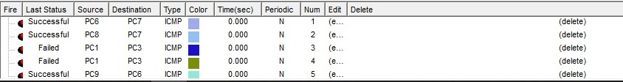

In this lab task, I designed a multi-layer network topology that includes wired connections, switches, and multiple routers to support organized communication between different subnets. A central switch connects to several branch switches, each distributing connections to multiple PCs. The main router links all subnetworks together, enabling overall network routing and communication. Several PCs are assigned static and dynamic IP configurations depending on their segments. Additional switches and interconnected routers help extend the network and ensure efficient data flow between all devices. This setup demonstrates a scalable and well-structured network model suitable for larger environments.

Task-2:
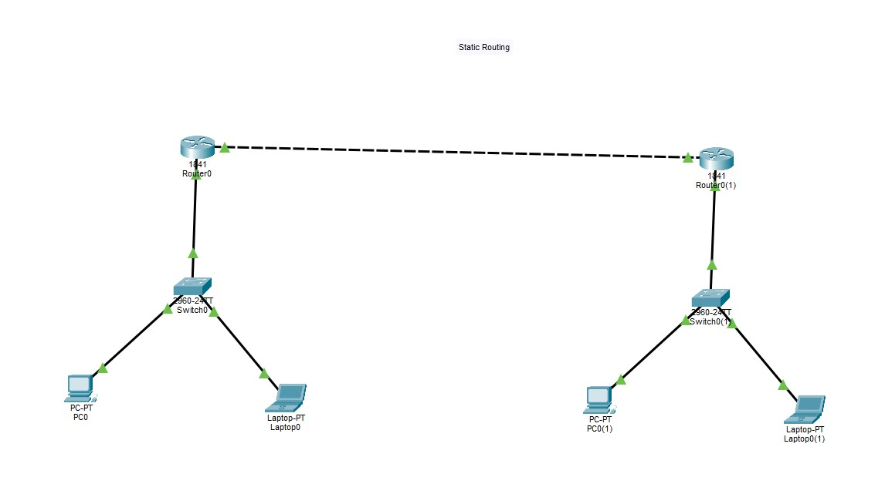
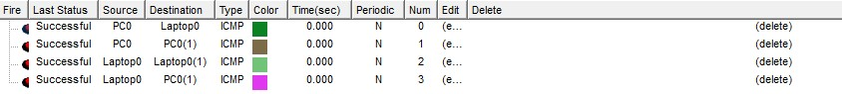
In this lab task, I created a simple static routing network consisting of two routers connected through a serial link. Each router is connected to a switch, which further links to a PC and a laptop within its local network. Static routes were manually configured on both routers to enable communication between the two separate LANs. The switches provide efficient local connectivity, while the routers handle inter-network packet forwarding. This setup demonstrates the basic concept of static routing and shows how devices from different networks can communicate using manually defined routes.

Task-3:
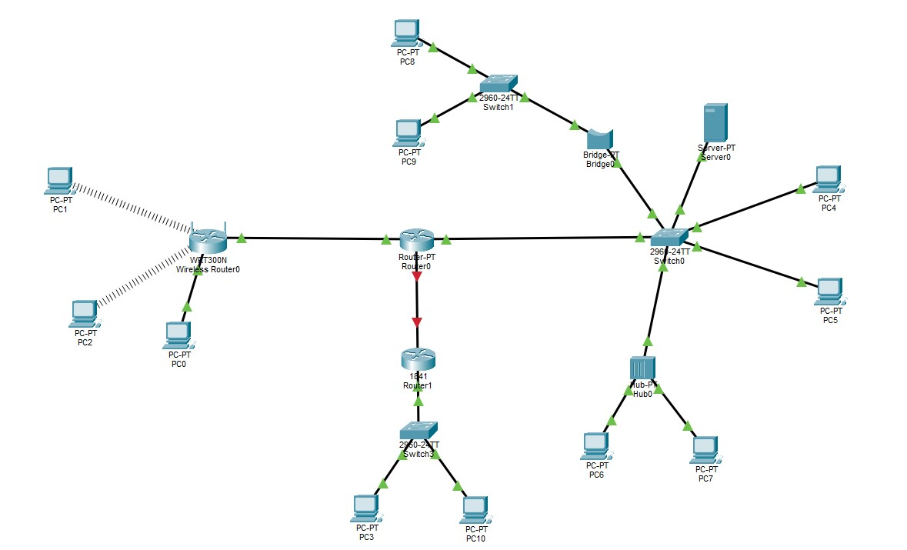
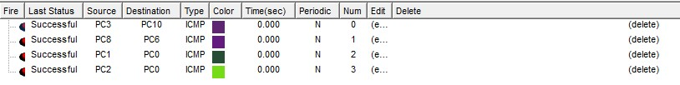
In this lab task, I designed an extended network combining wired and wireless communication using routers, switches, hubs, and a bridge. A wireless router connects multiple wireless PCs as well as a wired PC, forming the first subnet. The main router links this wireless network to several additional subnetworks through switches and another connected router. A bridge and a central switch distribute connections to multiple PCs and a server, enabling organized data flow. A hub is used to connect extra devices, demonstrating shared-medium communication. This overall topology models a larger, multi-segment network that uses both static and dynamic addressing to ensure full connectivity across all devices.

