

American International University-Bangladesh (AIUB)
Department of Computer Science
Faculty of Science & Technology (FST)
Subject: SOFTWARE QUALITY AND TESTING
Title:
SOFTWARE QUALITY AND TESTING PR
SUBMITTED
TO
ABHIJIT BHOWMIK

Semester: Spring 25_26 |  | Section: B
SN | Student Name | Student ID
1 | S.M. RASEL | 22-48039-2
2 | MD. ABRAR RAFID SHARIAR | 22-48055-2

- Introduction:
Software Quality Assurance plays a vital role in ensuring that a software system performs correctly, efficiently, and reliably. Among different testing approaches, automated testing has become highly popular due to its ability to execute repetitive tasks quickly and accurately.
Selenium is a powerful and widely used open-source automation tool for testing web-based applications. It allows testers to simulate real user interactions such as form submission, navigation, clicking buttons, and validating outputs. Selenium supports multiple programming languages including Python, Java, and C#, making it flexible for different development environments.
In this project, Selenium WebDriver with Python has been used to automate the testing process of a web-based user management system. The main objective of this work is to verify the correctness of core functionalities such as user registration, login authentication, profile update, and logout process. Automated testing ensures higher accuracy, reduces manual effort, and enhances the overall reliability of the system.

- Tools Used
Selenium WebDriver – Used for automating web browser actions
Python – Programming language used to write test scripts
Google Chrome – Browser used for testing
Chrome Driver – Required to control Chrome browser using Selenium

- Setup Process
In this step, Selenium was set up in the computer to perform automated testing.
  - First, Python was installed and verified using command prompt.
  - Then Selenium was installed using pip command (pip install selenium).
  - After that, the Chrome browser version was checked.
  - According to the Chrome version, ChromeDriver was downloaded and extracted.
  - ChromeDriver was properly placed and configured.
  - Finally, a test script was run to check whether Selenium is working correctly or not.

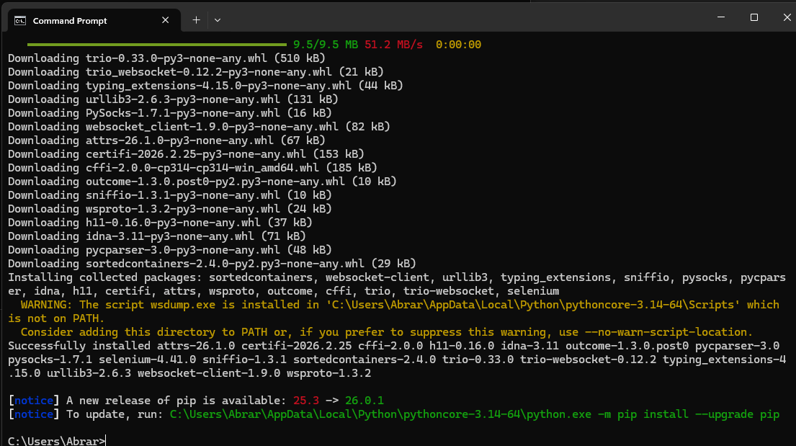
Fig.1 Check Python Version and Selenium install
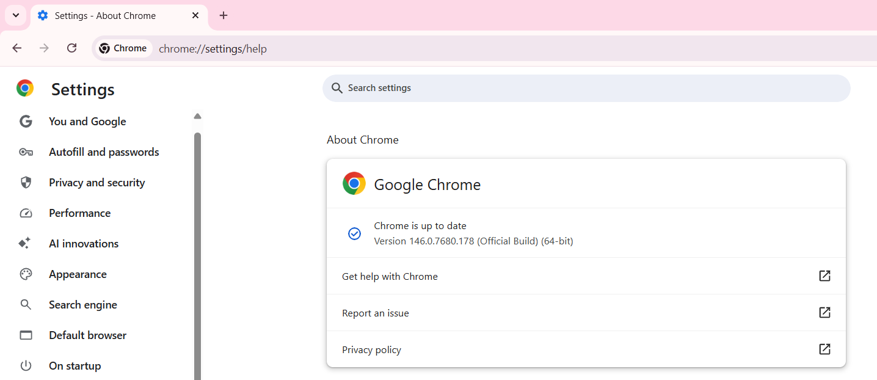

Fig.2 Chrome version check

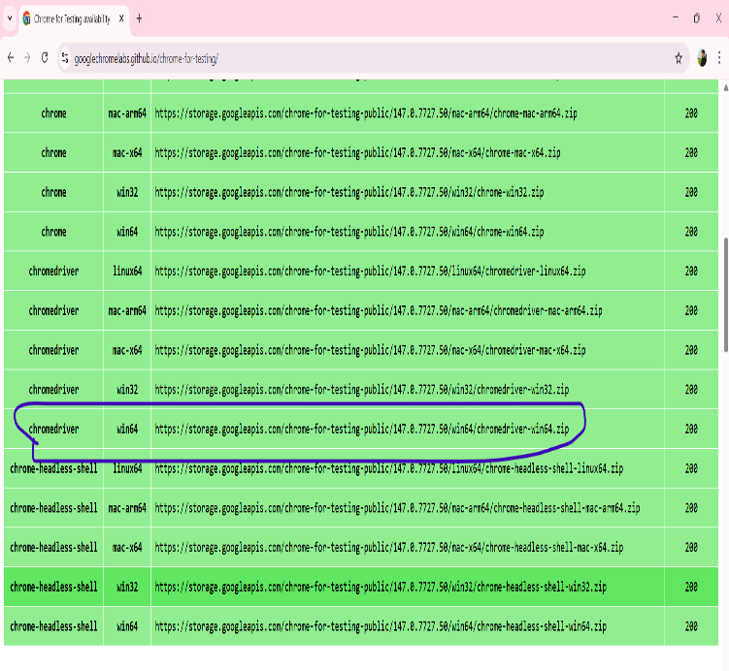
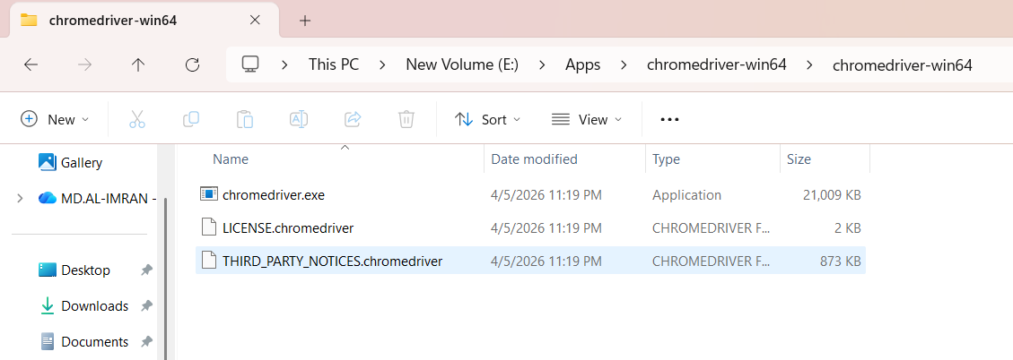

Fig.3 Chrome Driver Download & Extract

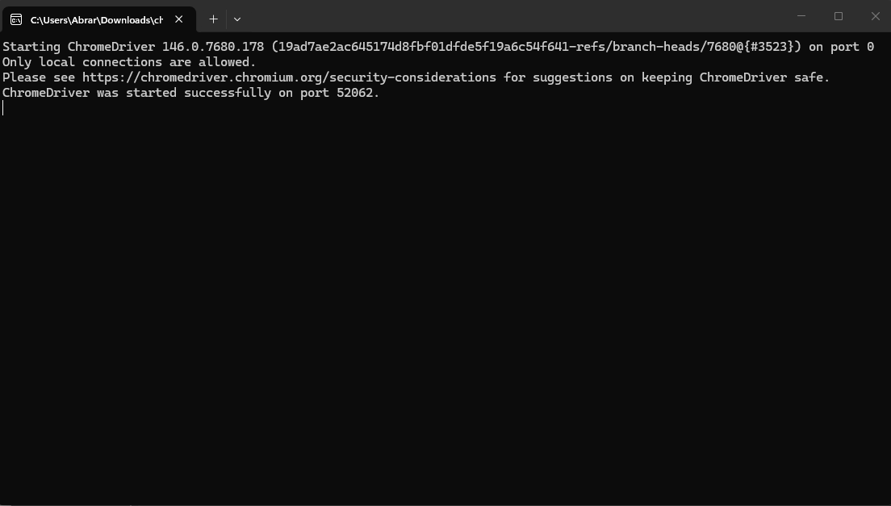
Fig.4 Chrome Driver Install

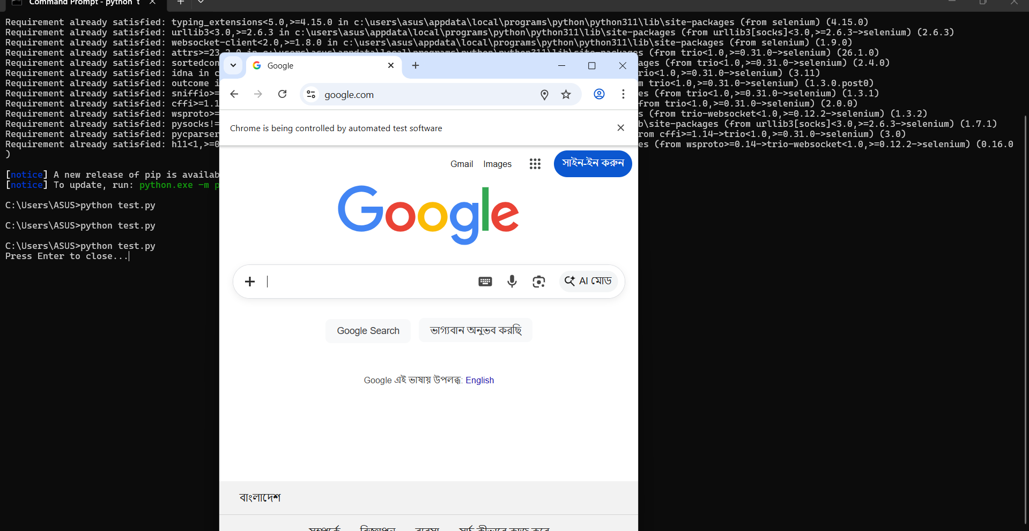
Fig.5 Check Selenium WORKING or Not

- Testing Description

In this project, automated testing was performed on a Blood Bank Management System using Selenium WebDriver. The testing process focused on verifying the core functionalities of the system to ensure proper performance, data accuracy, and user interaction.
- Registration Testing:
The registration functionality was tested by providing user information such as first name, last name, username, email, password, phone number, blood group, and other required details. The system validates the input fields and stores the data in the database upon successful submission. This confirms proper validation and data insertion.

- Login Testing:
The login functionality was tested using valid credentials. The user enters a username and password, and the system verifies the input against the database. If the credentials are correct, the user is redirected to the dashboard. Invalid credentials are handled by displaying an error message, ensuring secure authentication.

- Profile Update Testing:
The update functionality was tested by navigating from the dashboard to the “Edit Your Info” section. The user updates personal information such as email and phone number. After submission, the system updates the database and redirects the user back to the dashboard, confirming successful modification of user data.

- Logout Testing:
The logout functionality was tested to ensure proper session management. When the user logs out, the session is destroyed, and the system redirects the user to the login page. This ensures security and prevents unauthorized access.
This automated testing process ensures that all major functionalities of the Blood Bank Management System are working correctly and efficiently under normal operating conditions.
.
5. Result and process
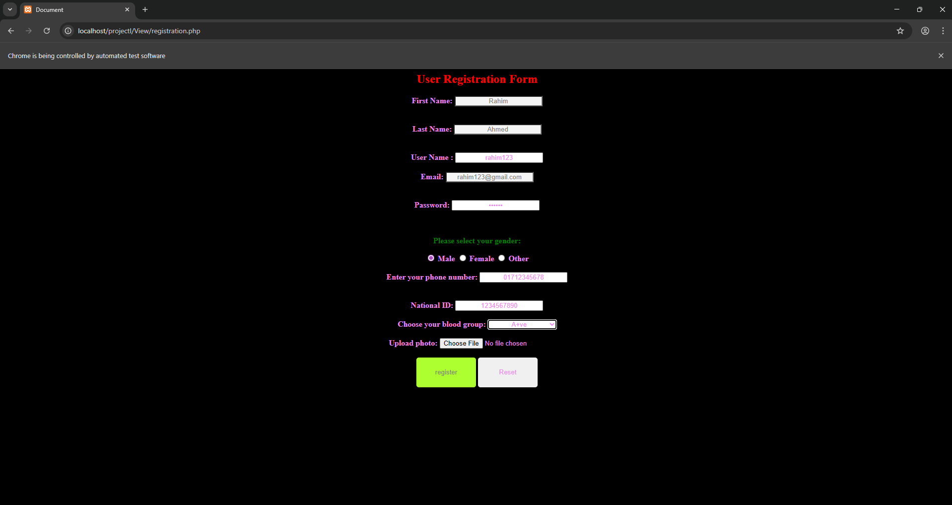
Fig.6: Automated Reg. page fill by selenium

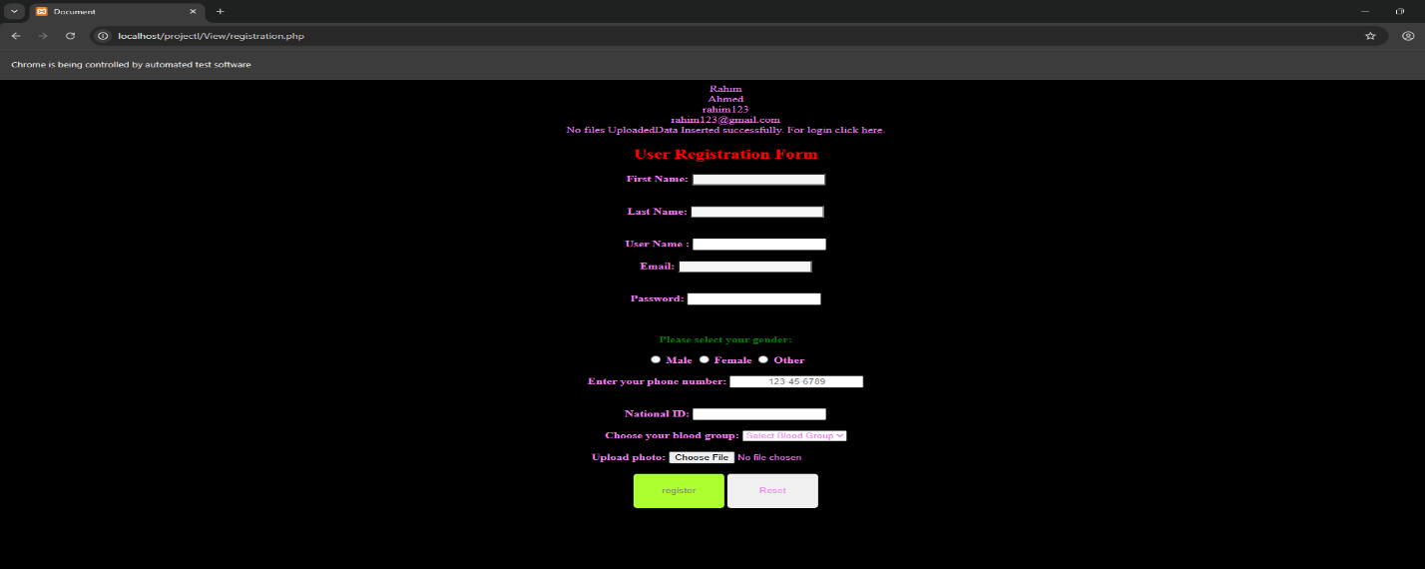
Fig.7: Registration Test done by Selenium

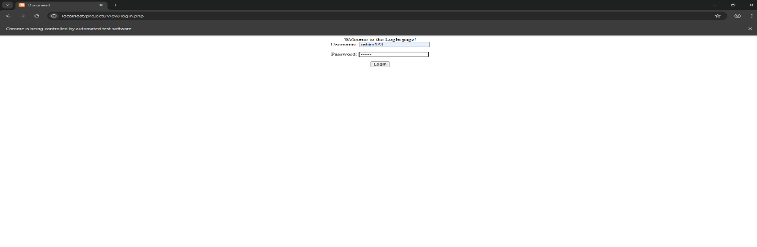
Fig.8: Login test done by selenium

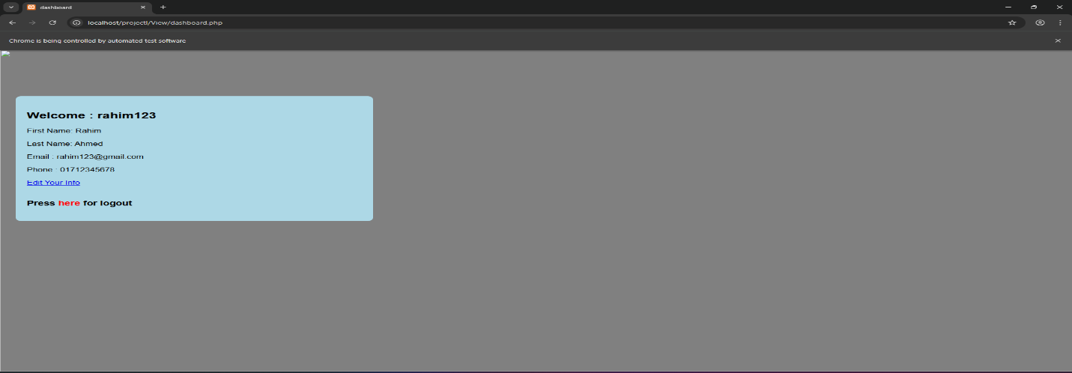
Fig.9: Login successful And go to dashboard
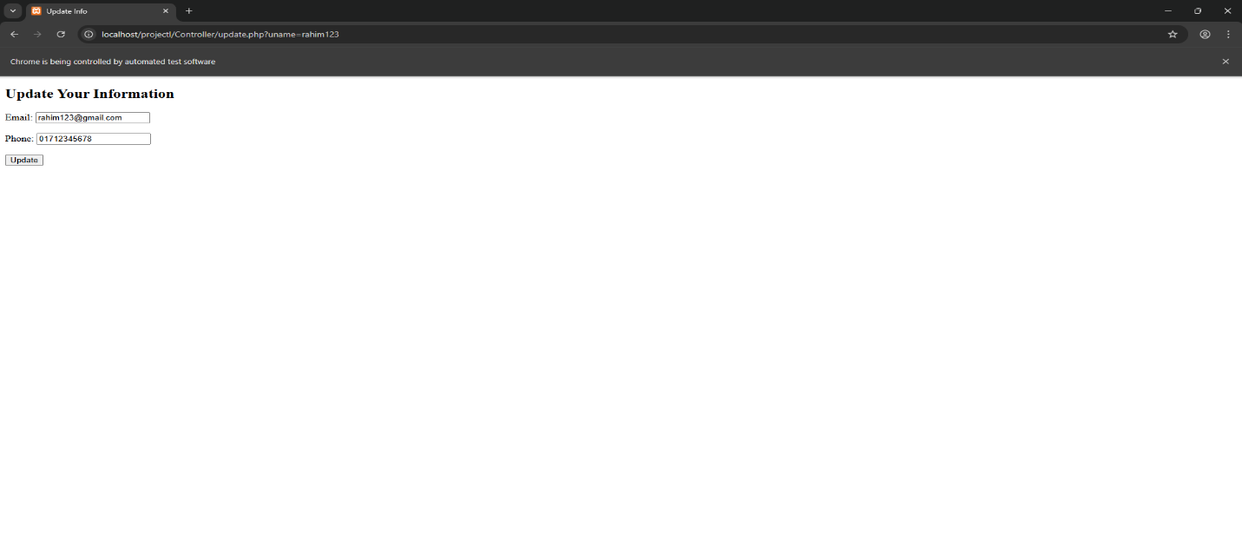
Fig.10: Update information test by selenium

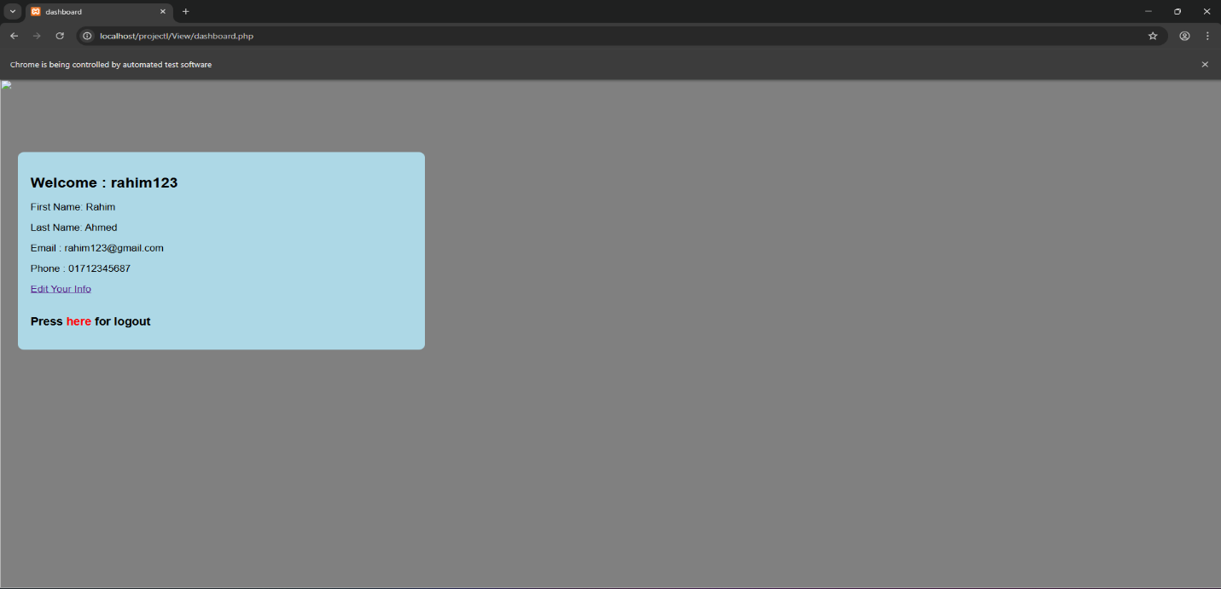
Fig.11: Updated successfully by selenium

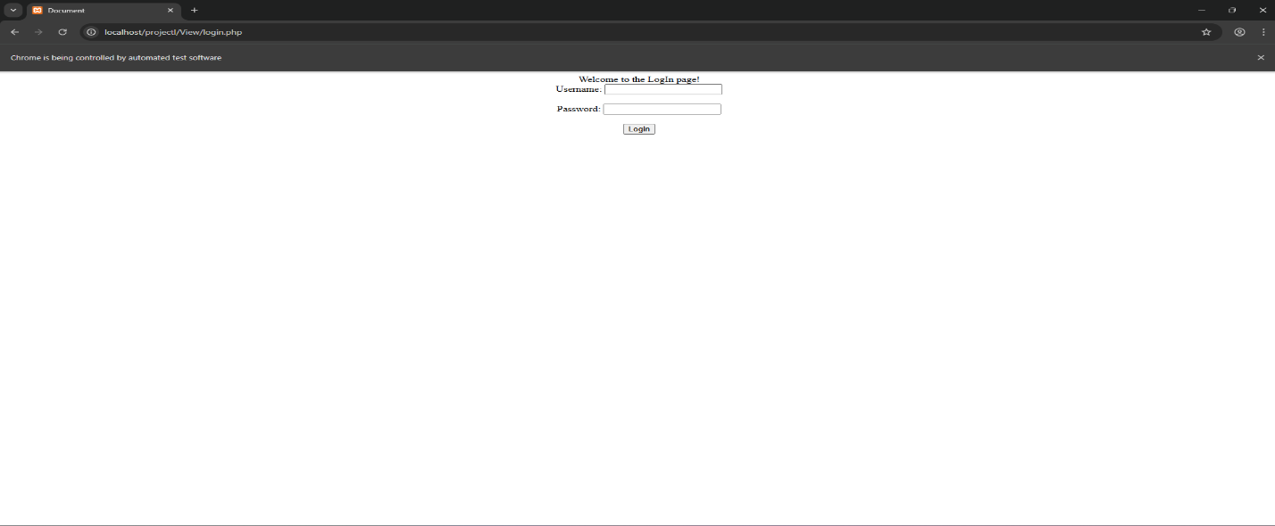
Fig.12: Logout successful & redirect to login page

6. Conclusion
This project demonstrates the effective use of Selenium WebDriver for automating the testing of a web-based application. The automated test scripts successfully validated the complete user workflow, including registration, login, profile update, and logout functionalities. The results indicate that automation significantly improves testing efficiency by reducing execution time and minimizing human errors. It also ensures consistency in repeated test executions, which is essential for maintaining software quality. However, automated testing alone is not sufficient for comprehensive quality assurance. Manual testing is still necessary to evaluate user interface design, usability, and overall user experience. In conclusion, the integration of both automated and manual testing techniques provides a more reliable and efficient approach to software quality assurance. This project highlights the importance of automation in modern software testing practices and its contribution to building robust and dependable systems.

