**INTRODUCTION TO DATABASE (E)**

**Report:** ***Vaccine Distribution Management System***

**Course Instructor: MD. SAJID BIN FAISAL**

**Final term spring**

**Session: 22-23**

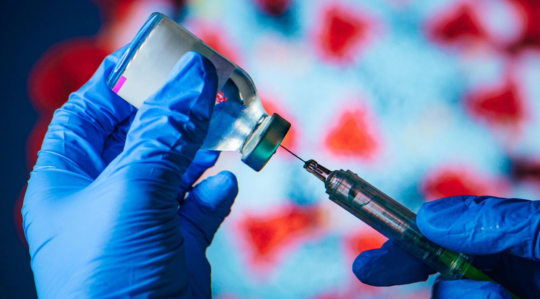

**Group 10**

**Group Members:**

|  |  |
| --- | --- |
| **Name** | **ID** |
| **SIDDATUL BIN SADI** | 22-47943-2 |
| **MD.TANJIL TASHRIK ZIM** | 22-48021-2 |
| **S.M. RASEL** | 22-48039-2 |
| **MD.ABRAR RAFID SHARIAR** | 22-48055-2 |

**Contents:**

**1.Introduction.**

**2.Scenerio Description.**

**3.ER-Diagram.**

**4.Normalization.**

**5.Finalization.**

**6.Table creation.**

**7.Value insertion.**

**8.Query Test.**

**9.Joinning**

**10.View.**

**11.Conclusion.**

**1.Introduction**

The title of the project is “Vaccine Distribution Management System”. This project is going to give you complete experience of database management systems. This management system keeps the record up to date for all the vaccine which have been manufactured by many different companies as well as having all the information about things that is related to vaccine distribution like hospital, doctor, patient etc.

**2.Scenerio Description:**

In “Vaccine Distribution Management System” the vaccine company wants to create a system to record the procedure of the distribution of vaccines. A vaccine company manufacture many vaccines. Vaccine company is identified by their company id. The system also stores vaccine name, email as well as it has manufacture date that is relational to vaccine company and vaccine. The manufactured vaccines are identified by their vaccine id. Vaccine name, expire date, batch number also store by the system. The manufactured vaccine that has come from different companies is distributed to many hospitals. Hospital is identified by hospital id, and it has name, phone number as well as address. The system has unique id of the delivery man and the quantity of distributed vaccine. Doctors work for the hospital and they have their id, name and phone numbers. The patients need to be registered in a hospital to get the vaccine. Patients are identified by their id. The system also stores their name, phone numbers as well as the register date and condition of the patient which is related to patient and hospital. Vaccine is injected by the doctor to patient.

**3.ER-Diagram**

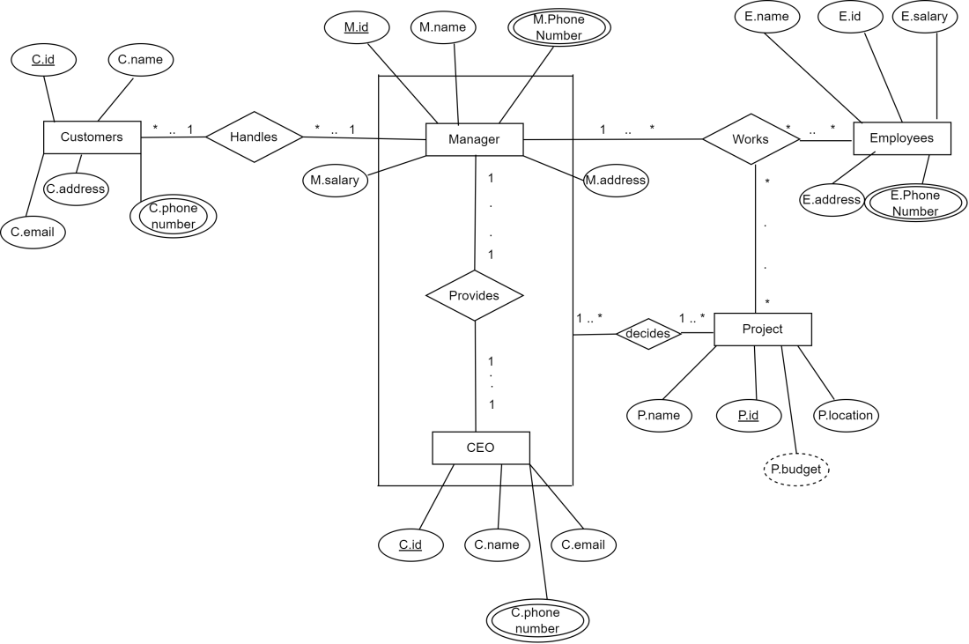

4)**NORMALISATION**

***(many to many)***

1NF:

c-id(pk), c-name, c-email, c-address, c-phone number, m-id,m-name, m-phone number, m -salary, m-address

2NF-

1) c-id(pk) c-name, e-email, c-address, c-phone number 2) m-id, m-name, m-phone number, m- salary, m-address, c-id (fk)

3)c-id (PK), m-id(FK)

3NF:

SAME AS 2NF

**MANAGER WORKS EMPLOYEES *(one to many)***

UNF (works):m-id, m-name, m-salary, m-phone, m-address, e-id, e-name, e-salary, e-phone, e-address,

1NF: m-id, m-name, m-salary, m-phone, m-address, e-id, e-name, e-salary, e-phone, e-address.

2NF: 1) m-id (pk), m-name, m-salary, m-phone, m-address, e-id (fk).

2) e-id (PK), e-name, e-salary, e-address, e-phone, m-id(fk)

3) m-id (fk), e-id (pk)

3NF: SAME AS 2NF

**EMPLOYEES WORK PROJECTS *(Many to many)***

UNF(work): e-id, e-name, e-salary, e-address, e-phone, p-location, p-name, p-id, p-budget.

1NF: e-id, e-name, e-salary. e-phone, e-address, p-id,p-name, p-budget, p-location

2NF: 1) e-id (pk), e-name, e- salary, e-phone, e-address.

2) p-id (pk), p-location, P- budget, p-name, e-id (fk)

3) p-id (PK) (k), e-id(fk).

3NF: SAME AS 2NF

**MANAGER PROVIDES CEO *(One to one)***

UNF (provides)

m-id, m-name, m-phone, m-salary, m-address, ceo-id, ceo-name, ceo-email,

1NF: m-id , m-name, m-phone, m-salary, m-address, ceo-id, ceo-name, ceo-email, ceo-phone

2NF:

1) m-id (pk), m-name, m-phone, m-salary, m-address 2)ceo-id, ceo-name, ceo-email, ceo-phone, m-id (fk)

3) m-id(fk), ceo-id (pk)

3NF- SAME AS 2NF

**MANAGER WORKS PROJECTS *(One to many)***

UNF (works):

m-id, m-name, m-salary, m-phone, m-address, p-id, p-name, p-budget, p- location.

1NF: m-id, m-name, m-salary, m-phone,m-address, p-id, p-name, p-budget, p-location

2NF:

1) m-id(pk), m-name, m-salary, m-phone, m-address.

2) p-id(pk), p-name, P-budget, p-location, m-id(fk)

3) m-id(fk), p-id(pk)

3 NF: SAME AS 2NF

**MANAGER,CEO DECIDE PROJECT *(One to many)***

UNF (Decides):

m-id, m-name, m-phone, m-salary, m-address, ceo-id, ceo-name, ceo-email, ceo-phone, p-id, p-name, p-location, p-budget.

1NF: m-id, m-name, m-phone, m-salary, m-address, ceo-id, ceo-name, ceo-email, ceo-phone, p-id, p-name, p-location, p-budget.

2NF:

1)m-id , m-name, m-salary, m-phone, m-address, ceo-Id(pk), ceo-name, ceo-phone, ceo-email. (Managerceo).

2) p-id, p-name, p-location, p-budget. (Project)

3) ceo-id, p-id (pk)(Decides)

3NF: SAME AS 2NF

**5.Finalization**

1. C_id (pk), C_name, C_email,C_address,C_phone number, m-id(fk), (Customers-manager)
2. m-id (pk), m-name, m-phone, m-salary, m-address, ~~e-id~~  (pk) (manager)
3. m-id(fk), c-id(pk) (handles)
4. m-id(pk), m-name, m-phone, m-salary, m-address(Manager)
5. Ceo-id(pk),Ceo-name,Ceo-email,Ceo-phone number, m-id(fk)

(ceomanager)

1. Ceo-id(pk), m-id(fk)(provides)
2. m-id(pk), m-name, m-phone, m-salary, m-address, ~~e-id (fk)~~(~~manageremployee~~)
3. e-id(pk),e-name, e-salary, e-address, e-phone, m-id(fk)(employee manger )
4. m_id(fk), e-id(pk)(manager works project)
5. m-id , m-name, m-phone, m-salary, m-address, ~~p-id(fk)~~ (manager ~~project~~)
6. p-id(pk), p-name, p-budget, p-location, m-id(fk) (project Manager)
7. m-id (fk), p-id (pk) (managerworksproject)
8. e-id(pk), e-name, e-salary, e-address, e-phone(employees)
9. p-id(pk), p-name, p-location, p-budget, e_id(fk)(projectemployees)
10. e_id(pk), p-id(fk)(employeeworksproject)
11. m_id, m-name, m-salary, m-phone, m-address,Ceo_id(pk),Ceo_name,Ceo_email,Ceo_phone(ManagerCeo)
12. p-id(pk), p-name, plocation, p-budget(projects)
13. Ceo-id, p-id(pk)(decides

**6.Table creation**

**1.COMPANY:**

**create table company (c_id number(10) , c_name varchar(50))**

**desc company**

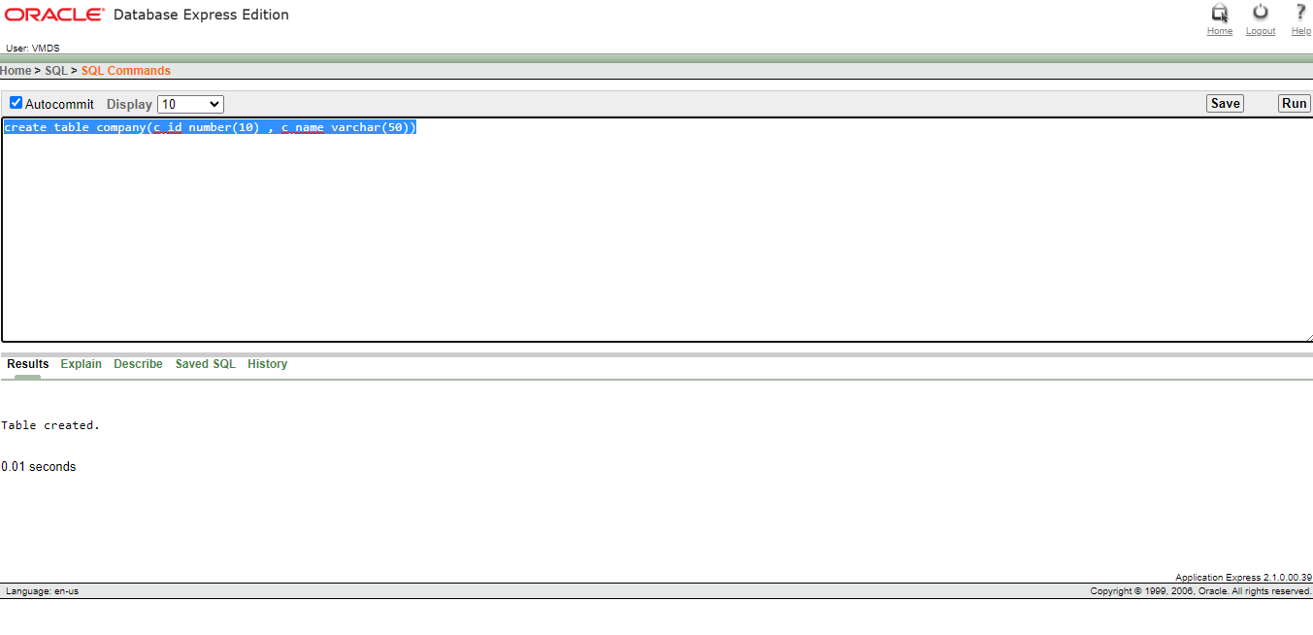

**2.Vaccine:**

**create table vaccine (v_id number(10) , v_name varchar(50) , exp_date varchar2(120))**

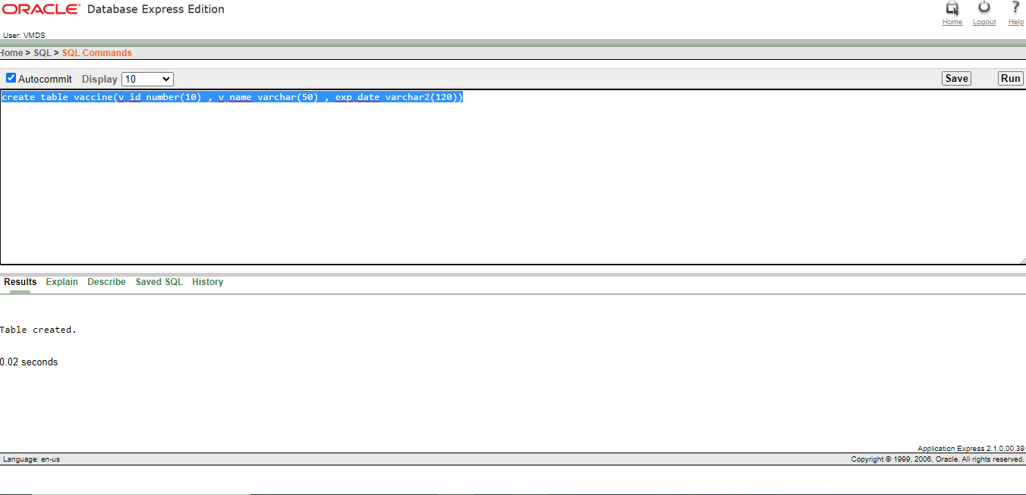

**3.Manufacture:**

**create table manufacture (c_id number(4) primary key, v_id number(5));**

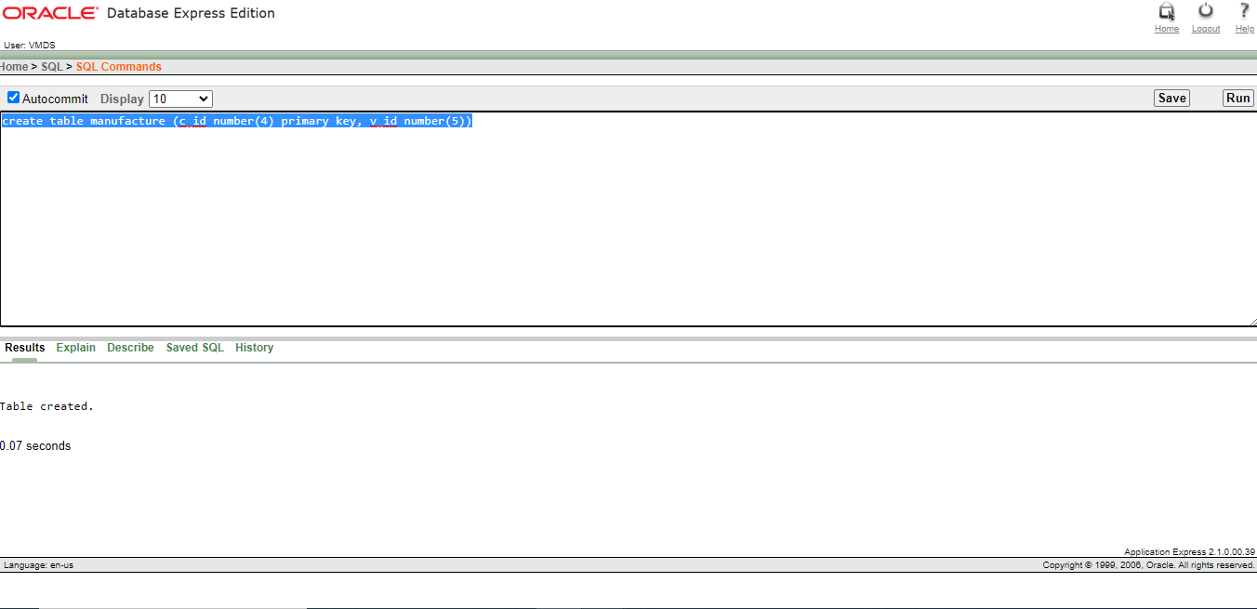

**4.Hospital:**

**create table hospital(h_id number(4) , h_name varchar2(40) , h_phone number(11) , h_address varchar(50))**

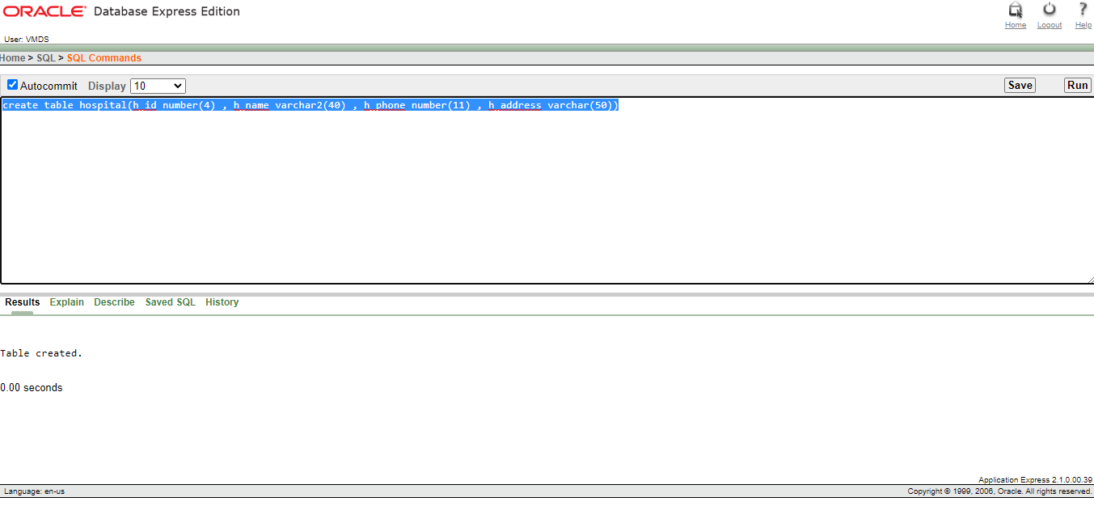

**5.Distribute:**

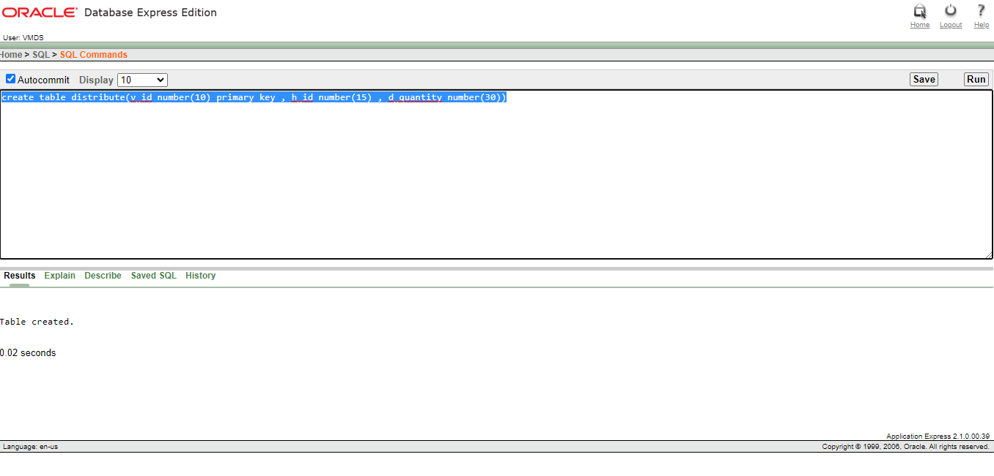

**6.Works_for:**

**create table works_for(d_id number(20) , d_name varchar2(15) , d_phone number(15) , h_id number(20))**

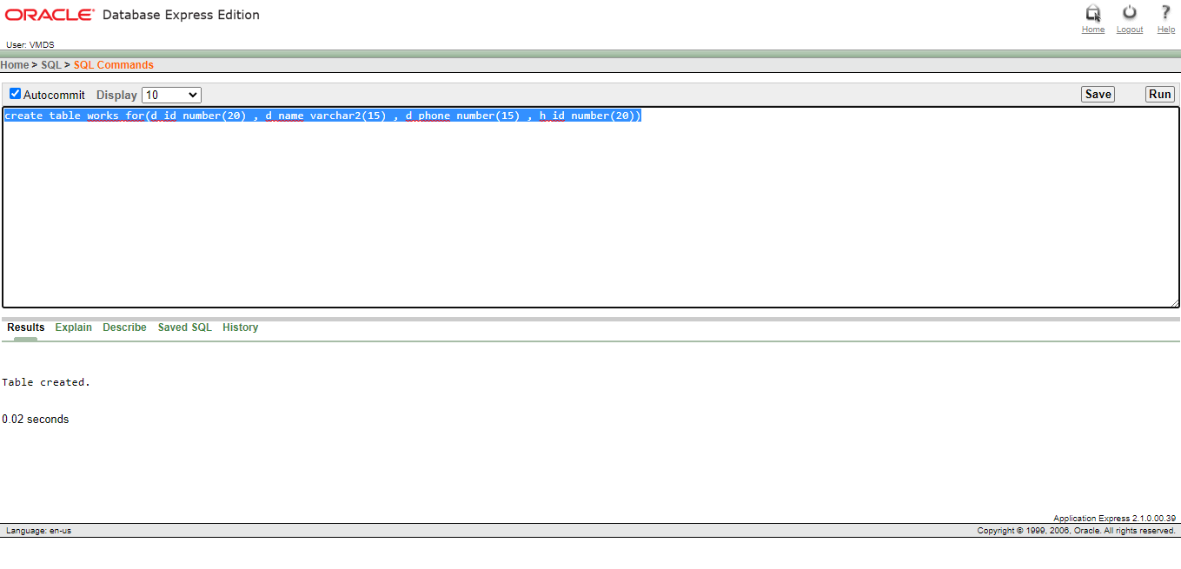

**7.Injects:**

create table injects(p_id number(5) primary key , p_name varchar2(20) , p_phone number(15) , d_id number(20))

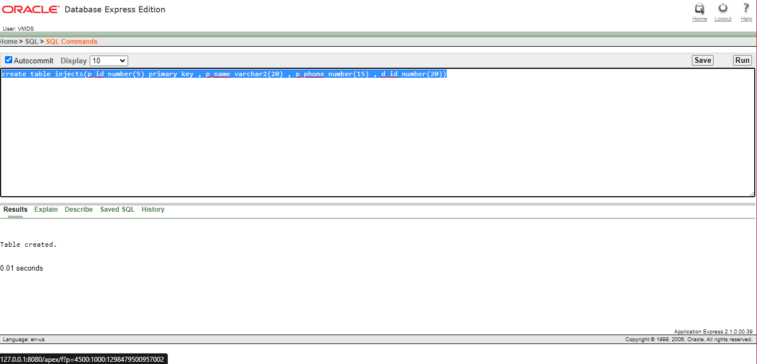

**8.Doctor:**

**create table doctor(d_id number(5) primary key , d_name varchar2(25) , d_phone number(11))**

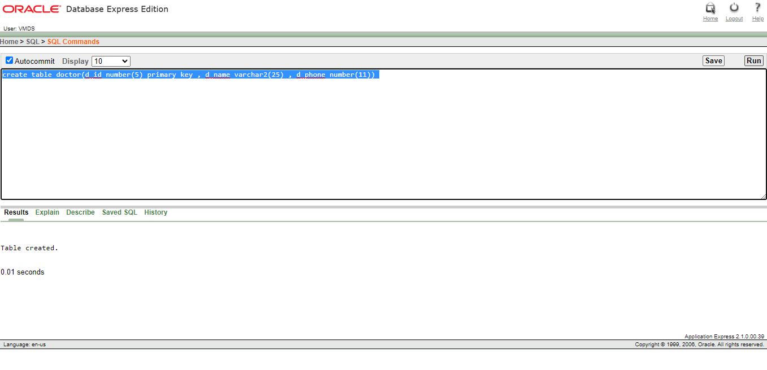

**9.Patient:**

**create table patient(p_id number(5) primary key , p_name varchar2(25) , p_phone number(11))**

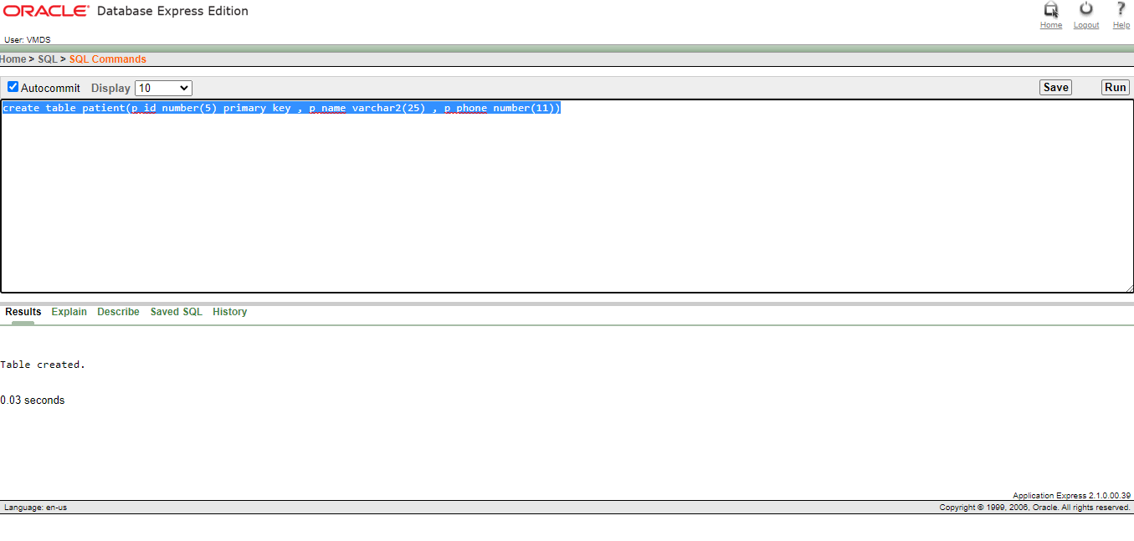

**10.Registers:**

**create table registers(h_id number(5) primary key , p_id number(5) , r_date varchar2(120))**

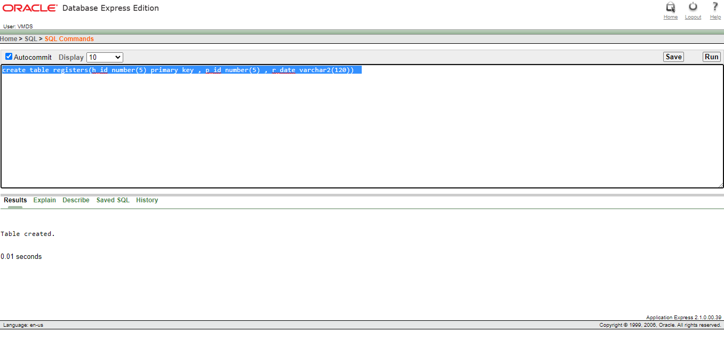

**7.Value insertion.**

**1.Company:**

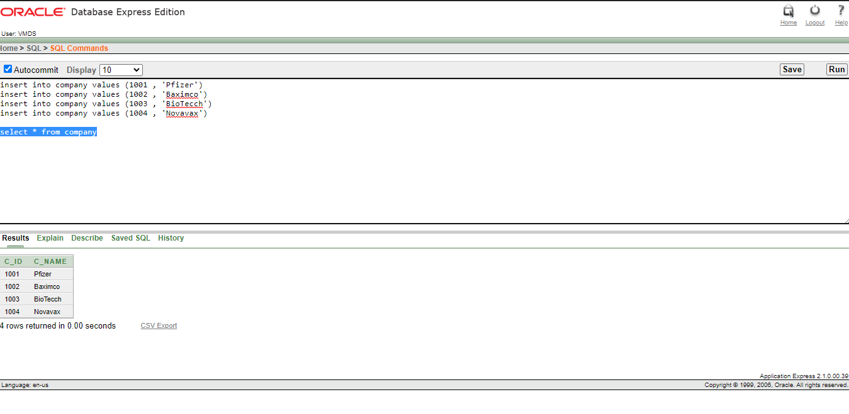

2.Vaccine:

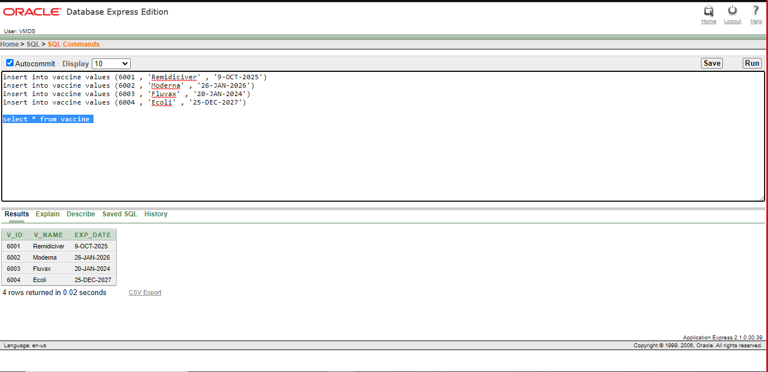

3.Manufacture:

4.Hospital:

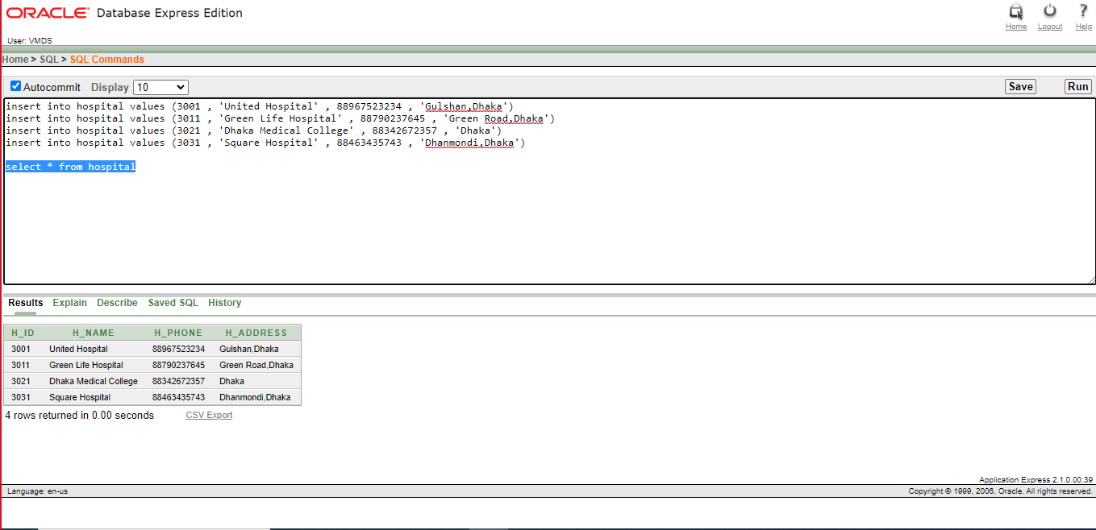

5.Distribute:

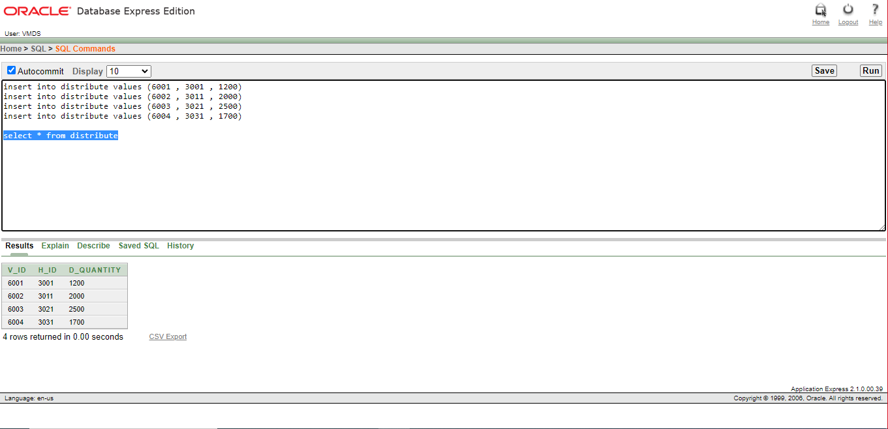

6.Works_for:

7.Injects:

8.Doctor:

9.Patient:

10.Registers:

**8.QUERY TEST:**

**Question:** Show the name and salary of the employees with the highest salary in the "employees” table.

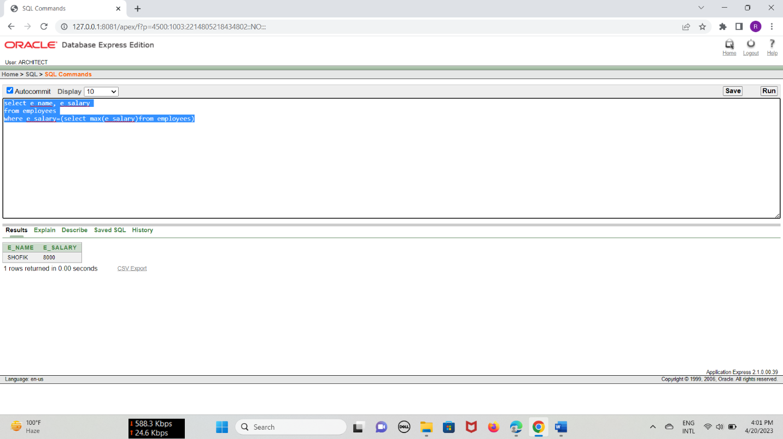

**Question:** Show the name, location, and budget of projects from the "projects" table where project located in “SHAMOLI".

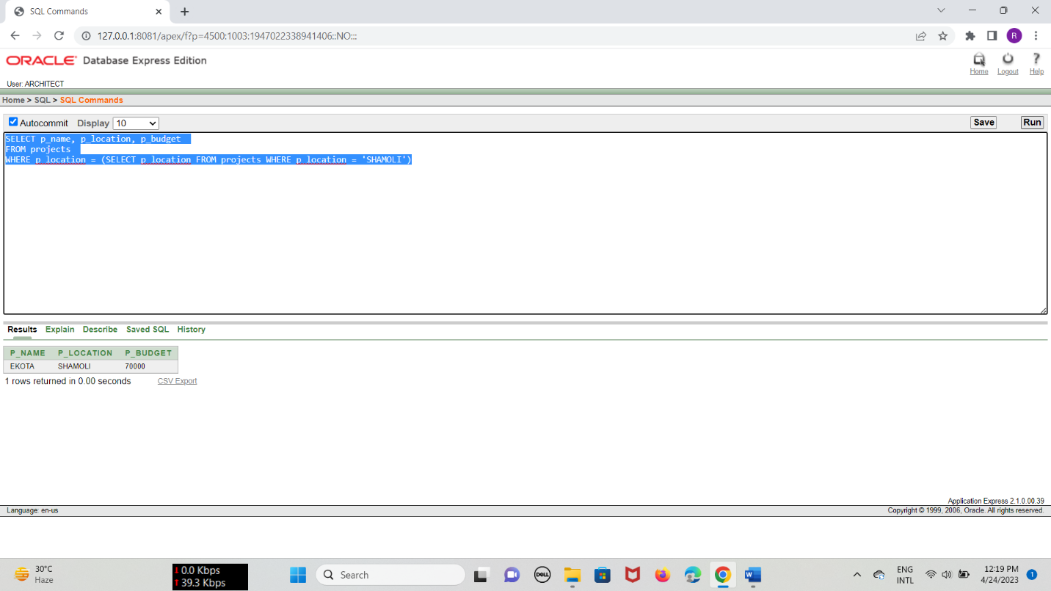

**9.JOINING**

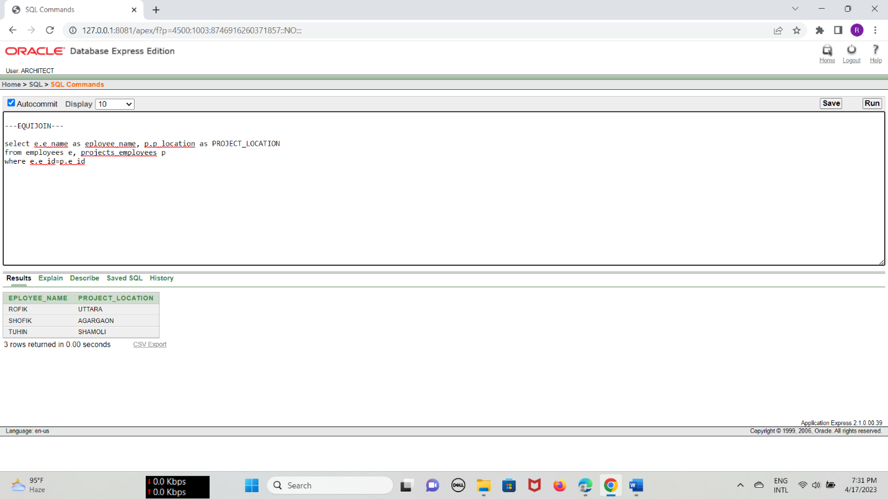

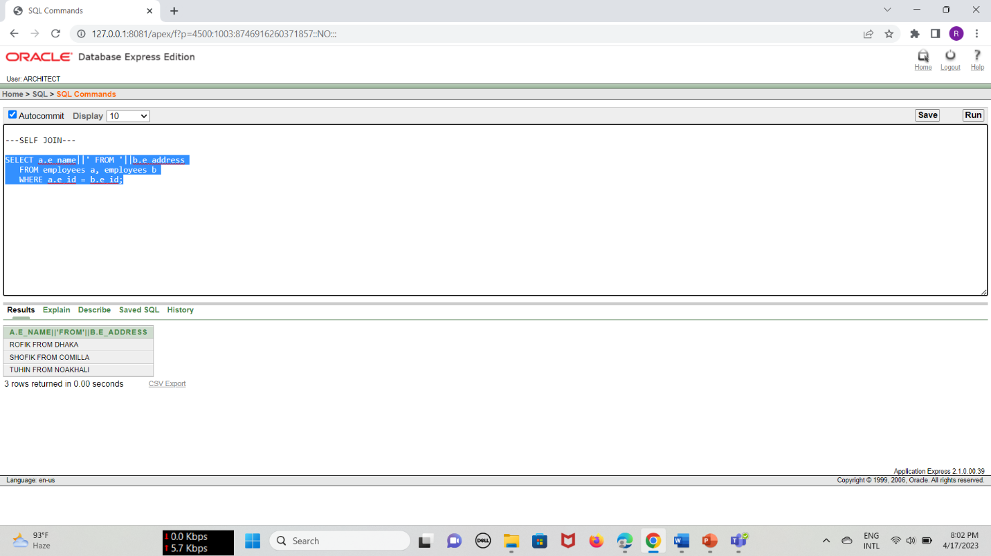

**10.VIEW**

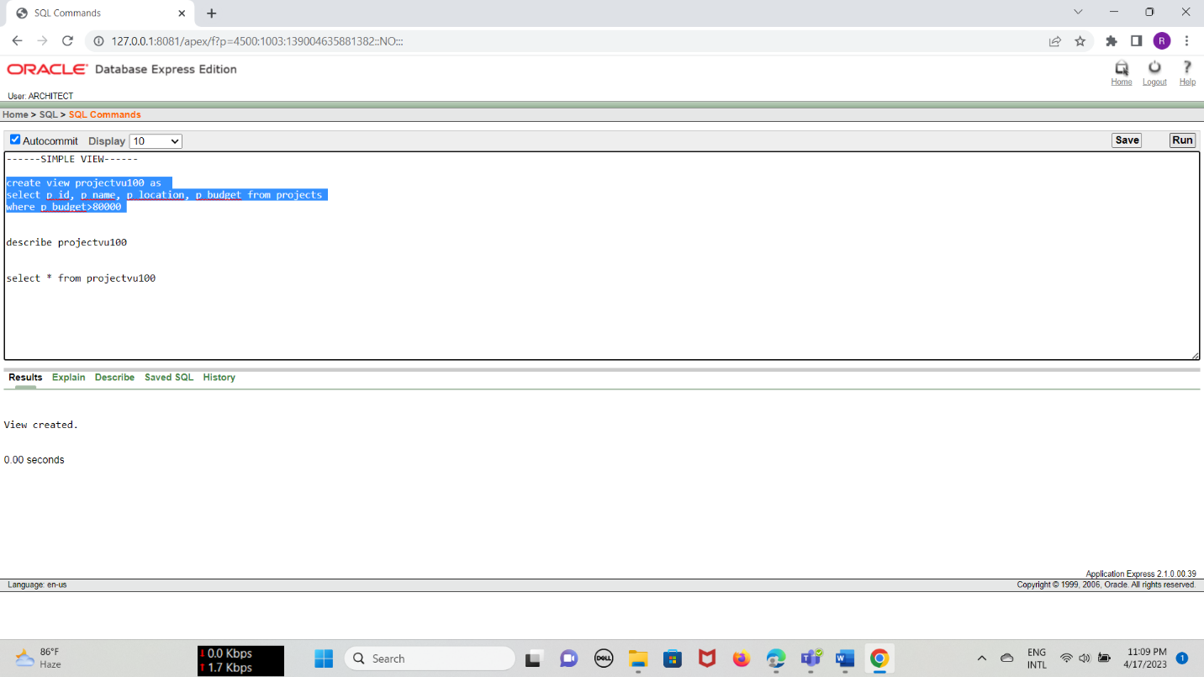

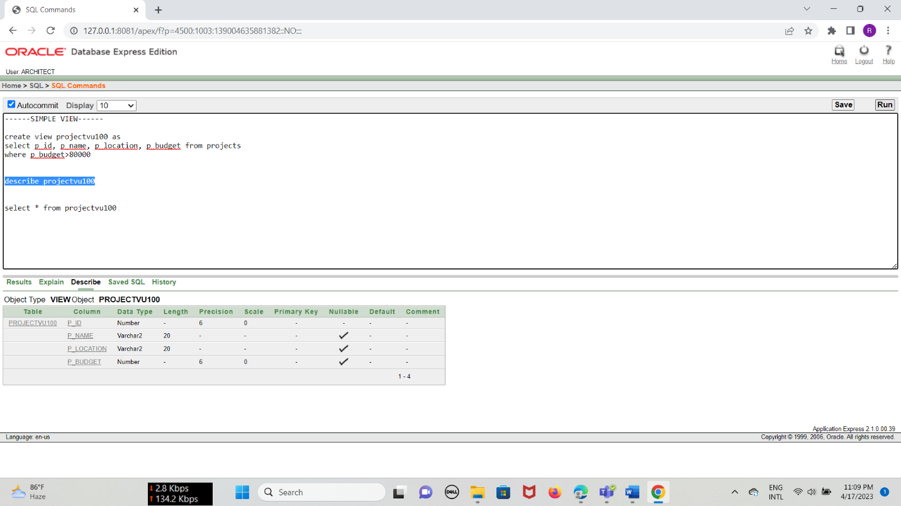

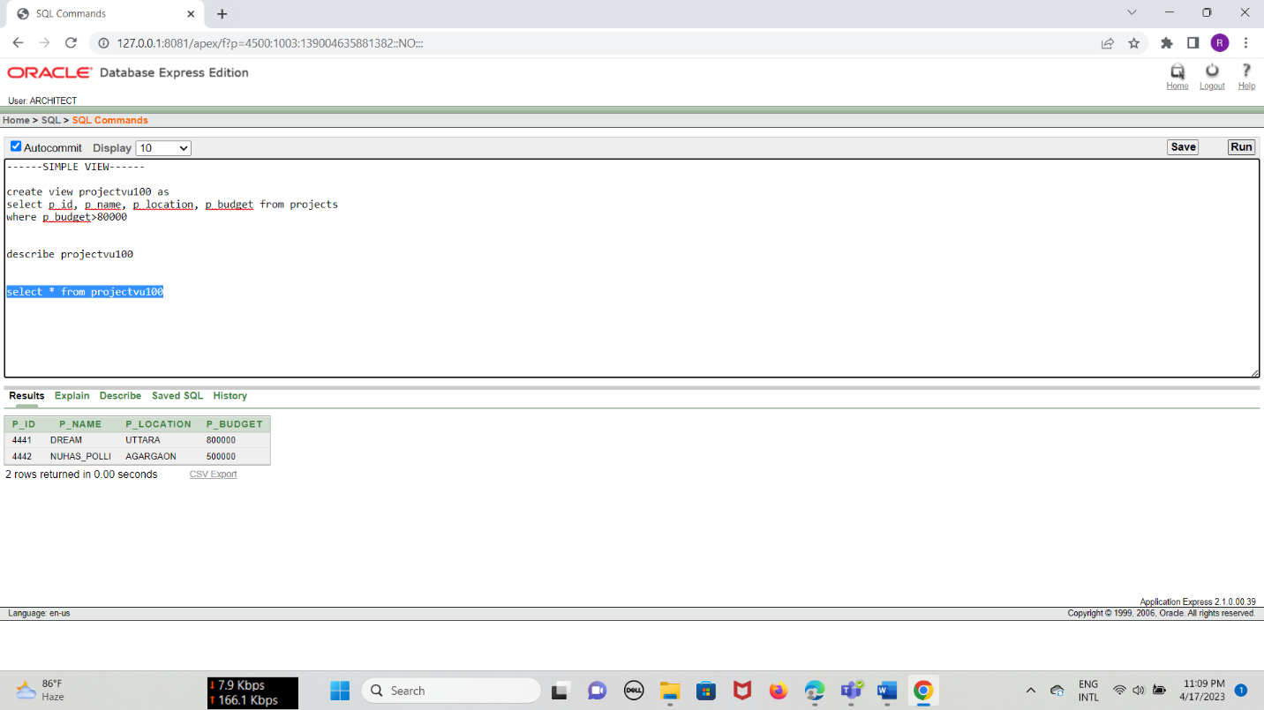

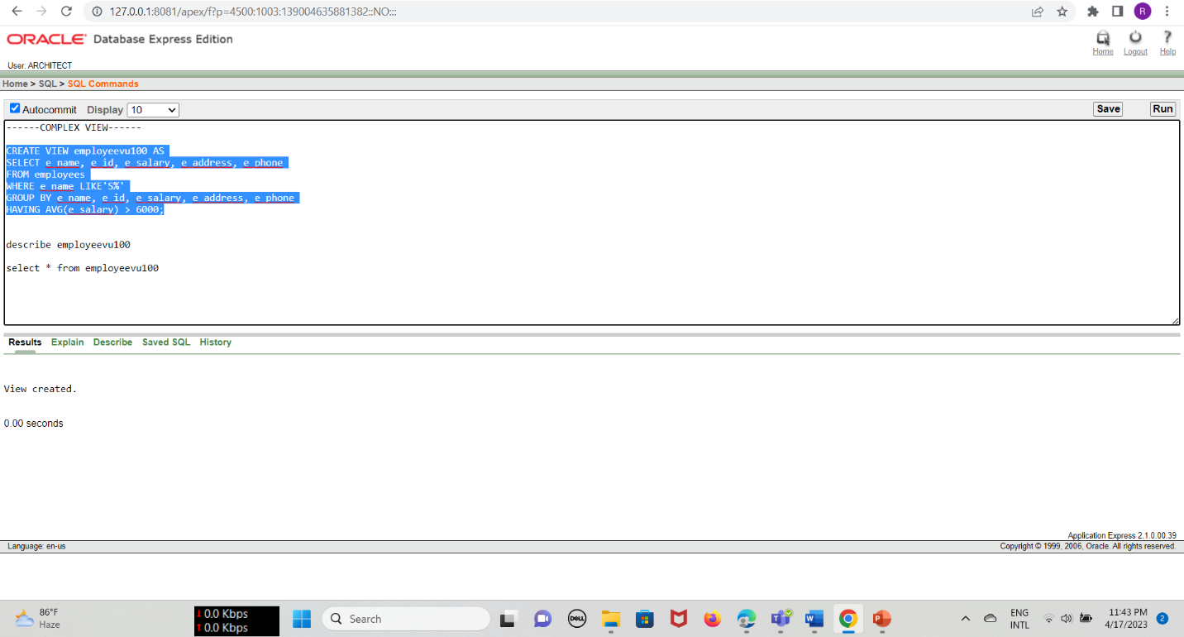

**11.Conclusion.**

This database management system can help the hospital to register all  
their details about vaccine company, vaccine, doctor, and patient. It can  
easily be modified and quickly shared among multiple users. In terms of  
expansion, this project can be updated any time in near future. Since it  
is a normalized project, there will be no problem in project expansion  
and adding data in the project.