1. Write a C/C++ program using the following instructions (filename: ID.c/ ID.cpp):
   1. Read a file named “program.cpp” (given below).
   2. After reading file you have to **identify and count** the ***unique*** name of the variables and name of the preprocessor and print the result.

|  |
| --- |
| Input: program.cpp |
| #include<iostream>  #include<string>  #define max 5  using namespace std;  int add(int x, int y){  return x+y;  }  int sub(int x, int y){  return x-y;  }  int main(){  int a=10, b=9, c=0;  cout<<"Hello";  c = a + b;  int d, e;  d = c - 10;  e = d * 5 ;  return 0;  } |

|  |
| --- |
| Sample Output: |
| Variable-1: a  Variable-2: b  Variable-3: c  Variable-4: d  Variable-5: e  Total number of the variables: 5  Preprocessor-1: include  Preprocessor-2: define  Total number of preprocessor: 2 |

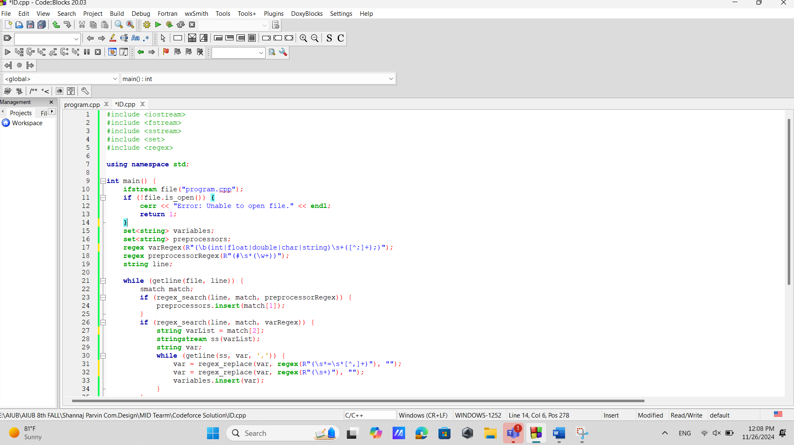Program attachment sample (do not crop):

