Lab Taks-3

Submission Guidelines-
- Rename the file to your id only. If your id is 18-XXXXX-1, then the file name must be 18-XXXXX-1.docx.
- Must submit within time that will be discussed in class VUES to the section named Lab Tak-3
- Must include resources for all the section in the table
Question- 1

Draw five storied building with windows and a front door

Graph Plot (Picture)-
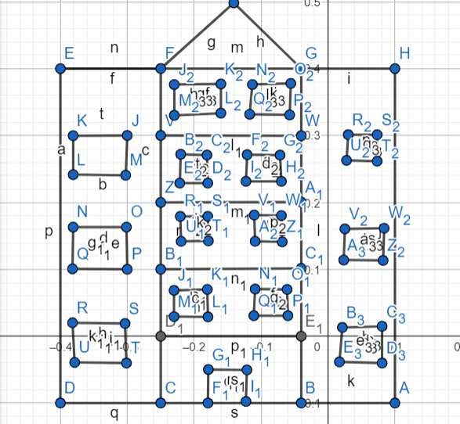

Code-

#include <windows.h>
#include <GL/glut.h>

void display() {

glClearColor(1.0f,1.0f,1.0f, 0.0f);
glClear(GL_COLOR_BUFFER_BIT);

// r00f
glBegin(GL_TRIANGLES);
glColor3ub(60,60,60);
glVertex2f(.587506,.780470);
glVertex2f(.380341,.565883);
glVertex2f(.806590,.565883);
glEnd();

// Mblock
glBegin(GL_QUADS);
glColor3ub(178,250,178);
glVertex2f(.380341,.565883);
glVertex2f(.806590,.565883);
glVertex2f(.806590,-.139347);
glVertex2f(.380341,-.139347);
glEnd();

// MWin
glBegin(GL_QUADS);
glColor3ub(0,0,0);
glVertex2f(.416630,.527850);
glVertex2f(.497649,.527850);
glVertex2f(.497649,.488002);
glVertex2f(.416630,.488002);
glEnd();

glBegin(GL_QUADS);
glColor3ub(0,0,0);
glVertex2f(.673397,.527850);
glVertex2f(.749430,.527850);
glVertex2f(.749430,.488002);
glVertex2f(.673397,.488002);
glEnd();

glBegin(GL_QUADS);
glColor3ub(0,0,0);
glVertex2f(.416630,.527850);
glVertex2f(.497649,.527850);
glVertex2f(.497649,.488002);
glVertex2f(.416630,.488002);
glEnd();

glBegin(GL_QUADS);
glColor3ub(0,0,0);
glVertex2f(.673397,.271328);
glVertex2f(.745691,.271328);
glVertex2f(.745691,.227744);
glVertex2f(.673397,.227744);
glEnd();

glBegin(GL_QUADS);
glColor3ub(0,0,0);
glVertex2f(.673397,.136840);
glVertex2f(.745691,.136840);
glVertex2f(.745691 ,.092011);
glVertex2f(.673397 ,.092011 );
glEnd();

glBegin(GL_QUADS);
glColor3ub(0,0,0);
glVertex2f(.673397,.404570);
glVertex2f(.749430,.404570);
glVertex2f(.749430,.359741);
glVertex2f(.673397,.359741);
glEnd();

glBegin(GL_QUADS);
glColor3ub(0,0,0);
glVertex2f(.416630,.271328);
glVertex2f(.497649,.271328);
glVertex2f(.497649,.227744);
glVertex2f(.416630,.227744);
glEnd();

glBegin(GL_QUADS);
glColor3ub(0,0,0);
glVertex2f(.416630,.404570);
glVertex2f(.497649,.404570);
glVertex2f(.497649,.359741);
glVertex2f(.416630,.359741);
glEnd();

glBegin(GL_QUADS);
glColor3ub(0,0,0);
glVertex2f(.416630,.136840);
glVertex2f(.497649,.136840);
glVertex2f(.497649,.085785);
glVertex2f(.416630,.085785);
glEnd();

// lblock
glBegin(GL_QUADS);
glColor3ub(111,250,168);
glVertex2f(.380341,.565883);
glVertex2f(.111721,.565883);
glVertex2f(.111721,-.139347);
glVertex2f(.380341,-.139347);
glEnd();

// lblock win

glBegin(GL_QUADS);
glColor3ub(0,0,0);
glVertex2f(.213394,.272573);
glVertex2f(.294412,.272573);
glVertex2f(.294412,.227744);
glVertex2f(.213394,.227744);
glEnd();

glBegin(GL_QUADS);
glColor3ub(0,0,0);
glVertex2f(.213394,.405494);
glVertex2f(.294412,.405494 );
glVertex2f(.294412,.360665);
glVertex2f(.213394,.360665 );
glEnd();

glBegin(GL_QUADS);
glColor3ub(0,0,0);
glVertex2f(.213394,.130614);
glVertex2f(.294412,.130614);
glVertex2f(.294412,.085785);
glVertex2f(.213394,.085785);
glEnd();

// rblock
glBegin(GL_QUADS);
glColor3ub(111,250,168);
glVertex2f(1.075210,.565883);
glVertex2f(.806590,.565883);
glVertex2f(.806590,-.139347);
glVertex2f(1.075210,-.139347);
glEnd();

// rblocks win
glBegin(GL_QUADS);
glColor3ub(0,0,0);
glVertex2f(.906295, .136840);
glVertex2f(.987314, .136840);
glVertex2f(.987314, .092011);
glVertex2f(.906295, .092011);
glEnd();

glBegin(GL_QUADS);
glColor3ub(0,0,0);
glVertex2f(.906295 ,.272573);
glVertex2f(.987314, .272573);
glVertex2f(.987314, .227744);
glVertex2f(.906295, .227744);
glEnd();

glBegin(GL_QUADS);
glColor3ub(0,0,0);
glVertex2f(.906295,.404570);
glVertex2f(.987314,.404570);
glVertex2f(.987314,.359741);
glVertex2f(.906295,.359741);
glEnd();

// line
glLineWidth(2);

glBegin(GL_LINES);
glVertex2f(.380341f,.050918f);
glVertex2f(.806590f,.050918f);
glEnd();

glBegin(GL_LINES);
glVertex2f(.806590f,.565883f);
glVertex2f(.806590f,-.139347f);
glEnd();

glBegin(GL_LINES);
glVertex2f(.380341f,.565883f);
glVertex2f(.380341f,-.139347f);
glEnd();

glBegin(GL_LINES);
glVertex2f(.380341f,.174198f);
glVertex2f(.806590f,.174198f);
glEnd();

glBegin(GL_LINES);
glVertex2f(.380341f,.309930f);
glVertex2f(.806590f,.309930);
glEnd();

glBegin(GL_LINES);
glVertex2f(.380341f,.441927f);
glVertex2f(.806590f,.441927f);
glEnd();

// Door

glBegin(GL_POLYGON);
glColor3ub(0,0,0);
glVertex2f(.561217,-.013835);
glVertex2f(.639772,-.013835);
glVertex2f(.639772,-.123418);
glVertex2f(.561217,-.123418);
glEnd();

glFlush();

}

int main(int argc, char** argv) {
glutInit(&argc, argv);
glutCreateWindow("Building");
glutInitWindowSize(5000,5000);
glutInitWindowPosition(50,50);
glutDisplayFunc(display);
gluOrtho2D(-1.0,2.0,-1.0,1.0);
glutMainLoop();
return 0;
}

Output Screenshot (Full Screen)-
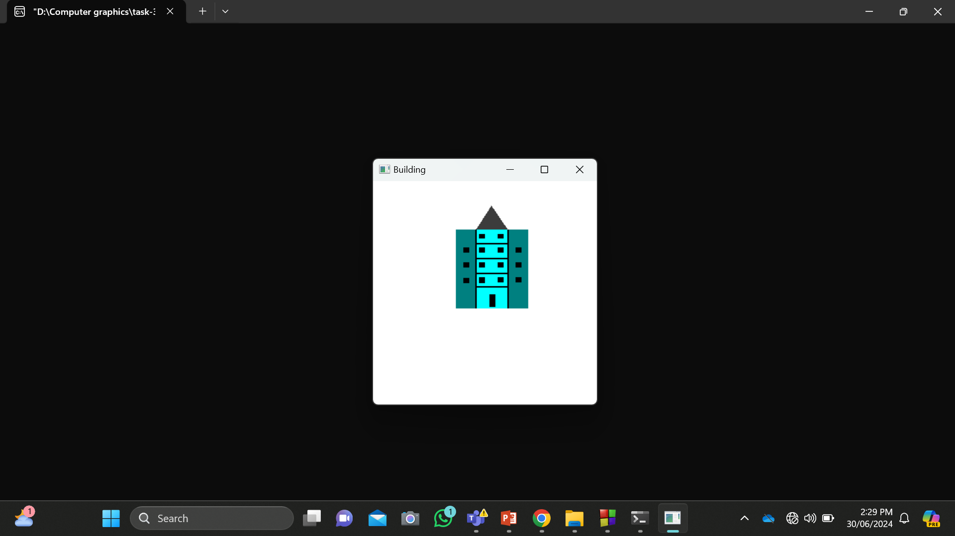

Question- 2

Draw a tree

Graph Plot (Picture)-

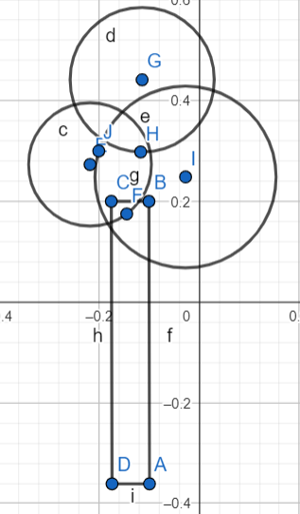
Code-
#include <windows.h>
#include <GL/glut.h>
#include <math.h>
void circle(float radius, float xc, float yc, float r, float g, float b)
{
glBegin(GL_POLYGON);
for(int i=0;i<200;i++)
{
glColor3ub(r,g,b);
float pi=3.1416;
float A=(i*2*pi)/200;
float r=radius;
float x = r * cos(A);
float y = r * sin(A);
glVertex2f(x+(-0.25),y+0.2);
}
glEnd();

glBegin(GL_POLYGON);
for(int i=0;i<200;i++)
{
glColor3ub(53,205,30);
float pi=3.1416;
float A=(i*2*pi)/200;
float r=radius;
float x = r * cos(A);
float y = r * sin(A);
glVertex2f(x+(-0.08),y+0.2);
}
glEnd();

glBegin(GL_POLYGON);
for(int i=0;i<200;i++)
{
glColor3ub(135, 190, 54);
float pi=3.1416;
float A=(i*2*pi)/200;
float r=radius;
float x = r * cos(A);
float y = r * sin(A);
glVertex2f(x+(-0.16),y+0.36);
}
glEnd();
}
void display() {
glClearColor(1.0f, 1.0f, 1.0f, 1.0f);
glClear(GL_COLOR_BUFFER_BIT);

glBegin(GL_POLYGON);
glColor3ub(140,69,69);

glVertex2f(-.195376,.160641);
glVertex2f(-.100480, .160641);
glVertex2f(-.100480,-.350604);
glVertex2f(-.195376,-.350604);

glEnd();

circle(0.30,-0.2,0.15,70,111,26 );

glFlush();
}

int main(int argc, char** argv) {
glutInit(&argc, argv);
glutCreateWindow("TREE");
gluOrtho2D(-1.0,1.0,-1.0,1.0);
glutInitWindowSize(320, 320);
glutDisplayFunc(display);
glutMainLoop();
return 0;
}

Output Screenshot (Full Screen)-
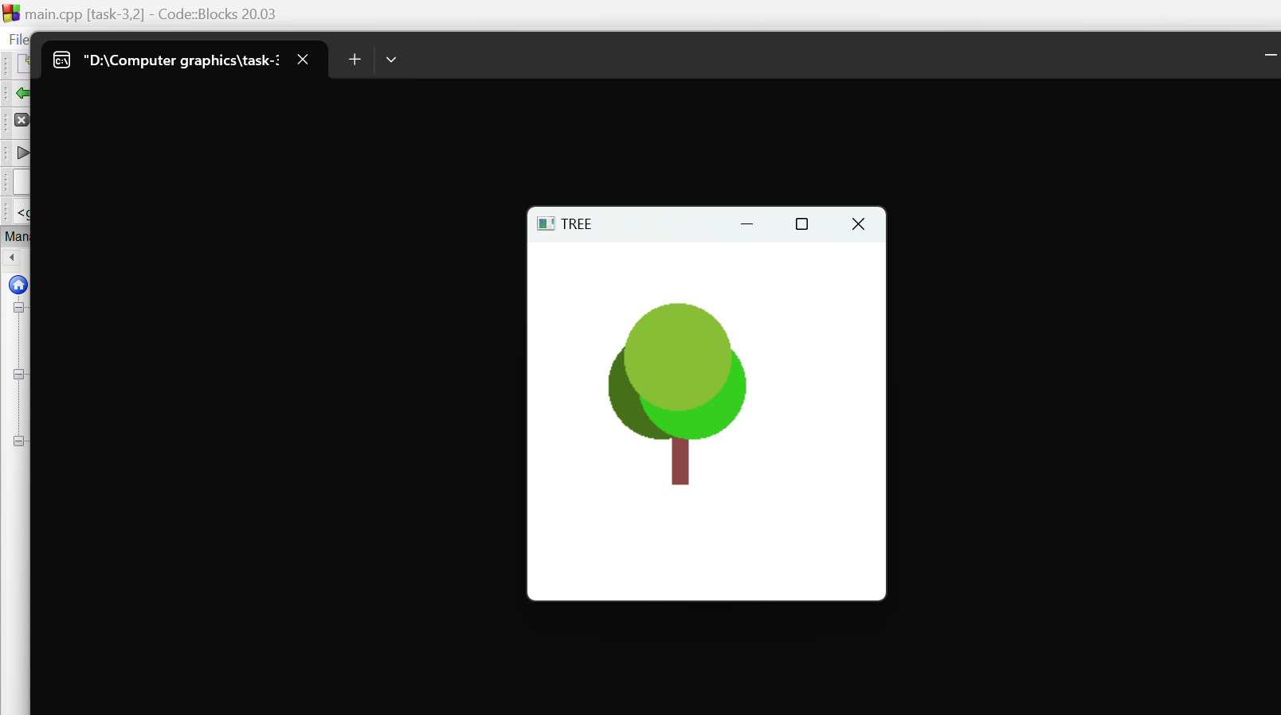

Question- 3

Draw a lamppost with black background

Graph Plot (Picture)-
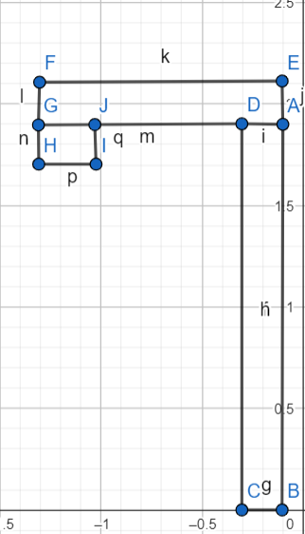
Code-
#include <windows.h>
#include <GL/glut.h>

void display() {

glClearColor(0.0f,0.0f,0.0f,0.0f);
glClear(GL_COLOR_BUFFER_BIT);

glBegin(GL_POLYGON);
glColor3ub(160,160,160);
glVertex2f(1.877369,.281884);
glVertex2f(1.852140,.281884);
glVertex2f(1.852140,-.418816);
glVertex2f(1.877369,-.418816);
glEnd();

glBegin(GL_POLYGON);
glColor3ub(160,160,160);
glVertex2f(1.852140, .281884);
glVertex2f(1.495967, .281884);
glVertex2f(1.495967, .254999);
glVertex2f(1.852140, .254999);
glEnd();

glBegin(GL_POLYGON);
glColor3ub(255,255,0);
glVertex2f(1.495967,.254999);
glVertex2f(1.572461,.254999);
glVertex2f(1.572461,.222667);
glVertex2f(1.495967,.222667);
glEnd();

glFlush();

}

int main(int argc, char** argv) {
glutInit(&argc, argv);
glutCreateWindow("Lamp post");
glutInitWindowSize(5000,5000);
glutInitWindowPosition(50,50);
glutDisplayFunc(display);
gluOrtho2D(0.0,4.0,-1.0,1.0);
glutMainLoop();
return 0;
}

Output Screenshot (Full Screen)-
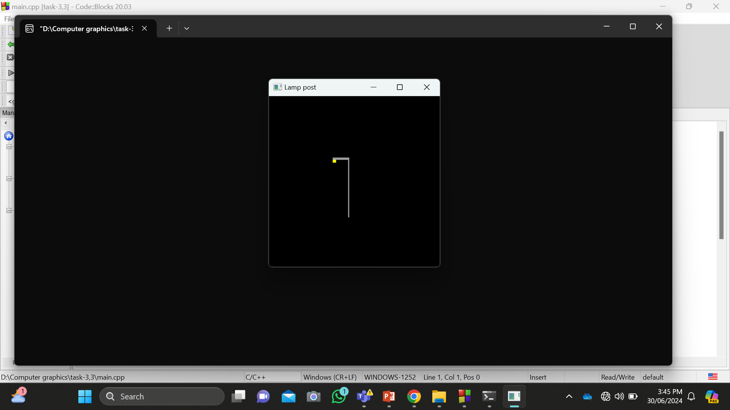

Question- 4

Draw a bench

Graph Plot (Picture)-
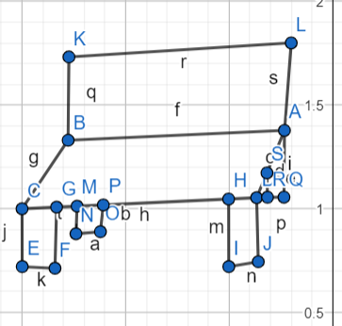
Code-

#include <windows.h>
#include <GL/glut.h>

void display() {

glClearColor(1.0f,1.0f,1.0f, 0.0f);
glClear(GL_COLOR_BUFFER_BIT);

glBegin(GL_POLYGON);
glColor3ub(51,55,212);
glVertex2f(1.424646,-.288870);
glVertex2f(1.758150, -.288870);
glVertex2f(1.758150, -.207672);
glVertex2f(1.424646, -.207672);
glEnd();

glBegin(GL_POLYGON);
glColor3ub(51,55,212);
glVertex2f(1.355918, -.348087);
glVertex2f(1.703748, -.348087);
glVertex2f(1.757074, -.288870);
glVertex2f(1.424646 , -.288870);
glEnd();

glBegin(GL_POLYGON);
glColor3ub(51,55,212);
glVertex2f(1.355195 , -.419362);
glVertex2f(1.382495 , -.419362);
glVertex2f(1.382495 , -.345689);
glVertex2f(1.355195 , -.345689);
glEnd();

glBegin(GL_POLYGON);
glColor3ub(51,55,212);
glVertex2f( 1.676447,-.418598);
glVertex2f( 1.703748, -.418598);
glVertex2f( 1.703748, -.344925);
glVertex2f( 1.676447, -.344925);
glEnd();

glBegin(GL_POLYGON);
glColor3ub(51,55,212);
glVertex2f(1.424646, -.345055);
glVertex2f(1.438245, -.345055);
glVertex2f(1.438245, -.367214);
glVertex2f(1.424646, -.367214);
glEnd();

glBegin(GL_POLYGON);
glColor3ub(51,55,212);
glVertex2f(1.743042,-.367214);
glVertex2f(1.757074 , -.367214);
glVertex2f(1.757074 , -.288870);
glVertex2f(1.743042, -.304437);
glEnd();

glFlush();

}

int main(int argc, char** argv) {
glutInit(&argc, argv);
glutCreateWindow(" bench");
glutInitWindowSize(3000,3000);
glutInitWindowPosition(50,50);
glutDisplayFunc(display);
gluOrtho2D(-1.0,4.0,-1.0,1.0);
glutMainLoop();
return 0;
}

Output Screenshot (Full Screen)-

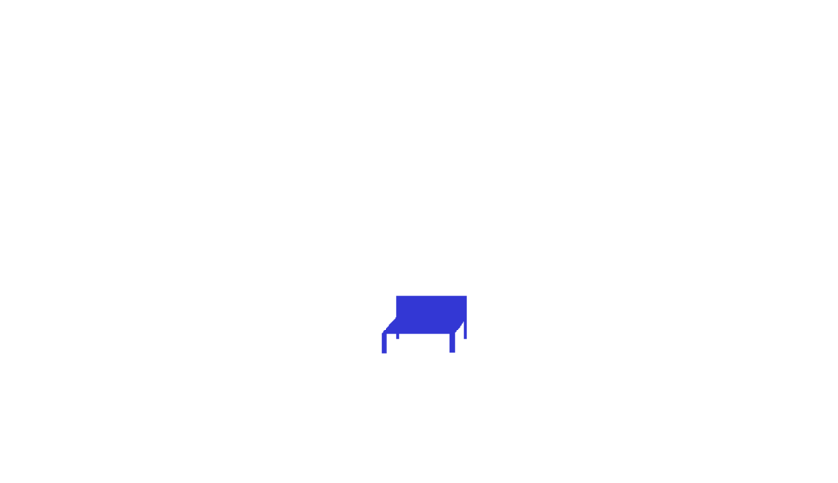

Question- 5

Use the building, tree, lamppost and bench to create a scenario

Graph Plot (Picture)-
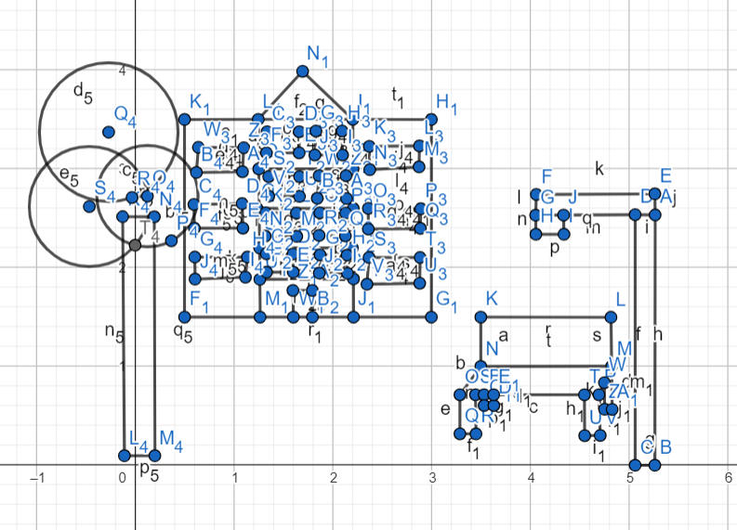
Code-
#include <windows.h>
#include <GL/glut.h>
#include<math.h>

void circle(float radius, float xc, float yc, float r, float g, float b)
{
glBegin(GL_POLYGON);
for(int i=0;i<200;i++)
{
glColor3ub(r,g,b);
float pi=3.1416;
float A=(i*2*pi)/200;
float r=radius;
float x = r * cos(A);
float y = r * sin(A);
glVertex2f(x+(-0.25),y+0.2);
}
glEnd();

glBegin(GL_POLYGON);
for(int i=0;i<200;i++)
{
glColor3ub(53,205,30);
float pi=3.1416;
float A=(i*2*pi)/200;
float r=radius;
float x = r * cos(A);
float y = r * sin(A);
glVertex2f(x+(-0.08),y+0.2);
}
glEnd();

glBegin(GL_POLYGON);
for(int i=0;i<200;i++)
{
glColor3ub(128, 183, 54);
float pi=3.1416;
float A=(i*2*pi)/200;
float r=radius;
float x = r * cos(A);
float y = r * sin(A);
glVertex2f(x+(-0.16),y+0.36);
}
glEnd();
}

void display() {

glClearColor(0.0f,0.0f,0.0f, 0.0f);
glClear(GL_COLOR_BUFFER_BIT);

/// Building
/// roof
glBegin(GL_TRIANGLES);
glColor3ub(60,60,60);
glVertex2f(.587506,.780470);
glVertex2f(.380341,.565883);
glVertex2f(.806590,.565883);
glEnd();

/// main block
glBegin(GL_QUADS);
glColor3ub(178,250,178);
glVertex2f(.380341,.565883);
glVertex2f(.806590,.565883);
glVertex2f(.806590,-.139347);
glVertex2f(.380341,-.139347);
glEnd();

/// Middle Windows
glBegin(GL_QUADS);
glColor3ub(0,0,0);
glVertex2f(.416630,.527850);
glVertex2f(.497649,.527850);
glVertex2f(.497649,.488002);
glVertex2f(.416630,.488002);
glEnd();

glBegin(GL_QUADS);
glColor3ub(0,0,0);
glVertex2f(.673397,.527850);
glVertex2f(.749430,.527850);
glVertex2f(.749430,.488002);
glVertex2f(.673397,.488002);
glEnd();

glBegin(GL_QUADS);
glColor3ub(0,0,0);
glVertex2f(.416630,.527850);
glVertex2f(.497649,.527850);
glVertex2f(.497649,.488002);
glVertex2f(.416630,.488002);
glEnd();

glBegin(GL_QUADS);
glColor3ub(0,0,0);
glVertex2f(.673397,.271328);
glVertex2f(.745691,.271328);
glVertex2f(.745691,.227744);
glVertex2f(.673397,.227744);
glEnd();

glBegin(GL_QUADS);
glColor3ub(0,0,0);
glVertex2f(.673397,.136840);
glVertex2f(.745691,.136840);
glVertex2f(.745691 ,.092011);
glVertex2f(.673397 ,.092011 );
glEnd();

glBegin(GL_QUADS);
glColor3ub(0,0,0);
glVertex2f(.673397,.404570);
glVertex2f(.749430,.404570);
glVertex2f(.749430,.359741);
glVertex2f(.673397,.359741);
glEnd();

glBegin(GL_QUADS);
glColor3ub(0,0,0);
glVertex2f(.416630,.271328);
glVertex2f(.497649,.271328);
glVertex2f(.497649,.227744);
glVertex2f(.416630,.227744);
glEnd();

glBegin(GL_QUADS);
glColor3ub(0,0,0);
glVertex2f(.416630,.404570);
glVertex2f(.497649,.404570);
glVertex2f(.497649,.359741);
glVertex2f(.416630,.359741);
glEnd();

glBegin(GL_QUADS);
glColor3ub(0,0,0);
glVertex2f(.416630,.136840);
glVertex2f(.497649,.136840);
glVertex2f(.497649,.085785);
glVertex2f(.416630,.085785);
glEnd();

/// left block
glBegin(GL_QUADS);
glColor3ub(111,250,168);
glVertex2f(.380341,.565883);
glVertex2f(.111721,.565883);
glVertex2f(.111721,-.139347);
glVertex2f(.380341,-.139347);
glEnd();

/// left block windows

glBegin(GL_QUADS);
glColor3ub(0,0,0);
glVertex2f(.213394,.272573);
glVertex2f(.294412,.272573);
glVertex2f(.294412,.227744);
glVertex2f(.213394,.227744);
glEnd();

glBegin(GL_QUADS);
glColor3ub(0,0,0);
glVertex2f(.213394,.405494);
glVertex2f(.294412,.405494 );
glVertex2f(.294412,.360665);
glVertex2f(.213394,.360665 );
glEnd();

glBegin(GL_QUADS);
glColor3ub(0,0,0);
glVertex2f(.213394,.130614);
glVertex2f(.294412,.130614);
glVertex2f(.294412,.085785);
glVertex2f(.213394,.085785);
glEnd();

/// right block
glBegin(GL_QUADS);
glColor3ub(111,250,168);
glVertex2f(1.075210,.565883);
glVertex2f(.806590,.565883);
glVertex2f(.806590,-.139347);
glVertex2f(1.075210,-.139347);
glEnd();

/// right blocks windows
glBegin(GL_QUADS);
glColor3ub(0,0,0);
glVertex2f(.906295, .136840);
glVertex2f(.987314, .136840);
glVertex2f(.987314, .092011);
glVertex2f(.906295, .092011);
glEnd();

glBegin(GL_QUADS);
glColor3ub(0,0,0);
glVertex2f(.906295 ,.272573);
glVertex2f(.987314, .272573);
glVertex2f(.987314, .227744);
glVertex2f(.906295, .227744);
glEnd();

glBegin(GL_QUADS);
glColor3ub(0,0,0);
glVertex2f(.906295,.404570);
glVertex2f(.987314,.404570);
glVertex2f(.987314,.359741);
glVertex2f(.906295,.359741);
glEnd();

/// lines
glLineWidth(2);

glBegin(GL_LINES);
glVertex2f(.380341f,.050918f);
glVertex2f(.806590f,.050918f);
glEnd();

glBegin(GL_LINES);
glVertex2f(.806590f,.565883f);
glVertex2f(.806590f,-.139347f);
glEnd();

glBegin(GL_LINES);
glVertex2f(.380341f,.565883f);
glVertex2f(.380341f,-.139347f);
glEnd();

glBegin(GL_LINES);
glVertex2f(.380341f,.174198f);
glVertex2f(.806590f,.174198f);
glEnd();

glBegin(GL_LINES);
glVertex2f(.380341f,.309930f);
glVertex2f(.806590f,.309930);
glEnd();

glBegin(GL_LINES);
glVertex2f(.380341f,.441927f);
glVertex2f(.806590f,.441927f);
glEnd();

/// Doors

glBegin(GL_POLYGON);
glColor3ub(0,0,0);
glVertex2f(.561217,-.013835);
glVertex2f(.639772,-.013835);
glVertex2f(.639772,-.123418);
glVertex2f(.561217,-.123418);
glEnd();

/// Chair

glBegin(GL_POLYGON);
glColor3ub(51,55,212);
glVertex2f(1.424646,-.288870);
glVertex2f(1.758150, -.288870);
glVertex2f(1.758150, -.207672);
glVertex2f(1.424646, -.207672);
glEnd();

// chair flat surface
glBegin(GL_POLYGON);
glColor3ub(51,55,212);
glVertex2f(1.355918, -.348087);
glVertex2f(1.703748, -.348087);
glVertex2f(1.757074, -.288870);
glVertex2f(1.424646 , -.288870);
glEnd();

/// chair sticks
glBegin(GL_POLYGON);
glColor3ub(51,55,212);
glVertex2f(1.355195 , -.419362);
glVertex2f(1.382495 , -.419362);
glVertex2f(1.382495 , -.345689);
glVertex2f(1.355195 , -.345689);
glEnd();

glBegin(GL_POLYGON);
glColor3ub(51,55,212);
glVertex2f( 1.676447,-.418598);
glVertex2f( 1.703748, -.418598);
glVertex2f( 1.703748, -.344925);
glVertex2f( 1.676447, -.344925);
glEnd();

glBegin(GL_POLYGON);
glColor3ub(51,55,212);
glVertex2f(1.424646, -.345055);
glVertex2f(1.438245, -.345055);
glVertex2f(1.438245, -.367214);
glVertex2f(1.424646, -.367214);
glEnd();

glBegin(GL_POLYGON);
glColor3ub(51,55,212);
glVertex2f(1.743042,-.367214);
glVertex2f(1.757074 , -.367214);
glVertex2f(1.757074 , -.288870);
glVertex2f(1.743042, -.304437);
glEnd();

/// Lamp

glBegin(GL_POLYGON);
glColor3ub(160,160,160);
glVertex2f(1.877369,.281884);
glVertex2f(1.852140,.281884);
glVertex2f(1.852140,-.418816);
glVertex2f(1.877369,-.418816);
glEnd();

glBegin(GL_POLYGON);
glColor3ub(160,160,160);
glVertex2f(1.852140, .281884);
glVertex2f(1.495967, .281884);
glVertex2f(1.495967, .254999);
glVertex2f(1.852140, .254999);
glEnd();

// Main light
glBegin(GL_POLYGON);
glColor3ub(255,255,0);
glVertex2f(1.495967,.254999);
glVertex2f(1.572461,.254999);
glVertex2f(1.572461,.222667);
glVertex2f(1.495967,.222667);
glEnd();

glFlush();
/// Trees
glBegin(GL_POLYGON);
glColor3ub(140,69,69);

glVertex2f(-.195376,.160641);
glVertex2f(-.100480, .160641);
glVertex2f(-.100480,-.350604);
glVertex2f(-.195376,-.350604);

glEnd();

circle(0.30,-0.2,0.15,70,111,26 );

glFlush(); // Render now
}

int main(int argc, char** argv) {
glutInit(&argc, argv);
glutCreateWindow("Scenario with Building, Lamp post,Tree, Chair");
glutInitWindowSize(5000,5000);
glutInitWindowPosition(50,50);
glutDisplayFunc(display);
gluOrtho2D(-1.0,3.0,-1.0,1.0);
glutMainLoop();
return 0;
}

Output Screenshot (Full Screen)-
