Lab Taks-1

Submission Guidelines-
- Rename the file to your id only. If your id is 18-XXXXX-1, then the file name must be 18-XXXXX-1.docx.
- Must submit within the given deadline given in the class in VUES to the section named Lab Tak-1
- Must include resources for all the section in the table

Question-1
Draw the object-

Graph Plot (Picture)-
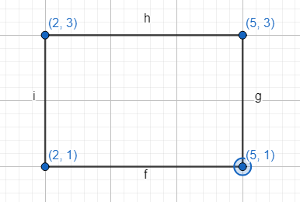
Code-

#include <windows.h> // for MS Windows
#include <GL/glut.h> // GLUT, include glu.h and gl.h
/* Handler for window-repaint event. Call back when the window first appears and
whenever the window needs to be re-painted. */
void sqr_Coordinate()
{
glLineWidth(2.5);
// Draw a Red 1x1 Square centered at origin
glBegin(GL_LINES); // Each set of 4 vertices form a quad
glColor3f(1.0f, 0.0f, 0.0f); // Red
glVertex2f(2,3); // x, y
glVertex2f(5,3);
glEnd();
glBegin(GL_LINES); // Each set of 4 vertices form a quad
glColor3f(1.0f, 0.0f, 0.0f); // Red
glVertex2f(5,1); // x, y
glVertex2f(2,1);
glEnd();
glBegin(GL_LINES); // Each set of 4 vertices form a quad
glColor3f(1.0f, 0.0f, 0.0f); // Red
glVertex2f(2,3); // x, y
glVertex2f(2,1);
glEnd();
glBegin(GL_LINES); // Each set of 4 vertices form a quad
glColor3f(1.0f, 0.0f, 0.0f); // Red
glVertex2f(5,1); // x, y
glVertex2f(5,3);
glEnd();
}
void display() {
glClearColor(0.0f, 0.0f, 0.0f, 1.0f); // Set background color to black and opaque
glClear(GL_COLOR_BUFFER_BIT); // Clear the color buffer (background)
sqr_Coordinate();
glEnd();
glFlush(); // Render now
}
/* Main function: GLUT runs as a console application starting at main() */
int main(int argc, char** argv) {
glutInit(&argc, argv); // Initialize GLUT
glutCreateWindow("OpenGL Setup"); // Create a window with the given title
glutInitWindowSize(320, 320); // Set the window's initial width & height
glutDisplayFunc(display);
gluOrtho2D(-6,6, -6, 6); // Register display callback handler for window re-paint
glutMainLoop(); // Enter the event-processing loop
return 0;
}

Output Screenshot (Full Screen)- 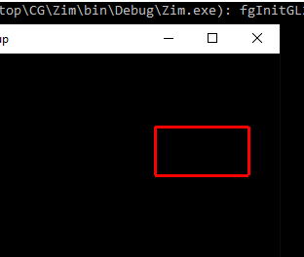

Question-2
Draw the object-

Graph Plot (Picture)- 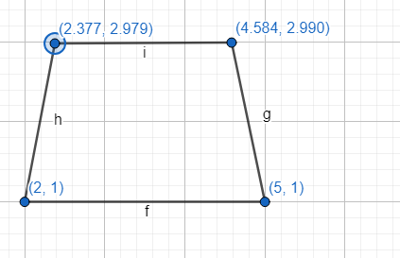

Code-
#include <windows.h> // for MS Windows
#include <GL/glut.h> // GLUT, include glu.h and gl.h
void Coordinate()
{
glPointSize(5.0);
// Draw a Red 1x1 Square centered at origin
glBegin(GL_POLYGON); // Each set of 4 vertices form a quad

glColor3f(1.0f, 0.0f, 0.0f); // Red
glVertex2f(2.00f, 1.00f); // x, y
glVertex2f(5.00f, 1.00f);
glVertex2f(4.584f, 2.990f);
glVertex2f(2.377f, 2.979f);
}

/* Handler for window-repaint event. Call back when the window first appears and
whenever the window needs to be re-painted. */
void display() {
glClearColor(0.0f, 0.0f, 0.0f, 1.0f); // Set background color to black and opaque
glClear(GL_COLOR_BUFFER_BIT); // Clear the color buffer (background)

Coordinate();
glEnd();

glFlush(); // Render now
}

/* Main function: GLUT runs as a console application starting at main() */
int main(int argc, char** argv) {
glutInit(&argc, argv); // Initialize GLUT
glutCreateWindow("LAB TASK"); // Create a window with the given title
glutInitWindowSize(800, 800); // Set the window's initial width & height

glutDisplayFunc(display); // Register display callback handler for window re-paint
gluOrtho2D(-7,7,-7,7);
glutMainLoop(); // Enter the event-processing loop
return 0;
}

Output Screenshot (Full Screen)- 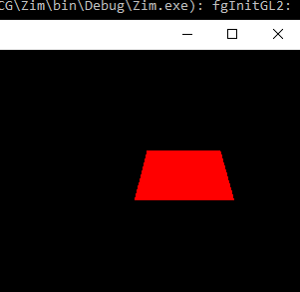

Question-3
Draw the object-
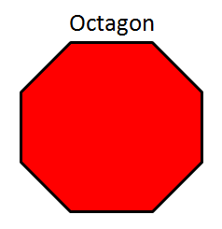

Graph Plot (Picture)- 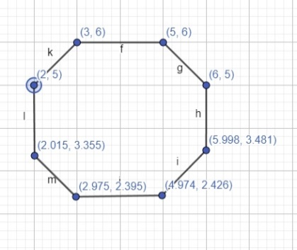

Code-
#include <windows.h> // for MS Windows
#include <GL/glut.h> // GLUT, include glu.h and gl.h

void initGL() {

glClearColor(0.0f, 0.0f, 0.0f, 1.0f); // Black and opaque
}
void Coordinate()
{
glBegin(GL_POLYGON);
glColor3ub(255 ,0 ,0);

glVertex2f(3.0f, 6.0f);
glVertex2f(5.0f, 6.0f);
glVertex2f(6.0f, 5.0f);
glVertex2f(5.998f, 3.481f);
glVertex2f(4.974f, 2.426f);
glVertex2f(2.975f, 2.395f);
glVertex2f(2.015f, 3.355f);
glVertex2f(2.0f,5.0f);

glEnd();
}

/* Handler for window-repaint event. Call back when the window first appears and
whenever the window needs to be re-painted. */
void display() {
glClear(GL_COLOR_BUFFER_BIT); // Clear the color buffer with current clearing color

Coordinate();

glFlush(); // Render now
}

/* Main function: GLUT runs as a console application starting at main() */
int main(int argc, char** argv) {
glutInit(&argc, argv); // Initialize GLUT
glutCreateWindow("Vertex, Primitive & Color"); // Create window with the given title
glutInitWindowSize(320, 320); // Set the window's initial width & height
glutInitWindowPosition(50, 50); // Position the window's initial top-left corner
glutDisplayFunc(display); // Register callback handler for window re-paint event
gluOrtho2D(-8,8,-8,9);
initGL(); // Our own OpenGL initialization
glutMainLoop(); // Enter the event-processing loop
return 0;
}
Output Screenshot (Full Screen)- 

Question-4
Draw the object-



Graph Plot (Picture)- 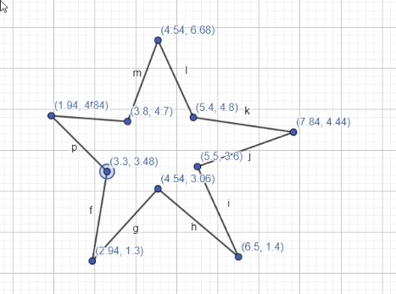

Code-
#include <windows.h> // for MS Windows
#include <GL/glut.h> // GLUT, include glu.h and gl.h
void initGL() {

glClearColor(0.0f, 0.0f, 0.0f, 1.0f); // Black and opaque
}
void Coordinate()
{
glBegin(GL_POLYGON);
glColor3ub(255 ,0 ,0);

glVertex2f(3.3f,3.48f);
glVertex2f(1.94f,4.84f);
glVertex2f(3.8f,4.7f);
glVertex2f(4.54f,6.68f);
glVertex2f(5.4f,4.8f);
glVertex2f(7.84f,4.44f);
glVertex2f(5.5f,3.6f);
glVertex2f(6.5f,1.4f);
glVertex2f(4.54f,3.06f);
glVertex2f(2.94f,1.3f);
glVertex2f(3.3f,3.48f);

glEnd();
}

/* Handler for window-repaint event. Call back when the window first appears and
whenever the window needs to be re-painted. */
void display() {
glClear(GL_COLOR_BUFFER_BIT); // Clear the color buffer with current clearing color

Coordinate();
glFlush(); // Render now
}

/* Main function: GLUT runs as a console application starting at main() */
int main(int argc, char** argv) {
glutInit(&argc, argv); // Initialize GLUT
glutCreateWindow("Vertex, Primitive & Color"); // Create window with the given title
glutInitWindowSize(320, 320); // Set the window's initial width & height
glutInitWindowPosition(50, 50); // Position the window's initial top-left corner
glutDisplayFunc(display); // Register callback handler for window re-paint event
gluOrtho2D(-8,8,-8,9);
initGL(); // Our own OpenGL initialization
glutMainLoop(); // Enter the event-processing loop
return 0;
}

Output Screenshot (Full Screen)- 

Question-5
Draw the object-

Graph Plot (Picture)- 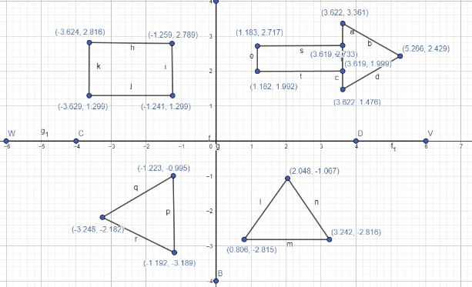

Code-
#include <windows.h> // for MS Windows
#include <GL/glut.h> // GLUT, include glu.h and gl.h

void Coordinate()
{
glClear(GL_COLOR_BUFFER_BIT); // Clear the color buffer (background)
glLineWidth(3.5);
glBegin(GL_LINES);
glColor3f(1.0f, 0.0f, 0.0f);
glVertex2f(-6.0f, 0.0f);
glVertex2f(6.0f, 0.0f);
glVertex2f(0.0f, -4.0f);
glVertex2f(0.0f, 4.0f);
glEnd();
//Triangle1
glBegin(GL_POLYGON);
glColor3ub(255,255,0);
glVertex2f(2.048, -1.067);
glVertex2f(3.242, -2.816);
glVertex2f(0.806, -2.815);
glEnd();
// Triangle2
glBegin(GL_POLYGON);
glColor3ub(138, 43, 226);
glVertex2f(-1.223, -0.995);
glVertex2f(-1.192, -3.189);
glVertex2f(-3.248, -2.182);
glEnd();
//Sqr
glBegin(GL_POLYGON);
glColor3ub(255,0,0);
glVertex2f(-3.624, 2.816);
glVertex2f(-1.259, 2.789);
glVertex2f(-1.241, 1.299);
glVertex2f(-3.629, 1.299);
glEnd();
//Arrow
glBegin(GL_POLYGON);
glColor3ub(50, 205, 50);
glVertex2f(1.183, 2.717);
glVertex2f(3.619, 2.733);
glVertex2f(3.619, 1.999);
glVertex2f(1.182, 1.992);
glEnd();

glBegin(GL_POLYGON);
glColor3ub(50 ,205 ,50);
glVertex2f(3.622, 3.361);
glVertex2f(5.266, 2.429);
glVertex2f(3.622, 1.476);
glEnd();
}
void display() {
glClearColor(0.0f, 0.0f, 0.0f, 1.0f); // Set background color to black and opaque
Coordinate();
glFlush();
}

/* Main function: GLUT runs as a console application starting at main() */
int main(int argc, char** argv) {
glutInit(&argc, argv); // Initialize GLUT
glutCreateWindow("OpenGL Setup"); // Create a window with the given title
glutInitWindowSize(320, 320); // Set the window's initial width & height
glutDisplayFunc(display); // Register display callback handler for window re-paint
gluOrtho2D(-8, 8, -8, 9); // Set the orthographic projection
glutMainLoop(); // Enter the event-processing loop
return 0;
}

Output Screenshot (Full Screen)- 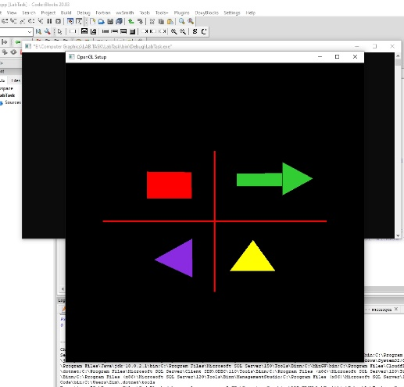

Question-6
Draw the object-

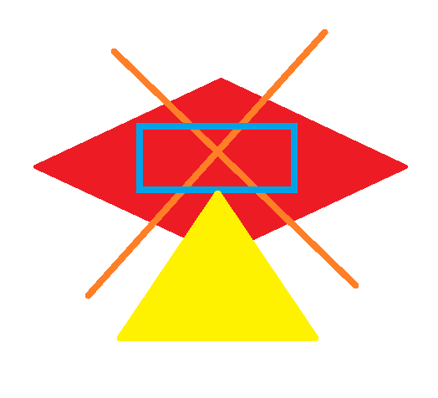

Graph Plot (Picture)- 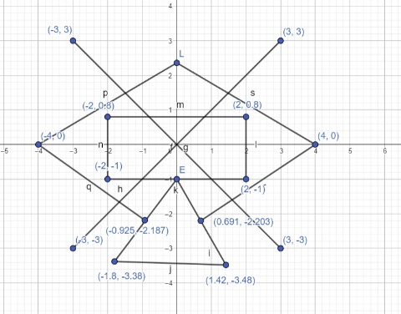

Code-
#include <windows.h> // for MS Windows
#include <GL/glut.h> // GLUT, include glu.h and gl.h

/* Handler for window-repaint event. Call back when the window first appears and
whenever the window needs to be re-painted. */
void Coordinate()
{

//diamond
glBegin(GL_POLYGON);
glVertex2f(-0.925f, -2.187f);
glVertex2f(-4, 0);
glVertex2f(0.0f,2.36f);
glVertex2f(4,0);
glVertex2f(0.691f, -2.203f);
glEnd();
//trianagle
glBegin(GL_POLYGON);
glColor3ub(255,255,0);
glVertex2f(0.0f,-2.0f);
glVertex2f(1.42f, -3.48f);
glVertex2f(-1.8f, -3.38f);
glEnd();

glBegin(GL_LINES);
glColor3f(1.0f, 0.0f, 0.0f);
glVertex2f(-2.0f, 0.8f);
glVertex2f(2.0f, 0.8f);
glVertex2f(2.0f, 0.8f);
glVertex2f(2.0f, -1.0f);
glVertex2f(2.0f, -1.0f);
glVertex2f(-2.0f, -1.0f);
glVertex2f(-2.0f, -1.0f);
glVertex2f(-2.0f, 0.8f);

glEnd();

glBegin(GL_POLYGON);

glVertex2f(-0.925, -2.187);
glVertex2f(-4, 0);
glVertex2f(0.0f,2.36f);
glVertex2f(4,0);
glVertex2f(0.691f, -2.203f);
glEnd();

//sqr
glBegin(GL_LINES);
glColor3ub(30, 144 ,255);
glVertex2f(-2.0f, 0.8f);
glVertex2f(2.0f, 0.8f);

glVertex2f(2.0f, 0.8f);
glVertex2f(2.0f, -1.0f);

glVertex2f(2.0f, -1.0f);
glVertex2f(-2.0f, -1.0f);

glVertex2f(-2.0f, -1.0f);
glVertex2f(-2.0f, 0.8f);

glEnd();
//cross
glBegin(GL_LINES);

glColor3ub(255,165,0);
glVertex2f(-3.0f, -3.0f);
glVertex2f(3.0f, 3.0f);

glVertex2f(-3.0f, 3.0f);
glVertex2f(3.0f, -3.0f);

glEnd();
}
void display() {
glClearColor(0.0f, 0.0f, 0.0f, 1.0f); // Set background color to black and opaque
glClear(GL_COLOR_BUFFER_BIT); // Clear the color buffer (background)
glLineWidth(4.5);

Coordinate();

glFlush(); // Render now
}

/* Main function: GLUT runs as a console application starting at main() */
int main(int argc, char** argv) {
glutInit(&argc, argv); // Initialize GLUT
glutCreateWindow("OpenGL Setup"); // Create a window with the given title
glutInitWindowSize(320, 320); // Set the window's initial width & height
glutDisplayFunc(display); // Register display callback handler for window re-paint
gluOrtho2D(-8, 8, -8, 9); // Set the orthographic projection
glutMainLoop(); // Enter the event-processing loop
return 0;
}

Output Screenshot (Full Screen)- 